BCSE355L — Cloud Architecture Design
Project Phase-I Report

Smart Cloud Archival Framework for National Digital Libraries using Knowledge Graphs

Submitted by:
Sharad Panchal — 24BIT0405
Mohammad Saquib — 24BIT0297

Course Instructor: Dr. Priya V
B.Tech Information Technology, VIT University, Vellore
Submission Deadline: 31 July 2026

Abstract
National digital libraries such as India's National Digital Library (NDLI) aggregate tens of millions of learning resources contributed by government bodies, universities, and public archives, yet most of this content is stored and searched as flat, item-centric metadata records. Because the relationships between resources — which authors worked together, which subjects connect across languages, which institutions contributed related material — are never made explicit, users are limited to keyword search and cannot easily discover connected material or reason across the collection. This project proposes a Smart Cloud Archival Framework that re-architects national digital library operations around a knowledge graph (KG), hosted on Amazon Web Services (AWS), so that entities such as works, authors, subjects, institutions, and languages become linked graph nodes rather than isolated metadata fields. Amazon Neptune serves as the managed graph database at the core of the framework, while a serverless ingestion pipeline (AWS Lambda, Amazon Textract for OCR, Amazon Comprehend for entity recognition, and Amazon Bedrock for LLM-assisted relation extraction) automatically constructs and enriches the graph from newly digitized, multilingual content with minimal manual ontology curation. Access rights and provenance are modelled as first-class graph properties, aligned with NDLI's five-tier access model (Open, Subscribed, Authorized, Members-only, Limited), so that authorization and audit history become queryable rather than only stored as flat fields. Secure authentication (Amazon Cognito, AWS IAM), encryption (AWS KMS), monitoring (Amazon CloudWatch), and notifications (Amazon SNS) support the pipeline end to end. The proposed design is benchmarked conceptually against NDLI's real scale (approximately 71.5 million records, multilingual, federated across contributing institutions). Expected outcomes include relationship-based discovery beyond keyword search, faster knowledge-graph enrichment through LLM-assisted extraction, and multilingual entity linking that lets the same author, subject, or place resolve to one graph node across languages. This report presents the literature survey, individual research gap analysis, project objectives, novelty summary, dataset details, and AWS service plan developed for Project Phase-I.

1. Literature Survey
Fifteen research papers were surveyed for this project, drawn from IEEE Xplore, the ACM Digital Library, SpringerLink, MDPI, Emerald, SAGE, ScienceDirect (Elsevier), IOS Press's Semantic Web journal, and Dagstuhl's TGDK, with a preference for work published between 2023 and 2026. The survey spans the sub-themes that together define this project's problem space: (a) knowledge-graph foundations for smart digital libraries, (b) the real, flat-metadata architecture of India's National Digital Library (NDLI) as a baseline to improve on, (c) linked-data/BIBFRAME adoption across libraries, (d) knowledge-graph visualization and cultural-heritage KG applications, (e) LLM-assisted knowledge-graph construction, (f) multilingual knowledge-graph question answering, (g) knowledge-graph representation learning (embeddings), (h) production-scale scholarly knowledge graphs (dblp), (i) knowledge-aware graph-neural-network recommendation, and (j) access control and secure query answering over knowledge graphs. The table below summarises the method, dataset/context, advantages, limitations, and research gap identified in each paper; a fuller, paper-by-paper analysis follows in Section 2.
Paper | Method | Dataset / Context | Advantages | Limitations | Research Gap
P1 — Meesad & Mingkhwan (2024) | Conceptual overview of KG concepts, construction, and applications in smart digital libraries (SDLs). | Conceptual/survey chapter — no primary dataset. | Clearly motivates KG use for discoverability, accuracy, and personalization. | Conceptual only; no implementation, cloud deployment, or scale specified. | No worked example of deploying this model on a commercial cloud at national-library scale.
P2 — Bhowmick, Das, Chakrabarti & Sanyal (2022) — NDLI | Describes NDLI's production architecture: ingestion, federated search (Apache SolrCloud), integration, and outreach, built on flat, item-centric metadata records. | National Digital Library of India — ~71.5 million records; ~32GB metadata DB; ~500GB search index. | Proven at true national scale; multilingual; five-tier access-rights model. | Metadata is stored and searched as flat, item-centric records with no explicit relationship graph. | No published account of representing NDLI's entities and relationships as a queryable knowledge graph.
P3 — Gaitanou, Andreou, Sicilia & Garoufallou (2024) | Systematic literature review of linked-data adoption in libraries, covering BIBFRAME, FRBR-based models, and the shift from MARC to RDF-based description. | Literature-based systematic review (no primary dataset). | Comprehensive map of linked-data standards (BIBFRAME, RDF) and adoption challenges across many libraries. | Review-level synthesis; no concrete cloud-hosted graph implementation tested. | No evaluation of BIBFRAME-style linked data hosted on a managed cloud graph database at scale.
P4 — ITAL (2024) | Proposes a knowledge-graph system and visualization interface for digital heritage collections, letting users browse relationships between items. | Three deployed KG systems for archive/digital-humanities resources. | Demonstrated across three real deployed systems; tackles the item-centric, no-visible-relationships problem. | Focused on visualization/UX; less focused on backend scalability or cloud architecture. | No discussion of running this approach against a managed, elastic cloud graph database at national-library scale.
P5 — Journal of Documentation (Emerald, 2026) | Chains three LLMs with Cultural Heritage ontologies (ATR4CH framework) to convert unstructured text into queryable knowledge graphs. | Wikipedia articles describing disputed cultural-heritage items/documents/artifacts. | Automates KG construction from free text via LLMs; replicable across cultural-heritage domains. | Demonstrated only on clean Wikipedia text; authors note human oversight is still required. | Not tested on scanned/OCR'd institutional archive text of the kind a national digital library ingests.
P6 — MDPI Information, ROSES Review (2026) | ROSES-based systematic review of knowledge-graph applications across cultural-heritage preservation systems, 2015–2024. | Systematic literature review (no primary dataset). | Broad, methodologically transparent map of how KGs are used across many cultural-heritage projects. | Synthesis-level review; proposes no new architecture of its own. | Does not focus on national-library-scale collections or AWS-native implementation.
P7 — MDPI Information (2024) | Reviews generalized pipelines for constructing and continuously updating knowledge graphs, covering extraction, alignment, and metadata management. | Survey/review of existing KG construction pipelines. | Identifies concrete, generalizable pipeline stages applicable to any KG-construction domain. | General-purpose; no library-specific case study; notes metadata support adds complexity. | No domain-specific guidance for handling library metadata standards (Dublin Core, MARC/BIBFRAME).
P8 — Perevalov, Both & Ngonga Ngomo (2024) | Systematic review of multilingual Knowledge Graph Question Answering (mKGQA), comparing information-extraction-style and semantic-parsing-style approaches. | Systematic review of existing mKGQA systems and benchmarks. | Directly addresses multilingual querying — highly relevant to a multilingual national digital library. | Review-level; not tested against a library/archive-domain knowledge graph. | No evaluation of multilingual KGQA specifically over a national-digital-library KG covering Indian languages.
P9 — ScienceDirect / Elsevier (2024) | Comprehensive experimental comparison of knowledge-graph embedding (representation-learning) models. | Standard KG-embedding benchmark datasets used across the compared models. | Experimentally grounded comparison of embedding models, useful for choosing a model in practice. | Benchmarked on generic KG datasets, not on bibliographic/library data. | No guidance on which embedding approach suits sparse, multilingual bibliographic knowledge graphs.
P10 — ACM / ICEKIM (2025) | Builds a science-and-technology knowledge graph from crawled literature, with ontology construction via hierarchical analysis and semantic association, LLM-assisted. | Crawled scientific/technology literature data (web-sourced, deduplicated and cleaned). | Concrete, applied crawl-to-KG pipeline demonstrating feasibility for a real technical domain. | Assumes open-web crawling rather than an institutional ingestion workflow with access rules. | No adaptation of this pipeline to institutional ingestion with defined access-rights categories.
P11 — dblp KG / TGDK (2024) | Introduces the dblp Knowledge Graph: a production RDF representation of 30+ years of computer-science bibliographic data, served via public SPARQL endpoint. | dblp computer-science bibliography — hundreds of millions of RDF triples, daily-updated. | Real, production-scale, continuously updated scholarly KG with open FAIR SPARQL/API access. | Scoped to computer-science bibliographic metadata only; not multilingual or multi-format. | No equivalent production-scale scholarly KG exists for a general, multilingual, multi-format national library.
P12 — IEEE — GNN Recommendation Survey | Surveys graph neural network (GNN) approaches to recommendation: knowledge-aware, session-based, user-item bipartite, and social recommendation. | Survey of existing GNN-based recommendation models and benchmarks. | Clear categorization of GNN recommendation approaches, including knowledge-aware recommendation. | General recommendation-systems survey; not focused on library/archive discovery. | No application of knowledge-aware GNN recommendation to archival material discovery via a KG.
P13 — ScienceDirect / Elsevier (2026) | Evaluates LLM performance at automatically generating knowledge graphs from unstructured text, versus rule-based/regex approaches. | Unstructured text/log data used to benchmark LLM-based KG generation. | Shows LLM-based extraction captures context-dependent relationships regex cannot. | Not benchmarked on bibliographic/library-domain text; output variability flagged as a challenge. | No evaluation of LLM-based KG generation specifically for bibliographic/archival text.
P14 — Buron, Kathuria, Manolescu & Siachamis (2026) | Develops algorithms for answering conjunctive RDF queries over knowledge graphs in the presence of RDFS ontologies and access-control restrictions. | RDF/RDFS knowledge-graph query-answering setting (algorithmic/formal evaluation). | Directly addresses secure querying of RDF knowledge graphs at the query-answering level. | Formal/algorithmic contribution; not demonstrated on a library-scale or multilingual KG. | No demonstration of this approach applied to a national-library-style KG with tiered access rights.
P15 — Valzelli & Palmonari (2020) | Proposes an Attribute-Based Access Control (ABAC) extension for Neo4j/Cypher plus a query-rewriting algorithm that enforces access policies automatically. | Property-graph access-control model evaluation (Neo4j/Cypher setting). | Practical, implementable ABAC model integrated directly with a widely used graph database. | Predates the LLM-assisted KG-construction wave; edge-attribute handling noted as incomplete. | Not evaluated against a Neptune/Gremlin deployment or a real multilingual library access model.
Note: full bibliographic details for P1–P15 are given in the References section at the end of this report.

2. Individual Research Gap Analysis
This section expands each of the fifteen papers into a full Existing-Method / Advantages / Limitations / Research-Gap / Possible-Improvement analysis, written independently rather than copied from any paper's own stated limitations or future-work section. Each entry also states, concretely, how the proposed Smart Cloud Archival Framework responds to the identified gap.
P1 — Meesad & Mingkhwan (2024)
Existing Method: Provides a conceptual overview of how knowledge graphs organize and integrate structured knowledge in smart digital libraries (SDLs), covering core KG concepts, construction techniques, and how KGs enhance discoverability, accuracy, and personalization by linking collections, metadata, and external resources.
Advantages: As a foundational overview, it clearly lays out why item-centric library systems benefit from a KG layer: it connects diverse collections and metadata that would otherwise sit in separate silos, directly improving discovery and personalization.
Limitations: It is a conceptual/survey chapter rather than an implemented system; it does not specify a concrete cloud deployment, a target scale, or a real construction pipeline.
Research Gap: There is no worked example showing how this conceptual KG model would actually be deployed and scaled on a commercial cloud for a real national-scale library collection.
Possible Improvement (this project's response): This project turns the conceptual model into a concrete deployment: Amazon Neptune as the graph store, with Textract/Comprehend/Bedrock feeding entities and relationships into it from real digitized content.
P2 — Bhowmick, Das, Chakrabarti & Sanyal (2022) — NDLI
Existing Method: Documents how NDLI actually runs in production: a federated-search layer built on Apache SolrCloud indexes about 71.5 million records contributed by many institutions, tagged into five access categories, but each record is treated and searched as an independent item.
Advantages: It is the clearest evidence available that a national-scale digital library can serve millions of concurrent users and tens of millions of multilingual records — a strong real-world benchmark for scale and access-rights design.
Limitations: Because records are indexed and searched as flat items, NDLI cannot directly answer relationship-based questions (e.g., other works by contributors who also worked with this author) without a separate, explicit graph layer.
Research Gap: There is no published work modelling NDLI's (or a comparable national library's) entities and relationships explicitly as a knowledge graph, which would enable relationship-based discovery beyond keyword search.
Possible Improvement (this project's response): This project layers a knowledge graph (Amazon Neptune) on top of the same kind of metadata NDLI holds, turning authors, subjects, and institutions into linked graph nodes so relationship-based queries become possible without discarding the proven federated-search layer.
P3 — Gaitanou, Andreou, Sicilia & Garoufallou (2024)
Existing Method: Systematically reviews how libraries worldwide are adopting linked-data standards — chiefly BIBFRAME as a successor to MARC — to expose bibliographic description as RDF and connect it to the wider Semantic Web.
Advantages: It gives a thorough, well-evidenced picture of where linked-data adoption already stands in libraries, including known modelling difficulties (e.g., over-specific entity descriptions) that a new implementation should anticipate.
Limitations: As a review, it stops short of testing any of the surveyed approaches on a concrete, managed cloud graph database, or at the record volumes a national library would need.
Research Gap: Nobody has evaluated how a BIBFRAME-style linked-data model performs once it is actually hosted on a managed cloud graph database at tens-of-millions-of-records scale.
Possible Improvement (this project's response): This project takes the BIBFRAME-style entity model surveyed here and implements it concretely on Amazon Neptune, testing it against a representative NDLI-scale sample rather than leaving it at the standards-review stage.
P4 — ITAL (2024)
Existing Method: Builds a knowledge-graph-backed visualization interface for digital heritage collections, moving beyond item-centric search results to let users browse and understand relationships between items, drawing on experience from three real deployed KG systems.
Advantages: Because it is grounded in three actual deployed systems rather than a purely theoretical design, its design recommendations (graph database choice, visualization library choice, UX patterns) are practically tested rather than speculative.
Limitations: The paper's focus is the visualization and UX layer; it does not go deep into how the underlying graph database would be provisioned, scaled, or secured on a commercial cloud.
Research Gap: There is no discussion of running this kind of KG visualization against a managed cloud graph database sized for tens of millions of national-library records.
Possible Improvement (this project's response): This project adopts the relationship-browsing visualization approach recommended here but backs it with Amazon Neptune so the same idea can scale to NDLI-sized collections rather than the smaller archive collections it was originally tested on.
P5 — Journal of Documentation (Emerald, 2026)
Existing Method: Chains three large language models together with a Cultural Heritage ontology framework (ATR4CH) to automatically extract entities and relationships from unstructured text and assemble them into a queryable knowledge graph, applied to Wikipedia articles about scholarly/historical disputes.
Advantages: It shows convincingly that LLM-assisted extraction can replace a large share of manual ontology population, and that the resulting pipeline is reusable across different cultural-heritage domains, not just one collection.
Limitations: The input text (Wikipedia articles) is clean, well-formed prose; the authors themselves note the output KG still needs human oversight during post-processing before it can be trusted.
Research Gap: It is untested on the noisier, OCR-derived text a national digital library actually processes — scanned books, handwritten manuscripts, inconsistent institutional metadata — which is a harder extraction problem than clean Wikipedia prose.
Possible Improvement (this project's response): This project runs the same LLM-plus-ontology extraction idea (using Amazon Bedrock in place of a self-hosted LLM chain) directly on Textract-OCR'd archive text, with a human-in-the-loop review step for low-confidence extractions.
P6 — MDPI Information, ROSES Review (2026)
Existing Method: Applies the ROSES systematic-review protocol to catalogue and analyze how knowledge graphs have been applied across cultural-heritage preservation systems over a ten-year span (2015–2024).
Advantages: Its transparent review protocol makes it easy to trust the resulting map of KG use cases, common ontologies, and recurring implementation patterns across many independent cultural-heritage projects.
Limitations: Being a review, it does not itself propose or test any new architecture, and it does not focus specifically on library-scale (as opposed to smaller heritage-collection-scale) deployments.
Research Gap: None of the reviewed applications specifically targets national-library-scale collections deployed on a commercial elastic cloud such as AWS.
Possible Improvement (this project's response): This project draws on the recurring implementation patterns this review identifies (common ontology choices, extraction pipelines) and applies them specifically to an AWS-hosted, national-library-scale archive.
P7 — MDPI Information (2024)
Existing Method: Surveys the current state of generalized pipelines for constructing and continuously updating knowledge graphs, examining how metadata-management support increases the complexity of the resulting graph structure and its queries.
Advantages: It distills the KG-construction problem into clear, reusable pipeline stages, and honestly flags where added metadata support costs processing time — useful, practical guidance for anyone building a new KG pipeline.
Limitations: The guidance stays general-purpose; there is no worked example tailored to library metadata standards or to a continuously growing, multi-institution archive.
Research Gap: It does not address how to fold library-specific metadata standards (Dublin Core, MARC/BIBFRAME, access-rights categories) into the generalized construction pipeline it describes.
Possible Improvement (this project's response): This project instantiates the reviewed pipeline stages specifically for Dublin-Core-aligned library metadata, measuring whether the added metadata-management complexity the paper warns about stays acceptable at archive scale.
P8 — Perevalov, Both & Ngonga Ngomo (2024)
Existing Method: Systematically reviews multilingual Knowledge Graph Question Answering (mKGQA) systems, comparing information-extraction-style approaches (which rank candidate answers) against semantic-parsing-style approaches (which convert questions into formal queries), including how each handles multiple languages.
Advantages: It is exactly the kind of survey a multilingual country needs: it maps out which mKGQA techniques currently exist and how well they generalize across languages, rather than assuming an English-only setting.
Limitations: The review is not tied to any particular domain KG; it does not test how well mKGQA techniques perform specifically over a library/archive-style knowledge graph.
Research Gap: Nobody has evaluated multilingual KGQA techniques specifically over a national-digital-library KG spanning the ten-plus languages a system like NDLI supports.
Possible Improvement (this project's response): This project plans a small mKGQA pilot — natural-language questions in two or three Indian languages answered against the prototype Neptune graph — directly informed by the techniques this survey identifies as most language-robust.
P9 — ScienceDirect / Elsevier (2024)
Existing Method: Runs a comprehensive experimental comparison of knowledge-graph-embedding (representation-learning) models, which convert graph entities and relations into vector form so they can be used in downstream machine-learning tasks such as link prediction or recommendation.
Advantages: Because the comparison is experimental rather than purely theoretical, it gives practical, evidence-based guidance on which embedding approach to reach for, rather than leaving the choice to intuition.
Limitations: All the benchmark datasets used are generic KG-research datasets; none reflect the sparse, multilingual, access-rights-tagged structure of a real bibliographic archive.
Research Gap: There is no equivalent experimental comparison specifically for sparse, multilingual, access-rights-aware bibliographic knowledge graphs such as the one this project proposes.
Possible Improvement (this project's response): This project benchmarks a small number of the top-performing embedding approaches identified here against the prototype archival KG, to see whether their generic-dataset performance carries over to library data.
P10 — ACM / ICEKIM (2025)
Existing Method: Builds a science-and-technology knowledge graph end to end: a Selenium-based crawler gathers literature data, the data is deduplicated and cleaned, and an ontology is constructed via hierarchical analysis and semantic association before the KG is assembled with LLM assistance.
Advantages: It is a genuinely applied, working pipeline — not just a theoretical model — showing that crawl-to-KG construction with ontology design is feasible for a real technical literature domain.
Limitations: The pipeline assumes literature can be crawled from the open web; it does not address ingesting content that arrives directly from contributing institutions under defined access-rights rules, as a national library would.
Research Gap: There is no version of this crawl-to-KG pipeline adapted to an institutional ingestion workflow where content arrives from many contributing libraries with different access-rights categories rather than being crawled from the open web.
Possible Improvement (this project's response): This project replaces the web-crawling stage with an institutional ingestion API (so contributing libraries push content directly) while keeping the same ontology-construction-plus-LLM-extraction pattern for building the KG.
P11 — dblp KG / TGDK (2024)
Existing Method: Introduces the dblp Knowledge Graph: the dblp team's own semantic RDF representation of over 30 years of curated computer-science bibliographic data, augmented with OpenCitations citation data, and exposed through daily-updated RDF dumps, monthly archived releases, and a public SPARQL endpoint.
Advantages: It is a rare example of a scholarly knowledge graph that is genuinely in production at scale, continuously maintained, and openly queryable — solid proof that a bibliographic KG can be operated reliably over decades, not just prototyped.
Limitations: It is deliberately scoped to one field (computer science) and one resource type (bibliographic records); it does not need to handle the multilingual, multi-format mix (books, theses, audio, video) a national digital library holds.
Research Gap: There is no equivalent production-grade, continuously updated scholarly KG built for a general-purpose, multilingual, multi-format national digital library rather than a single academic field.
Possible Improvement (this project's response): This project borrows dblp KG's operational pattern — daily-updated exports and a public query endpoint — but applies it to NDLI-style multi-format, multilingual content rather than computer-science bibliographic records alone.
P12 — IEEE — GNN Recommendation Survey
Existing Method: Surveys how graph neural networks (GNNs) are applied to recommendation, organizing existing approaches into four categories — knowledge-aware, session-based, user-item bipartite, and social recommendation — and discussing graph-building, aggregation, and scalability considerations for each.
Advantages: Its knowledge-aware recommendation category maps almost directly onto what a KG-backed digital library needs: using the graph of entities and relationships to recommend related material, not just similar keywords.
Limitations: The survey is written for general recommender-systems use cases (e-commerce, social platforms); it does not examine library discovery or archival-content recommendation specifically.
Research Gap: Nobody has applied knowledge-aware GNN recommendation techniques to help readers discover related archival material through a national digital library's own knowledge graph.
Possible Improvement (this project's response): This project plans a lightweight knowledge-aware recommendation feature — readers who explored this topic also explored — built directly on the Neptune graph structure, following the patterns this survey categorizes.
P13 — ScienceDirect / Elsevier (2026)
Existing Method: Evaluates how well large language models perform at automatically generating knowledge graphs from unstructured text, benchmarking LLM-based extraction against rule-based and regex-based approaches for identifying meaningful relationships.
Advantages: It provides concrete evidence that LLM-based extraction captures context-dependent relationships that rule-based or regex approaches simply cannot, which matters for messy, real-world text rather than clean structured input.
Limitations: The variability of LLM outputs is flagged as a real challenge for any pipeline that needs deterministic, repeatable results, and the evaluation is not run on bibliographic or archival text specifically.
Research Gap: There is no evaluation of LLM-based KG generation applied specifically to bibliographic/archival text, which has its own vocabulary (titles, subject headings, institutional names) different from the general text or log data studied.
Possible Improvement (this project's response): This project evaluates Amazon Bedrock-based extraction specifically on OCR'd archival text and adds a confidence-threshold-plus-human-review step to manage the output variability this paper identifies as a challenge.
P14 — Buron, Kathuria, Manolescu & Siachamis (2026)
Existing Method: Develops query-answering algorithms for conjunctive RDF queries over knowledge graphs governed by RDFS ontologies and access restrictions, under a model where all users see the full graph by default except where specific restrictions apply.
Advantages: It solves a real, specific problem: how to answer graph queries correctly and efficiently when parts of the graph are access-restricted, rather than simply hiding restricted nodes crudely or relying only on an external authorization layer.
Limitations: The contribution is algorithmic and formally evaluated; it is not demonstrated on a real library-style knowledge graph or at multilingual, national-archive scale.
Research Gap: There is no demonstration of this restricted-query-answering approach applied to a national-digital-library KG using a real multi-tier access model such as NDLI's Open/Subscribed/Authorized/Members/Limited categories.
Possible Improvement (this project's response): This project maps NDLI's five access-rights categories directly onto the restriction model this paper formalizes, so that Neptune query answers are correctly filtered per user role instead of relying solely on an external IAM policy layer disconnected from the graph.
P15 — Valzelli & Palmonari (2020)
Existing Method: Extends the Neo4j property-graph database with Attribute-Based Access Control (ABAC) support and a query-rewriting algorithm that automatically transforms an arbitrary Cypher query into a 'safe' one, returning only the data a given user is authorized to see, integrated directly into the database rather than as an external layer.
Advantages: Because the access-control logic is rewritten directly into the query rather than filtered afterward, it is both more efficient and harder to accidentally bypass than a bolt-on authorization layer.
Limitations: The work predates the recent wave of LLM-assisted KG construction, and the authors note that edge/relationship-level attributes are not fully handled by the access-control comparisons they present.
Research Gap: It has not been evaluated on Amazon Neptune's Gremlin-based query model, nor against a real multi-tier, multilingual access-rights model like a national digital library's.
Possible Improvement (this project's response): This project adapts the same query-rewriting principle to Neptune's Gremlin/openCypher interface, enforcing NDLI-style access categories at the query level rather than only through a separate IAM policy check before the query runs.

3. Project Objectives
The following four to six objectives are measurable and achievable within the scope of a Phase-I prototype, while remaining consistent with the eventual goal of operating at national-library scale.
- Design and populate a knowledge graph in Amazon Neptune that models entities — works, authors, subjects, institutions, languages — and the relationships between them for a representative subset of national digital library content, rather than storing them as flat bibliographic tables.
- Automate entity and relation extraction from OCR'd, multilingual archival text using AWS AI services (Amazon Textract, Amazon Comprehend, Amazon Bedrock), targeting a measurable reduction in manual ontology-curation effort compared with hand-built knowledge graphs.
- Enable relationship-based semantic search over the archive (for example, other works by contributors linked to this author) that goes beyond keyword/item-centric search, and measure the improvement in discovery of related material.
- Model access rights and provenance as first-class properties of the graph, aligned to NDLI's five-tier access model (Open, Subscribed, Authorized, Members-only, Limited), so authorization and audit history are directly queryable.
- Support multilingual entity linking so that the same author, subject, or place referenced in different Indian languages resolves to a single graph node, improving cross-lingual discovery.
- Provide a graph-visualization dashboard that lets administrators and users explore relationships between archived resources, rather than only paging through a ranked list of search results.

4. Novelty Summary
What differentiates this project from the existing work surveyed above is not any single technique but how the identified gaps are stitched together into one coherent, AWS-native design. The novelty is organised below under the eight dimensions suggested in the project guidelines.
New feature: Represents national digital library content as an explicit, queryable knowledge graph — linking authors, subjects, institutions, and languages — instead of the flat, item-centric metadata records used by systems such as NDLI today (directly answering the gap identified in P2 and P3).
Better algorithm: Uses Amazon Bedrock-based LLM-assisted entity and relation extraction, following the direction shown in P5 and P10, to build and enrich the graph automatically, instead of the purely manual ontology curation typical of earlier library KG efforts.
Better architecture: Layers a Neptune-backed graph store alongside the existing object-storage and relational-metadata layers, rather than replacing proven infrastructure — extending, not discarding, patterns like NDLI's federated search (P2) or the dblp KG's production pipeline (P11).
Better AWS integration: Chains Textract → Comprehend/Bedrock → Neptune → API Gateway → Cognito/IAM into one coherent extraction-to-query pipeline, instead of the single-service focus seen in most of the surveyed knowledge-graph papers.
Better security: Models access rights and provenance as first-class graph properties, drawing on the restricted-query-answering approach in P14 and the query-rewriting ABAC model in P15, so authorization is enforced at the graph-query level rather than only through an external IAM check.
Better automation: Automated, continuous KG enrichment as new content is ingested, rather than the one-time or manually curated graph-construction approach found in most surveyed systems.
Better accuracy: Multilingual entity linking (informed by the mKGQA survey in P8) resolves the same real-world entity across languages to a single graph node, improving precision over the single-language extraction methods surveyed in P5 and P10.
Better scalability: Designed to scale toward NDLI's approximately 71.5-million-record scale using Neptune's managed, distributed graph engine, informed by the KG-construction and representation-learning scalability findings in P7 and P9.

5. Proposed Architecture
Two architecture diagrams are presented below, hand-drafted for Project Phase-I and reproduced here from the team's working sketches.

Diagram 1 — AWS Cloud / Knowledge-Graph Architecture
This diagram shows how the AWS-hosted services interact: digitization centres feed source material into the cloud layer, where metadata extraction and knowledge-graph distribution happen before content reaches the admin/curator control layer and end users.
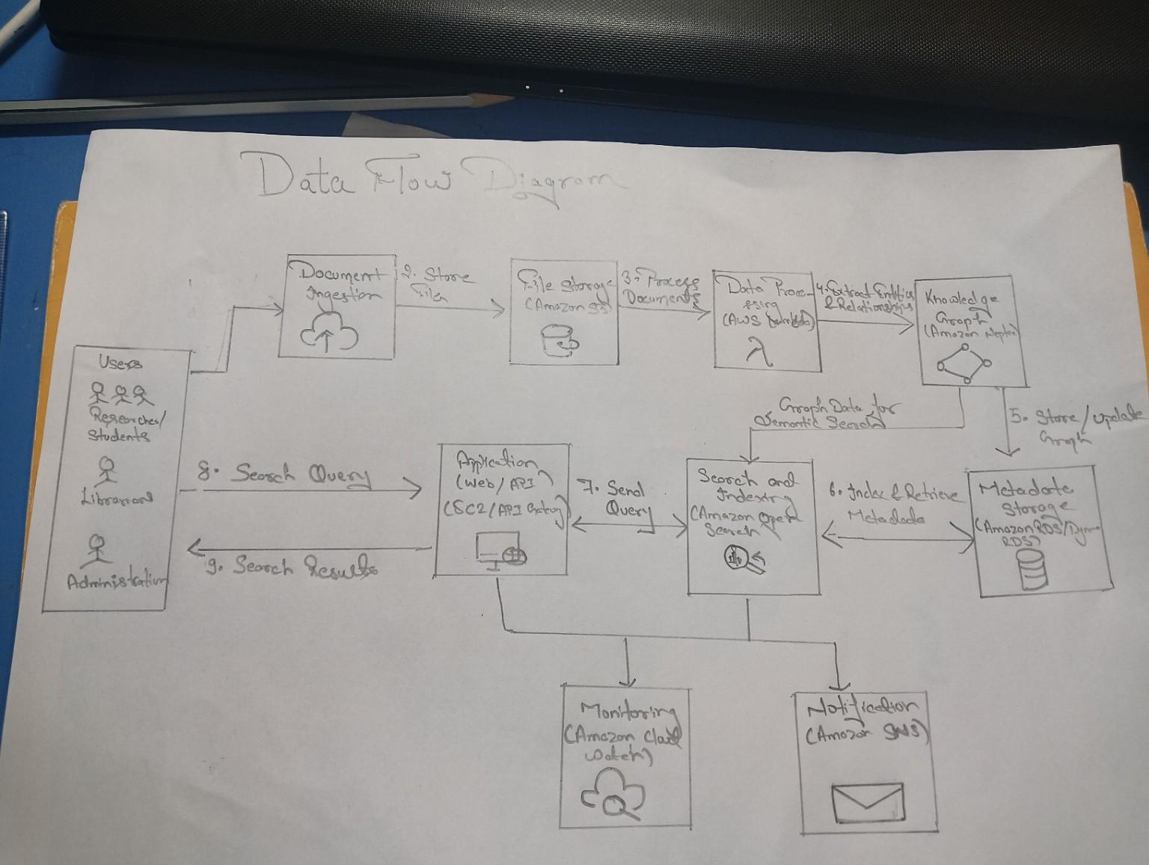
Fig. 1 — AWS Cloud Architecture (Metadata Extraction → Knowledge Graph Distribution)
National Archives, University Libraries, and Government Museum Records feed the Digitalization Centres via the ingestion flow. Digitized content moves into the cloud layer (Amazon Neptune/S3-backed), passing through Metadata Extraction and then Knowledge Graph Distribution. The Admin/Curator Control Center oversees the pipeline, with email/call-based user notifications and a User Access Point for end users, and a separate Institution Portal / App Gateway for contributing institutions, connected via the data/query flow shown by the double-headed arrows.

Diagram 2 — Complete System Architecture
This diagram shows the overall project workflow end to end: how content from contributing institutions is digitized, ingested into the central knowledge-graph cloud platform, and made available to administrators and end users.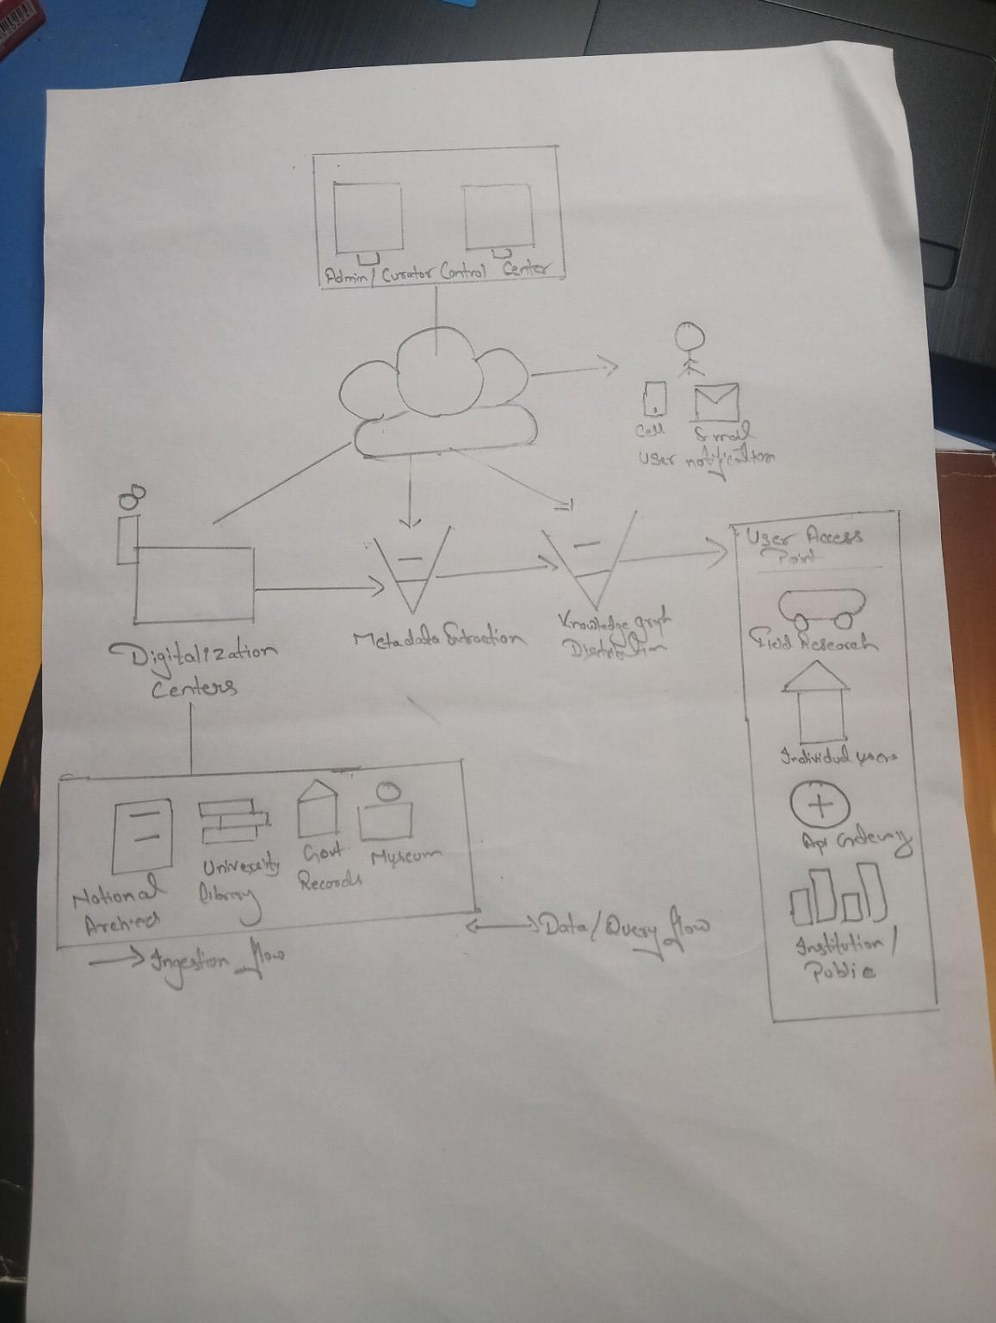
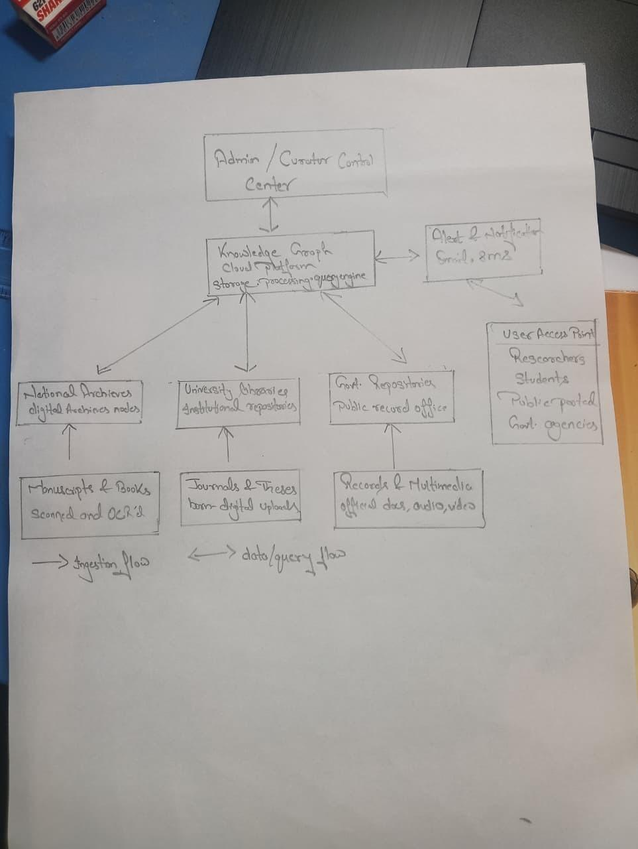
Fig. 2 — Complete System Architecture (overall project workflow)
Three categories of contributing institutions — National Archives, University Libraries/Institutional Repositories, and Government Repositories/Public Record Offices — supply source material: manuscripts and books (scanned and OCR'd), journals and theses (born-digital uploads), and records/multimedia (official documents, audio, video). All three feed into the central Knowledge Graph Cloud Platform (storage, processing, and query engine), which is supervised by the Admin/Curator Control Center and pushes alerts/notifications (email, SMS). End users — researchers, students, the public, and government agencies — reach the system through the User Access Point, with the ingestion flow and data/query flow distinguished in the legend.

6. Dataset Details
The framework is grounded in the real architecture and scale of India's National Digital Library (NDLI) rather than a hypothetical dataset, since NDLI is itself the flagship example of a national digital library and is the natural reference point for this project's title and scope.
Dataset Name | National Digital Library of India (NDLI) metadata repository — a representative subset is remodelled as a knowledge graph for Phase-I prototyping.
Source | National Digital Library of India, developed and operated by IIT Kharagpur, sponsored by the Ministry of Education, Government of India, under the National Mission on Education through ICT (NMEICT).
URL | https://ndl.iitkgp.ac.in/ (also accessible at https://www.ndl.gov.in/). NDLI exposes an API to registered institutions/developers for metadata harvesting.
Size (full production repository) | Approximately 32 GB structured metadata database and approximately 500 GB federated search index (Apache SolrCloud). The Phase-I prototype will work with a much smaller representative sample loaded into Neptune, not the full repository.
Number of Records | Approximately 71.5 million records in the production NDLI repository. The prototype proposes sampling a representative subset — for example, 5,000–10,000 records across two or three subject domains — to populate the prototype graph.
Entity & Relationship Types (Graph Schema) | Proposed node (entity) types: Work, Author, Subject, Institution, Language, Access-Category. Proposed edge (relationship) types: authoredBy, hasSubject, contributedBy, translatedFrom, relatedTo, accessGovernedBy — derived from the same ~15–20 Dublin-Core-aligned metadata fields NDLI already records, restructured as a graph instead of flat columns.
Data Type | Structured metadata restructured as a labelled property graph (nodes, edges, and properties) in Amazon Neptune, with linked pointers to source-repository content such as PDF, scanned image, video, or audio, depending on the resource.
License | Metadata is generally made available for non-commercial educational and research reuse via NDLI; the underlying source content follows five access categories set by the contributing repository — Open, Subscribed, Authorized, NDLI-members-only, and Limited.
Purpose of Using the Dataset | To design and test the framework's graph-construction, entity-linking, relationship-query, and access-control components against a realistic, large-scale, multilingual metadata schema, rather than an artificial toy graph.
Preprocessing Required | Schema normalisation/mapping from flat Dublin-Core-aligned fields to graph entities and relationships; entity resolution and de-duplication across contributing repositories so the same author/subject is not duplicated as separate nodes; language identification and cross-lingual entity linking; validation of access-rights tags before mapping them to graph-level access properties; and stratified sampling to build a representative prototype subgraph.

7. AWS Services Planning
The table below lists the AWS services planned for implementation and the specific purpose each serves in the Smart Cloud Archival Framework, following the same Service / Purpose format suggested in the project guidelines.
AWS Service | Purpose in This Project
Amazon Neptune | Managed graph database at the core of the framework; stores works, authors, subjects, institutions, and languages as nodes and their relationships as edges, and serves relationship-based queries.
Amazon Bedrock | Managed access to foundation models for LLM-assisted entity and relation extraction, used to construct and continuously enrich the knowledge graph from unstructured archival text.
Amazon S3 (Standard + Intelligent-Tiering) | Primary object storage for ingested documents, images, and derivative files; Intelligent-Tiering automatically moves objects to cheaper tiers as access frequency drops.
Amazon S3 Glacier / Glacier Deep Archive | Low-cost, long-term archival storage for historical source files that are rarely accessed but must be retained indefinitely.
AWS Lambda | Serverless functions that run the ingestion, OCR-trigger, entity-extraction, and graph-update logic without managing servers.
Amazon Textract | Optical character recognition (OCR) and text extraction from scanned books, manuscripts, and image-based documents, feeding raw text to Comprehend/Bedrock.
Amazon Comprehend | Extracts named entities and key phrases from digitized text as a lighter-weight, complementary source of graph entities alongside Bedrock.
Amazon RDS / Amazon DynamoDB | Staging storage for raw ingestion records and audit logs before they are transformed into graph entities and relationships in Neptune.
Amazon API Gateway | Exposes REST APIs for graph queries, ingestion, and integration with contributing institutions.
Amazon Cognito | Authenticates learners, contributing-institution staff, and administrators; manages access-category permissions (Open/Subscribed/Authorized/Members/Limited).
AWS IAM | Fine-grained, role-based permissions for internal services, pipelines, and administrators.
AWS KMS | Manages encryption keys for data at rest across S3, Neptune, and RDS/DynamoDB.
Amazon CloudWatch | Monitors pipeline health, graph-update throughput, error rates, and overall system performance.
Amazon SNS | Sends notifications to administrators and contributing institutions on ingestion events, graph updates, or flagged content.
Amazon QuickSight | Visualizes ingestion volume, graph growth (nodes/edges over time), and access statistics on administrative dashboards.

8. GitHub Guidelines
Repository: https://github.com/saquibjawed9304-dot/Smart_Cloud_Archival-framework-for-digital-library-using-KG
The repository above has been created and is currently empty; the structure, branches, and workflow below are the team's plan for populating it over the course of Project Phase-I and Phase-II, adapted from the course guidelines for a two-member team (rather than the three-member example given in the guidelines).

Proposed Repository Structure
Smart_Cloud_Archival-framework-for-digital-library-using-KG/
│
├── README.md
├── LICENSE
├── .gitignore
│
├── docs/
│ ├── Project_Report.docx
│ ├── Literature_Survey.docx
│ ├── Research_Gap.docx
│ ├── Objectives.docx
│ └── Novelty.docx
│
├── architecture/
│ ├── AWS_KG_Architecture.png (Diagram 1)
│ └── System_Architecture.png (Diagram 2)
│
├── dataset/
│ ├── raw/
│ ├── processed/
│ └── dataset_description.pdf
│
├── src/
│ ├── ingestion/ (Textract / Comprehend / Bedrock pipeline)
│ ├── knowledge_graph/ (Neptune schema, entity & relation loaders)
│ ├── frontend/ (search UI + graph visualization)
│ ├── backend/ (API Gateway / Lambda handlers)
│ └── aws/ (IAM, Cognito, monitoring, IaC configs)
│
├── results/
│
└── presentation/

Branch Allocation (Team of 2)
main
▲
│
develop
┌──────┴──────┐
│ │
feature/ feature/
student1 student2
(Sharad Panchal (Mohammad Saquib
— 24BIT0405) — 24BIT0297)
Each student works only in their own feature branch and opens a Pull Request into develop for review before it is merged; develop is merged into main once the phase is stable, tagged as v1.0-Phase1.

Student 1 — Sharad Panchal (24BIT0405)
feature/student1 (Sharad Panchal — 24BIT0405)
│
├── src/
│ ├── frontend/ (search UI, graph-visualization front end)
│ └── backend/ (API Gateway, Lambda handlers)
│
├── src/aws/
│ ├── S3, Cognito, IAM, KMS configs
│ └── CloudWatch, SNS setup
│
├── docs/
│ └── Research_Gap_Student1.docx (Papers P1–P8)
│
└── architecture/
└── System_Architecture.png

Student 2 — Mohammad Saquib (24BIT0297)
feature/student2 (Mohammad Saquib — 24BIT0297)
│
├── src/knowledge_graph/
│ ├── neptune_schema/ (node & edge definitions)
│ └── entity_linking/ (multilingual entity resolution)
│
├── src/ingestion/
│ └── textract_comprehend_bedrock_pipeline/
│
├── docs/
│ └── Research_Gap_Student2.docx (Papers P9–P15)
│
└── architecture/
└── AWS_KG_Architecture.png

Workflow
- Create the repository (done) and the develop branch.
- Each student creates their own feature/studentX branch from develop.
- Students commit their work regularly to their own branch.
- Raise a Pull Request (PR) from each feature branch into develop.
- Both team members review each other's changes before merging.
- Resolve any merge conflicts collaboratively.
- Merge approved changes into develop.
- Once Phase-I is stable, merge develop into main and tag the release (v1.0-Phase1).

Expected Contribution Matrix (2-Member Team)
Activity | Sharad Panchal (24BIT0405) | Mohammad Saquib (24BIT0297)
Literature Survey | ✓ (P1–P8) | ✓ (P9–P15)
Research Gap Analysis | ✓ (P1–P8) | ✓ (P9–P15)
Frontend & API Development | ✓
Knowledge Graph / Neptune Schema Design |  | ✓
Ingestion Pipeline (Textract/Comprehend/Bedrock) |  | ✓
AWS Infrastructure (S3, IAM, Cognito, monitoring) | ✓
Testing | ✓ | ✓
Documentation | ✓ | ✓
Presentation | ✓ | ✓
GitHub Commits | ✓ | ✓
Each student is expected to make approximately 20–30 meaningful commits, raise at least 2 Pull Requests, participate in code review on their partner's PRs, and commit on a regular weekly basis with continuous documentation updates, consistent with the course's expected GitHub activity guidelines.

References
The following are the fifteen research papers surveyed for this project (numbered P1–P15 above), followed by the primary source used for the Dataset Details section.
[1] Meesad, P., & Mingkhwan, A. (2024). Knowledge Graphs in Smart Digital Libraries. In Libraries in Transformation, Studies in Big Data, vol. 157. Springer, Cham. https://doi.org/10.1007/978-3-031-69216-1_9
[2] Bhowmick, P. K., Das, P. P., Chakrabarti, P. P., & Sanyal, D. K. (2022). National digital library of India: Democratizing education in India. Communications of the ACM, 65(11), 62–69. https://doi.org/10.1145/3550480
[3] Gaitanou, P., Andreou, I., Sicilia, M.-A., & Garoufallou, E. (2024). Linked data for libraries: Creating a global knowledge space — a systematic literature review. Journal of Librarianship and Information Science (SAGE). https://doi.org/10.1177/01655515221084645
[4] Knowledge Graph Visualization Interface for Digital Heritage Collections: Design Issues and Recommendations. Information Technology and Libraries, 43(1) (2024). https://ital.corejournals.org/index.php/ital/article/view/16719
[5] Knowledge graphs generation from cultural heritage texts: Combining LLMs and ontological engineering for scholarly debates. Journal of Documentation (Emerald), 2026. https://www.emerald.com/jd/article/82/7/206/1352307/
[6] Knowledge Graph Applications in Cultural Heritage: A ROSES-Based Systematic Review. Information (MDPI), 17(3), 269 (2026). https://www.mdpi.com/2078-2489/17/3/269
[7] Construction of Knowledge Graphs: Current State and Challenges. Information (MDPI), 15(8), 509 (2024). https://doi.org/10.3390/info15080509
[8] Perevalov, A., Both, A., & Ngonga Ngomo, A.-C. (2024). Multilingual question answering systems for knowledge graphs – A survey. Semantic Web, 15(5), 2089–2124. https://doi.org/10.3233/SW-243633
[9] Knowledge graph representation learning: A comprehensive and experimental overview. ScienceDirect (Elsevier), 2024. https://www.sciencedirect.com/science/article/abs/pii/S1574013724000996
[10] Research on Construction and Application of Knowledge Graph in Science and Technology Field Based on Large Language Model. Proceedings of the 2025 6th International Conference on Education, Knowledge and Information Management (ICEKIM 2025). ACM. https://doi.org/10.1145/3756580.3756635
[11] The dblp Knowledge Graph and SPARQL Endpoint. Transactions on Graph Data and Knowledge (TGDK), Dagstuhl (2024). https://doi.org/10.4230/TGDK.2.2.3
[12] Graph neural networks for recommendation systems: A survey and future directions. IEEE Conference Publication. https://ieeexplore.ieee.org/abstract/document/11404762/
[13] Performance evaluation of large language models for automated knowledge graph generation. ScienceDirect (Elsevier), 2026. https://www.sciencedirect.com/science/article/pii/S2666827026000885
[14] Buron, M., Kathuria, H., Manolescu, I., & Siachamis, G. (2026). RDF Query Answering in the Presence of Access Restrictions. Springer Nature. https://link.springer.com/chapter/10.1007/978-3-032-15538-2_18
[15] Valzelli, M., & Palmonari, M. (2020). A Fine-grained Access Control Model for Knowledge Graphs. In Proceedings of the 17th International Joint Conference on e-Business and Telecommunications (ICETE 2020) – SECRYPT, pp. 595–601. https://www.scitepress.org/Papers/2020/98335/98335.pdf
[16] National Digital Library of India (NDLI). IIT Kharagpur / Ministry of Education, Government of India. https://ndl.iitkgp.ac.in/ (accessed July 2026).

