**5 BEST MOVIES OF ALL TIME**

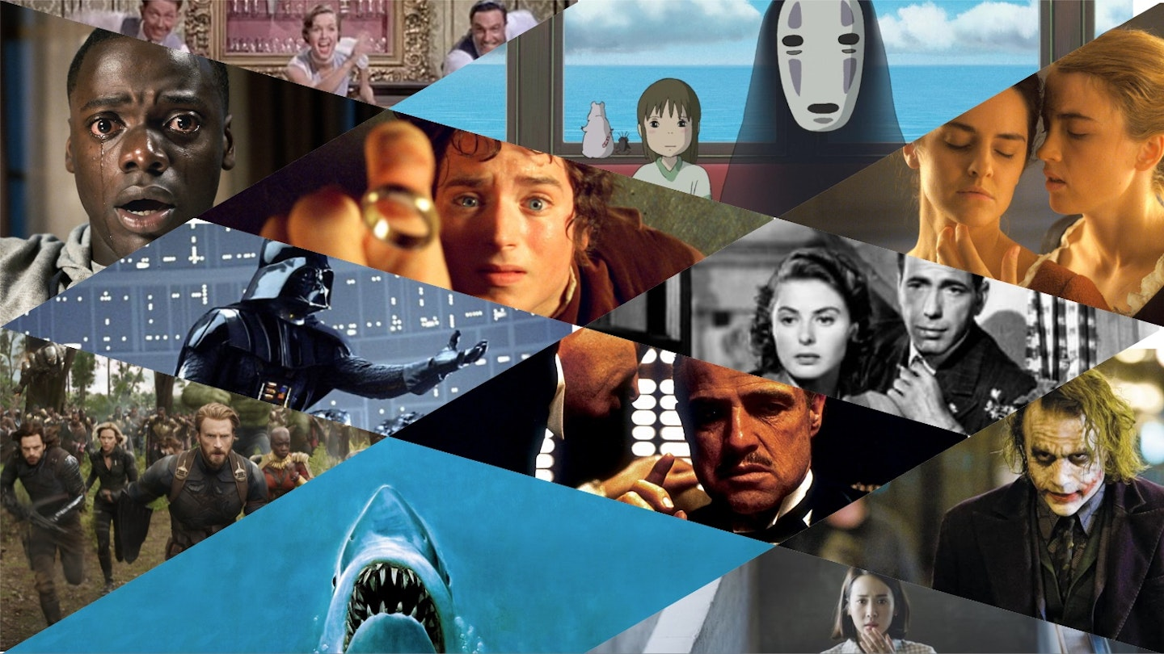

"What are the 5 best movies of all time?" It's a hell of a question to ask, and an even harder one to answer — even for the team here at *Empire*, the world's biggest and best-loved movie magazine. After all, there are all kinds of reasons why individual films stand the test of time, connecting with us personally while speaking to the universal. The very best exemplars of the form conjure indelible images, evoke overwhelming emotions, tell unforgettable stories, and bring us characters who — love 'em or loathe 'em — we truly believe in.

**5) The Shawshank Redemption (1994)**

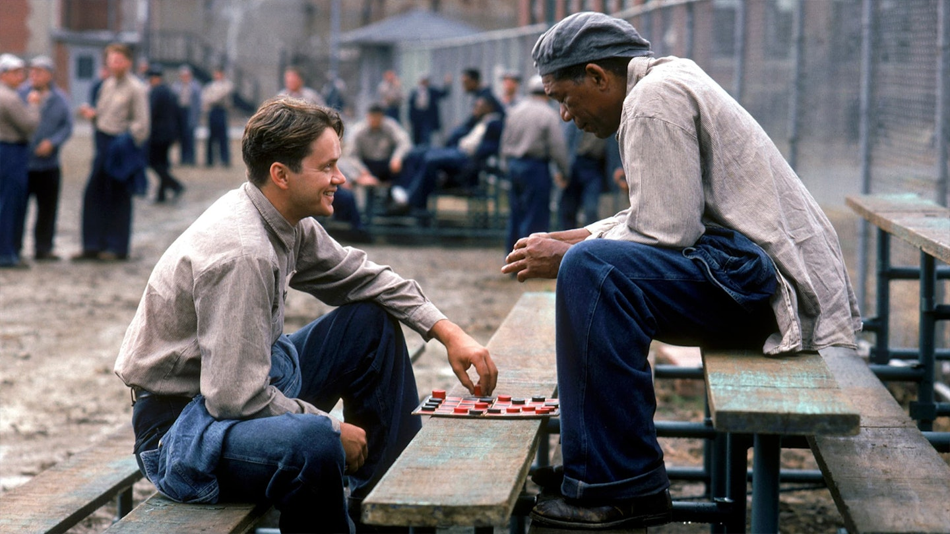

**Director:** Frank Darabont

**Starring:** Tim Robbins, Morgan Freeman, William Sadler

The warm, leathery embrace of Morgan Freeman's narration... The reassuringly Gary Cooper-ish rumple of Tim Robbins' face... Odd that a movie which features such harshness and tragedy should remain a feel-good perennial — even odder when you consider it was a box-office flop on release. Few directorial debuts are so deftly constructed; no surprise, then, that Frank Darabont has yet to top it.

**4) The Dark Knight (2008)**

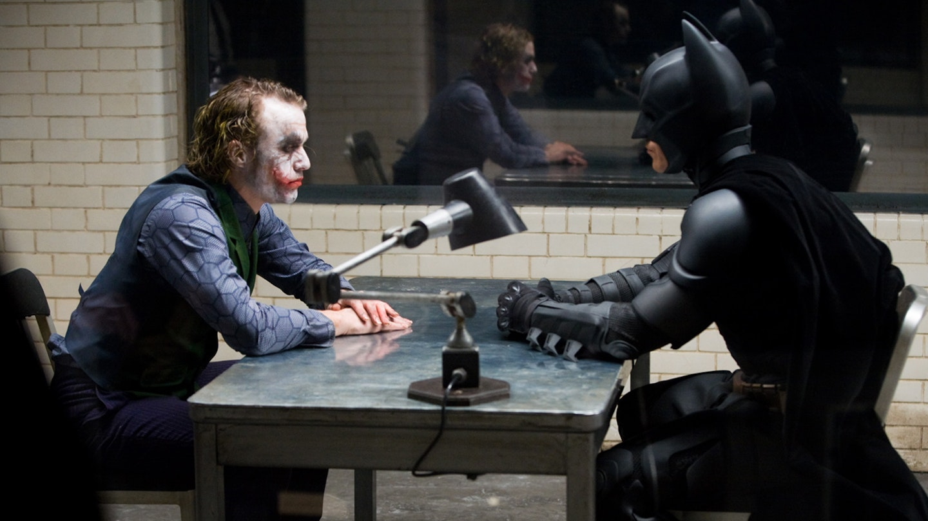

**Director:** Christopher Nolan

**Starring:** Christian Bale, Heath Ledger, Aaron Eckhart, Maggie Gyllenhaal, Gary Oldman

And away… we… go! After constructing a whole new Gotham in [*Batman Begins*](https://www.empireonline.com/movies/reviews/batman-begins-review/), Christopher Nolan introduced the clown intent on tearing the whole thing down. Despite being a [Batman](https://www.empireonline.com/movies/features/why-batman-is-cinemas-greatest-superhero/) movie (albeit the first ever not to have 'Batman' in the title), *The Dark Knight* is absolutely The Joker's show – the late, great Heath Ledger (an initially controversial choice) putting in a visceral, transformative, truly terrifying performance as the Clown Prince Of… not exactly Crime, but pure, unadulterated Chaos. Less than a decade after 9/11, Nolan re-conceived Batman's greatest foe as an unpredictable terrorist intent on turning the people of Gotham against each other – his actions intended to spark mass discord pulled off in jaw-dropping set-pieces. For all the spectacle, this is a very different blockbuster from the off – the genius opening clown-mask bank heist is the film in miniature, an ambitious crime saga clad in superhero trappings, daring and ruthless and full of surprises. *The Dark Knight* is full-strength, no-holds-barred, firing-on-all cylinders Nolan, and not just an all-time great comic book movie, but an all-time great movie period — as the movie's rightful high ranking here attests.

**3) The Godfather (1972)**

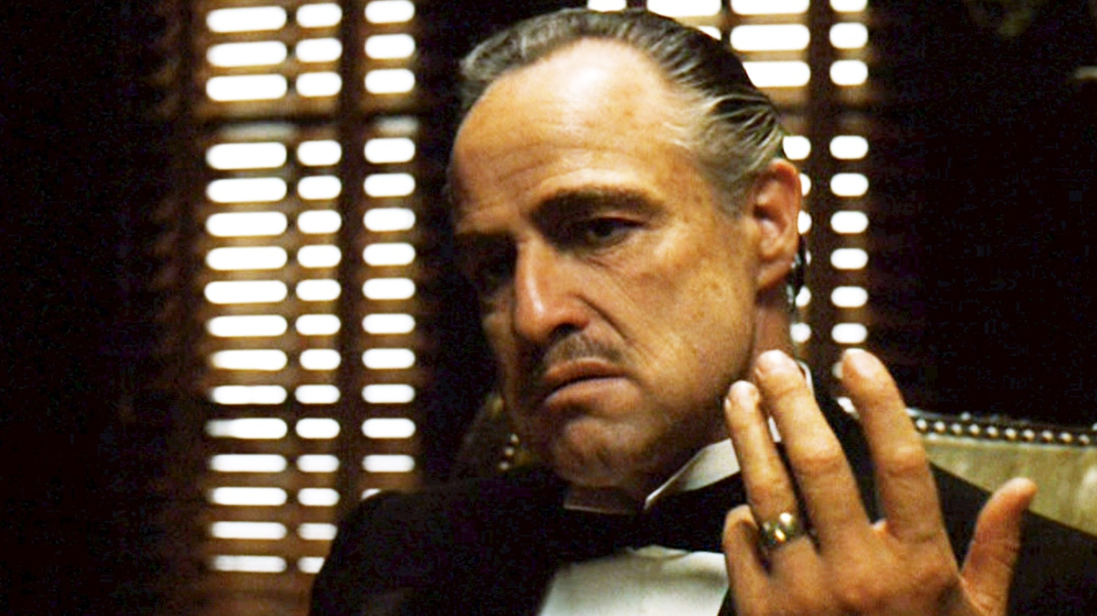

**Director:** Francis Ford Coppola

**Starring:** Marlon Brando, Al Pacino, James Caan, John Cazale, Talia Shire

Stanley Kubrick once described Francis Ford Coppola's adaptation of Mario Puzo's novel as the best film ever made – though having previously topped this list, this time it falls to bronze position. At once an arthouse drama and a commercial blockbuster, *The Godfather* marked the dawn of the age of the mega-movie. An icon of the gangster genre, it’s imprinted in popular culture – "Luca Brasi sleeps with the fishes", the horse's head in the bed – but the first instalment of Brando's cotton-cheeked patriarch's fight for power is so much more than [those moments](https://www.empireonline.com/movies/features/the-20-best-moments-from-the-godfather-trilogy/). With performances, style and substance to savour, it managed to both smash box office records and [live on](https://www.empireonline.com/movies/news/francis-ford-coppola-godfather-at-50-changed-my-life-exclusive/) as a staple of cinematic canon.

**2) Star Wars: The Empire Strikes Back (1980)**

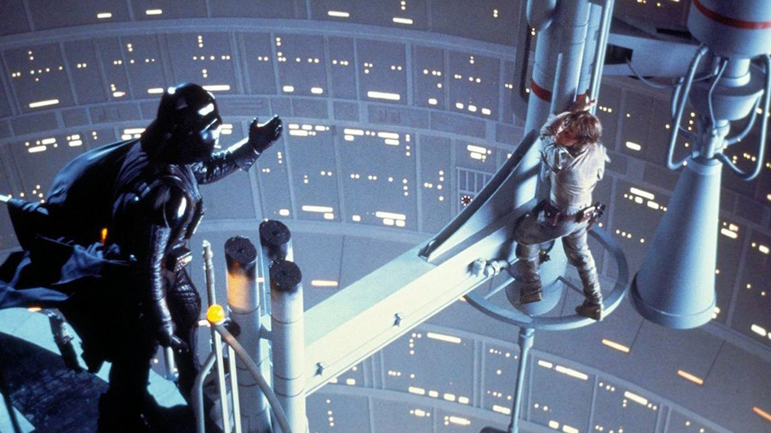

**Director:** Irvin Kershner

**Starring:** Mark Hamill, Harrison Ford, Carrie Fisher, Billy Dee Williams, David Prowse

If *Star Wars* gave us a whole new cinematic galaxy, Empire made that galaxy feel so much larger, deeper, and richer. Bolstered by the original's success, George Lucas shot for the moon a second time around, teaming up with director Irvin Kershner to tell the story of Luke training under Master Yoda, Han and Leia heading to Cloud City, and Darth Vader dropping the daddy of all twists. *Episode V* ramped up the scope with more astonishing model work, dizzying dogfights, the snowy Hoth battle, and a ferocious lightsaber duel between Luke and Vader. It is, simply, bigger and better than the original *Star Wars*, influential in its own right with its downer-ending and game-changing familial revelations. We love it. You know.

**1) The Lord Of The Rings: The Fellowship Of The Ring (2001)**

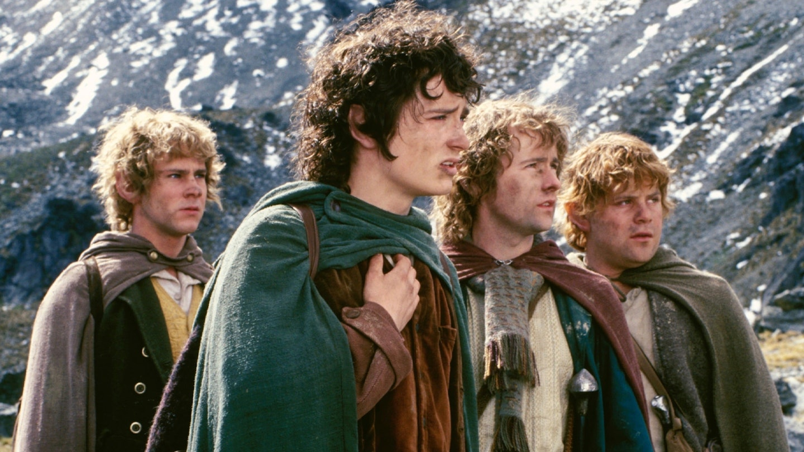

**Director:** Peter Jackson

**Starring:** Elijah Wood, Sean Astin, Ian McKellen, Viggo Mortensen, Orlando Bloom, Sean Bean, Cate Blanchett, Liv Tyler

A wizard is never late. Nor is he early. He arrives precisely when he... well, you know the rest. It might have taken 20 years for Peter Jackson's plucky fantasy to clamber, Mount-Doom-style, to the very pinnacle of our greatest-movies pantheon. But here it is, brighter and more resplendent than ever. [*The Fellowship Of The Ring*](https://www.empireonline.com/movies/features/fellowship-ring-2/) contains so much movie. Even at the halfway point, as the characters take a breather to bicker in Rivendell, you already feel sated, like you've experienced more thrills, more suspense, more jollity and ethereal beauty than a regular film could possibly muster up. But Jackson is only getting started.

An ornately detailed masterwork with a huge, pulsing heart, it's just the right film for our times — full of craft, conviction and a belief that trudging forward, step by step, in dark days is the bravest act of all. Its ultimate heroes aren't the strongest, or those with the best one-liners, but the ones who just keep going. And so *Fellowship* endures: a miracle of storytelling, a feat of filmmaking and still the gold standard for cinematic experiences. Right, now that's decided, who's up for a second breakfast?