**CONTENTS**

Contents…………………………………………………………….....1

1. Introduction…………………………………………………………2

2. The Security Vigilante Game……………………………………….3

3. Technologies Used……………………………………………….....4

4. The Detailed Game Play…………………………………………....6

Conclusion…………………………………………………………….20

**Introduction**

PC games, also known as computer games or personal computer games, are video games played on a personal computer rather than a dedicated video game console or arcade machine. Their defining characteristics include a lack of any centralized controlling authority, a greater degree of user control over the video-gaming hardware and software used and a generally greater capacity in input, processing, and output.

An online game is a computer game that is either partially or primarily played through the Internet or another computer network.Online games are ubiquitous on modern gaming platforms, including PCs, consoles and mobile devices, and span many genres, including puzzle-type, first-person shooters, strategy games and massively multiplayer online role-playing games (MMORPGs).

A browser based online game is a computer game that is played over the Internet using a web browser. They do not require any client software to be installed apart from a web browser or browser plug-in. The creation of such games usually involves use of standard web technologies as a frontend and other technologies to provide a backend. Browser games include all video game genres and can be single-player or multiplayer. Browser games are also portable and can be played on multiple different devices, web browsers and operating systems.

These browser games prevail more generally as a 2-d game rather than a 3-d one. Such games are often free-to-play, but charge for extra in-game features. Multiplayer browser games have an additional focus on social interaction, either between several players or on a massive scale. Due to the accessibility of browser games, they are often played in more frequent, shorter sessions compared to traditional computer games.

Standard web technologies such as HTML, CSS and JavaScript can be used to make browser games, but these have had limited success because of issues with browser compatibility and quality. These technologies, collectively termed as dynamic HTML, allow for games that can be run in all standards-compliant browsers. In addition, dedicated graphics technologies such as SVG and canvas allow for the fast rendering of vector and raster graphics respectively and WebGL allows for hardware-accelerated 3D support in the browser.

**The Security Vigilante Game**

**About the game:**

The idea is a to develop a single player browser based video game that aims to teach basic security related vulnerabilities and cyber security concepts to common computer users through its gameplay.

**Gameplay:**

Apart from the story based top-down view gameplay, the game will have an in-game computer screen with normal computer features such as a start-menu, file explorer, terminal, mail-box, multiple social networking profiles, bank accounts, in-game browser with several websites, several apps and in-game games. These will be the places where several game tasks will be carried out using social engineering and hacking practices such as phishing, click-jacking, identity theft, cross site scripting, malware attacks, etc. While the player will be required to perform several tasks in order to proceed in the story, each of them worth points, some of them will be attempts to actually hack the player. In case he succeeds avoiding those tasks, he’ll score points.

**Objective:**

The objective of the game is to complete all the tasks while trying to obtain as many points as possible.

**Basic Storyline:**

A mob boss’s bank account gets hacked. He calls in for a professional hacker to track the hacker. In the process, the hacker gets introduced to the boss’s family members who’ll represent the different age groups of computer users and sets out to teach them about cyber security through interesting tasks.

**Stand Out Point:**

While several games like Hack this site and Capture The Flag Contests which are already available on the internet teach cyber security through challenges, they are designed to make their websites vulnerable to security attacks so that the players can hack into them and learn the basics. But the downside to them is that they require a thorough knowledge of some other computer related subjects like basic web development, server side programming, databases, cryptography, etc. This game is being made for regular computer users and hence every application needs to be completely virtual.

**Technologies Used**

**1. Phaser Game Engine:**

### Phaser is a JavaScript framework for game development on desktop and mobile platforms. If the device is capable then it uses WebGL for rendering, otherwise it reverts to Canvas. It's just plain JavaScript, and doesn't use any faux OO-style practices internally. There's no massive inheritance chain or component system, and you don't have to force your objects into any fixed class structure, either.

### Games created with Phaser require a modern web browser that supports the canvas tag. It also works on mobile web browsers. In addition, the game made with Phaser framework can be easily ported to Android using softwares like Phonegap.

### 2. HTML5:

### HTML5 is the latest and most enhanced version of HTML (Hyper Text Markup Language). HTML5 is a standard for structuring and presenting content on the World Wide Web. HTML5 is designed, as much as possible, to be backward compatible with existing web browsers. New features build on existing features and allow you to provide fallback content for older browsers.

### 3. CSS:

CSS is the acronym for "Cascading Style Sheet". It is used to control the style of a web document in a simple and easy way.

**4. Javascript:**

JavaScript is a lightweight, interpreted programming language. It is designed for creating network-centric applications. JavaScript is very easy to implement because it is integrated with HTML. It is most commonly used as a part of web pages, whose implementations allow client-side script to interact with the user and make dynamic pages. It is dynamic computer programming language.

Client-side JavaScript is the most common form of the language. The script should be included in or referenced by an HTML document for the code to be interpreted by the browser. It means that a web page need not be a static HTML, but can include programs that interact with the user, control the browser, and dynamically create HTML content.

**5. Node.js:**

Node.js is a very powerful server side JavaScript-based framework/platform built on Google Chrome's JavaScript Engine (V8 Engine). It is used to develop I/O intensive web applications like video streaming sites, single-page applications, and multiplayer gaming applications. It uses an event-driven, non-blocking I/O model that makes it lightweight and efficient, perfect for data-intensive real-time applications that run across distributed devices. It is an open source, cross-platform runtime environment for developing server-side and networking applications.

Node.js applications are written in JavaScript, and can be run within the Node.js runtime on OS X, Microsoft Windows, and Linux. It also provides a rich library of various JavaScript modules which simplifies the development of web applications using Node.js to a great extent. So effectively, Node.js = Runtime Environment + Javascript Library.

**6. MongoDB:**

MongoDB is a cross-platform, document oriented database that provides, high performance, high availability, and easy scalability. MongoDB works on concept of collection and document. Any relational database has a typical schema design that shows number of tables and the relationship between these tables while in MongoDB there is no concept of relationship. It is completely schema-less. In MongoDB, data is stored in the form of JSON style documents.

**7. JSON:**

JSON or JavaScript Object Notation is a lightweight text-based open standard designed for human-readable data interchange. The official Internet media type for JSON is application/json. The JSON filename extension is .json.

**8. Ajax:**

Ajax, short for asynchronous JavaScript and XML is a set of web development techniques used for creating fast and dynamic pages. With Ajax, web applications can send data to and retrieve from a server asynchronously (in the background by exchanging small amounts of data) without interfering with the display and behavior of the existing page i.e. without reloading the whole page.

**The Detailed Game Play**

**Landing Page:**

The game will present a landing page in the beginning where the user will have an option of logging in with a registered mail id or through facebook or gmail. In addition, he has the option to sign up using an email account. After logging in he’ll have access to the main frame where he can switch to game, computer and about sections as portrayed at the bottom in the below picture. Also, he has the option of logging out beside which user info will be displayed.

**Bottom Navigation Bar Section:**

1. Game

Below depicted is the main game screen along with the main menu.



The player can change game settings using the main menu bar at the top. After start is clicked by the user, a laptop screen appears with a bunch of code automatically being typed onto it. After a while, through the code, it’s understood that the user of the in-game laptop (not the player) is trying to hack into someone’s bank account. The player now needs to confirm the commands on screen by hitting Enter key at 3-4 places while hacking is carried out after which a message displays “Transfer Completed”. This will be the prologue.

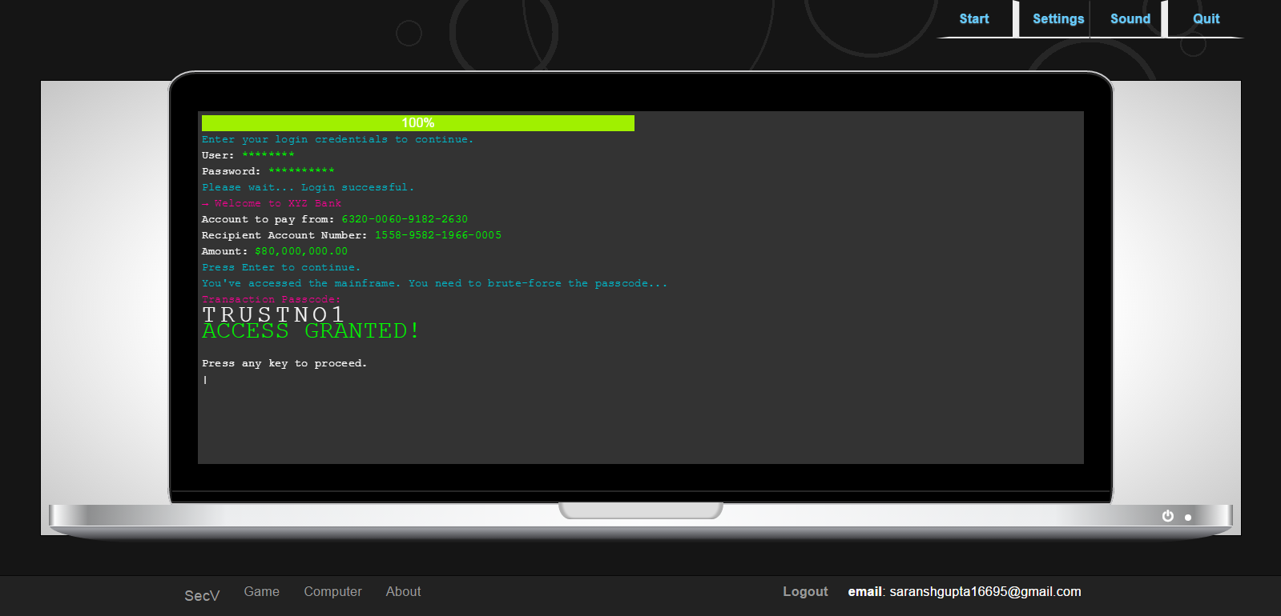

After the prologue, the actual gameplay will start which would look something like as shown below. The gameplay will be of top down view with the point and click movement system. As of now due to the lack of a graphics designer, this section is not yet developed.

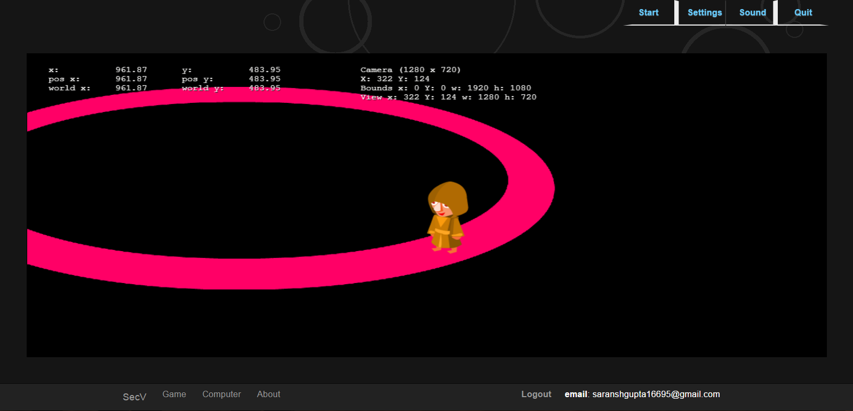

1. Computer

The actual tasks throughout the game will be carried out on an in-game computer which can be accessed at any time by clicking the computer button at the bottom navigation bar. A centralized Apps section is made in metro style similar to that of Windows 8 to give the players familiarity to the computer. As of now only three applications are integrated in the start-menu which are explorer, chatbox and looknmeet respectively.

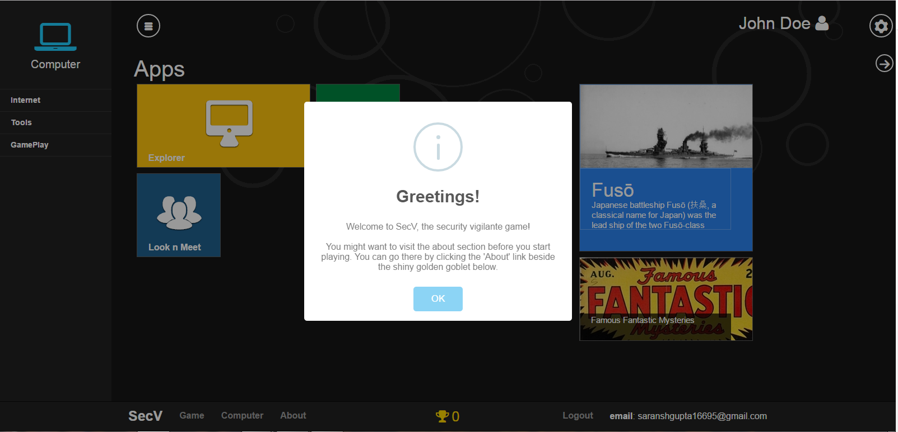

A charms bar is integrated as well which appears when the mouse is hovered in the top right corner.

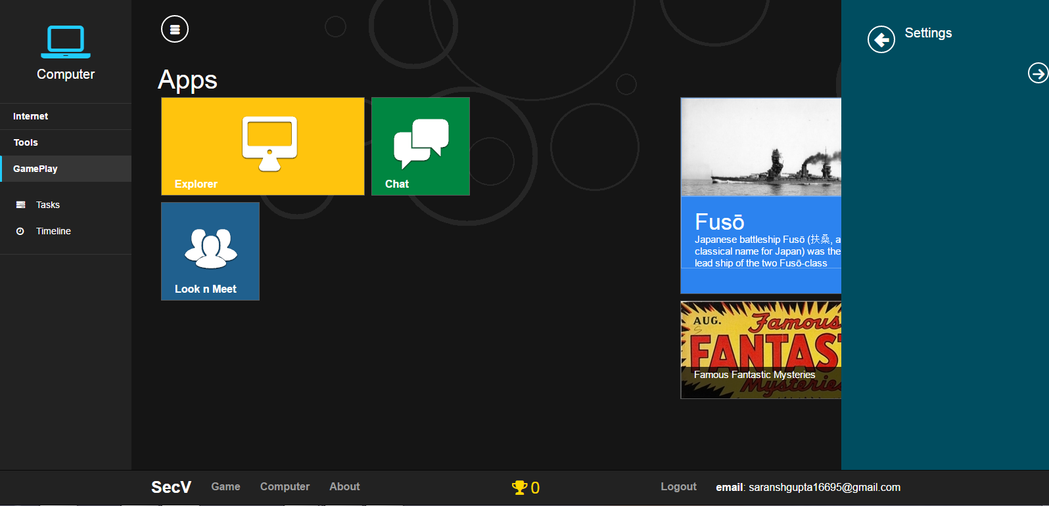

**Apps Section:**

The individual apps in this section will be described in detail below.

1. Explorer

As can be seen below, a complete explorer is designed and integrated into the game with the basic features of any explorer such as opening/closing of folders and files, maximization/minimization, etc.

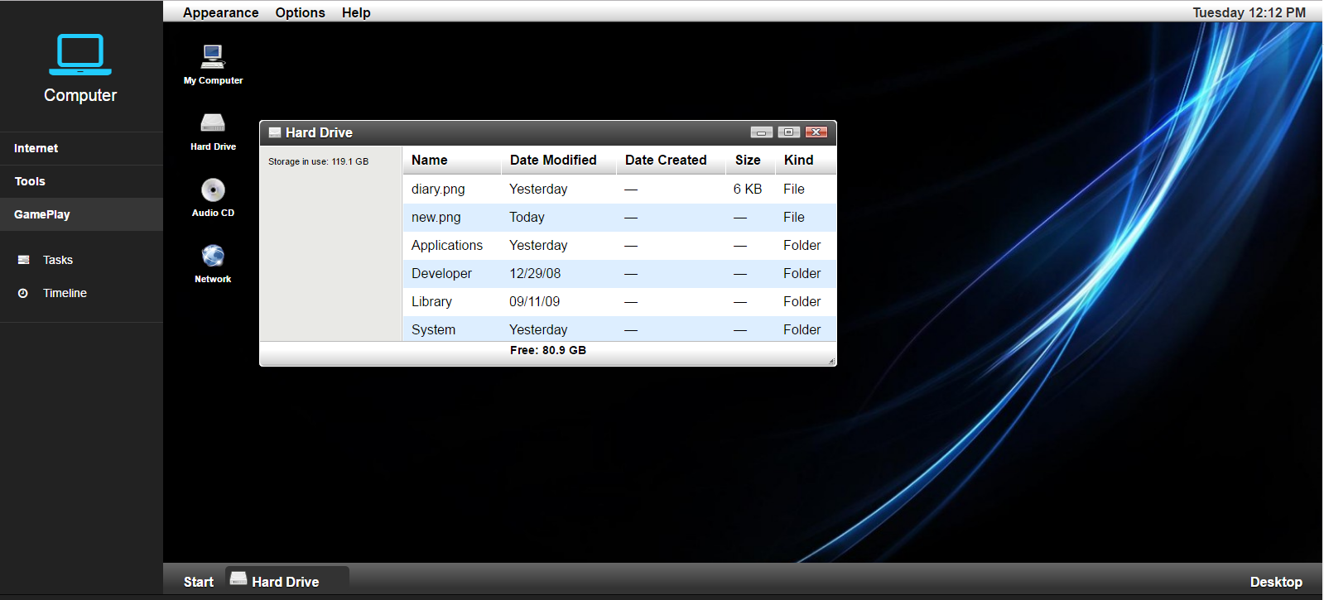

1. Chat Box

A Chat Box is a chat room where several characters will require to chat with in-game characters or bots to get instructions about how to proceed in the game. The internal workings are similar to that of Gabber and hence will be explained in the Gabber section. It will be like an in-game social network for the character.

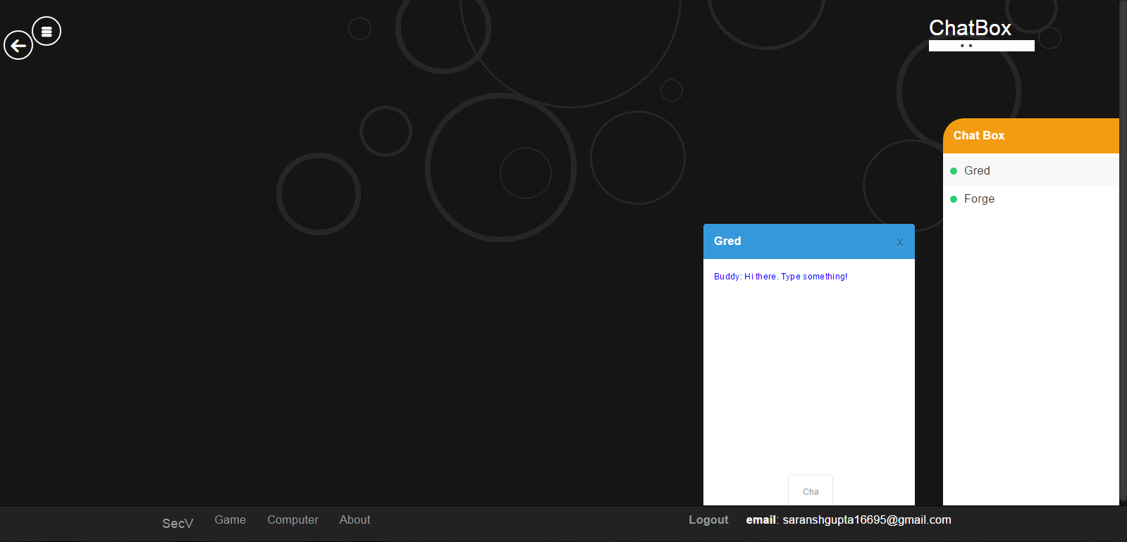

1. Look n Meet

This will be an in-game dating network which will be built and integrated later according to the story. Right now, only the registration page is developed.

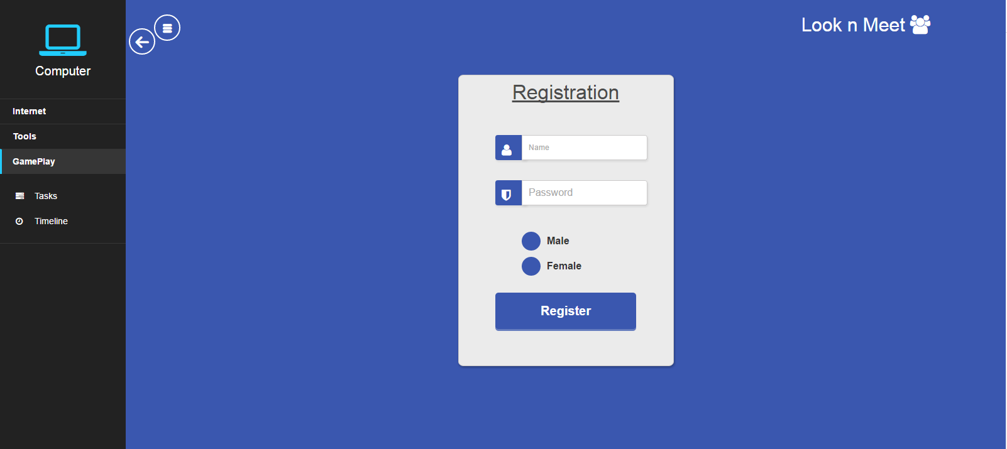

**Left Navigation Pane Applications:**

On the left, a navigation pane is added that can be hidden on a button click. This pane will have several other applications and settings which will be later required to be accessed by the player. For the time being, only browser with some web sites and an error page, a downloads folder, tasks section and timeline section are developed.

1. Browser

A customized browser is made for the game where several important attacks like phishing and click-jacking will take place. In addition, the user will need to use several websites to commit to the tasks necessary to proceed in the game. URL’s are entered in the format ‘www.name.game’ where name is the name of the website.

1. **Index Page**

When the browser is opened, an index page arrives which gives the list of working websites and the details about them. This page can be accessed at any time by clicking the button with the book icon on it at the top right corner of the browser.

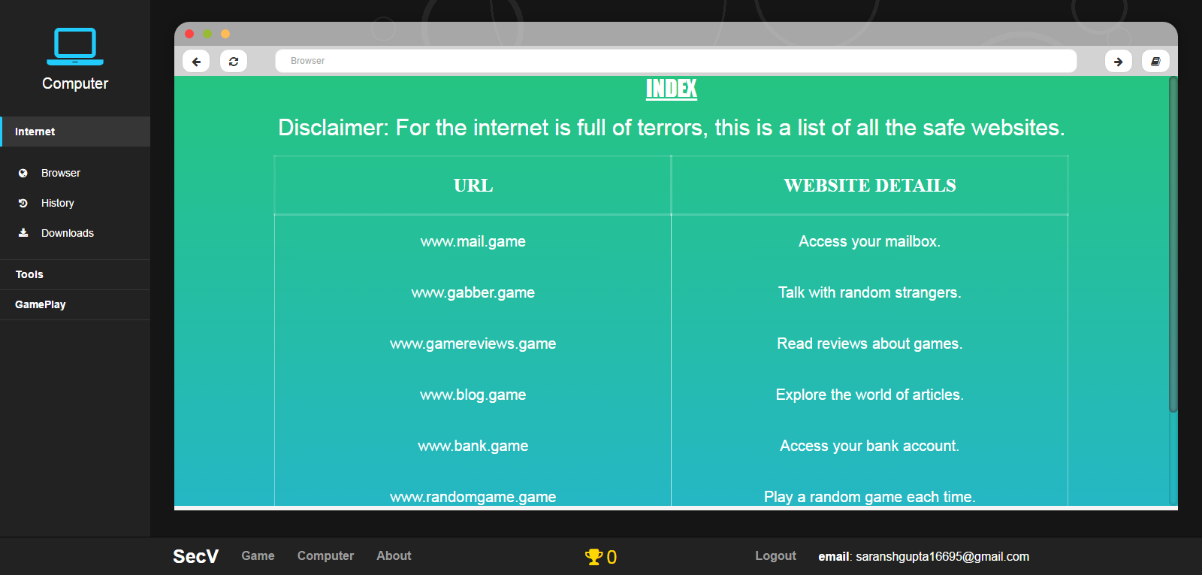

1. **Error Page**

Every time the user enter an invalid url or tries to go to a website without entering an url, a custom error page appears which outputs a random witty comment and provides an option to go back to the index page in order to see the working urls. This was added to increase the game appeal.

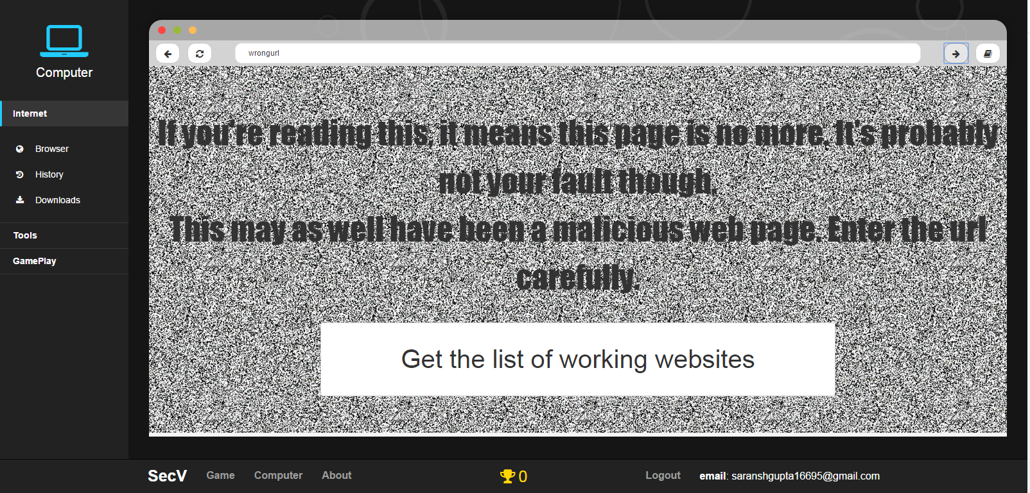

1. **www.gabber.game**

This is a complete website that can be accessed by inputting ‘www.gabber.game’ in the address bar of the browser. This is a place where the player will be able to chat with random strangers (or chat-bots) who at times will be trying to access confidential information from the player though conversations.

JSON files are built where several regular expressions are stored. Corresponding to the user input, random replies will be generated.

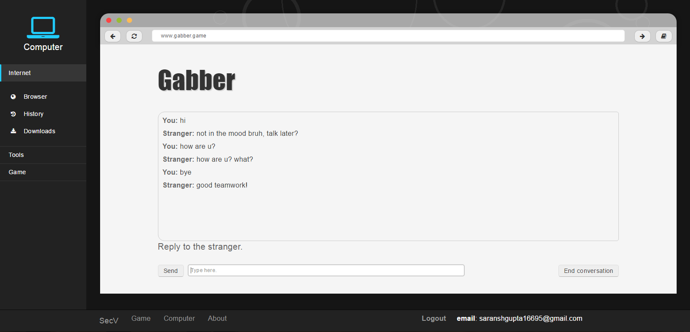

1. **www.mail.game**

This is one of the most important websites that can be accessed by entering ‘www.mail.game’ in the address bar of the browser. This mailbox will have several features such as composition of a new mail after which those mails will be stored in a json file, spam folder, unread folder, inbox folder and sent folder which can be used to work through the tasks in the game.

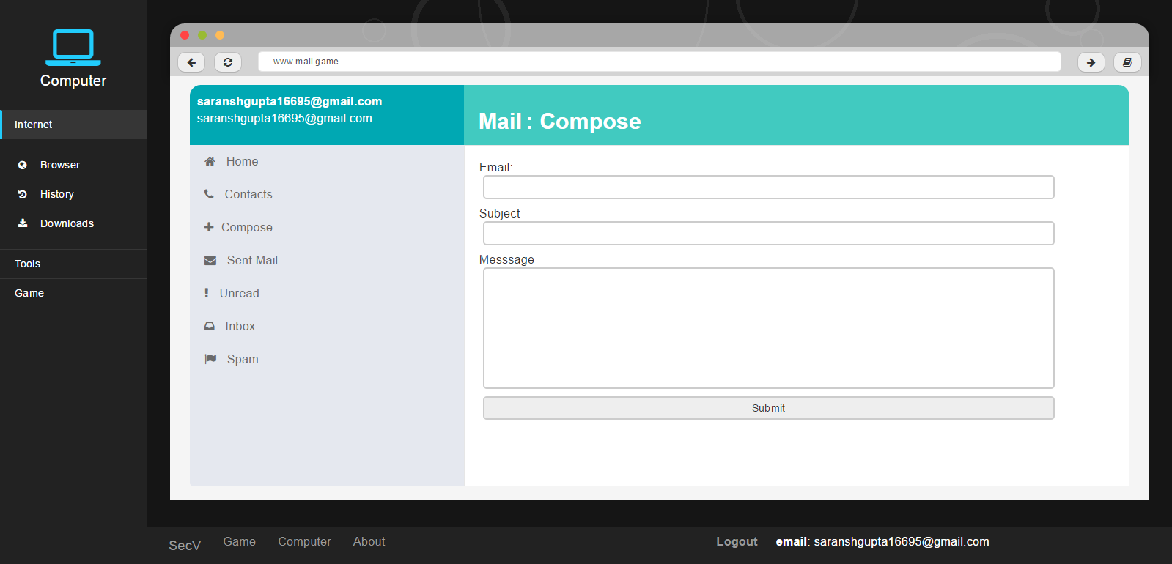

All the mails are getting generated directly from JSON files. So, when changes would be needed to be made, only amendments in the JSON files would suffice.

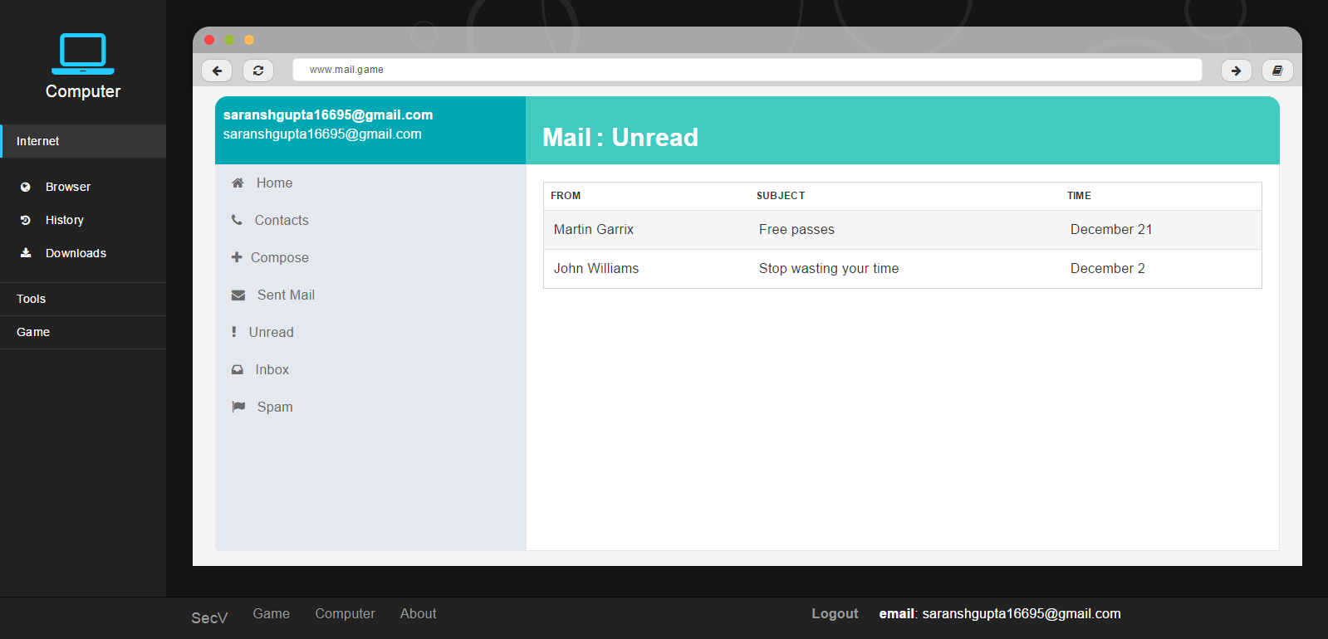

Mails can be opened by clicking on them.

Upon being clicked, these mails will display the actual message content in an alert box and depending on the data in the JSON file, they may contain a downloadable file or a hyperlink. The former when clicked will result in a notification that will say that the download is complete and it will be added in the following downloads section. The latter on the other hand when clicked would redirect to the hidden url in that hyperlink. It may be later used for phishing purposes.

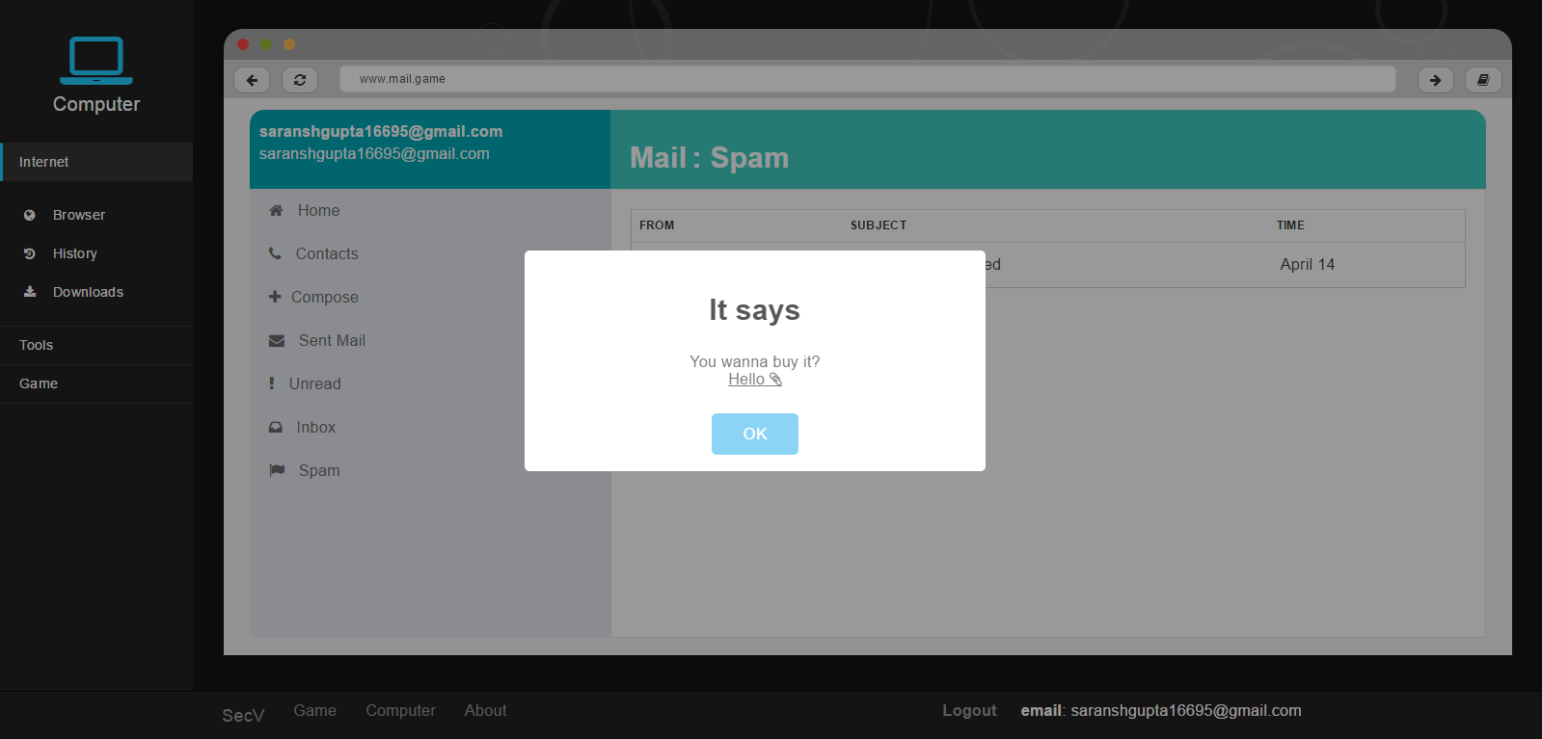

1. **www.randomgame.game**

This is the home of several in-game games which will be redirected randomly from here. Some of those game websites may be malicious and the individual scores of those games will be added to the main score.

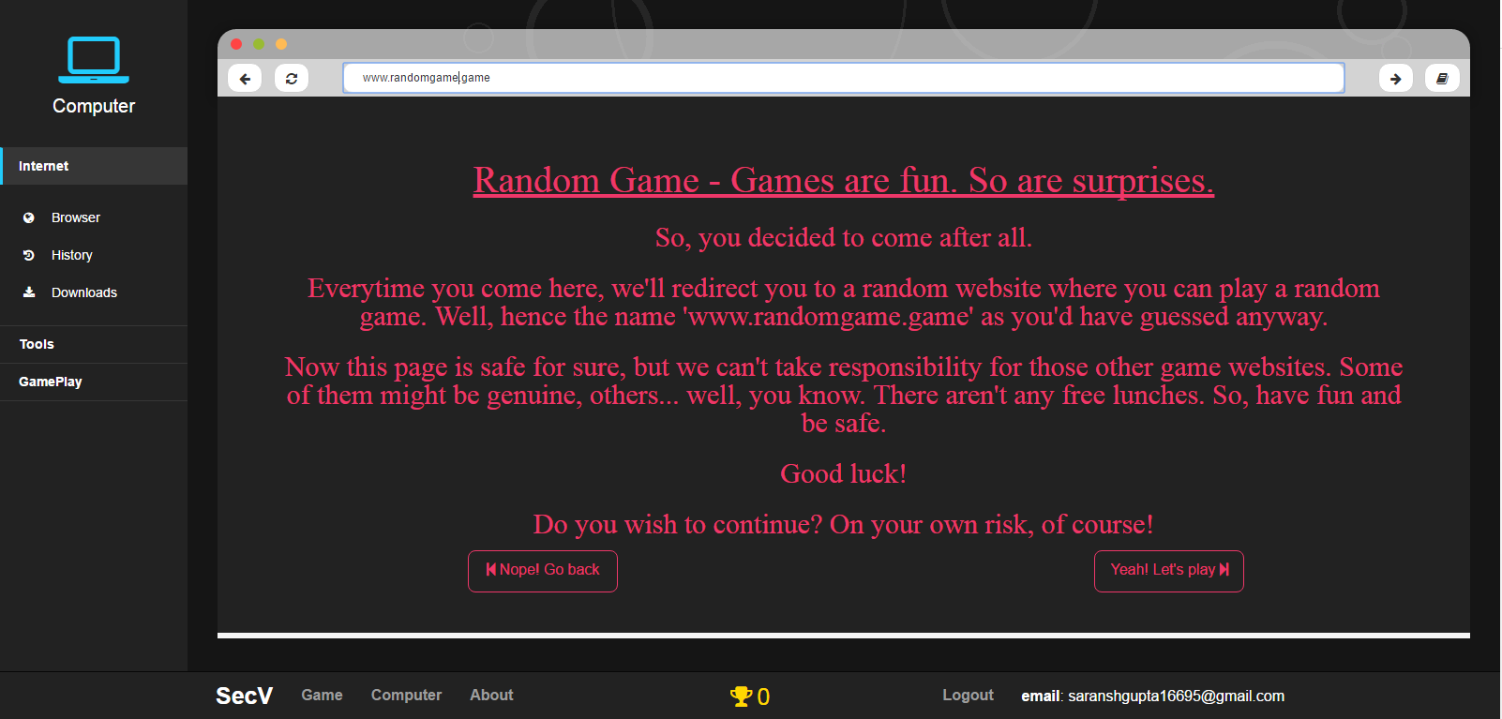

Right now, only three games are integrated. Several games can and will be integrated later as well.

1. Tic-Tac-Toe

This doesn’t really need any introduction.

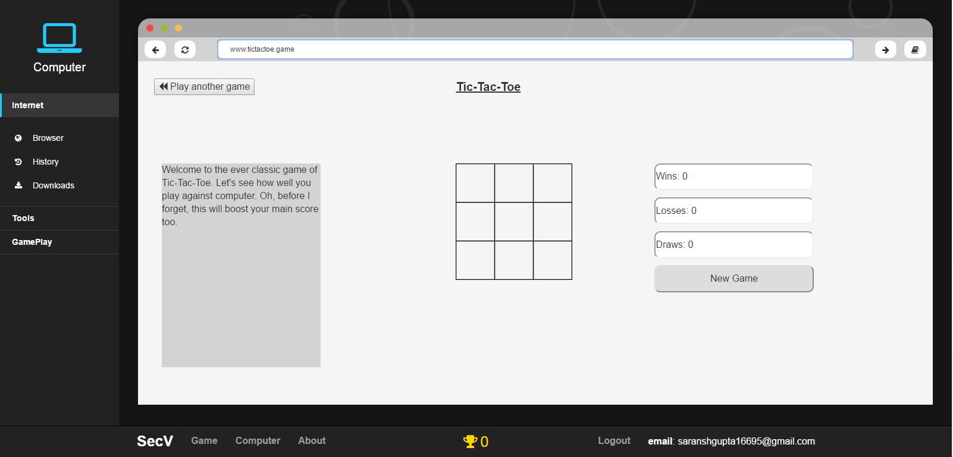

1. Guess What

This is a basic version of guess the number game where a range of numbers will be inputted and the player will need to guess the number that the computer picked.

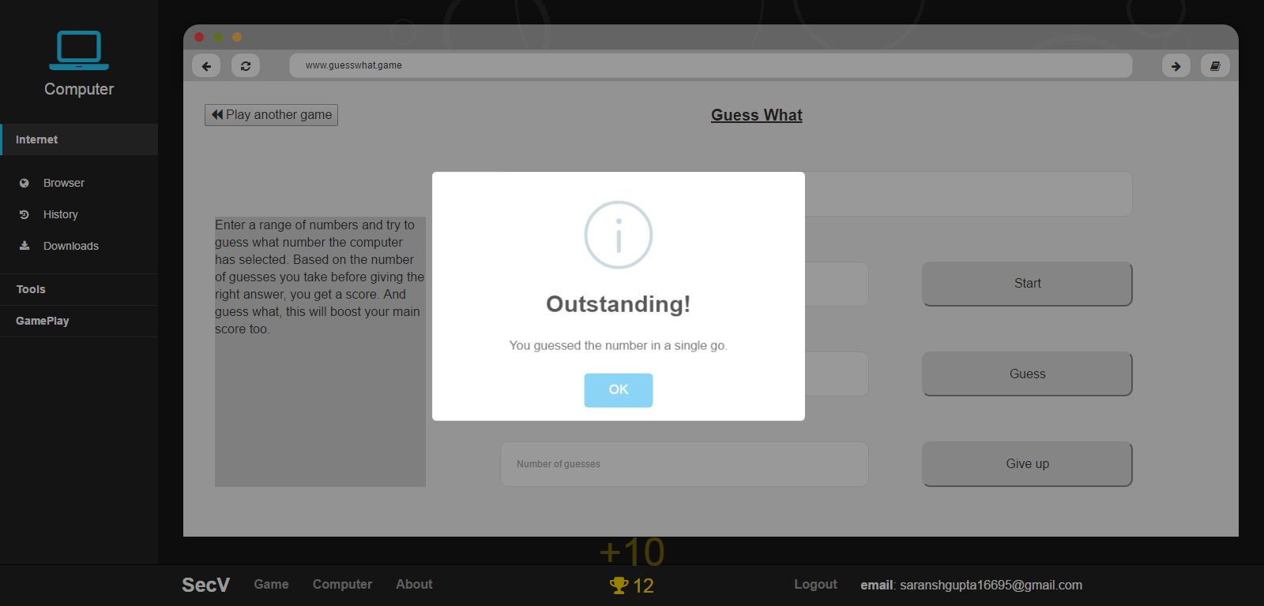

1. Mole Buster

Based on how many times you whack the jumping and skipping mole within 30 seconds, you’ll be awarded,

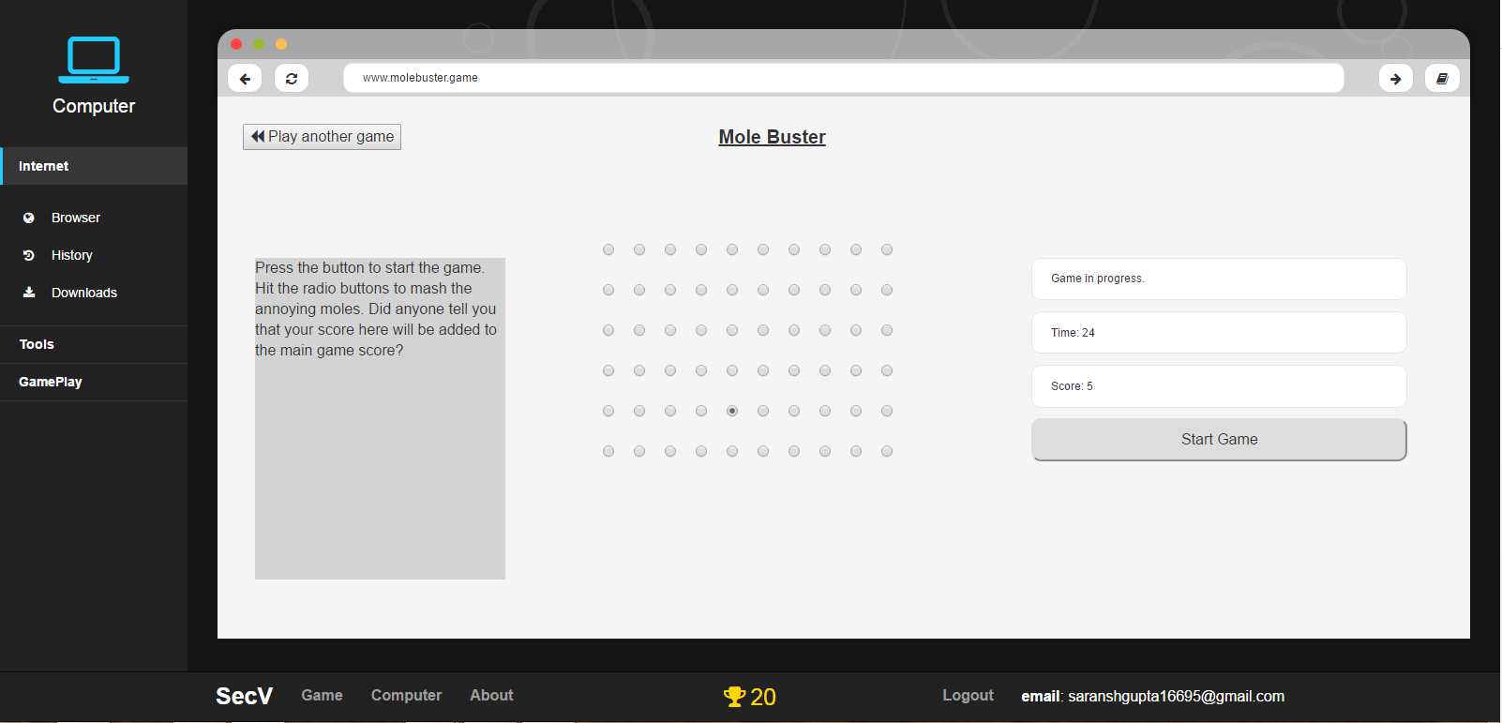

**Note:** While these games may seem pointless now, they can be utilized very well in the long run for disguising attacks..

1. **www.blog.game**

An in-game blog website is the place where a bunch of articles will be appearing from json files. In the long run, these articles will be helping in the tasks, story and wil be home of several malicious websites.

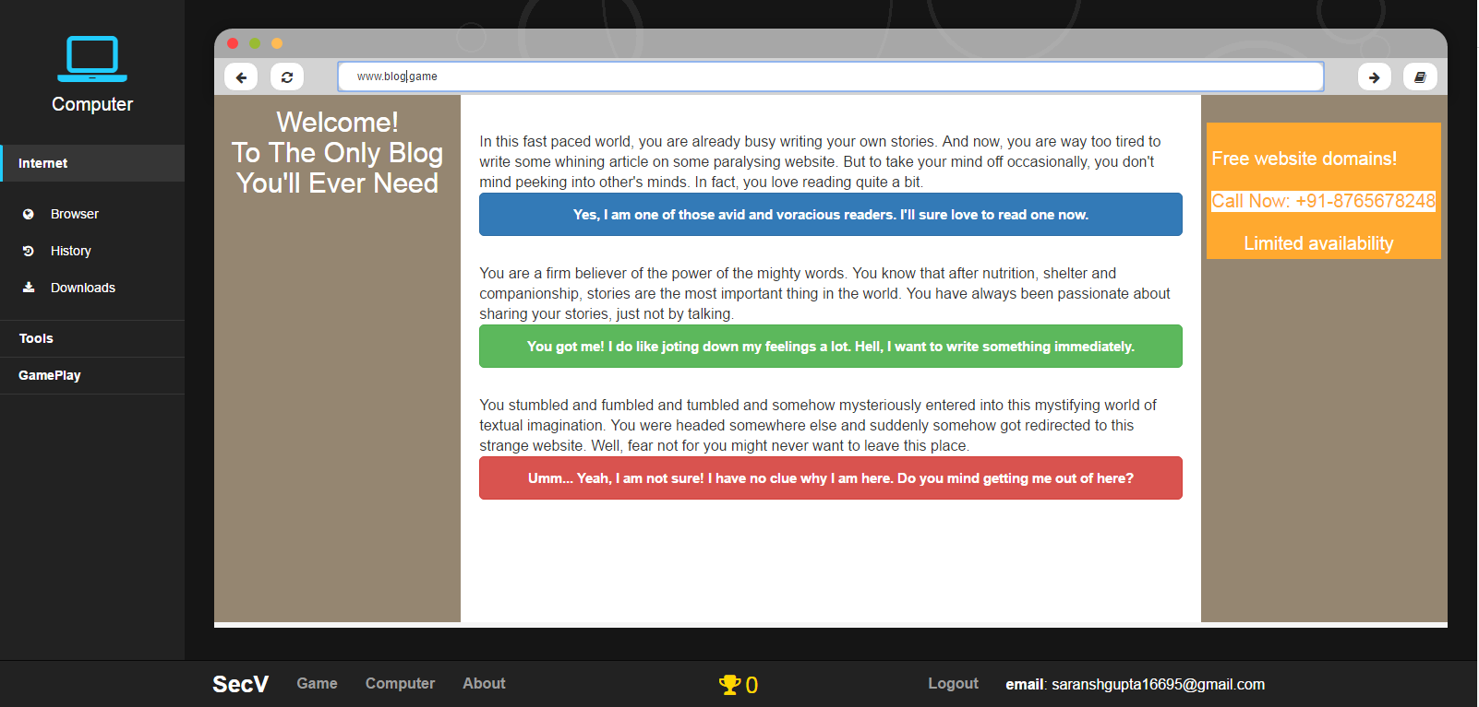

1. **www.bank.game**

This website can be referred to at any point of time to keep track of money transactions of all the family members.

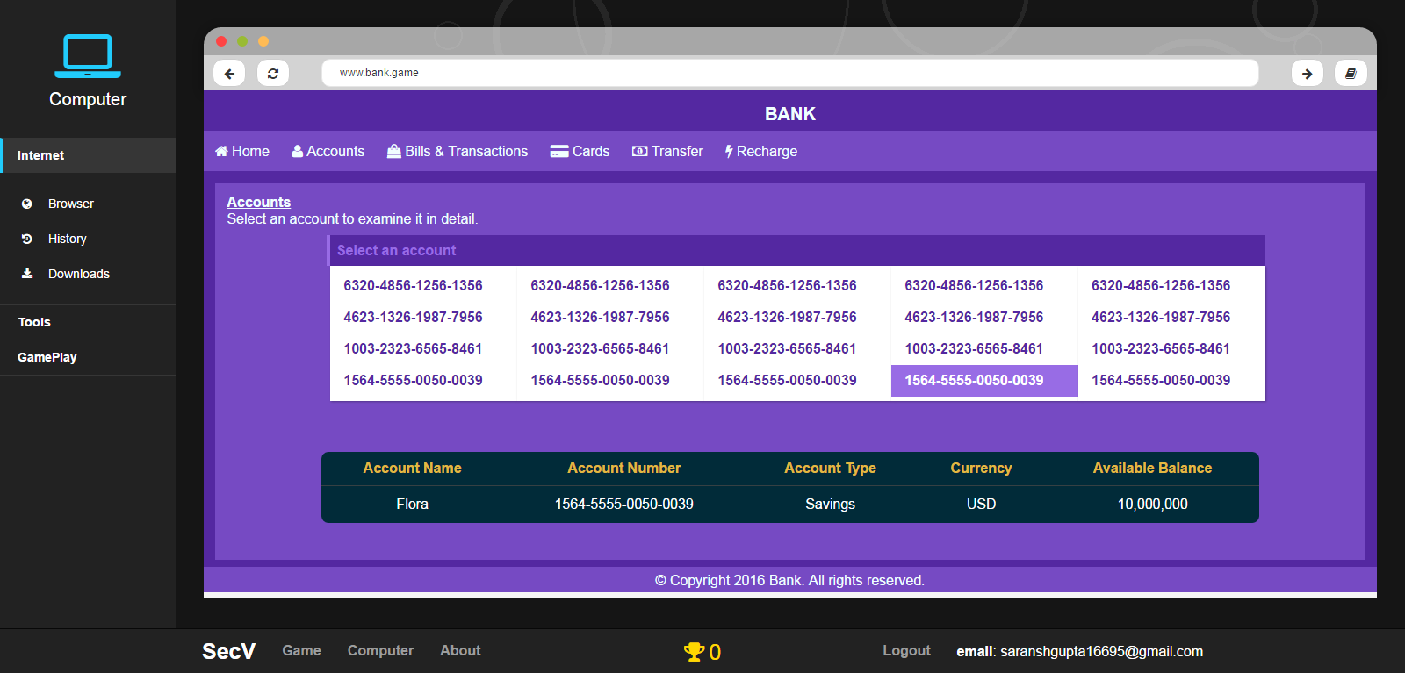

This too will help a lot in future tasks based on transactions and for story based endeavours.

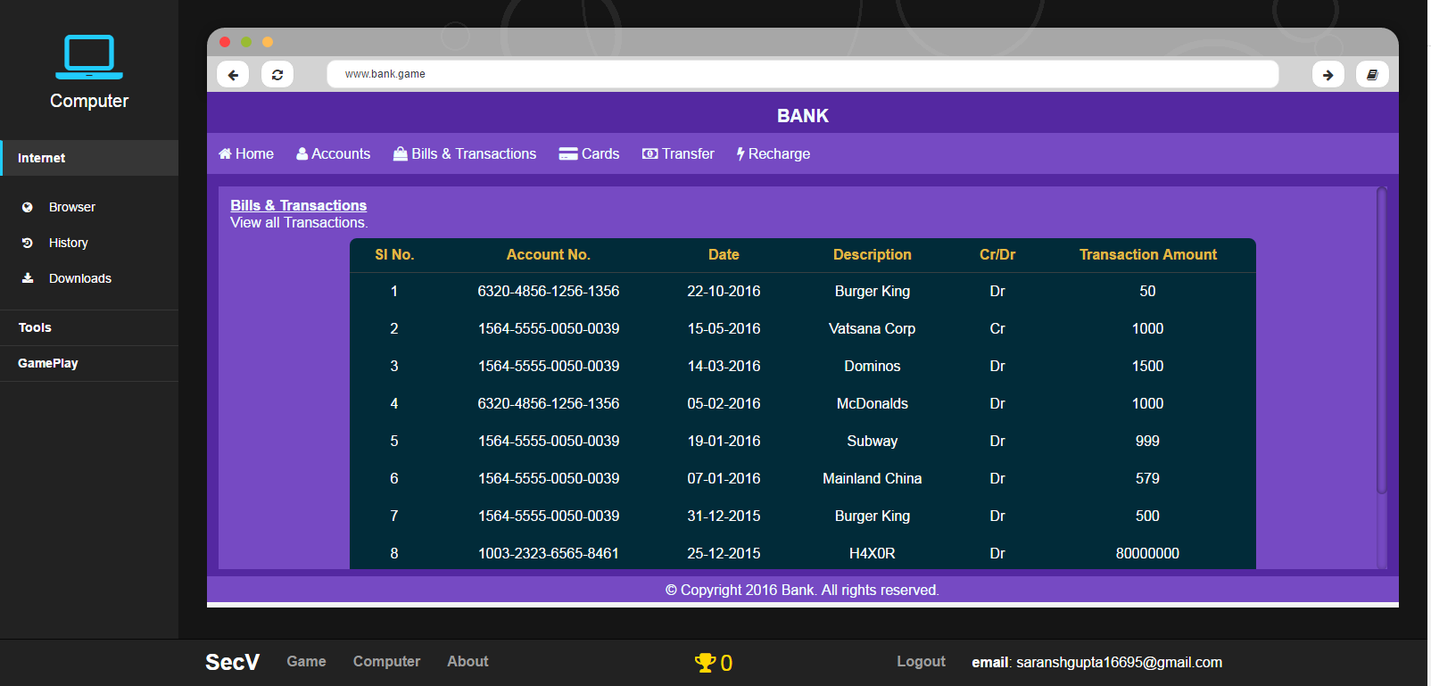

**Note:** Few other websites are made as well. But they are accessible only through tasks. On the other hand, while the above websites help in the tasks, they can be used for general gameplay as well.

1. Downloads Section

This section will contain all the downloaded files which are being imported from JSON files as well. When clicked they’ll show the contents of the file in the right pane.

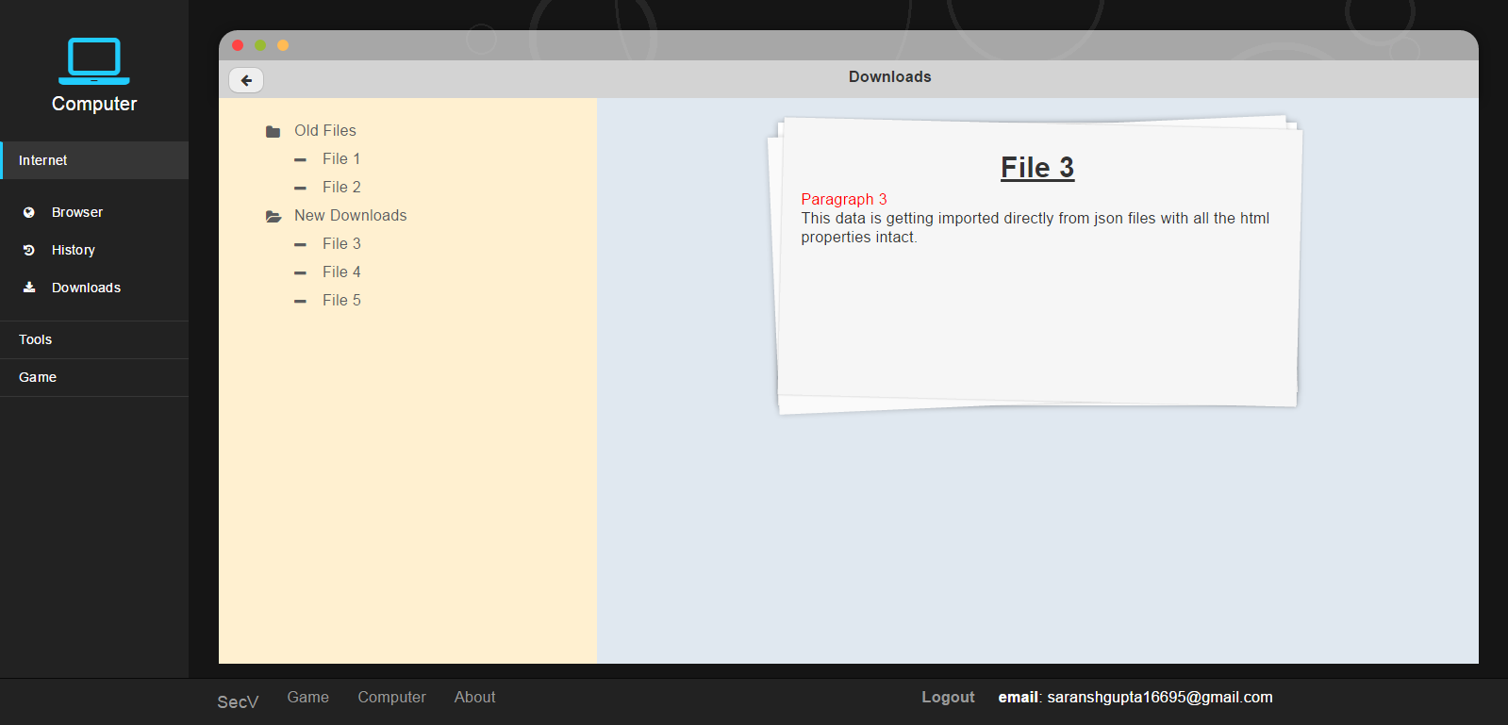

1. Tasks Section

Due to the unavailability of graphics, for the time being an option will be given to play the game tasks wise, where the user will be able to directly play the tasks without any storyline. This can be later used as an option to replay the tasks.

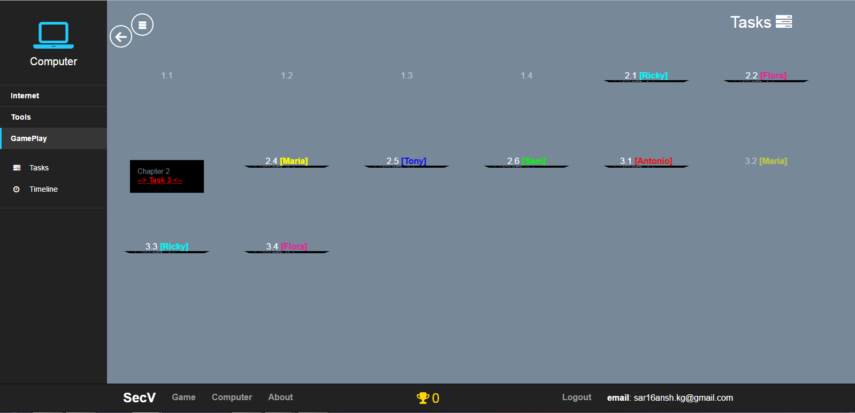

1. Gameplay Section

The player will be able to walk through his past achievements in this section with timestamps. Also, detailed information about the security vulnerabilities introduced in particular tasks and individual task scores will be accessible through here.

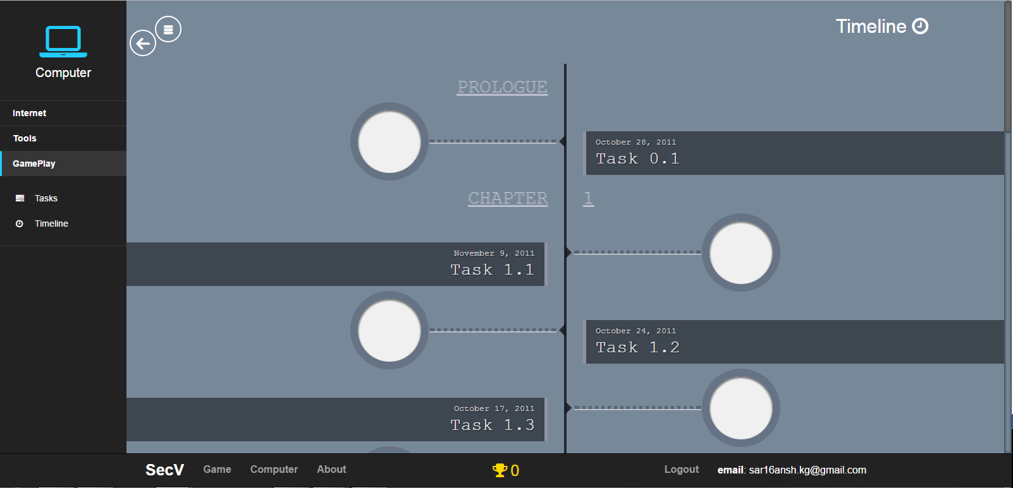

1. About

Since, without graphics and story, maintaining a smooth flow between the tasks is difficult, the ‘About’ section walks through the basic storyline and basic assumptions the player needs to keep in mind before exploring the game.

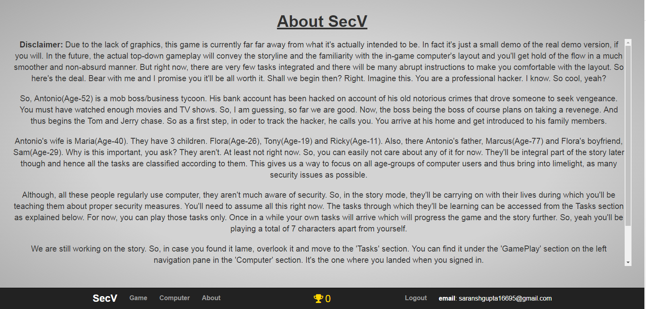

**Additional Features**

1. Help button:

Every time a task is initiated, a help button with a question mark on it will appear on the bottom pane as shown below. Clicking it will display the instructions of the task again.

1. Directions button:

Every time a task is initiated, a directions button with a compass on it will appear on the bottom pane as shown below. Clicking it will display the step by step directions for reaching the appropriate location of the task. This feature will be available only till Chapter 3 tasks to make the player comfortable with the computer layout.

1. Unlock tasks button

Due to the lack of gameplay and story, an unlock tasks button is given to unlock all the tasks at once. Although it’s recommended to play the game task by task.

1. Score system

A golden goblet with the current score will always be visible as shown below. Every time a task gets completed, points will be added here based on the performance.



**Conclusion**

On a finishing note, the complete initial layout of the game is ready. Any further changes in the tasks or the story will need only amendments in the JSON files or in the corresponding functions. In case new apps, websites or a new layout needs to be added, it can be done easily by creating a separate file for it and linking it to the main file. Since, the graphics could not be integrated as of now, the gameplay is still in the basic stage and it is only a scaffolding of the actual plan.