|  |
| --- |
| Goal • Check your understanding of the Chemistry Unit |

What to Do

Circle the letter of the best answer.

 1. Which subatomic particle(s) make up most of the mass of an atom?

A. electrons

B. neutrons

C. electrons and protons

D. neutrons and protons

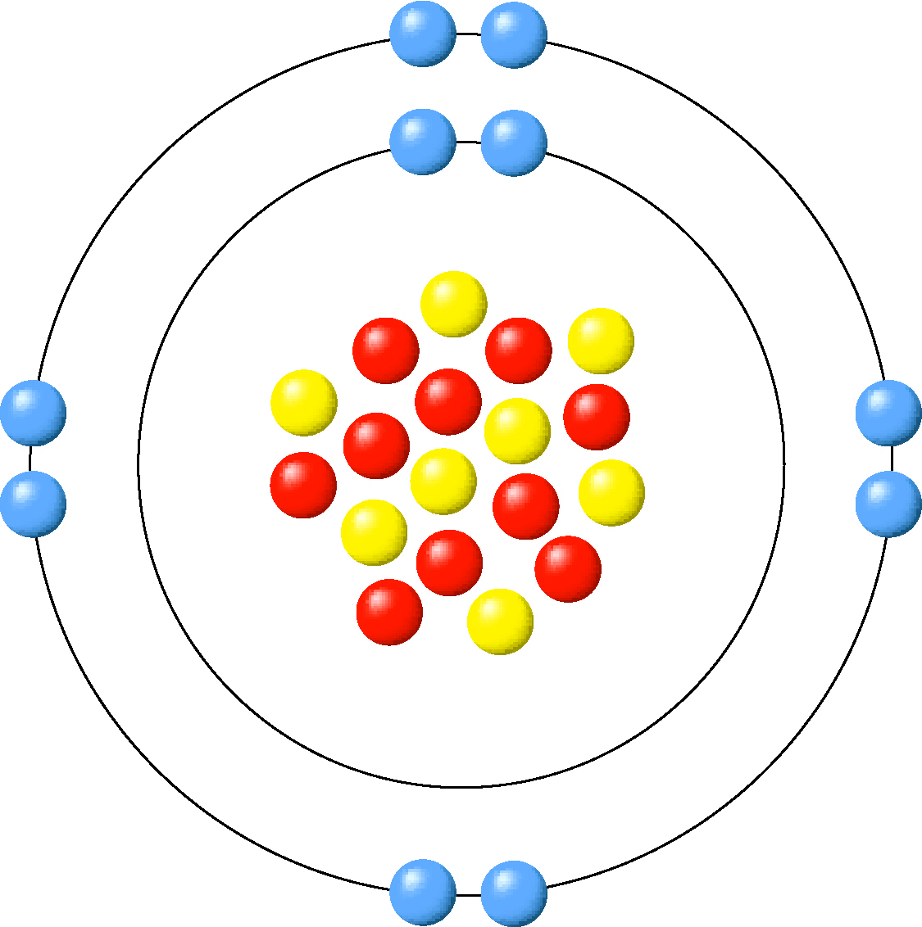

 2. Which statement best describes the diagram to the right?

A. This is a Bohr diagram that shows eight neutrons.

B. This is a Lewis diagram that shows eight neutrons.

C. This is a Bohr diagram that shows ten neutrons.

D. This is a Lewis diagram that shows ten neutrons.

 3. Which statement best describes the following diagram?

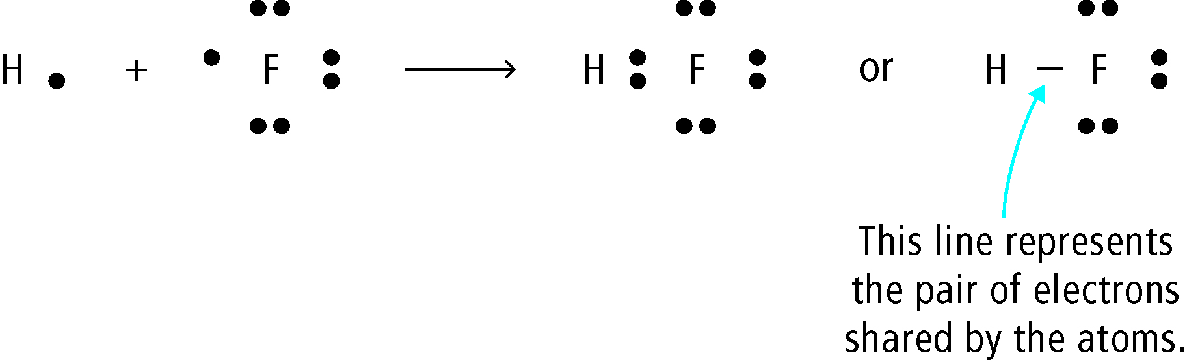

A. The pure substance is an element, and the line refers to a charge of 1–.

B. The pure substance is a compound, and the line refers to a charge of 1–.

C. The pure substance is an element, and the line refers to a pair of bonding electrons.

D. The pure substance is a compound, and the line refers to a pair of bonding electrons.

 4. What is the name of PbO2?

A. lead(II) dioxide

B. lead(IV) oxide

C. lead dioxide

D. phosphorus boron oxide

 5. What is the correct formula for aluminum hydroxide?

A. Al3OH

B. AlOH3

C. Al(OH)3

D. Al(OH3)

 6. Which statement best describes (NH4)2Cr2O7?

A. It is an ionic compound with 16 atoms in total.

B. It is an ionic compound with 19 atoms in total.

C. It is a covalent compound with 16 atoms in total.

D. It is a covalent compound with 19 atoms in total.

 7. What is the charge on the plutonium atom (Pu) in the compound Pu2O5?

A. 3+

B. 4+

C. 5+

D. 6+

 8. What are the coefficients, from left to right, that correctly balance the following equation?



A. 1, 3, 2, 3

B. 1, 7, 2, 3

C. 2, 7, 4, 6

D. 2, 3, 4, 6

 9. What are the coefficients, from left to right, that correctly balance the following equation?



A. 3, 4, 12, 1

B. 3, 3, 6, 1

C. 6, 3, 4, 2

D. 6, 4, 2, 12

10. Which statement best describes the following equations?

|  |  |
| --- | --- |
| I. |  |
| II. |  |

A. I is a word equation, and II is a skeleton equation.

B. I is a skeleton equation, and II is a balanced equation.

C. I is a balanced equation, and II is a word equation.

D. I is a skeleton equation, and II is a word equation.

|  |  |
| --- | --- |
| Match the Term on the left with the best Descriptor on the right. Each Descriptor may be used only once. | |
| Term | Descriptor |
| E 11. binary covalent compound  A 12. polyatomic ion  G 13. ionic compound  B  14. element  D 15. atomic number  F 16.reactant | A. PO43–  B. Br­2  C. substance made during a reaction  D. equal to the number of protons in an atom  E. CH4  F. substance consumed during a reaction  G. MgCl2  H. equall to the number of neutrons in an atom |

Short Answer Questions

17. (a) Draw a Lewis diagram representing ammonia (NH3).

Work on Paper

(b) Draw a Bohr diagram representing MgO.

Work on Paper

18. Write the formula or name of the following compounds.

(a) Iron(III) Chloride: FeCl3

(b) Ammonium Phosphate: NH4PO4

(c) Dinitrogen Trisulphide: N2S3

(d) P4O10 : Tetra Phosphorus Deca Oxide

(e) Na2SO4 : Sodium Sulphate

19. Balance the following equations.

(a)  3KI + AlCl3 →   3KCl +   AlI3

(b)  C3H8 + 5O2 → 3CO2 +  4H2O

20. Which of the following household items is basic?

A. baking soda

B. grapes

C. bananas

D. water

 21. What are the colours of methyl red indicator and bromothymol blue indicator in separate samples of water at pH 7?

A. Methyl red indicator is red, and bromothymol blue indicator is yellow.

B. Methyl red indicator is yellow, and bromothymol blue indicator is blue.

C. Methyl red indicator is yellow, and bromothymol blue indicator is green.

D. Methyl red indicator is orange, and bromothymol blue indicator is green.

 22. Which is properties characteristic of an acid but not a base?

A. sour, reacts with magnesium, turns litmus blue

B. bitter, reacts with magnesium, turns litmus red

C. slippery touch, does not react with magnesium, turns litmus blue

D. sour, turns phenolphthalein indicator colourless, turns litmus red

 23. What the best chemical definition of a salt?

A. a material found by evaporating sea water

B. a material formed by the reaction of an acid with a base

C. a material containing a metal ion and an oxide ion

D. a material containing a metal ion and carbonate ion

 24. Burning magnesium in air produces a brilliant white flame and a white powder. When the white powder is placed in water, it dissolves. What is the colour when bromothymol blue indicator is added to this solution?

A. colourless

B. yellow

C. green

D. blue

 25. What is formed when HCl and NaOH solutions are combined?

A. NaCl and H2O

B. NaH and ClOH

C. NaOCl and H2

D. There is no reaction.

 26. Which list shows the elements that are the most reactive towards water on the left and least reactive towards water on the right?

A. cesium, magnesium, potassium

B. cesium, potassium, magnesium

C. potassium, cesium, magnesium

D. magnesium, potassium, cesium

 27. Which of the following compounds are organic?

|  |  |
| --- | --- |
| I | Na2CO3 |
| II | CH3CH2CH3 |
| III | CH3OH |

A. I and II only

B. II and III only

C. I, II, and III

D. None of these compounds is organic.

 28. Consider the two representations of ethane. What kind of representation is each?

|  |  |
| --- | --- |
|  |  |

A. The left is a molecular formula, and the right is a structural formula.

B. The left is a structural formula, and the right is a molecular formula.

C. The left is a ball-and-stick formula, and the right is a space-filling model.

D. The left is a space-filling model, and the right is a ball-and-stick model.

29. Which of the following is true of the element carbon?

|  |  |
| --- | --- |
| I | Carbon can form four bonds. |
| II | Carbon atoms can combine to form long chains. |

A. I only

B. II only

C. Both statements are true.

D. Neither statement is true.

|  |  |
| --- | --- |
| Match the Term on the left with the best Descriptor on the right. Each Descriptor may be used only once. | |
| Term | Descriptor |
| D 30. indigo carmine  B 31. inorganic  F  32. solvent  C 33. acid  H  34. concentration  E 35.pH scale | A. releases OH- ions in solution  B. compounds that do not contain carbon  C. releases H+ ions in solution  D. acid-base indicator  E. a set of numbers that measure acidity levels  F. a liquid capable of dissolving other substances  G. turns red in acid  H. a measure of the quantity of a substance dissolved in a given volume |

Short Answer Questions

36. Name the following compounds and indicate whether each is an acid, a base, or neither.

|  |  |  |  |
| --- | --- | --- | --- |
|  | Compound | Name | Acid, Base, or Neither? |
| (a) | H2SO4 | Sulfuric Acid | Acid |
| (b) | HCl | Hydrochloric Acid | Acid |
| © | Ca(OH)2 | Calcium Hydroxide | Base |

37. Complete the following chart.

|  |  |  |  |
| --- | --- | --- | --- |
| Indicator | Colour at pH 4 | Colour at pH 7 | Colour at pH 10 |
| Blue litmus paper | Red | Neutral Blue | Blue |
| Red litmus paper | Red | Neutral Red | Blue |

38. Complete and balance the following equations.

(a)  HBr +  KOH →  KBr + H2O

(b)  H2SO4 +  Al(OH)3 →  Al(SO4)3 +  H2O

(c)  The reactions in (a) and (b) are both of the same type. What is the name of this type of reaction? Neutralization

39. What type of reaction is the following?

silver + gold(III) nitrate → silver nitrate + gold

A. synthesis

B. neutralization

C. single replacement

D. double replacement

 40. What type of reaction is the following?

C3H8 + 5O2 → 3CO2 + 4H2O

A. single replacement

B. combustion

C. decomposition

D. double replacement

41. Classify the reaction type and predict the products of the following reaction.  
HCl + Mg(OH)2 → ?

A. double replacement: products are MgCl and H(OH)2

B. double replacement: products are MgCl2 and H2O

C. neutralization: products are MgCl and H(OH)2

D. neutralization: products are MgCl2 and H2O

 42. Which of the following reactions is double replacement?

A. Pb + 2CuCl2 → PbCl2 + 2Cu

B. Na2CO3 + CaBr2 → CaCO3 + 2NaBr

C. MgCO3 + 2HBr → MgBr2 + CO2 + H2O

D. Mg(OH)2 + 2HBr → MgBr2 + 2H­2O

 43. What are the products in the decomposition reaction involving aluminum oxide?

A. Al and O

B. Al2O3

C. Al and O2

D. AlO

 44. In order to start a campfire, wood is chopped into many small pieces, called kindling. Which factor makes it easier to light a fire using kindling instead of large pieces of wood?

A. temperature

B. concentration

C. surface area

D. catalyst

 45. When hydrogen gas is mixed with oxygen gas in a closed container, both gases mix but no noticeable reaction takes place. When a piece of platinum metal is placed in the gas mixture, the mixture suddenly explodes. After the explosion, analysis shows that the amount of platinum metal did not change during the explosion. What factor is responsible for the onset of the explosion?

A. The concentration of the oxygen was high.

B. The concentration of the hydrogen was high.

C. The platinum was a reactant.

D. The platinum was a catalyst.

 46. The chain on a bicycle rusts faster when the bicycle is left outside in damp conditions. Which of the following factors affect the rate at which the bicycle chain rusts?

|  |  |
| --- | --- |
| I | The surface area of the metal in the chain |
| II | The concentration of oxygen in the air |
| III | The temperature |

A. I only

B. II and III only

C. III only

D. I, II, and III

 47. A zinc metal strip is placed in hydrochloric acid. Which of the following changes could be made to decrease the rate of this reaction?

|  |  |
| --- | --- |
| I | Add water to dilute the hydrochloric acid. |
| II | Place the beaker on a hot plate in order to raise the temperature. |
| III | Add a catalyst. |
| IV | Change the shape of the magnesium to make it thicker and less wide. |

A. I and II only

B. II and III only

C. I and IV only

D. II and IV only

48. Suppose a chemist performed an experiment by dissolving equal masses of calcium carbonate in separate beakers containing sulphuric acid. The results of three trials are shown in the table below.

|  |  |  |  |
| --- | --- | --- | --- |
| Trial | Sulphuric Acid | Calcium carbonate | Temperature |
| 1 | Concentrated | Finely ground | 10oC |
| 2 | Concentrated | Lump | 10oC |
| 3 | Dilute | Lump | 15oC |

Trial 1 was the fastest, and Trial 2 was the slowest. Which of the following correctly lists the factors from most important to least important in increasing the rate of this reaction?

A. concentration, surface area, temperature

B. temperature, surface area, concentration

C. surface area, concentration, temperature

D. surface area, temperature, concentration

|  |  |
| --- | --- |
| Match the Term on the left with the best Descriptor on the right. Each Descriptor may be used only once. | |
| Term | Descriptor |
| G 49. synthesis  D  50. precipitate  B  51. combustion  F 52. surface area  C  53. neutralization  E  54. catalyst | A. a reaction in which a compound splits into two elements  B. the reaction involving a burning candle  C. the reaction of an acid with a base  D. a solid that forms when two ionic solutions are mixed  E. a substance that increases reaction rate without being used up by the reaction  F. affects the rate of a reaction between a solid and a liquid  G. a reaction in which two elements combine to form a compound |

Short Answer Questions

55. Identify each of the following descriptions as synthesis, decomposition, single replacement, double replacement, neutralization, or combustion.

(a) There is only one reactant. Decomposition

(b) One reactant is an element. The other is a compound. Single Replacement

(c) Two ionic compounds react to form two new ionic compounds. Double Replacement

56. Which of the four factors affecting reaction rate is most important in each question below? Choose from among concentration, temperature, surface area, and catalyst.

(a) Dust in a granary explodes when it comes in contact with a spark. Concentration

(b) Table sugar is digested in the mouth when it dissolves in saliva, which contains a digestive enzyme. Catalyst

(c) A person blows on a fire to help get it burning better. Temperature

57. Complete and balance each of the following equations. Then classify each reaction type.

(a)    Zn +    Cu(OH)2 → Cu + Zn(OH)2

Reaction type: Single Replacement

(b)    C2H4 +    3O2 → 2CO2 + 2H2O

Reaction type: Combustion

(c)    16Al +    3S8 → 8Al2S3

Reaction type: Synthesis

Circle the letter of the best answer. You may refer to a periodic table, an ion chart, and a common isotope pairs chart.

 58. Which of the following is true of subatomic particles in a nucleus of vanadium-50?

A. It has 23 protons and 27 neutrons.

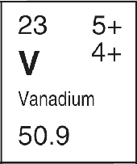

B. It has 23 protons and 28 neutrons.

C. It has 27 protons and 23 neutrons.

D. It has 27 protons and 51 neutrons.