**XML Class Exercises**

*Exercises*

1. *Simple questions:*
   1. How should an element with the name test element and the content "This is our first element!" look?



* 1. Please show (in xml-syntax) the hierarchy of the element book with the subelements chapters and author. author has the further subelements name and address.

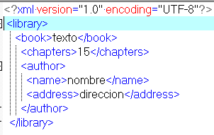

* 1. How does an element with the name entry which has got 2 attributes: no with the value 24 and date with the value 27.10.2004 look?

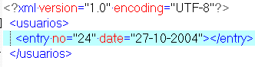

1. *XML tree structures*

Analyse the XML file below.

<?xml version='1.0' encoding='UTF-8' standalone='yes'?>  
<publication>  
 <newsitem>  
 <source>  
 <agency>STT</agency>  
 <editor>Miller</editor>  
 </source>  
 <class>local</class>  
 <article>  
 <heading>Snowstorms in Lappland</heading>  
 <text>snow.html</text>  
 <summary>snowx.html</summary>  
 </article>  
 </newsitem>  
</publication>

Create the file and save as Ex2.xml. Open the file with a web browser.

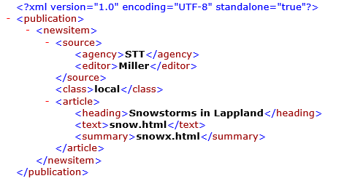

1. *XML structure*

Analyse the following XML file. Correct errors in design.

<?xml version='1.0' encoding='UTF-8'?>  
<phonebook>  
 <company>  
 <cname>Microsoft</cname>  
 <exchange>09-999000</exchange>  
 </company>  
 <president>Bill Gates  
 <extension>09-9990011</president></extension>  
 <secretary>Katharine Finch <extension>09-9990012</secretary></extension>  
 <company>  
 <cname>Oracle</cname>  
 <exchange>09-888000</exchange>  
 </company>  
 <president>Larry Ellison  
 <extension>09-8880011</president></extension>  
 <secretary>Helen Calhoun  
 <extension>09-8880012</secretary></extension>  
</phonebook>

Create a file called ex3-err.txt and write down every mistake and correction.

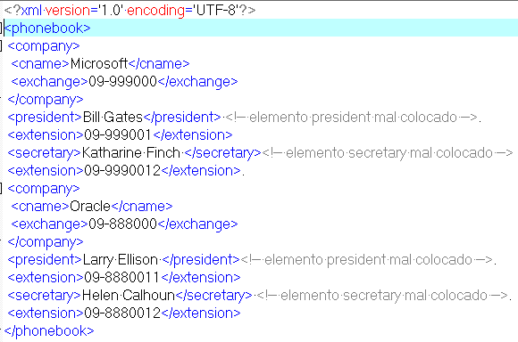

1. *Mark up the following email message to identify its information content:*

From: Simon North <north@synopsys.com>  
To: Nick <sintac@xs4all.nl>  
Subject: Hi  
Hi Nick, this is just a quick message  
to say I got the material. Thanks.

Create an xml file (ex4.xml) to store the necessary information

. 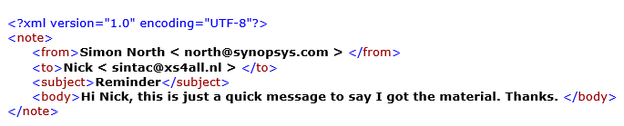

1. *XML file, CD information*

Plan an XML description for a music CD. You could use a root element called <CDList>. Information about the contents should include at least name of the record, artists, songs, publishing year, and music category. You can add more information e.g. about each track (number, duration, name, etc.) Plan first the tree structure of your XML data, and then find some data from the Web. Save as Ex5a.xml and test with your browser .

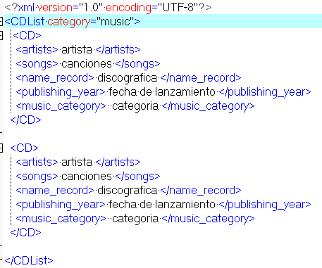

Next, add some information as attributes, like below <CD serial=B6B41B disc-length='36:55'> Save as Ex5b.xml and test. Fix errors. Add the following comment: <!-- This CD has more tracks than in this file -->

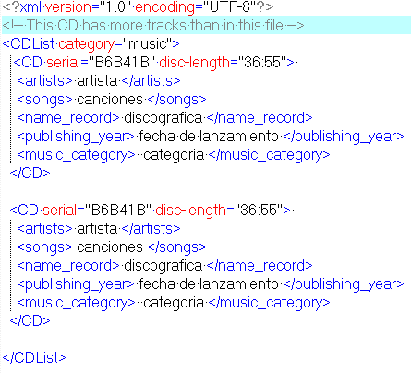

1. *XML: a letter template*

Create a letter structure in XML, including sender and receiver information, date, text body and a signature. Make a document instance with contents. Save your file as Ex6.xml.

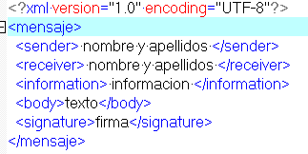

1. *The XML standard*

How XML should look is described in the [XML 1.0 W3C Recommendation](https://www.w3.org/TR/xml/). The language of the standard is somewhat technical and formal, but being able to read the standard yourself is quite useful. Look into the standard and answer the following questions:

* 1. What do comments look like in XML? (section 2.5)

<!-- Comentario correspondiente -->

* 1. Can an attribute be repeated in the same element? (section 3.1)

Un nombre de atributo no debe aparecer más de una vez en la misma etiqueta de inicio o etiqueta de elemento vacío.

* 1. Where is it stated that the element names in opening and closing tags must match?

Sección 3.1. Etiquetas de inicio, etiquetas finales y etiquetas de elementos vacíos”