MA-INF 2311 — Lab Computer Animation
  - Guideline Document for Master Students – Lab group Simsek/Voegele

General Expectations
This lab is a practical research and development project in the area of computer animation and related interactive systems. The goal is not only to produce code, but also to demonstrate structured thinking, planning, testing, communication, and scientific reasoning.
You are expected to work continuously throughout the semester and treat the lab as a long-term engineering project.
Source: https://bamainfo.informatik.uni-bonn.de/public/pa/Module-Handbook-MSc-Computer-Science.pdf
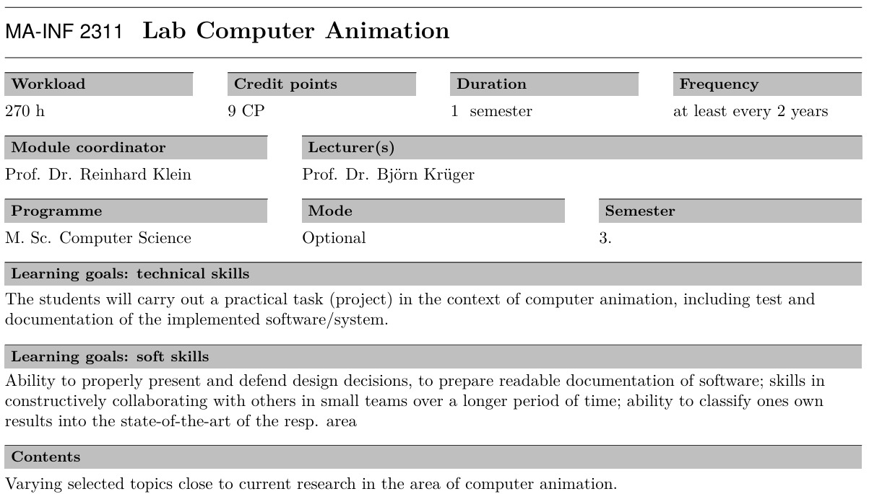

Time Planning
Please plan your work ahead. The workload of this lab corresponds to approximately:
- 10–15 hours per week
- sustained over the semester
- amounting to the ~270 h total mentioned in the regulations
Students who work continuously almost always achieve significantly better results than students who attempt to complete everything shortly before the deadline.
A successful lab project is usually the result of:
- regular progress,
- continuous testing,
- repeated refinement,
- and early identification of problems.

Start With the Final Presentation (YES, Really!)
Your first task is to create the presentation slides. This presentation is not meant to be final yet but it is an invaluable planning and orientation tool.
Why? Because if you know:
- what you want to achieve,
- why it matters,
- what the core contribution is,
- and what data/methods you need,
then you know where you are going — and the implementation becomes much easier and more structured.
Many failed code projects happen because people start coding before clearly defining the actual goal.
The presentation helps us:
- structure the project,
- identify risks early,
- define the scope,
- and discuss feasibility together.
Do not worry if you find the questions difficult to answer at first (we do not expect you to know the answers off the bat and we will help you figure everything out).

Presentation Structure

Slide 1 – Topic and Examples
Introduce the topic and provide motivating examples.
Example „What are functional tests in the context of orthopaedic surgery?“
Show:
- the problem domain,
- practical examples,
- related workflows,
- or example systems.
The audience should quickly understand:
- what the project is about,
- and what kind of application area it belongs to.
Slide 2 – Contribution and Motivation („The WHY“)
Explain:
- Who benefits from this project?
- What problem does it solve?
- What is the actual contribution?
- What is new or improved?
This is one of the most important slides. You should be able to answer:
“Why should anyone care about this project?”
Examples:
- faster workflows,
- better visualization,
- improved interaction,
- automation,
- easier analysis,
- educational value,
- clinical relevance.

Slide 3 — Core Component
Define the core component of your lab project.
It is probably one of the following:
- the central algorithm,
- the main service,
- the core application,
- the rendering pipeline,
- the interaction system,
- the central analysis tool,
- the important step in data processing.
We do not expect you to know this upfront and can identify this together during supervision. However, we do want you to spend some time and energy thinking about the core component and why it is important.

Slide 4 — Data
Once you know what you are building, you know what data you will need and if you need to record more.
Describe:
- available datasets and resources,
- data you will need to acquire,
- records that you will generate.
Clarify:
- where the data comes from,
- whether access permissions are required,
- and how the data will be processed.

Slide 5 — Methods, Programming Languages, and Libraries
Describe:
- intended methods,
- frameworks,
- programming languages,
- libraries,
- APIs,
- Toolkits…
No need to over-engineer this slide. However, we need to discuss:
- dependencies,
- hardware/software access,
- GPU requirements,
- licenses,
- server access,
- or special tools early enough.

Slide 6 — Planned Tests and Evaluation
Describe the tests you intend to perform.
Examples:
- usability tests (how well does it work if someone uses it?),
- performance benchmarks and load tests (how fast is it compared to other methods? What resources are needed in comparison?),
- robustness testing (how does it perform on edge cases?)
- reproducibility checks (is the result the same every time it runs?),
- portability tests (can others execute the code on their machine?),
A project is only useful if we can demonstrate that it works reliably, so testing is not optional.

Check-Ins
We offer bi-weekly check-ins.

Office Hour (TBD)
Monday morning — 11:00 AM (every other Monday)
Tuesday morning – 11:00 AM (TBD, every other Tuesday)
The purpose of the check-ins is to:
- discuss progress,
- identify blockers,
- adjust the scope if necessary,
- and ensure that projects stay on track.
Please come prepared:
- show progress,
- bring questions,
- and demonstrate what currently works.

