<https://www.pugetsystems.com/labs/hpc/Install-TensorFlow-with-GPU-Support-on-Windows-10-without-a-full-CUDA-install-1172/>

1. Install anaconda – version ***Anaconda3-5.1.0-Windows-x86_64.exe*** (**"Just Me"**)

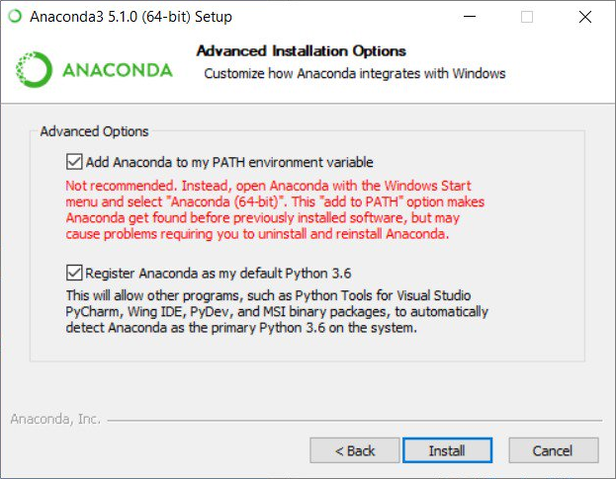

1. Run anaconda and Spyder to check everything is correct
2. Open cmd and check python version

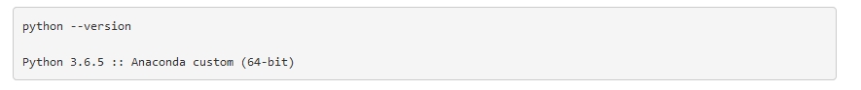

1. Install Keras and then Install TensorFlow GPU

conda install -c aaronzs tensorflow-gpu

or

pip install -c aaronzs tensorflow-gpu

1. Download Cuda 9.0 and patch2

<https://developer.nvidia.com/cuda-90-download-archive?target_os=Windows&target_arch=x86_64&target_version=10&target_type=exelocal>

1. Create a "personal" lib directory



1. Install CUDA9.0

* On the "Install options" panel select "Custom (Advanced)".
* Then on the "Custom installation options" panel un-select everything except "Runtime -- Libraries",

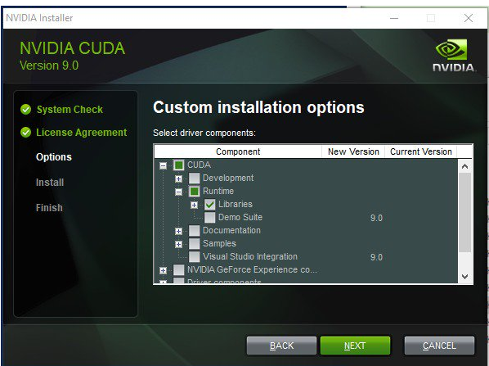

n the panel that asks for the install location "Browse" to the directory you created for the libraries and select that. Then finish the install.

You should now have a "bin" directory in that install directory. That is where all of the DLL's live that TensorFlow is going to need.

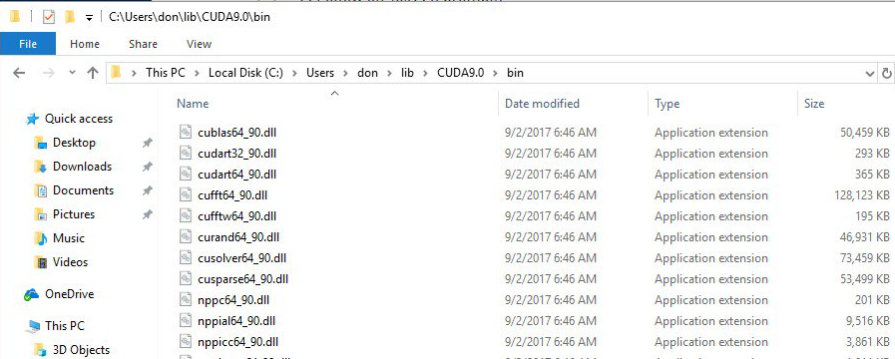

1. Do the same thing we did above with the Base Installer but this time using the "Patch 2 installer". It's name should be something like **cuda_9.0.176.2_windows.exe**. You only want the "Runtime" part of that install. It will update the **cublas64_90.dll** and **nvblas64_90.dll** Be sure to have it install in the same directory as you used for the base install.
2. Install cuDNN 7.0

<https://developer.nvidia.com/cudnn> -----> "Archived cuDNN Releases" --------> Download cuDNN v7.0.5 (Dec 5, 2017)

1. That will be a "zip" file called cudnn-9.0-windows10-x64-v7.zip. Open that file and go to "cuda\bin". There you will find cudnn64_7.dll Copy that file to the bin directory that has all of your other cuda DLL's. In my case that is **C:\Users\sarak\lib\CUDA9.0\bin**
2. Set your PATH environment variable.

Control Panel ---> system ---> Advanced system settings ----> Environment Variables

At the system variables click on **Path** and **Edit**

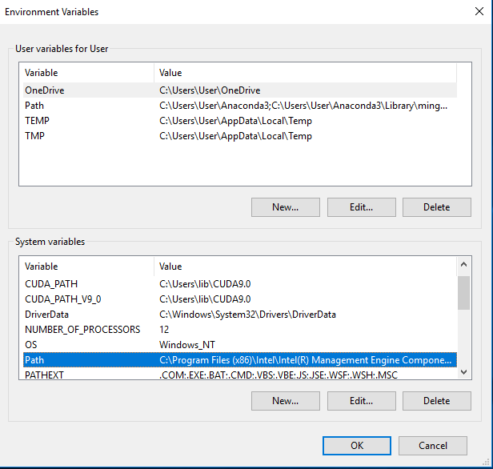

Click an New and add the path of lib directory.

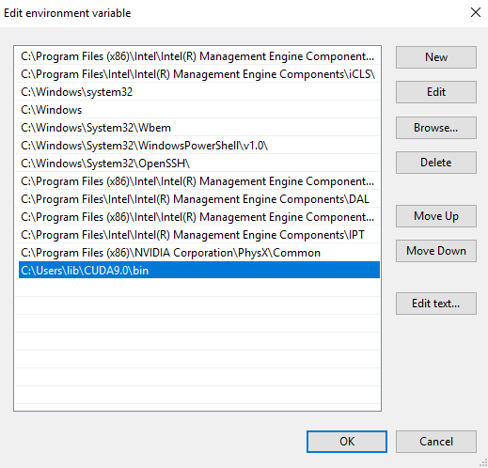

Reboot Windows

And import TensorFlow gpu

