**Bayesian**

In contract Bayesian statistics (named after Thomas Bayes), it describes that the probability of an event, based on conditions that might be related to the event. At the core of Bayesian statistics is Bayes’s theorem, which describes the outcome probabilities of related (dependent) events using the concept of conditional probability. For example, if a particular illness is related to age and life style, then applying a Bay’s theorem by

considering a person’s age and life style more accurately increases the probability of that individual having the illness can be assessed.

Bayes theorem is stated mathematically as the following equation:

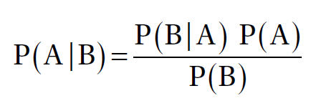

Where A and B are events and P (B) ≠ 0

• P (A) and P (B) are the probabilities of observing A and B without

regard to each other.

• P (A | B), a conditional probability, is the probability of observing

event A given that B is true.

• P (B | A) is the probability of observing event B given that A is true.

For example, a doctor knows that lack of sleep causes migraine 50% of the time. Prior probability of any patient having lack of sleep is 10000/50000 and prior probability of any patient having migraine is 300/1000. If a patient has a sleep disorder, let’s apply Bayes’s theorem to calculate the probability he/she is having a migraine.

P (Sleep disorder | Migraine) = P(Migraine | Sleep disorder) * P(Migraine) / P(Sleep disorder)

P (Sleep disorder | Migraine) = .5 * 10000/50000 / (300/1000) = 33%

In the above scenario, there is a 33% chance that a patient with a sleep disorder will also have a migraine problem.