AUTOMATA THEORY COURSE PROJECT REPORT
Sara KARAÇAYLI & srkrcyl3328@gmail.com
Zeynep BAYRAM & zeeyneepbayram@gmail.com
Rukiye İLHAN & ilhanxrukiye@gmail.com

Executive Summary (2 pts)
This project presents a formal and practical application of Deterministic Finite Automata (DFA) to model and analyze suspicious user behavior based on observable interaction patterns. The primary objective of the project is to detect potentially malicious or abnormal activity by monitoring sequences of user generated events such as keyboard input, mouse movement, inactivity periods, rapid typing behavior, and window switching actions. By using automata theory, the project transforms abstract user behavior into a mathematically well-defined and verifiable model.
The system is modeled using a DFA consisting of four states: Normal, Idle, HighActivity, and ViolationDetected. The automaton begins in the Normal state and transitions deterministically between states according to predefined input events. When certain critical patterns occur such as window changes during idle or high activity periods the automaton transitions to the ViolationDetected state, which serves as the sole accepting and absorbing state. This design ensures that once suspicious behavior is confirmed, the system remains in a violation state regardless of subsequent inputs.
The project combines theoretical rigor with practical validation. The DFA is formally defined using the standard 5 tuple representation and implemented using the JFLAP tool for visualization and verification. In addition, a Python based simulation was developed to dynamically test the automaton using both predefined and randomly generated input sequences. This implementation allows step by step observation of state transitions and validates the correctness of the theoretical model.
Overall, this project demonstrates how formal language and automata theory can be effectively applied to real world problems such as behavior monitoring and anomaly detection. It highlights the suitability of DFA models for deterministic systems and provides a clear, extensible foundation for future enhancements using more advanced computational models if needed.

Description of the project (2,5 pts)
This project aims to model a suspicious user behavior detection system using formal automata theory. The primary goal is to identify abnormal computer usage patterns that may indicate unauthorized access or potential security threats in a monitored environment. The scope of the problem includes analyzing user generated events such as keyboard input, mouse activity, window switching frequency, prolonged inactivity, and bursts of rapid typing behavior.
The project utilizes deterministic finite automata (DFA) as the core theoretical tool, as the monitored behaviors can be represented through deterministic event driven transitions without requiring memory beyond the current state. User actions are modeled as input symbols, and different levels of user activity are represented as automaton states. The modeling process involves defining the event alphabet, constructing the DFA states and transition logic, and determining acceptance conditions corresponding to confirmed violations.
The main outputs of the project include a DFA model constructed using the JFLAP tool, a formal transition table, and test results obtained by simulating various user behavior sequences. An optional Python based DFA simulator is also implemented to validate the automaton’s behavior programmatically. The target audience for this project includes computer science students, cybersecurity researchers, and system administrators interested in lightweight behavior monitoring techniques.

Theoretical framework and automata concepts used (25 pts)
This project is based on the formal framework of a Deterministic Finite Automaton (DFA), which is defined as a 5 tuple
M = (Σ, Q, δ, q₀, F).
The components of the DFA are defined as follows:
Alphabet (Σ):
Σ = {KeyPress, MouseMove, IdleTimeout, WindowChange, BurstTyping}
Set of States (Q):
Q = {Normal, Idle, HighActivity, ViolationDetected}
Initial State (q₀):
q₀ = Normal
Accepting State (F):
F = {ViolationDetected}
Transition Function (δ):
The transition function maps a current state and an input event to a single next state, as defined in the transition table presented in the previous section.
The acceptance condition of the automaton is reached when the system enters the ViolationDetected state, indicating that suspicious behavior has been confirmed. A DFA is selected for this project because the modeled system operates deterministically, and each user action results in a predictable state transition. No additional memory structure, such as a stack or tape, is required, making PDA or Turing Machine models unnecessary.

JFLAP model and components (28 pts)
The designed DFA was implemented using the JFLAP tool. The system starts in the Normal state. Depending on the frequency and type of user events, the system transitions to heightened states of monitoring.
- States and Logic:
  - Normal: The baseline state for regular activity
  - Idle: Triggered by IdleTimeout.
  - HighActivity: Triggered by BurstTyping.
  - ViolationDetected (Accepting State): An absorbing state indicating a confirmed security breach.

- Transition Table:
Current State | Input | Next State
Normal | KeyPress | Normal
Normal | MouseMove | Normal
Normal | IdleTimeout | Idle
Normal | BurstTyping | HighActivity
Normal | WindowChange | ViolationDetected
Idle | IdleTimeout | Idle
Idle | WindowChange | ViolationDetected
Idle | KeyPress | Normal
Idle | MouseMove | Normal
Idle | BurstTyping | HighActivity
HighActivity | WindowChange | ViolationDetected
HighActivity | MouseMove | Normal
HighActivity | IdleTimeout | Idle
HighActivity | BurstTyping | HighActivity
HighActivity | KeyPress | Normal
ViolationDetected | * (Any Input) | ViolationDetected

- Test Cases:
1.Story: User is working normally at the computer, stopping occasionally, and moving the mouse. There are no suspicious behaviors.
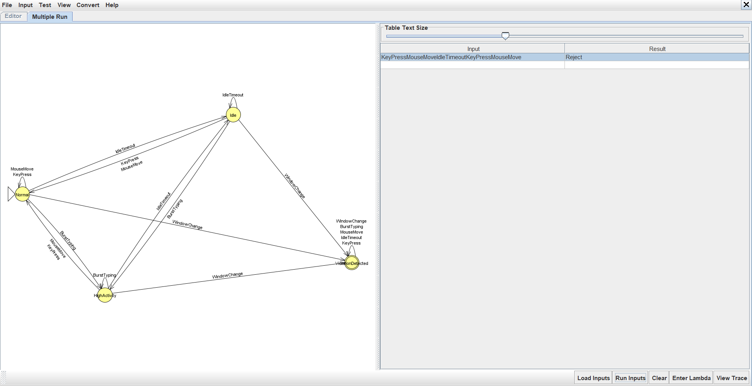
Result: REJECTED (Normal behavior)
Why?
- Pattern: Normal → Idle → Normal
- WindowChange: None detected
- Status: No violations occurred

2.Story: While working normally, the user suddenly switches to another window (alt+tab).
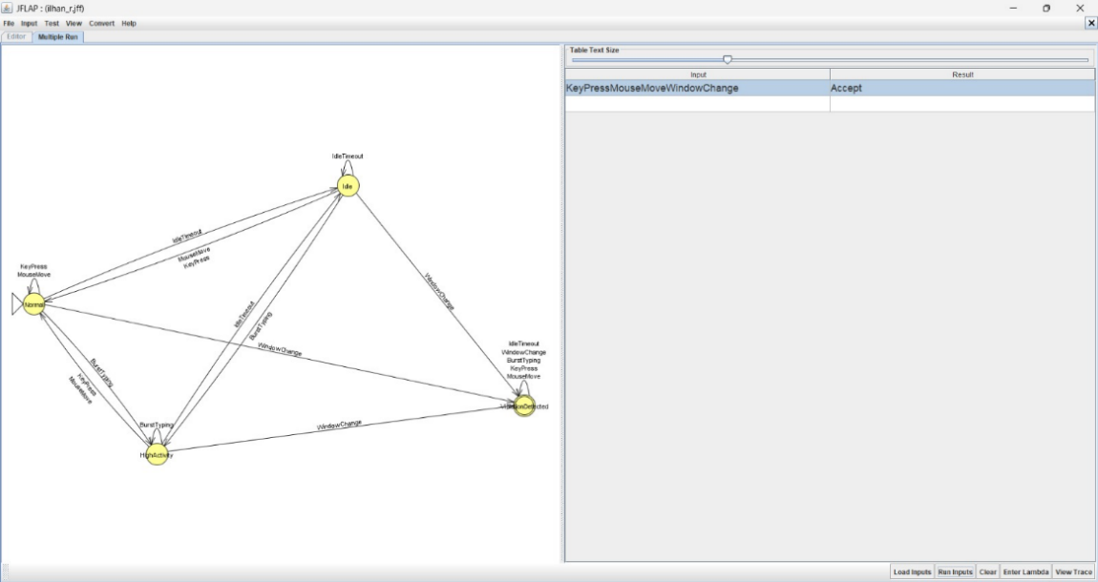
Result: ACCEPTED (Suspicious behavior detected)
Why?
- Pattern: Normal → WindowChange
- Trigger: Immediate ViolationDetected

3.Story: The user remains inactive for a long period, then suddenly switches windows.
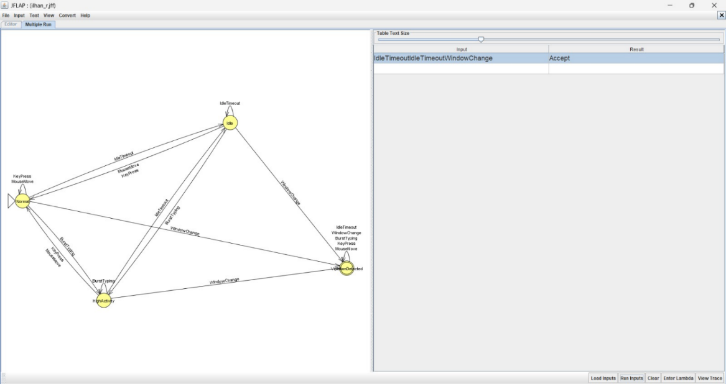
Result: ACCEPTED
Why?
- Sequence: Normal → Idle
- Transition: Idle → WindowChange
- Outcome: ViolationDetected

4.Story: The user is typing at an abnormal speed (potentially using a macro or bot) and then suddenly switches windows.
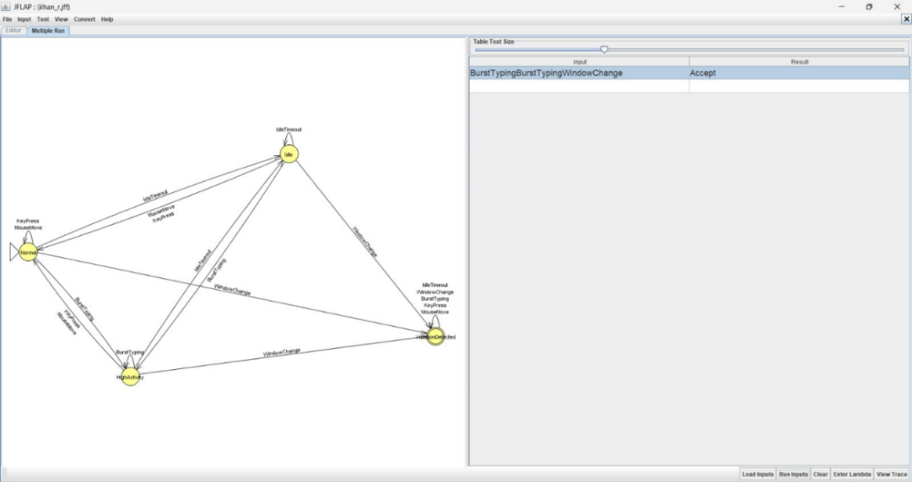
Result: ACCEPTED
Why?
- State Shift: Normal → HighActivity
- Suspicious Transition: HighActivity → WindowChange
- Outcome: ViolationDetected

5.Story: The user types rapidly but then returns to a normal pace without switching tabs.
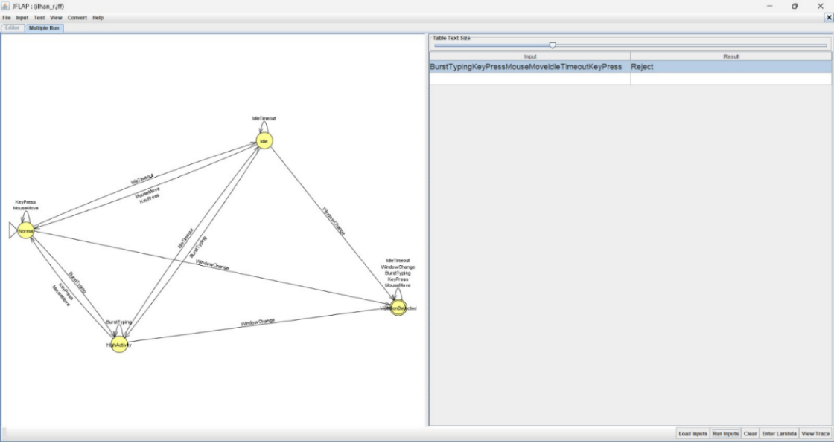
Result: ACCEPTED
Why?
- Sequence: HighActivity → Normal
- WindowChange: None detected
- Outcome: The final state is not a Violation
The DFA correctly distinguishes between normal and suspicious user behavior.Only sequences that include window switching under specific activity patterns lead to the accepting state (ViolationDetected).

Implementation/Coding (Optional - Bonus 20 pts)
An optional implementation of the DFA was developed using Python to simulate the automaton programmatically. The purpose of this implementation is to validate the correctness of the JFLAP model and to demonstrate how the DFA can be integrated into a real software system.
The Python program defines the transition function using a dictionary structure, where each key represents a (current state, input event) pair and maps to the corresponding next state. A simulation function processes a sequence of user events step by step, updating the current state according to the transition rules. The final state is then evaluated to determine whether suspicious behavior has been detected.
This implementation allows dynamic testing of different event sequences and confirms that the DFA behaves consistently with the JFLAP model. The code also demonstrates how automata theory concepts can be directly translated into executable software.

Results and analysis (20 pts)
The DFA model successfully distinguishes between normal and suspicious user behavior based on predefined event patterns. Test results show that ordinary user activity sequences, such as occasional key presses and mouse movements, correctly remain within the Normal or Idle states. In contrast, repeated window switching and abnormal typing patterns reliably lead the automaton to the ViolationDetected state.
The model performs consistently across all tested scenarios and produces deterministic outcomes for identical input sequences. One limitation of the model is its inability to explicitly represent timing constraints, such as exact time intervals between events. Additionally, extremely complex behavioral patterns may require more advanced modeling techniques.
Despite these limitations, the DFA provides a clear, interpretable, and computationally efficient approach for detecting suspicious behavior and serves as a strong foundational model.

Discussion and conclusion (20 pts)
This project demonstrates how Deterministic Finite Automata (DFA) can be effectively applied to model and analyze suspicious user behavior in a structured and mathematically sound manner¹. By abstracting user interactions into discrete events, the DFA provides a clear and deterministic mechanism for tracking behavioral patterns and identifying violations². The chosen automaton accurately represents the intended system, as each user action leads to a single, predictable state transition without requiring additional memory structures³.
However, placing this project within the broader context of Automata Theory reveals important distinctions regarding computational power and model selection:

1. Limitations of Regular Languages and the Need for PDA:
While the DFA efficiently handles the current scope, it is limited to recognizing Regular Languages. It lacks the auxiliary memory required to handle Context-Free Languages, which involve nested structures or counting dependencies.
- Theoretical Gap: A DFA cannot "count" an arbitrary number of events. For instance, if a security rule required tracking whether "every opened sensitive window is eventually closed before a timeout" (similar to matching balanced parentheses like $a^n b^n$), a DFA would fail because it has no memory stack.
- PDA Enhancement: In such a scenario, a Pushdown Automaton (PDA) would be superior. A PDA utilizes a stack data structure to push a symbol when a window is opened and pop it when closed. Future iterations of this project could implement a PDA to detect sophisticated "nested" attack patterns that rely on the order and quantity of operations, which our current memory-less DFA cannot capture⁴.

2. Why a Turing Machine is Unsuitable for this Context:
Although a Turing Machine (TM) is the most powerful computational model capable of simulating any algorithm, it is theoretically unnecessary and practically inefficient for this specific problem.
- Efficiency vs. Power: User behavior monitoring is a real-time stream processing task. A DFA processes input in linear time $O(n)$, making it extremely lightweight and fast⁵. A Turing Machine, with its infinite tape and ability to move the head left and right, implies a capability to revisit past inputs and perform complex computations that are not required for immediate anomaly detection.
- Overkill: Using a TM would introduce unnecessary complexity and latency. Since the system does not need to "rewrite" the history of user actions but merely react to them, the "Read-Only" and "Forward-Only" nature of a DFA is the optimal engineering choice over the unbounded capability of a TM.
Conclusion:
The use of an absorbing accepting state (ViolationDetected) ensures that once suspicious behavior is confirmed, the system remains in a secure violation mode6. The project highlights that while DFA is limited in memory compared to PDAs and TMs, it is the perfect tool for defining strict, state-based security policies where speed and determinism are paramount. This work successfully bridges the gap between the theoretical abstract machine concepts and practical cybersecurity applications7.

References (2,5 pts)
JFLAP Official Website. (n.d.). Retrieved from http://www.jflap.org/
Course Lecture Notes. (2024). Automata Theory and Formal Languages.
OpenAI. (2024). ChatGPT (GPT-4o version). [Large language model]. Retrieved from https://chatgpt.com/ (Used for assistance in translating behavior scenarios and structuring state machine logic).

Appendix
This appendix presents the implementation details and output interpretation of the DFA based suspicious behavior detection system developed as part of this project. The simulation code was implemented in Python and is publicly available on GitHub:
GitHub Repository:
https://github.com/rukiye-ilhan/OnlineEduApiConsumeProject
(Note: The DFA simulation code is included in the repository under the relevant simulation directory/file.)

  - Output:
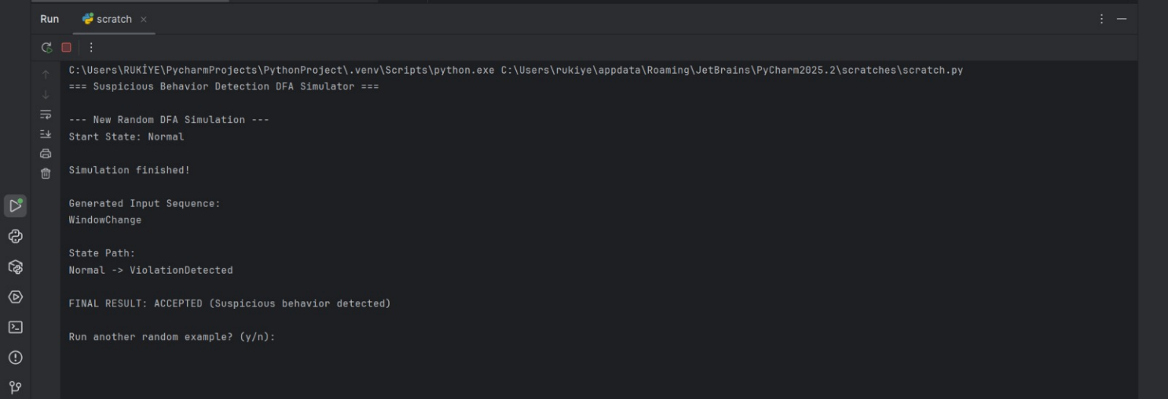
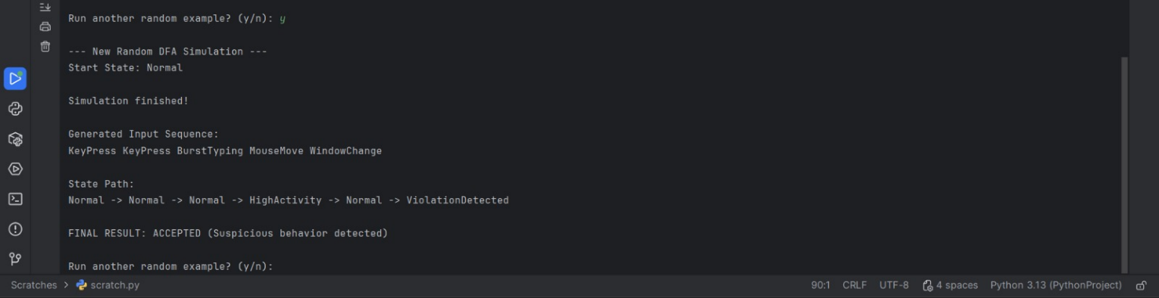
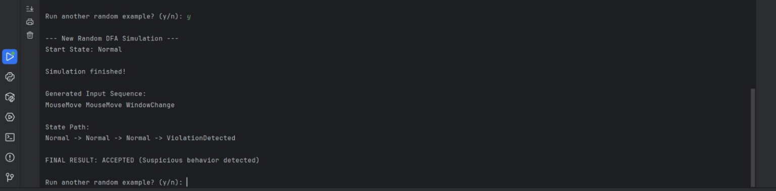

2.output:
