Sequential Interventions and their role in AI Adoption

Sara Maldon
Head of Business Automation & AI, Make (make.com)

Prepared for: Wharton Human-AI Research (WHAIR) Conference

AI and the Future of Work, May 20–21, 2026

Topic area: LLMs and the Organization

Date: March 2026

Abstract
Given the novelty of generative AI, there are few companies that have succeeded in AI transformation efforts. Empirical data from AI change initiatives is largely missing, which is why slowing the mandates for AI adoption within companies. This 18-months case study from a 387-person SaaS company show the journey of AI adoption on a large scale through three sequential interventions: voluntary tool access with no pro-active change management support in stage one, structural enablement with embedded departmental facilitators in stage two and the effect of mandatory accountability on AI adoption. This study analyses 8,789 workflows created by 387 unique employees across 7 departments. It projects the AI adoption journey at the employee level – the proportion of the workforce that actively built AI-enabled automation in a given month.
Tooling access without change management yielded a mean monthly adoption rate of 2.4% (consistent with Rogers’ innovator segment). Structural enablement raised this to 7.3%. The introduction of a mandatory accountability framework produced a 4.0x increase to 28.9%, with a single-month peak of 53.7%. Following the mandate period, monthly adoption settled at 23.5% - more than three times the pre-mandate ceiling. Cumulatively, 86.8% of eligible employees created at least one AI-enabled workflow.
This paper presents the observed adoption dynamics, examines the theoretical mechanisms that may explain them, and identifies limitations in the data and design that constrain causal interpretation.
Keywords: enterprise AI adoption, organizational change, mandate effects, employee-level metrics, longitudinal case study, workflows

Introduction

Enterprise AI adoption consistently stalls not at access, but at scale. The Wharton-GBK (2025) survey of 1,800+ enterprises confirms that voluntary tool provisioning yields single-digit active adoption rates, while McKinsey (2025) reports that despite 78% of organisations deploying AI in at least one function, most remain trapped in pilot-stage deployments. Eatough, Ferrazzi et al. (2026) quantify the underlying gap precisely: 78% of knowledge workers hold positive attitudes toward AI, yet only 23% use it regularly – a 55-percentage-point distance that is not closing on its own.

Diffusion theory predicts this: Rogers (2003) estimates voluntary adoption activates approximately 2.5% of any population, with broader uptake contingent on social contagion and perceived advantage, while Moore (1991) identifies the structural chasm between early adopters and the early majority that most innovations fail to cross.

More recent work has begun to identify the organisational conditions that close this gap – Brynjolfsson, Li and Raymond (2023) demonstrate that identical AI tools yield divergent productivity outcomes depending on organisational complements, Dell'Acqua et al. (2023) show that AI capability forms a "jagged frontier" that complicates uniform mandates, and Kamarova, Gagné et al. (2024) identify the SDT-grounded conditions under which externally mandated behaviour becomes self-sustaining.

What remains absent is longitudinal, employee-level data tracking what happens as a single organisation iterates through sequential intervention strategies. This paper fills that gap, reporting 18 months of adoption data – 8,789 workflows created by 387 unique employees across three distinct organisational phases – to examine whether each intervention establishes a new baseline that compounds, or whether adoption reverts once pressure is removed.

2. Research Setting & Data

2.1 The company
Make (make.com) is a visual AI automation platform in the no-code/low-code space. The eligible population for this study comprises 387 employees – the unique individuals who created at least one automation workflow on the Make platform during the study period. This excludes contractors and other personnel not participating in the programme. These 387 employees span 7 organizational units: Engineering, Product & Design, Customer Support, Marketing & Ecosystem, Revenue, Operations, and People.

2.2 The AI transformation setup
The AI transformation programme is led by a dedicated AI Transformation Lead and sponsored by the CEO. Three strategic rationales underpinned the mandate. First, as a company building automation and AI products, employees needed to be the most active users of their own product to understand the customer experience. Second, the company was strategically shifting from an automation platform to an AI-and-agents platform, and internal fluency needed to match external positioning. Third, AI fluency was becoming a market standard competency – prompting, process thinking, and AI application skills needed to be developed organisation-wide, not concentrated in a technical minority.

Table 1. Intervention Phases
Phase | Period | Intervention | Rationale
Phase 0 | Pre-Apr 2024 | No formal AI programme | Baseline
Phase 1 | Apr 2024 – Jan 2025 | Tool access | Tool availability, guidelines, optional learning
Phase 2 | Feb 2025 – Aug 2025 | Bottom-up mandate | Departmental AI facilitators (“Samurai”), formal training and mandate
Phase 3 | Sep 2025 – Jan 2026 | Top-down mandate | CEO-backed mandate: every employee required to build AI workflows
Phase 4 | Feb 2026 – present | Retention | Observing retention of active builders
Phase 0 – Organic Adoption (pre-Apr 2024). Employees had no formal access to AI capabilities, with no organisational visibility or governance. There was no formal goal; adoption was a side effect of individual curiosity. Resources were limited to the AI transformation lead headcount allocation.
Phase 1 – Tool access (Apr 2024 – Jan 2025). The organisation provisioned a governed AI toolkit and published usage guidelines. The goal was to remove access barriers and let adoption grow organically within a compliant framework. Main activities included tool provisioning, a data classification policy, and optional learning sessions.
Phase 2 – Bottom-up mandate (Feb – Aug 2025). Six dedicated AI facilitators ("Samurai") were embedded across departments in a matrix structure, reporting to both their VP and the AI transformation lead. The goal was to translate generic AI capabilities into department-specific workflows and break through the adoption ceiling left by Phase 1.
Phase 3 – Top-down mandate (Sep 2025 – Jan 2026). Every employee was required to show proof of building their own AI workflow, with completion tied to performance evaluations. The goal was to push adoption beyond the willing cohort to the entire organisation. Systemic change management efforts applied, including recognition, role modelling, and departmental enablements.

Phase 4 – Retention (Feb 2026 – present). Continuous monitoring of sustained adoption. Change management efforts remain in place.

2.3 AI workflows
This study measures enterprise AI adoption through automation workflows – discrete, executable units of business process automation that organizations build, deploy, and maintain without code.
Workflows are the appropriate unit of analysis because, unlike tool-level metrics (e.g., ChatGPT queries), they represent committed organizational investment – someone designed, tested, and deployed a persistent process, not a one-off interaction. They are also objectively classifiable: their technical composition can be programmatically inspected, enabling measurement free from self-report bias. Most critically, building a workflow requires both technical capability and a decision about how work should be done, making it a natural proxy for operational transformation.
Our dataset comprises 8,789 workflows created by 387 unique builders across 7 departments over 18 months (April 2024 – March 2026). Each workflow is classified into a three-tier taxonomy we term the agentic automation spectrum.

2.3.1 Agentic Automation Spectrum
Building on Davenport and Ronanki's (2018) cognitive technology taxonomy and Raisch and Krakowski's (2021) automation–augmentation paradox, we classify workflows into three tiers reflecting a graduated continuum from deterministic process execution to autonomous AI-driven operations:
Tier 1: Traditional Automation. Deterministic, rule-based workflows where the human designer specifies every decision branch at build time – what Zuboff (1988) termed "automating." Traditional workflows serve well-defined, high-volume processes where deterministic logic remains more reliable and auditable.
Tier 2: AI-Enhanced Workflows. Workflows embedding LLM modules within an otherwise deterministic sequence. The AI operates as a tool within the workflow – classifying, generating, or extracting at specific steps – while the overall process flow remains human-designed. This maps to Dell'Acqua et al.'s (2023) "jagged frontier" and Raisch and Krakowski's (2021) augmentation mode.
Tier 3: Agentic Workflows. Goal-directed AI agents that autonomously determine how to achieve objectives – selecting tools, sequencing actions, and responding to intermediate results. This aligns with Sapkota, Roumeliotis, and Karkee's (2026) distinction between task-specific AI agents and orchestrated agentic autonomy.

2.4 Methodology

This study employs a longitudinal, single-organization field study of enterprise AI adoption over 18 months (April 2024 – March 2026). The study observes the implementation of four sequentially distinct intervention phases under otherwise stable organizational conditions, producing a natural quasi-experiment with clear phase boundaries. The interventions were not designed ex ante as a controlled experiment; they emerged iteratively. The primary threat to internal validity is the confounding of intervention type with time; we address this by testing for structural discontinuities at phase transitions using Welch's t-tests and Cohen's d effect sizes rather than relying on trend extrapolation.

2.4.1 The Dataset
Data were extracted programmatically from the company's platform telemetry, not from surveys or interviews. Each record represents a single automation workflow ("scenario") and includes nine fields:
Table 2. Dataset Attributes
Attribute | Type | Description
ID_scenario | String | Unique workflow identifier
CreatedBy | String | Anonymized employee ID
Department | Categorical | One of 7 departments (Engineering, Product & Design, Customer Support, Revenue, Marketing & Ecosystem, Operations, People)
Created | Date | Workflow creation date (dd/m/yyyy)
LastEdit | Date | Most recent edit date (dd/m/yyyy)
isActive | Boolean (0/1) | Whether the workflow is currently active
isAiUsed | Boolean (0/1) | Whether the workflow uses AI modules (excluding AI agents)
isAiAgentUsed | Boolean (0/1) | Whether the workflow includes autonomous AI agents

The binary classification flags (isAiUsed, isAiAgentUsed) are determined by inspecting the technical composition of each workflow at extraction time, not by creator self-report. The eligible population is derived from the data itself: the 387 unique employees who created at least one scenario during the study period, excluding contractors and non-programme personnel.

2.4.2 The Analytical Approach
Analysis proceeds primarily at the employee level through six methods:
- Descriptive statistics. Phase means, ranges, month-over-month changes in the monthly employee adoption rate.
- Structural break testing. Welch's t-test to test whether Phase 2 → 3 is a statistically significant structural break (with Cohen's d for effect size)
- Cumulative diffusion analysis. S-curve tracking of first-time AI creators over time, with diffusion theory thresholds (Rogers 16%, 50% majority)
- Retention analysis. Builders are classified by depth (one-shot, light, regular, power), measuring % still active in last 3 months, cross-tabulated by first-adoption phase
- Department-level decomposition. Adoption rates computed per department under uniform conditions, comparing employee-level metrics against scenario-level metrics to demonstrate how unit-of-analysis choices affect reported adoption.
- Counter-argument testing. Three empirical checks against the compliance interpretation – active rates of mandate-era scenarios, one-shot builder proportions by phase, Gini coefficient of builder output concentration.
All analyses are descriptive. The quasi-experimental design supports causal inference through phase-transition logic and effect-size comparison rather than statistical controls.

2.4.3 The Key Metric

Monthly employee AI adoption rate =
unique employees who created ≥ 1 AI workflow
all eligible employees

AI workflow = workflow ∪ ( isAiUsed = 1 | isAiAgentUsed = 1 )

An AI workflow is any automation scenario where isAiUsed = 1 OR isAiAgentUsed = 1, i.e. any workflow incorporating either embedded AI modules (Tier 2) or autonomous AI agents (Tier 3). The two flags are combined as a union, not an intersection: a workflow qualifies if it uses AI in any form.

3. Findings
All metrics below use employee-level adoption: unique employees who built ≥ 1 AI workflow in a given month, divided by 387 eligible employees. The workflow-level metric is shown for comparison but is not treated as the primary measure.

3.1 The Four-Phase Adoption: Results
Each successive intervention produced a step-change in adoption. Voluntary tool access (Phase 1) activated 2.4% of the workforce per month, consistent with Rogers’ (2003) innovator segment of ~2.5%. Structural enablement (Phase 2) tripled this to 7.3%. The mandatory accountability framework (Phase 3) produced a further 4.0× increase to 28.9%, with a single-month peak of 53.7%. Phase 4, the first month after the mandate was lifted, recorded 23.5% – still more than three times the pre-mandate ceiling.

Table 3. Phase Summary (Employee-Level Adoption)
Phase | Mean Adoption | Range | Months | Workflow AI% | Multiplier
Phase 0  Pre-transformation phase | 0.7% | 0.0%–1.3% | 10 | 8.2% | —
Phase 1  Tool access | 2.4% | 1.3%–3.6% | 10 | 17.8% | 3.4×
Phase 2  Bottom-up mandate | 7.3% | 3.9%–10.3% | 7 | 29.1% | 3.1×
Phase 3  Top-down mandate | 28.9% | 10.9%–53.7% | 5 | 43.0% | 4.0×
Phase 4  Retention | 23.5% | 23.5% | 1 | 39.8% | 0.8×

The Phase 2–Phase 3 transition was not a gradual acceleration; it constituted a structural break. A Welch’s t-test comparing monthly adoption rates across the two phases yields t = −3.04, p = 0.037, with Cohen’s d = 2.14 (large effect). The difference of +21.7 percentage points is the largest of any phase transition in both absolute and relative terms. Every pre-mandate transition roughly tripled adoption; the mandate quadrupled it from a higher base.

3.2 Cumulative Reach
Over the 18-month study period, 336 of 387 eligible employees (86.8%) created at least one AI-enabled scenario. Phase 3 alone added 236 first-time AI creators at a rate of 47.2 per month – more than five times the Phase 2 rate of 8.3 per month.
Mapped against Rogers’ (2003) adoption thresholds: the 16% innovator-plus-early-adopter boundary was crossed in June 2025 (Phase 2); the 50% early-majority threshold in December 2025 (Phase 3); and the 75% late-majority mark in January 2026, still within Phase 3. The entire diffusion curve from innovators through late majority was compressed into approximately seven months once the mandate was introduced.

3.3 Counterfactual: The Cost of Not Mandating
Had the organisation continued at Phase 2’s growth rate without introducing a mandate, reaching the same 84.5% cumulative adoption would have required substantially longer. Two models illustrate the gap:
Table 4. Counterfactual projection: time to reach 84.5% cumulative adoption.
Model | Projected Time | Projected Date | Acceleration
Linear (8.3 adopters/mo) | 29 months | Jan 2028 | ~24 months saved
Logistic (saturation-adjusted) | 58 months | Jun 2030 | ~53 months saved
Actual (Phase 3 mandate) | 5 months | Jan 2026 | —
Note: Both models start from cumulative adoption at end of Phase 2 (91 employees, 23.5%). Linear assumes constant 8.3 new adopters/month; logistic accounts for the shrinking pool of non-adopters.

The mandate compressed 2–5 years of projected organic growth into five months. Even the conservative linear model suggests the mandate bought roughly two years of acceleration.

3.4 Post-Mandate Retention
A central question for mandated adoption: does the behaviour persist after the mandate is removed?

Table 5. Builder Retention Summary
Builder Type | Count | % of Builders | 30-Day Retention | AI Scenarios
One-shot (1 scenario) | 119 | 35.4% | 4.2% | 119
Light (2–5) | 117 | 34.8% | — | —
Regular (6–20) | 65 | 19.3% | — | —
Power (20+) | 35 | 10.4% | — | 1,778
All multi-builders (2+) | 217 | 64.6% | 39.2% | —
Note: Retention is measured over a 30-day window ending at the observation cutoff. Power builders are a subset of multi-builders.

Multi-builders (2+ scenarios) retained at 9.3× the rate of one-shot builders (39.2% vs. 4.2%), indicating that depth of engagement – not initial compliance – is the primary predictor of sustained AI use. Retention is defined as the proportion of builders still active within the last 30 days of the observation period.
The concentration of output is extreme: the Gini coefficient of scenario production across builders is 0.708. The top 10% of builders (35 power builders) account for 62.4% of all AI scenarios. This pattern is consistent with the well-documented Pareto distribution in creative output, but it also means that 43.2% of Phase 3 first-time adopters were one-shot builders – a finding that complicates the retention narrative (see Section 4, Threats to Validity).

3.5 Department-Level Heterogeneity
Identical tool access and a uniform mandate produced meaningfully different adoption patterns across seven departments. Cumulative employee-level adoption ranged from 90.7% (Product & Design) to 100.0% (People) – a spread of just 1.1×. This narrow range masks substantial variation in when departments adopted: Phase 3 adoption ranged from 73.7% (Operations) to 100.0% (People), a 1.4× spread.
Critically, the two metrics tell different stories. Engineering achieved the second-highest cumulative employee adoption (97.2%) but one of the lowest scenario-level AI percentages (26.7%), while Product & Design had the lowest employee adoption (90.7%) but the highest scenario AI share (44.7%). This divergence underscores why employee-level measurement matters: scenario-level metrics conflate breadth of participation with intensity of use by a smaller group of prolific builders

Table 6. Department-Level Adoption
Department | People | AI Users | Adoption % | Workflow AI% | P3 Adoption
Product & Design | 43 | 39 | 90.7% | 44.7% | 86.0%
Operations | 38 | 35 | 92.1% | 21.7% | 73.7%
Revenue | 49 | 46 | 93.9% | 32.3% | 85.7%
Marketing & Ecosystem | 42 | 40 | 95.2% | 34.4% | 92.9%
Customer Support | 61 | 59 | 96.7% | 36.9% | 82.0%
Engineering | 107 | 104 | 97.2% | 26.7% | 94.4%
People | 16 | 16 | 100.0% | 35.1% | 100.0%
Note: P3 Adoption is the department’s adoption rate during the mandate phase only. Spread across cumulative adoption: 1.1×.

4. Limitations
The sequential, non-randomized design introduces several threats to internal and external validity. These threats are organised into two categories: threats to causal interpretation and measurement constraints.

4.1 Threats to Causal Interpretation
Compliance versus internalized adoption. Phase 3 required employees to build AI workflows. A meaningful proportion may have created minimal, low-value scenarios solely to satisfy the requirement – workflow creation without sustained use or activation represents compliance rather than genuine adoption. We examine this threat empirically. One-shot builders constituted 43.2% of Phase 3 first-time adopters (vs. 12.1% in Phase 2). However, the active rate of Phase 3 AI workflows (32.7%) exceeds that of Phase 1 (9.7%) and Phase 2 (20.3%), suggesting that compliance alone does not fully account for the mandate-era increase. The compliance threat is real but bounded: it inflates the adoption rate during the mandate period but does not invalidate the post-mandate baseline.
Temporal confounds. Each phase coincided with substantive changes in the external AI environment. Multiple generations of frontier models launched during the study period, with each expanding the capability frontier for the tasks employees were attempting. Market and social pressure for AI adoption also intensified throughout. These confounds are uncontrolled: we cannot isolate how much of the Phase 3 increase reflects improved AI capability, heightened external expectations, or the organizational intervention itself. The within-firm design mitigates cross-firm confounds but cannot separate within-firm temporal effects from intervention effects.
Learning and peer effects. By the start of Phase 3, early adopters from Phase 1 had accumulated up to 17 months of platform experience, creating peer demonstration effects that may have contributed to adoption independently of the mandate. These learning spillovers are a feature of sequential designs – each phase inherits the accumulated knowledge of prior phases – but they prevent clean attribution of Phase 3 outcomes to the mandate alone.

4.2 Measurement Constraints
Limited post-mandate observation window. Phase 4 began in February 2026. We have one month of data. The observed rate of 23.5% may reflect Phase 3 momentum, novelty effects of the gamified intervention, or genuine internalization. These explanations cannot be distinguished from a single observation point. Any inference about Phase 4 sustainability should be treated as preliminary, and the 30-day window constrains all retention and persistence claims to short-term observation only.

5. Theoretical Interpretation

5.1 Diffusion of Innovation
Phase 1 adoption at 2.4% per month aligns with Rogers’ (2003) innovator segment (2.5%), consistent with the expectation that voluntary access activates a small, self-selected minority. The Phase 3 mandate-driven increase to 28.9% challenges the diffusion model’s assumption that adoption is primarily driven by social contagion and perceived innovation attributes. The technology did not change between phases – the organizational context did.
The Wharton-GBK (2025) survey of 1,800+ enterprises reports that organizations offering voluntary AI access typically observe single-digit active adoption rates. Our Phase 1 data is consistent with this finding, and the subsequent phases suggest a possible mechanism: the adoption “chasm” (Moore, 1991) may lie not between early adopters and the early majority per se, but between employees who self-select into new technology and those who require organizational scaffolding to engage.

5.2 Self-Determination Theory and Mandate Effects
Kamarova, Gagné et al. (2024) integrate Self-Determination Theory with organizational change to identify conditions under which externally mandated behaviour can become self-sustaining: autonomy support, competence development, and relatedness. Phase 4 was designed around these three conditions, though the single month of available data does not yet permit evaluation of internalization.
The retention data offer a partial test. Multi-Workflow builders retain at 9.3x the rate of one-shot builders. This is consistent with Kamarova et al.’s prediction that competence development – not mere exposure – mediates the transition from externally regulated to autonomously motivated behaviour.

5.3 Task-Technology Fit and the Jagged Frontier
Dell’Acqua et al. (2023) demonstrated that AI capability forms a “jagged frontier” – effective for certain tasks, counterproductive for others, without an obvious pattern. This framework may explain the department-level heterogeneity in Findings. Departments whose task portfolios align with current LLM capabilities exhibit higher adoption than those whose core work falls outside the frontier.

5.4 Organizational Complements
Brynjolfsson, Li & Raymond (2023) provide micro-level evidence that identical AI tools yield different productivity outcomes under different organizational conditions. Our data constitute a macro-level analogue: the same LLMs, platform, and tools produced 2.4% adoption (voluntary), 7.3% (enablement), and 28.9% (mandate). The technology was held constant; the organizational complement varied.
This within-firm longitudinal variation may represent evidence that organizational design, rather than AI capability alone, constitutes a binding constraint on enterprise adoption rates.

6. Implications and Conclusion
Voluntary access is necessary but insufficient for broad adoption. In our data, tool availability activated approximately 2.4% of employees per month – consistent with cross-sectional survey findings from Wharton-GBK (2025). Organizations relying solely on voluntary access should not expect double-digit adoption rates.
Structural enablement increases adoption but does not reach the majority. Dedicated departmental facilitators and formal training raised the adoption rate from 2.4% to 7.3%. While meaningful, this remained within the early-adopter range and did not produce majority engagement. Counterfactual modelling suggests that sustaining Phase 2 growth rates without a mandate would not have achieved majority adoption until approximately January 2028, nearly 29 months later than the actual timeline.
Mandates produce rapid adoption increases – accompanied by compliance behaviour. The mandatory accountability phase produced a 4.0x increase in adoption. However, the elevated one-shot builder rate during this phase (43.2% vs. 12.1% in Phase 2) indicates that a substantial portion of mandate-driven adoption may reflect compliance rather than sustained engagement.
Post-mandate intervention design warrants attention. The Phase 4 observation (23.5% vs. Phase 2’s 7.3%) suggests that the mandate may have established a higher baseline. However, this rests on a single data point and should be interpreted cautiously.
Employee-level metrics provide a more conservative and informative measure than workflow-level metrics. The workflow-level metric indicated Phase 1 was “14% AI.” The employee-level metric showed 2.4% of employees were building AI. Unit-of-analysis choices substantially affect reported adoption rates.

References

Primary Sources
Brynjolfsson, E., Li, D., & Raymond, L.R. (2023). Generative AI at work. NBER Working Paper No. 31161.
Davenport, T. H., & Ronanki, R. (2018). Artificial intelligence for the real world. Harvard Business Review, 96(1), 108–116.
Dell’Acqua, F., McFowland, E., Mollick, E., et al. (2023). Navigating the jagged technological frontier. HBS Working Paper 24-013.
Eatough, E.M., Ferrazzi, K., et al. (2026 Why AI adoption stalls – and what leaders can do about it.According to Industry Data. Harvard Business Review, February 2026.
Kamarova, S., Gagné, M., Forest, J., et al. (2024). Integrating behavior and organizational change literatures. Journal of Organizational Behavior, 45(9), 1225–1249.
McKinsey & Company (2025). The state of AI.
Raisch, S., & Krakowski, S. (2021). Artificial intelligence and management. Academy of Management Annals, 15(1), 192–236.
Sapkota, R., Roumeliotis, I., & Karkee, M. (2026).
Wharton-GBK (2025). Accountable acceleration: Unlocking AI’s potential in the enterprise.
Zuboff, S. (1988). In the Age of the Smart Machine. Basic Books.

Foundational References
Moore, G.A. (1991). Crossing the Chasm. HarperBusiness.
Rogers, E.M. (2003). Diffusion of Innovations (5th ed.). Free Press.

Appendix A: Figures
All figures were generated from the anonymised dataset of 8,789 automation workflows created by 349 unique employees between April 2024 and February 2026. Figures are numbered A.1 through A.6 and correspond to the analytical findings discussed in Sections 4 through 6 of the paper.
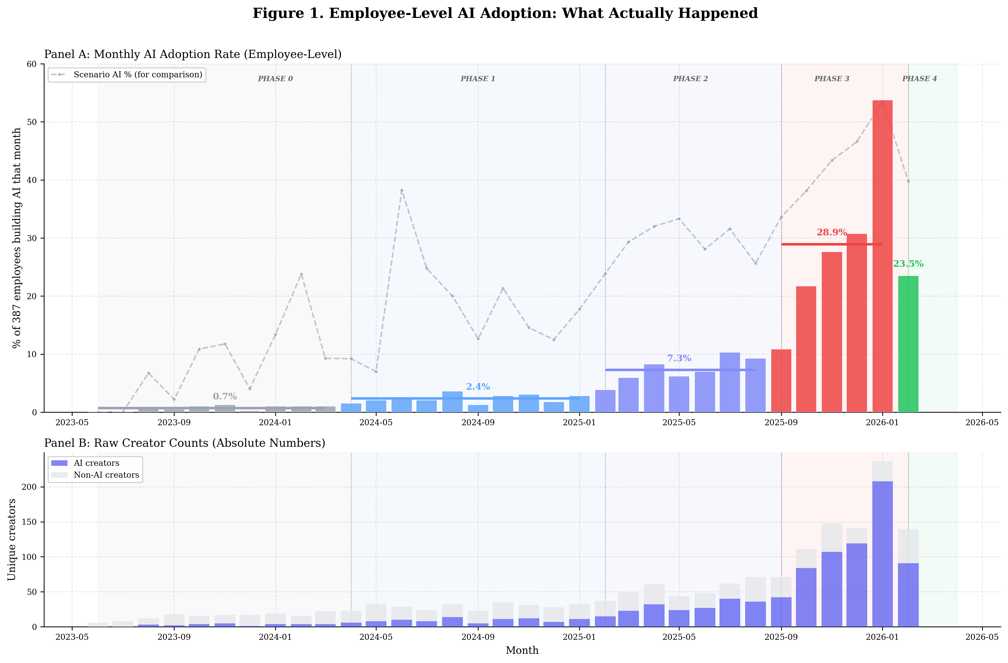
Figure A.1. Employee-Level AI Adoption Over Time. Panel A displays the monthly employee-level AI adoption rate (percentage of 387 employees who built at least one AI scenario that month), with phase-shaded backgrounds indicating intervention periods. The dashed grey line shows the scenario-level AI percentage for comparison, illustrating the divergence between per-employee and per-scenario metrics. Panel B presents raw creator counts decomposed into AI creators (blue) and non-AI creators (grey). Data span May 2023 through February 2026, illustrating the dramatic acceleration during the Phase 3 mandate period (September 2025 to January 2026).

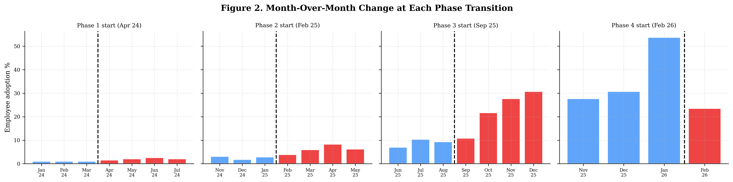
Figure A.2. Month-Over-Month Adoption Change at Each Phase Transition. Bar charts showing the monthly employee adoption rate in the months surrounding each phase transition. Dashed vertical lines mark the start of each new phase. Blue bars indicate pre-transition months; red bars indicate post-transition months. Phase 1 (Tool Access, April 2024) and Phase 2 (Bottom-up mandate, February 2025) produced modest incremental gains of 1 to 3 percentage points. The Phase 3 mandate (Top-down mandate, September 2025) produced the largest step-change, with adoption rates jumping from single digits to over 20% within one month.

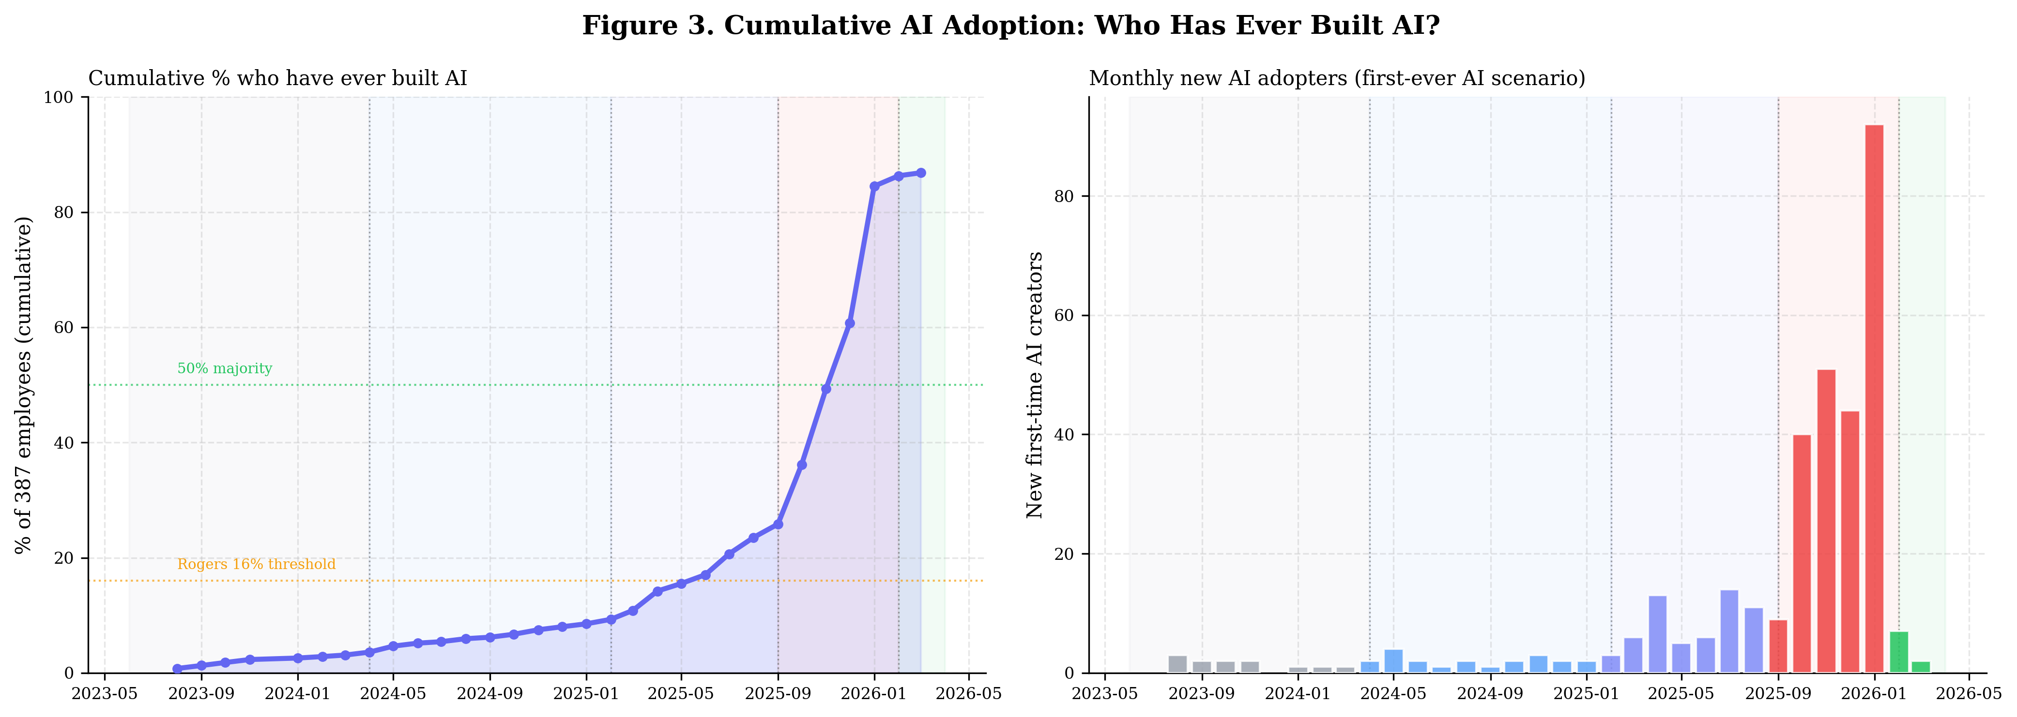
Figure A.3. Cumulative AI Adoption: S-Curve Dynamics. Left panel: Cumulative percentage of the 387-person workforce that has ever built an AI scenario, plotted over time. The curve exhibits classic S-curve dynamics, crossing Rogers' 16% innovator threshold during Phase 2 and reaching 50% majority during Phase 3. Right panel: Monthly count of new first-time AI adopters, showing the surge during the mandate period with over 80 new adopters in a single month at peak.
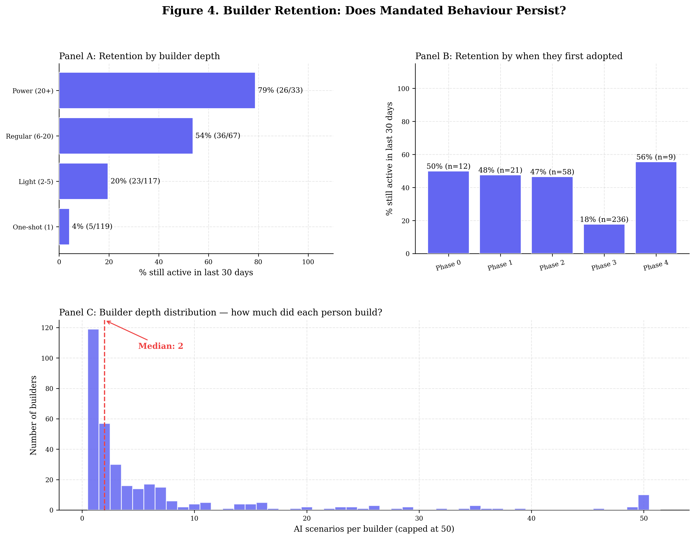
Figure A.4. Builder Retention: Does Mandated Behaviour Persist?. Panel A: 30-day retention rates segmented by builder depth (total number of AI scenarios created). Power builders (20+ scenarios) show 79% retention versus 4% for one-shot builders. Panel B: Retention by adoption phase, revealing that Phase 3 mandate adopters exhibit 18% retention compared to 47 to 50% for voluntary adopters from earlier phases. Panel C: Distribution of builder depth across all AI adopters, with a median of 2 scenarios per builder and a long tail of power users.
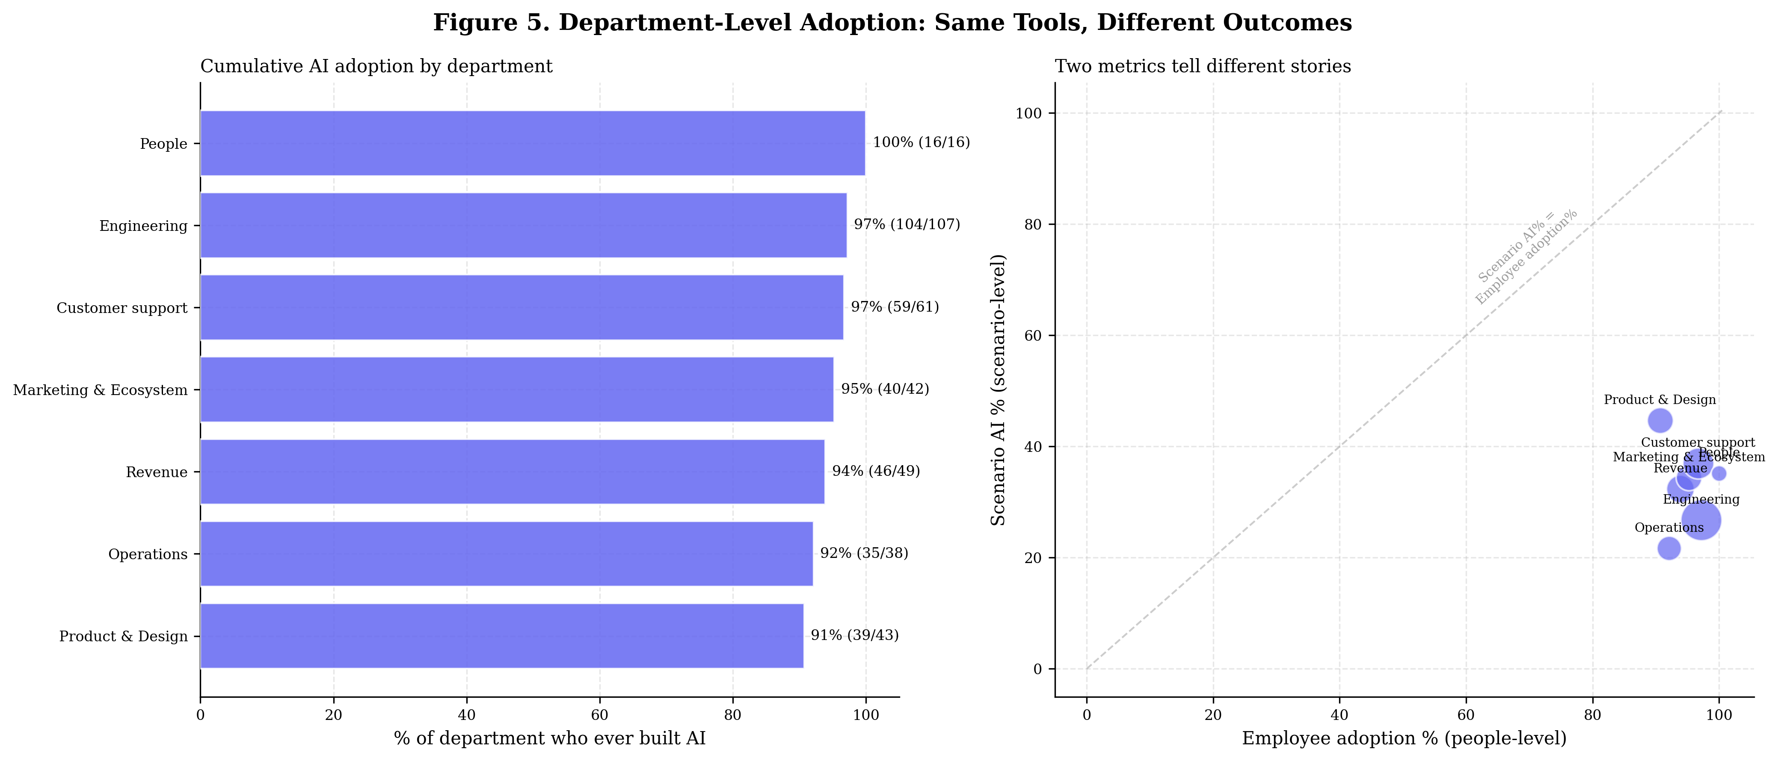
Figure A.5. Department-Level Adoption Heterogeneity. Left panel: Horizontal bar chart of cumulative AI adoption rates by department, ranging from 91% (Product and Design) to 100% (People). Right panel: Scatter plot comparing employee-level adoption (x-axis) against scenario-level AI percentage (y-axis) for each department. Bubble size is proportional to department headcount. The dashed 45-degree line represents parity between the two metrics. Departments above the line have higher scenario AI intensity relative to their headcount adoption, suggesting deeper per-capita AI integration.

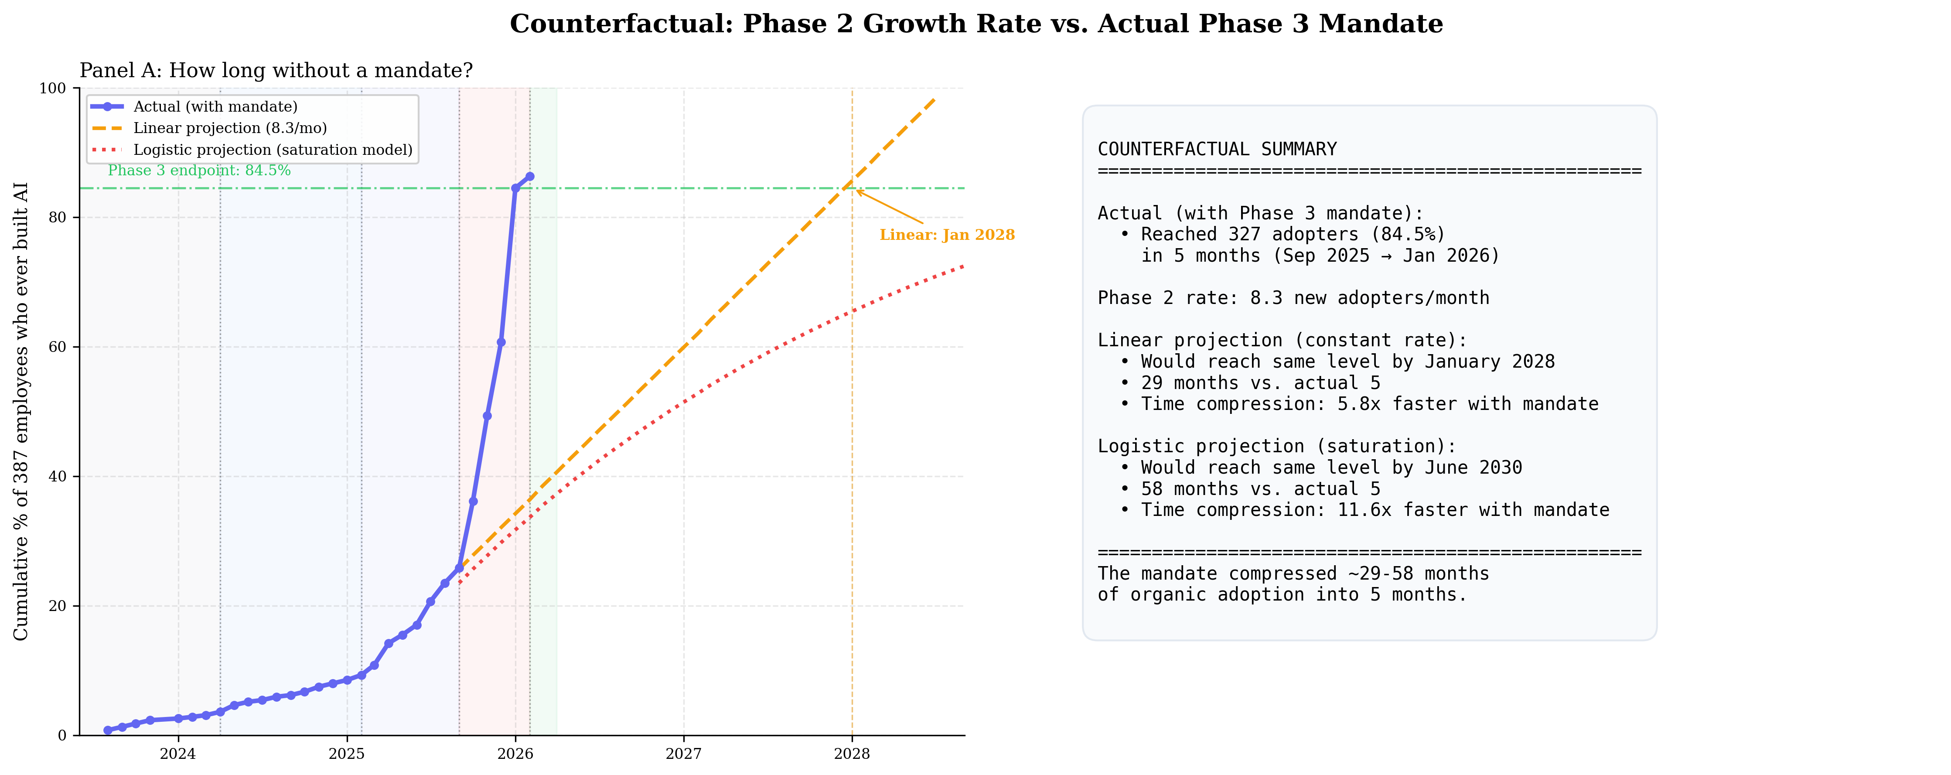
Figure A.6. Counterfactual Projection: Phase 2 Growth Rate vs. Actual Phase 3 Mandate. Panel A: Actual adoption trajectory (solid blue) compared against two hypothetical scenarios where Phase 2 organic growth continued without the mandate. The linear projection (dashed orange) assumes a constant rate of 8.3 new adopters per month; the logistic projection (dotted red) models a saturation effect with a shrinking pool of non-adopters. Panel B: Summary statistics showing the mandate compressed an estimated 29 months (linear model) to 58 months (logistic model) of organic adoption into just 5 months, representing a 5.6x to 11.6x acceleration factor.

