Data Analyst Project Report (2025/2026)
Student: Sara Naim
Program: Data Analyst
Academic year: 2025/2026
Supervisor: Dr. EL MKHALET MOUNA

Table of Contents
Table des matières
1. Introduction 4
2. Problem Statement 5
3. Objectives of the Project 6
4. Dataset Overview 6
5. 5. Report Structure 7
6. The application satisfies the following requirements: 7
7. Technologies and Libraries 8
8. User Interface Overview 8
9. Main Menu 9
10. PCA Module (ACP) 10
10.1 Correlation Heatmap 10
11. Explained Variance (Inertias) 11
11.1 Factorial Plan (Individuals) 11
11.2 Correlation Circle 12
12. AI Module (Clustering & Prediction) 14
12.1 K-Means Clustering Visualization 14
12.2 Random Forest: Evaluation : 15
13. Correspondence Analysis (AFC) 17
13.1 CA Factorial Plan 17
13.2 Contingency Table : 18
14. Cybersecurity Module (Anomaly Detection) 19
14.1 Isolation Forest 19
14.2 Local Outlier Factor (LOF) 20
15. Conclusion and Perspectives 22
References 23

List of Figures

Figure 1 : inertface 8
Figure 2: inerface2 9
Figure 3 : Heatmap 10
Figure 4 : inertie 11
Figure 5: plan factoriel 12
Figure 6: cercle de correlation 13
Figure 7 : clusters 15
Figure 8 : plan 17
Figure 9 : tableau de contingence 18
Figure 10 : Isolation forest 20
Figure 11 : LOF 21

Introduction
Maritime transportation plays a crucial role in global trade and economic development, as a large proportion of goods and resources are exchanged through seaports. The increase in port activity has generated large volumes of operational data related to vessel movements, docking operations, fuel consumption, cargo capacity, and environmental impact. Such data can provide valuable insights for improving port performance, optimizing logistics, and supporting strategic decision-making.
However, port traffic datasets are often characterized by multidimensional variables and complex relationships that are not easily interpreted using simple descriptive statistics. For this reason, advanced analytical methods such as multivariate analysis, clustering techniques, and anomaly detection models are increasingly needed to extract meaningful patterns and identify atypical behaviors.
In this project, we focus on a dataset describing maritime traffic and vessel characteristics, including variables such as tonnage, ship length, approach speed, docking duration, number of maneuvers, container capacity (TEU), fuel consumption, and CO₂ emissions. The main objective is to explore and model these variables through an integrated analytical pipeline developed in the application Data Analyst Suite — Design Pro.
The report is structured around four complementary analytical modules:
- Principal Component Analysis (PCA) to reduce dimensionality and interpret correlations between ship-related variables,
- Artificial Intelligence (AI) through K-Means clustering and Random Forest prediction to identify groups of vessels with similar operational profiles,
- Correspondence Analysis (CA) to study relationships between individuals and discretized variables, and
- Cybersecurity-oriented anomaly detection, using Isolation Forest and Local Outlier Factor (LOF), to detect unusual or potentially risky vessel behaviors that may represent rare events, operational incidents, or data inconsistencies.
Through this approach, the project demonstrates how statistical analysis and machine learning techniques can be combined to provide an interpretable and structured understanding of port traffic data while integrating cybersecurity-inspired monitoring methods for detecting abnormal patterns.

Problem Statement

Maritime ports generate large volumes of data describing vessel movements and operational activities, such as tonnage, ship length, docking duration, maneuver counts, fuel consumption, and CO₂ emissions. Although this information is highly valuable for improving port performance and supporting strategic decisions, it is often difficult to interpret because port traffic datasets are multidimensional, heterogeneous, and include variables that can be strongly correlated.
A first challenge is therefore to summarize and interpret these complex datasets in an understandable way. Traditional descriptive statistics are not sufficient to reveal the structure of the data or the relationships between key variables. Ports require analytical methods capable of reducing complexity while preserving meaningful information, in order to better understand vessel behavior and operational patterns.
A second challenge concerns the segmentation of vessels into coherent profiles. Because ships operate under different constraints (size, cargo capacity, docking conditions, fuel usage), manual classification is inefficient and subjective. Automated clustering methods are needed to identify homogeneous groups of ships and compare their characteristics objectively.
Finally, modern port operations increasingly rely on digital systems and automated monitoring, which makes it essential to detect atypical behaviors. Unusual patterns in port traffic data—such as abnormal speed, exceptionally long docking times, or inconsistent fuel and emissions values—may indicate rare operational events, data quality issues, or potential risks requiring further investigation. Detecting such anomalies is therefore an important step for operational control and, in a broader context, for cybersecurity-inspired monitoring.
The central question addressed in this project is:
How can port traffic data be analyzed in a structured and interpretable way to identify vessel profiles and detect unusual behaviors that may represent operational or risk-related events?
To answer this question, the project uses the Data Analyst Suite — Design Pro application, which integrates PCA, K-Means clustering, Correspondence Analysis, and anomaly detection algorithms (Isolation Forest and LOF).

Objectives of the Project

The main objective of this project is to analyze port traffic and ship operational characteristics using a complete analytical pipeline implemented in the application Data Analyst Suite — Design Pro. Specifically, the project aims to:
- Perform a detailed exploratory analysis of ship traffic variables to identify distributions, trends, and extreme values.
- Apply Principal Component Analysis (PCA) to reduce dimensionality and interpret correlations between variables.
- Use K-Means clustering to segment ships into homogeneous operational profiles, with a global adjustable number of clusters (k between 3 and 7).
- Evaluate the cluster segmentation through a Random Forest classifier and provide classification metrics such as accuracy and confusion matrix.
- Apply Correspondence Analysis (CA) to explore relationships between discretized variables and individuals.
- Detect anomalies through unsupervised algorithms (Isolation Forest and Local Outlier Factor) to identify atypical vessel behaviors that could represent rare events, suspicious profiles, or data inconsistencies.

Dataset Overview

The dataset used in this project includes information on vessels and their port activity, with a focus on both operational and environmental indicators. Typical variables include:
- Tonnage
- Ship length
- Approach speed
- Docking duration
- Number of maneuvers
- Container capacity (TEU)
- Fuel consumption
- CO₂ emissions
These variables provide a comprehensive view of ship traffic behavior and performance, enabling both economic and sustainability-oriented analysis.

5. Report Structure

This report is organized into four main analytical modules:
- PCA Module:
Correlation analysis, explained variance, factorial planes, correlation circle, COS² and contributions.
- AI Module:
K-Means clustering, cluster distribution, Random Forest evaluation, and cluster prediction for new individuals.
- CA Module:
Contingency table construction, chi-square dependence test, distance computation, and factorial representation.
- CYBER Module:
Anomaly detection with Isolation Forest and LOF, visualization of anomalous profiles, and interpretation of risky observations.
Finally, the report concludes with a discussion of findings, limitations, and possible improvements.

The application satisfies the following requirements:

• Import Excel/CSV datasets and automatically detect an ID column.
• Clean numerical values and handle missing values (median imputation).
• Standardize variables for PCA and K-Means; apply Min-Max scaling for anomaly detection.
• Provide a professional GUI with module navigation (Start → Menu → Modules).
• Display tables with styled headers, alternating rows and Excel export.
• Generate centered responsive plots with Matplotlib and a zoom/pan toolbar.
• Allow global modification of k (3 to 7) for clustering across all pages.
• Cybersecurity module with anomaly counts for Isolation Forest and LOF.

Technologies and Libraries
The application is implemented in Python. Core technologies include Tkinter for the GUI, Pandas/NumPy for data manipulation, Scikit-learn for machine learning algorithms, Matplotlib for visualization, and optionally Seaborn and SciPy for advanced heatmaps and convex hull computation.

8. User Interface Overview
The interface uses a modern theme with a light background, cards for module access, and consistent colors per module. Each module provides an action dashboard and a results page that can display a plot, a table or a text report.
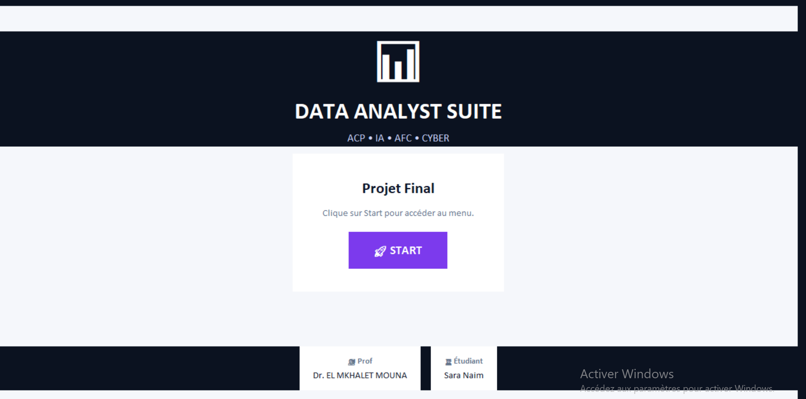
Figure 1 : inertface

9. Main Menu

This Figure presents the main menu interface of the “Data Analyst Suite — Design Pro” application.
The screen provides a clear and structured navigation system, allowing the user to access four main analytical modules: PCA analysis (ACP), Artificial Intelligence (K-Means + Random Forest), Correspondence Analysis (AFC), and Cybersecurity (Isolation Forest + LOF).
Each module is displayed as a card-style panel with a dedicated color theme, an icon, a short description of its purpose, and a direct “Access” button to open the corresponding dashboard. This design improves usability by offering an intuitive workflow and separating analytical tasks into independent components.
At the bottom of the interface, a status bar confirms that the dataset has been successfully loaded (DATA36_Trafic_portuaire_100_individus) and displays key information such as the selected number of clusters (k = 4), the detected identifier column (ID = Navire), and the number of numerical variables processed (vars = 8).
Overall, this menu demonstrates the application’s professional UI structure, ensuring a smooth user experience and a rapid transition between analytical modules.

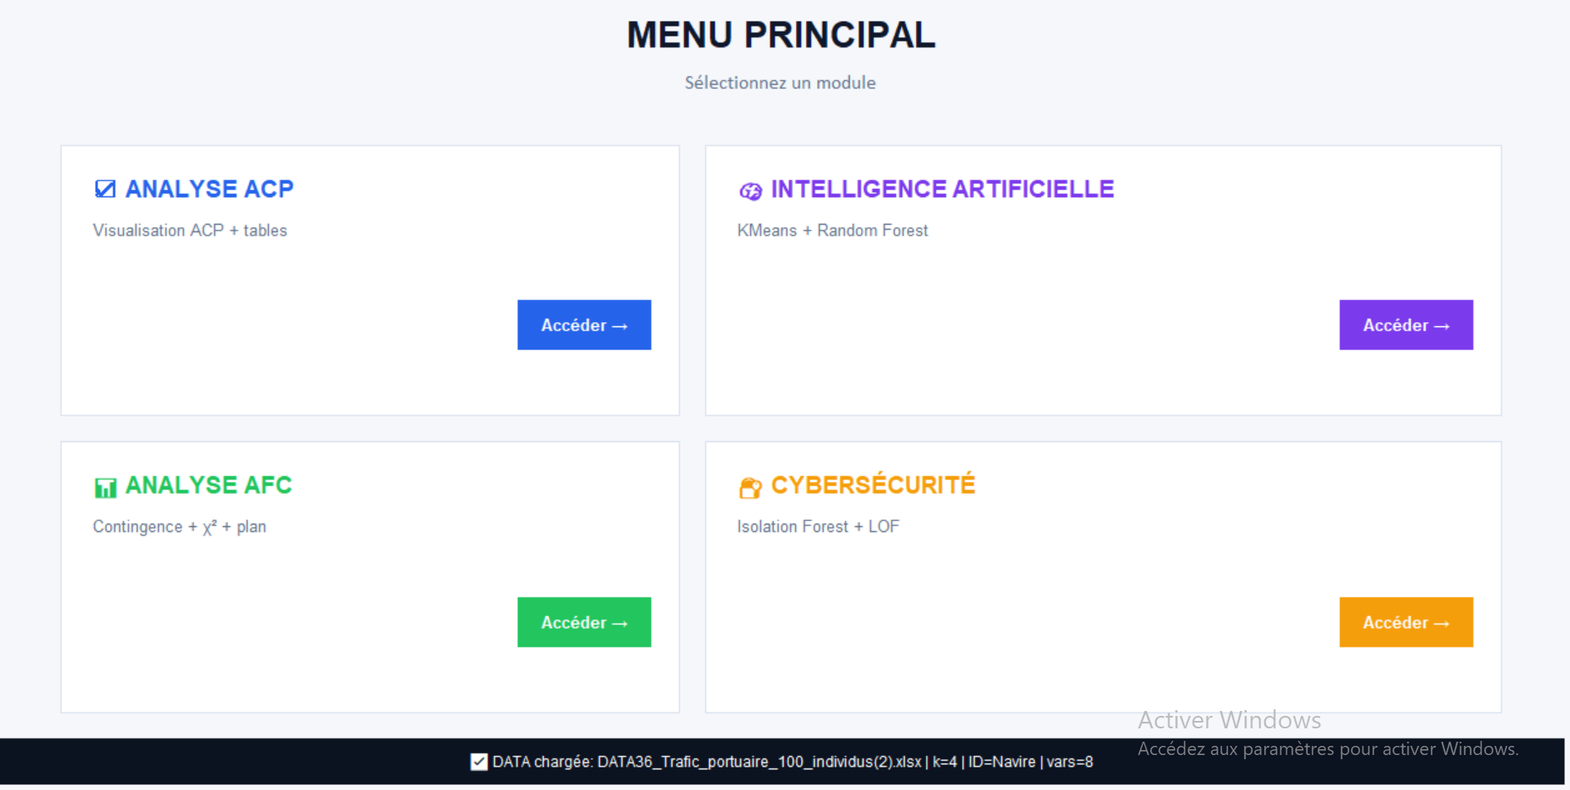
Figure 2: inerface2

PCA Module (ACP)

The PCA Module (ACP) is dedicated to Principal Component Analysis, a statistical method used to reduce the dimensionality of the dataset while preserving most of its information. This module allows the user to explore relationships between variables, identify correlations, and visualize individuals in a reduced two-dimensional space (PC1 and PC2). It provides key outputs such as descriptive statistics, the standardized matrix, correlation heatmaps, explained variance (inertia), factorial plans, the correlation circle, and quality indicators (COS² and contributions). Overall, the PCA module helps summarize complex port traffic data and supports interpretation of the main factors that explain variability among vessels.

10.1 Correlation Heatmap

Figure X shows the correlation heatmap of the port traffic variables. Overall, most correlation coefficients are close to zero, indicating weak linear relationships between variables. Only a few moderate correlations appear, such as the positive relationship between tonnage and ship length, and between fuel consumption and CO₂ emissions, which is logically consistent. This confirms that the dataset contains complementary information, and supports the use of PCA to better summarize and interpret the multidimensional structure of vessel activity.

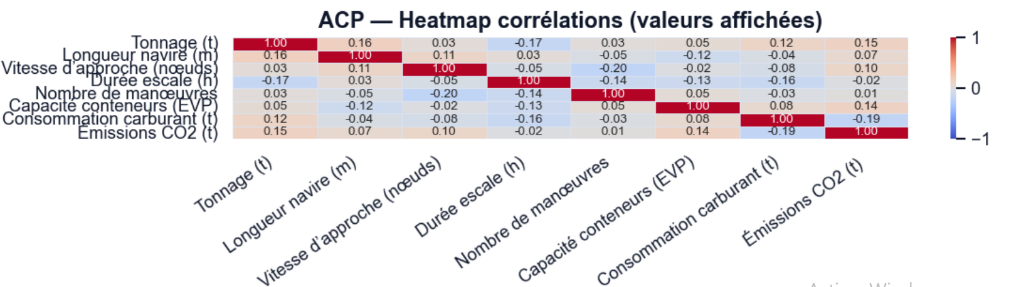
Figure 3 : Heatmap

Explained Variance (Inertias)

Figure X illustrates the explained variance of the PCA components using bars and the cumulative variance using a line. The first components capture the most important part of the information in the dataset, while the contribution of each additional component gradually decreases. The cumulative curve increases steadily and reaches approximately 60% around the 4th component, and more than 80% around the 6th component, indicating that a limited number of components is sufficient to represent most of the variability. Therefore, retaining the first two components (PC1 and PC2) allows a clear visual interpretation, while keeping more components improves the overall representation of the dataset.

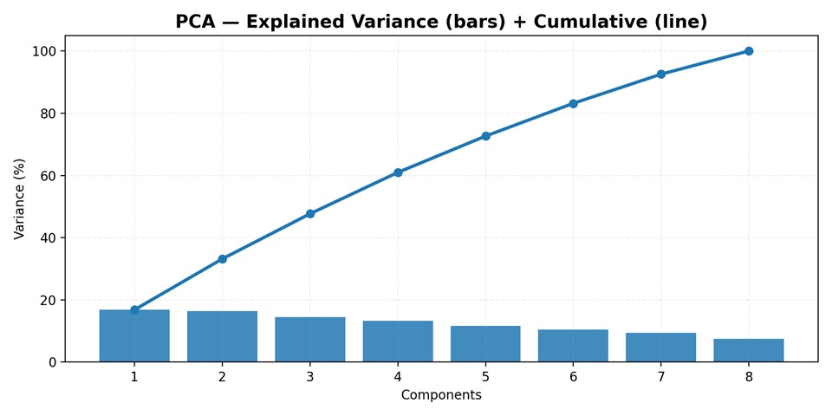
Figure 4 : inertie

11.1 Factorial Plan (Individuals)

Figure X presents the PCA individuals factor map projected on the first two principal components (PC1 and PC2). Each point represents a vessel (or observation), and the distance between points reflects their similarity in terms of operational and environmental variables. The first component PC1 explains 16.8% of the total variance, while PC2 explains 16.3%, meaning that this 2D representation summarizes a significant share of the dataset variability.
Observations located close to each other correspond to vessels with similar profiles (similar tonnage, speed, docking duration, fuel usage, etc.), whereas vessels positioned far apart exhibit distinct characteristics. A few individuals appear more isolated at the extremes of the axes, which may indicate atypical operational behaviors or extreme values in certain variables. Overall, the scatter distribution suggests that the dataset contains several differentiated vessel profiles, supporting the relevance of clustering and further segmentation analysis.
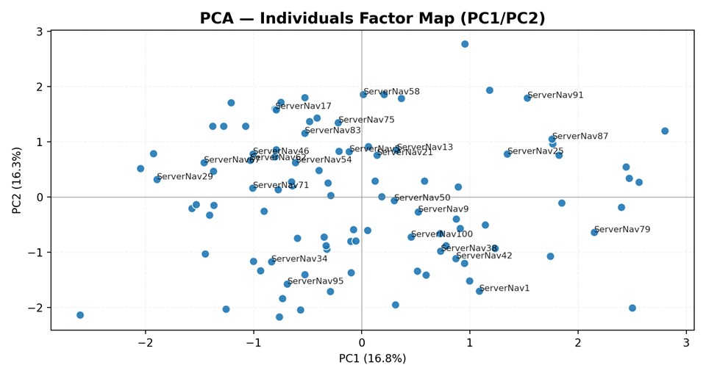
Figure 5: plan factoriel

11.2 Correlation Circle

Figure X shows the PCA correlation circle on the first two principal components (PC1 and PC2). Each arrow represents a variable, and its length indicates how well the variable is represented in the factorial plane: variables close to the circle are well explained by PC1 and PC2, whereas shorter vectors are less represented. Variables pointing in the same direction are positively correlated, while variables in opposite directions are negatively correlated. In this plot, indicators such as CO₂ emissions, tonnage, ship length, and approach speed appear oriented in a similar direction, suggesting that they contribute to a common underlying dimension related to vessel size and activity intensity. On the other hand, variables positioned differently (such as docking duration or maneuver-related indicators) may describe another operational aspect. Overall, the correlation circle helps interpret the meaning of PC1 and PC2 by identifying the variables that contribute most to each axis.
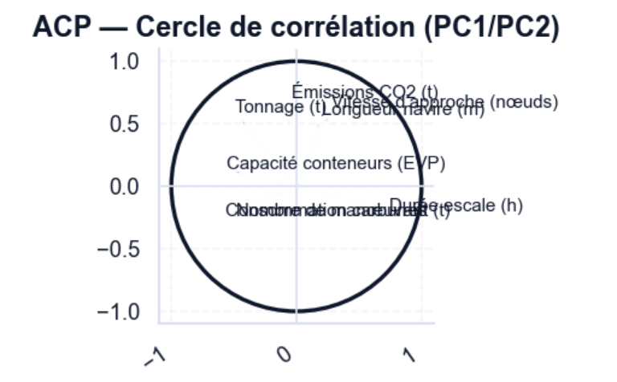
Figure 6: cercle de correlation

AI Module (Clustering & Prediction)
The AI Module (Clustering & Prediction) is designed to identify vessel profiles by combining unsupervised learning and supervised classification. First, the module applies K-Means clustering on the reduced PCA space (PC1–PC2) in order to group vessels into homogeneous clusters according to their operational and environmental characteristics (tonnage, speed, docking duration, TEU capacity, fuel consumption, and CO₂ emissions). The number of clusters k is configurable (from 3 to 7) and is globally applied across the application.
In a second step, a Random Forest classifier is trained to predict the cluster label of vessels, allowing the evaluation of clustering consistency through performance metrics such as accuracy, classification report, and confusion matrix. Finally, the module includes an interactive tool that enables the prediction of a new vessel profile by entering its variable values, providing an estimated cluster assignment.

12.1 K-Means Clustering Visualization

Figure X presents the K-Means clustering results (k = 4) projected on the PCA factorial plane (PC1/PC2). Each point represents a vessel and colors indicate the cluster membership, while the convex hulls outline the shape and boundaries of each group. The distribution shows that the four clusters are relatively well separated, meaning that vessels can be segmented into distinct operational profiles based on their characteristics (tonnage, speed, docking time, container capacity, fuel consumption, and CO₂ emissions). Moreover, the spread of points inside each hull reflects the degree of variability within each cluster. Overall, this clustering step provides a clear segmentation of port traffic data and supports further interpretation and prediction.
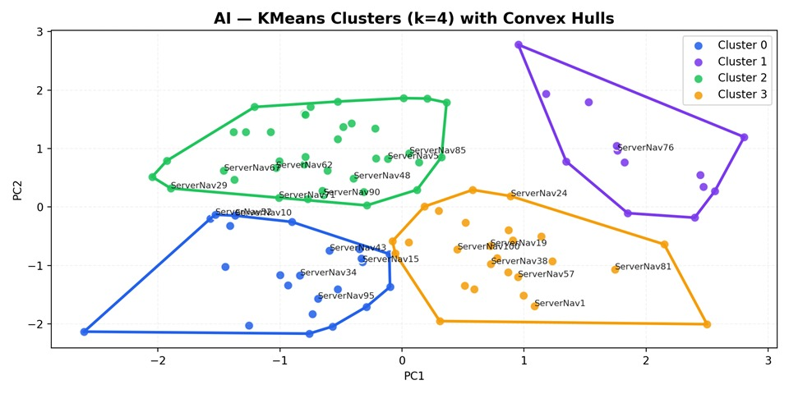
Figure 7 : clusters

12.2 Random Forest: Evaluation :

k = 4
Accuracy : 0.7333

Rapport de classification :
precision recall f1-score support

0 0.55 0.75 0.63 8
1 0.86 0.75 0.80 8
2 1.00 0.71 0.83 7
3 0.71 0.71 0.71 7

accuracy 0.73 30
macro avg 0.78 0.73 0.74 30
weighted avg 0.77 0.73 0.74 30

Matrice de confusion :
[[6 1 0 1]
[2 6 0 0]
[1 0 5 1]
[2 0 0 5]]

Correspondence Analysis (AFC)

Correspondence Analysis (CA) is used to explore associations between individuals and variables through a contingency table. In this application, an 8×8 contingency matrix is built by discretizing quantitative variables into categories. The Chi-square statistic (χ²) and its p-value are computed to test dependence, and a factorial map is generated to represent both individuals and variables in a reduced space. This visualization helps identify relationships and similarities within the dataset.

13.1 CA Factorial Plan

Figure X presents the Correspondence Analysis (CA/AFC) factorial map, where individuals (ships) are represented by blue points and variables by orange diamonds. The proximity between an individual and a variable indicates an association: individuals located near a variable tend to be characterized by higher values (or stronger presence) of that variable category. In this map, some ships appear close to operational indicators such as approach speed or fuel consumption, while others are positioned near variables like docking duration or number of maneuvers, suggesting different operational profiles. Overall, the factorial representation highlights relationships between vessels and key port traffic variables, helping identify similarities and contrasts within the dataset.
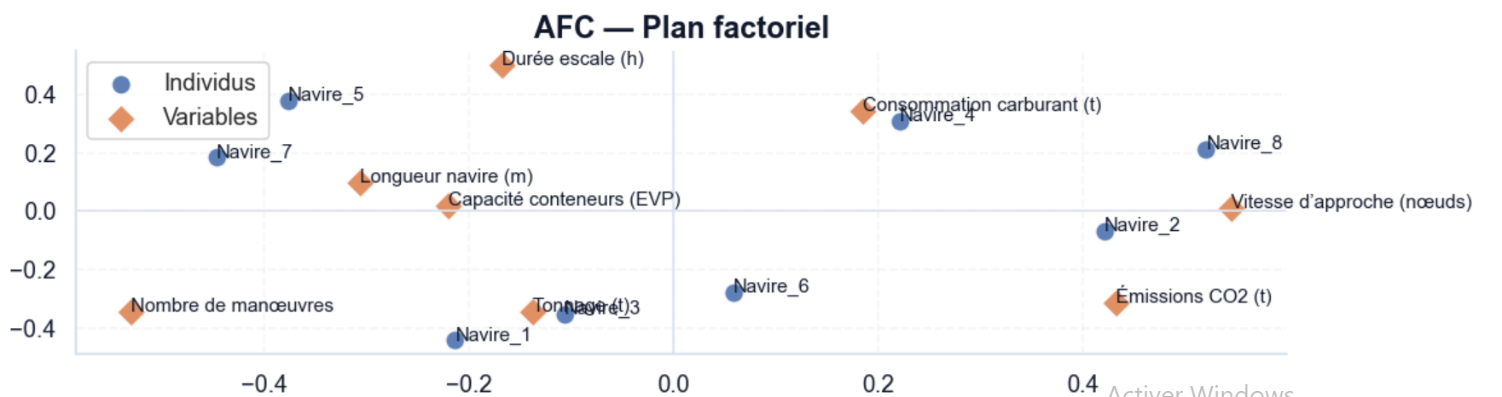
Figure 8 : plan

13.2 Contingency Table :

Figure X displays the 8×8 contingency table used for the Correspondence Analysis (CA/AFC). The rows represent the first eight individuals (ships) and the columns correspond to selected operational variables (tonnage, ship length, approach speed, docking duration, maneuvers, container capacity, fuel consumption, etc.). Since the original data is quantitative, each variable is discretized into categories (from 1 to 10), allowing the construction of a contingency matrix suitable for CA. This table is the main input for computing the frequency matrix, the Chi-square statistic, and the factorial representation of individuals and variables.

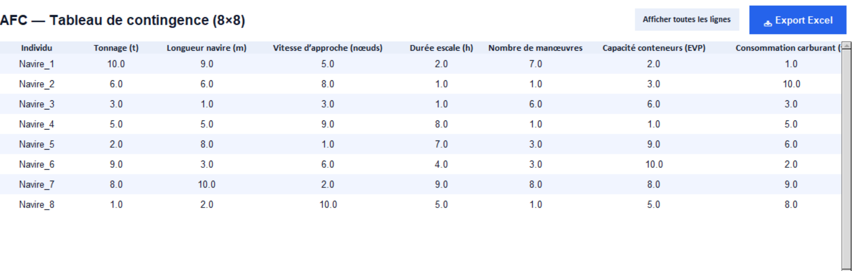
Figure 9 : tableau de contingence

14. Cybersecurity Module (Anomaly Detection)

The cybersecurity module is designed to detect atypical observations that may correspond to unusual behaviors, operational incidents, or data quality issues. It applies two unsupervised anomaly detection methods: Isolation Forest and Local Outlier Factor (LOF). Detected anomalies are highlighted in red on a 2D PCA projection, and the module also displays the number of anomalous profiles identified by each algorithm.

14.1 Isolation Forest

Figure X presents the anomaly detection results obtained using the Isolation Forest algorithm. The observations are projected onto the first two PCA components (PC1 and PC2), which provide a two-dimensional visualization of the dataset. Normal profiles are displayed in blue, while detected anomalies are highlighted in red.
In this experiment, the model identifies 10 anomalous observations, as shown in the top-left indicator. These red points are generally located at the edges of the PCA space or isolated from dense groups, meaning that their combination of variables significantly differs from the majority of vessels. Such anomalies may correspond to rare operational situations, extreme values (e.g., unusual docking duration, speed, or fuel consumption), inconsistent measurements, or potentially suspicious behaviors requiring further investigation.
Overall, this result demonstrates the usefulness of Isolation Forest as an unsupervised method for detecting atypical vessel profiles in port traffic monitoring.

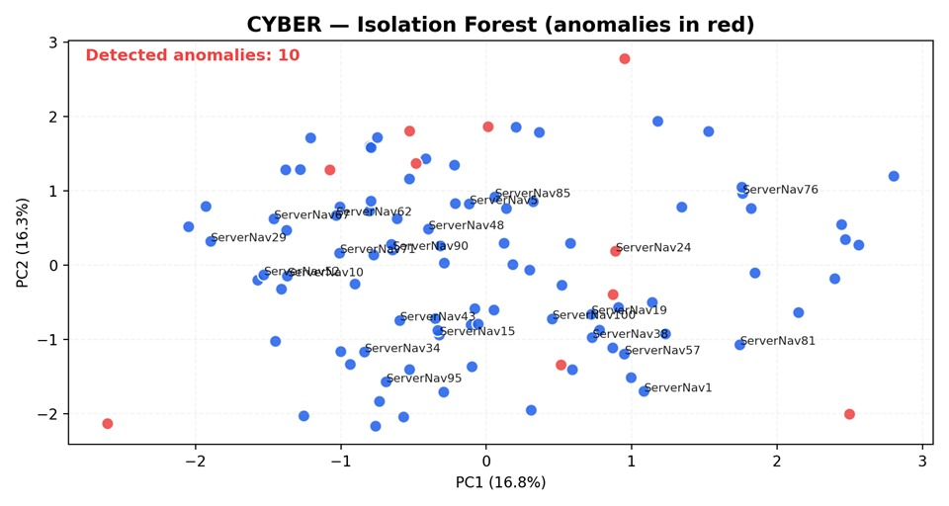
Figure 10 : Isolation forest

14.2 Local Outlier Factor (LOF)

Figure X shows the anomaly detection results obtained using the Local Outlier Factor (LOF) algorithm. As in the previous analysis, observations are projected on the first two PCA components (PC1 and PC2) to provide a clear two-dimensional visualization. Normal vessel profiles are represented in blue, whereas anomalous observations are highlighted in red.
The LOF model detects 10 anomalies, which correspond to vessels that have a lower local density compared to their neighbors. Unlike Isolation Forest, which focuses on global isolation, LOF emphasizes local deviations, meaning that an observation can be considered anomalous even if it is located within the overall data range but remains unusual relative to its surrounding points.
The detected anomalies therefore represent vessel behaviors that significantly differ from nearby profiles, possibly indicating rare operational conditions, inconsistent records, or potential risk signals. Overall, LOF complements Isolation Forest by identifying anomalies based on neighborhood structure, improving the robustness of anomaly detection in port traffic monitoring.
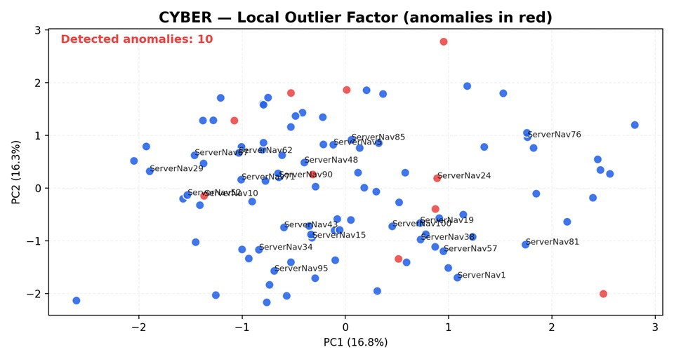
Figure 11 : LOF

15. Conclusion and Perspectives

In this project, we developed and applied the Data Analyst Suite — Design Pro, a complete Python application designed to analyze port traffic and vessel operational data through an integrated analytical pipeline. The dataset included multiple quantitative indicators related to maritime activity, such as tonnage, ship length, approach speed, docking duration, number of maneuvers, container capacity (TEU), fuel consumption, and CO₂ emissions. Due to the multidimensional nature of these variables, advanced statistical and machine learning techniques were necessary to extract meaningful patterns and support interpretation.
First, the PCA module provided a global understanding of the dataset by reducing dimensionality and highlighting the main sources of variability. Through correlation analysis, explained variance, factorial maps, and the correlation circle, PCA helped summarize relationships among variables and visualize vessel profiles on a reduced plane.
Second, the AI module applied K-Means clustering to segment vessels into homogeneous groups and identify distinct operational profiles. The results showed that the dataset could be structured into meaningful clusters, and the integration of a Random Forest classifier allowed the evaluation of cluster predictability and offered a practical tool for predicting the cluster of a new vessel based on its characteristics.
Third, the Correspondence Analysis (AFC) module explored associations between individuals and discretized variables using a contingency table and a factorial representation. This analysis provided an additional perspective on relationships between vessels and key operational indicators.
Finally, the Cybersecurity module introduced a monitoring approach based on anomaly detection. Using Isolation Forest and Local Outlier Factor (LOF), the application successfully identified atypical vessel profiles that may correspond to rare operational events, data inconsistencies, or potentially risky patterns requiring further investigation. Highlighting anomalies in red and displaying their number improved interpretability and enabled effective comparison between detection methods.
Overall, the Data Analyst Suite — Design Pro demonstrates the relevance of combining statistical analysis and machine learning techniques within a professional and interactive interface. The application is well suited for academic demonstrations and provides a strong foundation for further development. Future improvements may include the integration of additional clustering methods (such as DBSCAN/HDBSCAN), automatic selection of the optimal number of clusters, the use of interpretability tools, and the extension of anomaly detection to time-series monitoring and real-time dashboards.

References
• Scikit-learn documentation — PCA, KMeans, RandomForest, IsolationForest, LOF.
• Matplotlib documentation — embedding in Tkinter and NavigationToolbar2Tk.
• Pandas documentation — Excel/CSV import and data cleaning.

