**Join the conversation using Sli.do**

To join the session, go to **Slido.com** and enter the event code: **#eventcode**



Select the **‘’Q&A’’** tabto **answer questions**

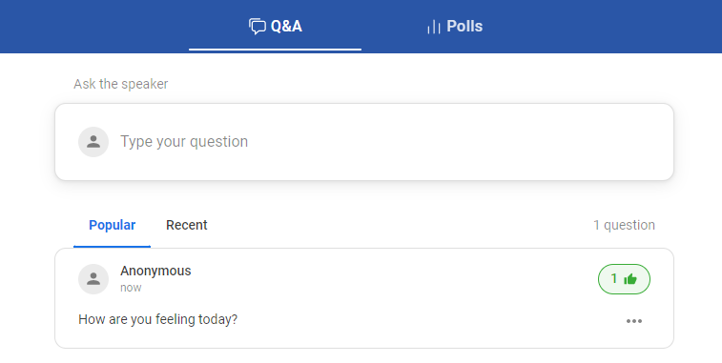

Stay **anonymous** or attach your name to the question

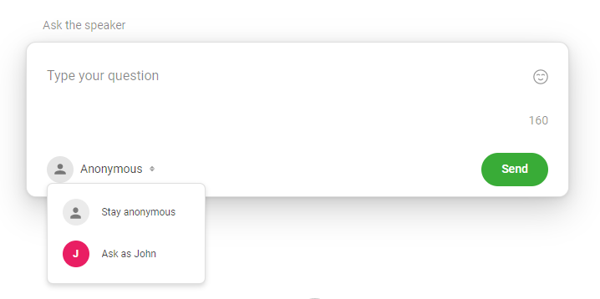

Select the **‘’Polls’’** tab to share your thoughts and opinions by voting in **live polls**

