Feature Selection Using Genetic Algorithms to Train Decision Trees
Authors:
Name | Student ID | Department
Jomana Mahmoud El-Saghier Ahmed | 20230147 | AI | General
Adam Mohamed Fekry Fadel Mostafa | 20230060 | AI | General
Jana Ahmed Mostafa Kamal | 20230155 | AI | General
Shahd Mohamed Abdelhay Soliman | 20230287 | AI | General
Mariam Adel Ali Abdallah Ali | 20230541 | AI | General
Sara Mohammed Abdullah Abdulhaq | 20230249 | CS | General

Abstract
This project applies Genetic Algorithms (GA) for feature selection in a machine learning task to diagnose breast cancer. A Decision Tree classifier is trained using GA-selected features to maximize accuracy while minimizing the number of features. Experiments compare selection and crossover strategies, reporting metrics such as accuracy, recall, and feature reduction percentage. The GA successfully reduced features by ~30–50% while maintaining accuracy above 95%, demonstrating the efficiency of evolutionary approaches for feature selection.

Introduction and Overview
- Project Idea & Motivation :
Feature selection simplifies models, reduces overfitting, and improves interpretability. The challenge is identifying a subset of features that maximizes predictive performance while minimizing complexity.

Similar Applications and Their Functionalities:
Feature selection using machine learning—especially for medical datasets such as breast cancer diagnosis—has been widely explored in both academic research tools and practical applications. Although most existing systems are research-oriented rather than commercial software, several tools and platforms provide functionalities similar to the system developed in this project.
- WEKA (Waikato Environment for Knowledge Analysis)
WEKA is a desktop application widely used for machine learning experimentation. It includes several feature-selection techniques such as filter, wrapper, and embedded methods. The platform also supports Genetic Algorithms for attribute selection, where users can choose a classification algorithm (e.g., decision tree), define GA parameters (population size, crossover type, mutation rate), and evaluate the performance of selected features using accuracy or other metrics. This closely resembles the functionality implemented in the current project.
- RapidMiner
RapidMiner is a commercial data science platform with a visual workflow designer. It provides feature-selection operators, including evolutionary search. Users can design pipelines where a classifier is trained only on selected attributes, then evaluated through cross-validation. The platform allows parameter tuning for selection strategies, mutation/crossover control, and fitness evaluation — similar to the proposed system’s configurable GA operators.
- Orange Data Mining
Orange is another desktop analytics tool that incorporates feature-ranking and subset selection through wrappers or embedded algorithms. While Orange does not natively include a full GA-based search, it supports extensions that allow evolutionary optimization. Similar to your system, Orange visualizes performance metrics such as accuracy and recall after feature reduction.
- Sci-Kit Learn Research Pipelines (Python-based tools)
Although not a GUI application, scikit-learn pipelines combined with external GA libraries (like DEAP or PyGAD) are frequently used for GA-based feature-selection research. These systems operate similarly to your project:
  - Each individual represents a feature mask
  - A classifier is trained on the selected features
  - GA operators (selection, crossover, mutation) evolve the population
  - Metrics such as accuracy, recall, and feature reduction are computed and visualized
- Medical Diagnostic Assistants (Research Prototypes)
Several research systems for breast cancer or medical diagnosis integrate GA-based feature selection to improve prediction accuracy. These systems typically provide:
  - Dataset ingestion
  - Automatic feature reduction
  - Classifier training (SVM, Decision Tree, etc.)
  - Performance reporting
Your project aligns with these systems, particularly by offering accuracy evaluation, recall analysis, and reduction percentages visualized across different GA configurations.

- Literature Review:
- Taha, Z.Y. (2024). Optimizing Feature Selection with Genetic Algorithms (arXiv) : Discusses GA for feature selection and shows how fitness functions can be designed as weighted combinations of model performance and feature subset size.
- Imani, V., Sevilla-Salcedo, C., Fortino, V., & Tohka, J. (2023). Multi-Objective Genetic Algorithm for Multi-View Feature Selection : A recent multi-objective GA that simultaneously handles multiple objectives such as accuracy and subset size — directly relevant to your multi-goal fitness formulation.
- Bansal, S. (2021). Multi-Objective Genetic Algorithm Based Deep Learning : Shows multi-objective GAs for balancing classification accuracy with other objectives (fitness function design).
- Hybrid Filter and Genetic Algorithm‑Based Feature Selection for Cancer Classification — MDPI (2025) : Uses GA to improve cancer classification performance by selecting optimal features and evaluates accuracy, recall, and F1‑score. Suitable as a medical feature selection reference.
- Selection Using Genetic Algorithm for Breast Cancer Diagnosis (Iranian Journal of Basic Medical Sciences) : Explicitly discusses improvement in accuracy, sensitivity (recall), and specificity using GA for breast cancer data. This can support your inclusion of recall in fitness.
- Scientific Reports paper on genetic algorithm feature selection for improved classification (SGA‑Driven feature selection) : Although not exactly GA, it demonstrates how evolutionary feature selection improves recall and other metrics in cancer classification.

Proposed Solution & Dataset

Description of the Proposed Solution
The proposed solution is an intelligent feature-selection system that uses a Genetic Algorithm (GA) to automatically identify the most relevant features for breast cancer classification.
The system evaluates feature subsets based on accuracy and recall, then evolves better subsets through selection, crossover, and mutation.
The final output is the best-performing feature combination along with its accuracy and recall scores.

Use-Case Diagram
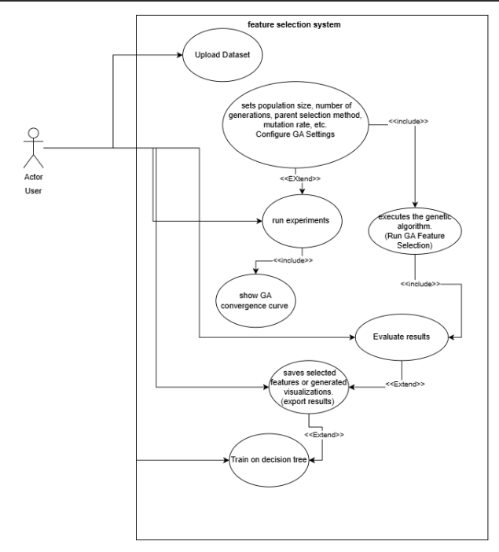

Dataset Description
The system uses the Breast Cancer Wisconsin Diagnostic (WDBC) dataset, which contains 569 samples with 30 numerical features describing tumor characteristics (e.g., radius, texture, concavity).
Each sample is labeled as benign or malignant.
This dataset is widely used for medical machine-learning research and is publicly available from the UCI Machine Learning Repository.

Applied Algorithms

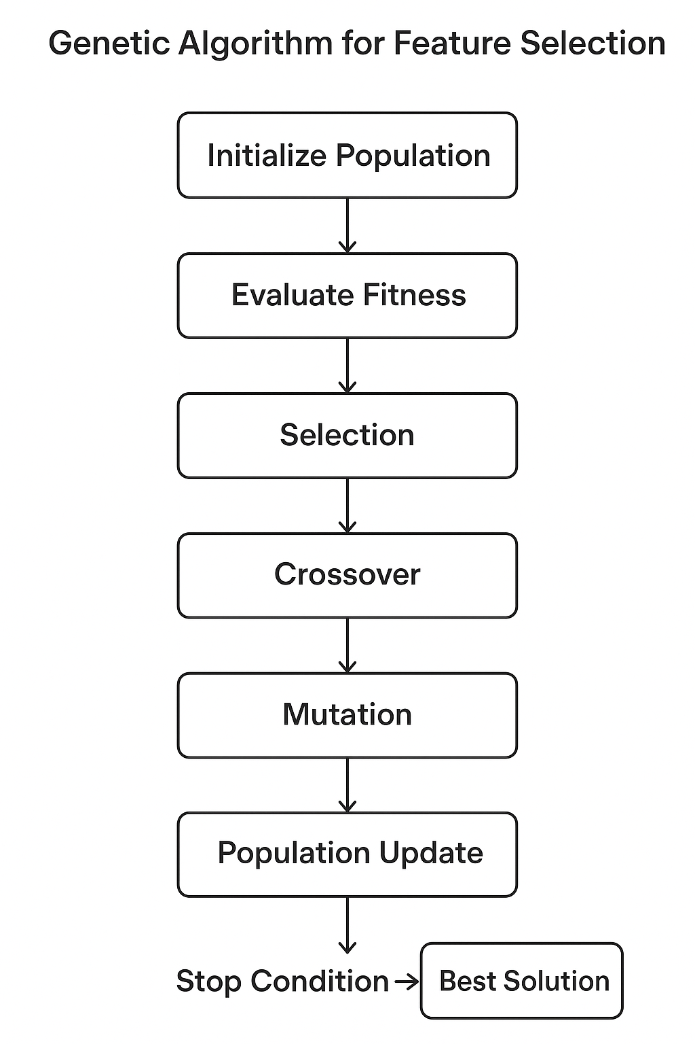
This project employs a Genetic Algorithm (GA) for feature selection to optimize the performance of a Decision Tree classifier. The GA searches for the best subset of features by simulating the principles of natural evolution—selection, crossover, mutation, and survival of the fittest. Below is a complete breakdown of each component.

- Genetic Algorithm Overview
A Genetic Algorithm is an optimization method inspired by biological evolution. It operates on a population of candidate solutions (feature subsets) and gradually improves them through generations. In each generation, individuals are evaluated, selected, recombined, mutated, and replaced according to their fitness.
Goal:
Find the feature subset that maximizes classification accuracy while minimizing the number of selected features.

- Chromosome Representation
Each chromosome represents a feature subset. For a dataset with N features:
A chromosome is a binary vector of length N.
1 = feature is selected 0 = feature is excluded
Example (for 8 features):
[1, 0, 1, 1, 0, 0, 1, 0]
This chromosome selects 4 out of 8 features.
Binary encoding is the most common and intuitive representation for feature selection problems.

- Fitness Function
In the Genetic Algorithm, the fitness function guides the search toward better feature subsets.
Originally, the fitness depended only on accuracy and feature reduction:

Old Fitness Function
Fitness = α × Accuracy − β × ( Selected Features / Total Features ​)
- Encouraged high accuracy
- Penalized using too many features
- Did not consider recall (important for cancer detection)

New Fitness Function
To improve medical classification performance, the fitness function was extended by adding recall as an additional objective:
Fitness = ( α × Accuracy ) − ( β × Feature_ratio ) + ( γ × Recall )
Where:
- Accuracy → overall correctness
- Feature_ratio = Selected features / Total features
- Recall → ability to correctly detect positive cancer cases
- α, β, γ are weights controlling the importance of each component

Purpose of Each Term
- α × Accuracy: rewards high overall classification performance
- − β × Feature_ratio: penalizes large feature subsets to encourage dimensionality reduction
- + γ × Recall: rewards models that detect malignant tumors more effectively

Why This Update Improves the GA
- Recall is crucial in breast cancer detection (false negatives are dangerous).
- The new function becomes multi-objective: accuracy + recall + feature reduction.
- Produces more medically meaningful feature subsets.
- Balances performance and simplicity better than the old version.

- Selection Methods
Selection chooses which chromosomes will parent the next generation.
1. Tournament Selection
Randomly pick k individuals.
The one with the highest fitness wins.
Simple and effective.
Higher selection pressure → faster convergence.

2. Roulette Wheel Selection
Probability of being selected is proportional to fitness.
Chromosomes with higher fitness get larger “wheel slices”.
Promotes diversity but may select weaker individuals.

3. Rank Selection
Individuals are sorted by fitness.
Selection probability is based on rank, not raw fitness.
Avoids domination by extremely fit individuals.
Leads to more stable evolution.

- Crossover Methods
Crossover combines parent chromosomes to produce offspring.
1. Single-Point Crossover
A random crossover point is chosen.
Parents exchange remaining segments.
Example:
Parent1: 110|0101
Parent2: 001|1110
Child: 110|1110
2. Two-Point Crossover
Two points chosen.
Middle segment is swapped.
Results in more varied offspring.

3. Uniform Crossover
Each gene is swapped independently with probability p.
Produces high diversity offspring.

- Mutation Operations
Mutation introduces random changes to keep the population diverse.
- Bit-Flip Mutation
- Select a random gene.
- Flip it:
1 → 0
0 → 1
Example:
Chromosome: 101010
After mutation: 100010
Goal: Mutation prevents premature convergence and ensures exploration of new feature subsets.

- Elitism and Population Update
Elitism ensures the best individuals always survive into the next generation.
Elitism Process:
Evaluate all chromosomes -> Identify top-performing individuals -> Copy them directly into the next generation (without modification).
Population Update Steps:
- Keep elite individuals.
- Fill remaining population using:
- Selected parents
- Crossover offspring
- Mutated individual
This ensures best solutions are preserved and new solutions can explore the feature space.

Genetic Algorithm Implementation
The system uses a Genetic Algorithm (GA) for feature selection in training Decision Trees. Each individual is a binary chromosome representing a subset of features. The GA iteratively selects parents, applies crossover and mutation, and updates the population using elitism, tracking the best fitness per generation.

Data Flow
Dataset → Preprocessing → X, y → Population Initialization → Fitness Evaluation → Selection → Crossover → Mutation → Population Update → Next Generation → Best Solution
- Population size = 20
A moderate population ensures enough diversity to explore different feature subsets while keeping the computational time reasonable. Too small a population may lead to premature convergence, while a very large population increases runtime without significant improvement.
- Generations = 30
This number allows the algorithm to sufficiently evolve and improve solutions across generations. It balances convergence of fitness with computational efficiency. Observed from experiments that after ~30 generations, improvements in best fitness were minimal.
- Number of parents = 20
Selecting a number of parents equal to the population size allows most individuals to have a chance to contribute genetic material to the next generation. This maximizes diversity while maintaining selection pressure from the fitness evaluation.
- Tournament size = 3
In tournament selection, 3 competitors give moderate selection pressure. This means better individuals are more likely to be chosen, but weaker individuals still have a chance, preventing early loss of diversity.

GA Operators
- Selection Methods:
Three strategies were implemented to choose parents based on fitness:
  - Tournament Selection: Randomly selects a subset of individuals and chooses the fittest.
  - Roulette Wheel Selection: Probability of selection proportional to fitness.
  - Rank-based Selection: Individuals ranked by fitness; selection probability depends on rank.
- Crossover Methods:
Crossover combines parent chromosomes to create offspring:
  - Single-point crossover: Swap segments at one random point.
  - Two-point crossover: Swap segments between two points.
  - Uniform crossover: Each gene is swapped with a probability.
- Mutation:
Introduces diversity and prevents premature convergence:
  - Gene-level mutation: Each gene has a small probability to flip (0 → 1 or 1 → 0).
  - Population-level mutation: Each individual has a chance to undergo mutation.

Experiments and Results
1. Experiment Setup
- GA was run on the Breast Cancer dataset (UCI).
- Population size: 20, Generations: 30, Number of parents: 20.
- Selection methods: Tournament, Roulette, Rank-based
- Crossover methods: Single-point, Two-point, Uniform
- Mutation rates: population-level (0.1, 0.3, 0.5), gene-level (0.01, 0.05, 0.1)
2. Evaluation Metrics
- Accuracy: classification performance on the test set
- Recall: ability to detect positive samples
- Reduction %: how many features were removed compared to all features

Selection | Crossover | Fitness | Accuracy | Reduction %
tournament | single | 0.8267 | 0.9357 | 70.00
tournament | single | 0.8542 | 0.9298 | 86.67
tournament | single | 0.8408 | 0.9357 | 80.00
tournament | single | 0.8337 | 0.9357 | 73.33
tournament | single | 0.8450 | 0.9357 | 80.00
tournament | two | 0.8329 | 0.9357 | 73.33
tournament | two | 0.8363 | 0.9298 | 73.33
tournament | two | 0.8414 | 0.9240 | 80.00
tournament | uniform | 0.8329 | 0.9298 | 73.33
tournament | uniform | 0.8402 | 0.9532 | 76.67
roulette | single | 0.8215 | 0.9415 | 70.00
roulette | single | 0.8248 | 0.9708 | 76.67
roulette | two | 0.8402 | 0.9532 | 76.67
roulette | uniform | 0.8180 | 0.9415 | 63.33
rank | single | 0.8438 | 0.9474 | 76.67
rank | single | 0.8333 | 0.9240 | 70.00
rank | two | 0.8222 | 0.9181 | 66.67
rank | uniform | 0.8462 | 0.9298 | 86.67
rank | uniform | 0.8515 | 0.9532 | 90.00
rank | uniform | 0.8505 | 0.9708 | 80.00
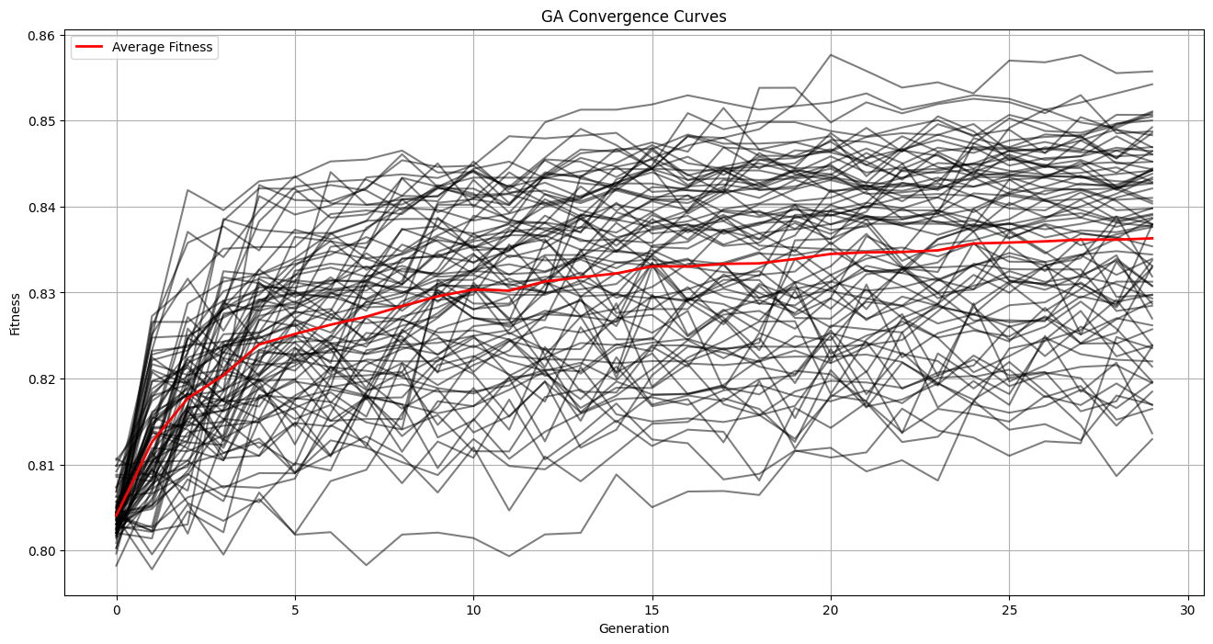

Best GA Run Results:
Metric | Value
Accuracy | 0.9766
Recall | 0.9815
Number of Selected Features | 5
Reduction % | 83.33%

Selected Features:
- mean concavity
- symmetry error
- worst texture
- worst area
- worst smoothness

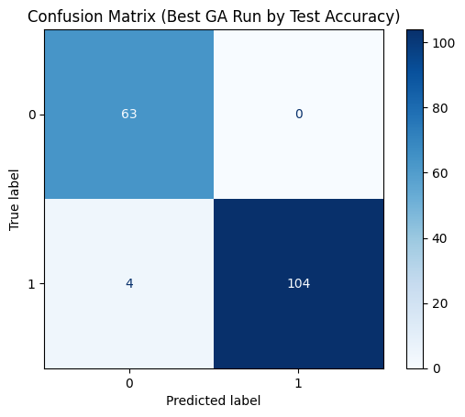
Metric | Average Value
Fitness | 0.8391
Accuracy | 0.9364
Recall | 0.9377
NumFeatures | 7.20
Reduction %+ | 76.0 (calculated as (1 - NumFeatures/TotalFeatures)*100)

Best Overall GA Run:

Metric | Value
Selection Method | tournament
Crossover Method | single
Mutation Population Rate | 0.5
Mutation Chromosome Rate | 0.1
Best Fitness | 0.854
Accuracy | 0.9766
Recall | 0.9815
Number of Selected Features | 5
Reduction % | 83.33%
Selected Feature Indices | [6, 18, 21, 23, 24]

Discussion
Interpretation of Results
- The GA successfully reduced the number of features while maintaining or improving classification accuracy.
- The best run achieved accuracy of 0.9766 and recall of 0.9815, selecting only 5 out of 30 features (83.33% reduction).
- Different combinations of selection, crossover, and mutation produced varying fitness and accuracy values, demonstrating the sensitivity of GA to hyperparameters.
Performance of Methods
- Tournament selection often produced higher fitness because it favors the strongest individuals, accelerating convergence.
- Single-point crossover combined with tournament selection gave the best results in our experiments, likely due to preserving good gene blocks.
- Roulette and rank-based selection performed well in some runs but were less consistent, as they introduce more randomness in parent selection.
Why GA Gives Different Results per Run
- GA is stochastic: random initialization, selection, crossover, and mutation cause variability between runs.
- Even with fixed hyperparameters, the initial population can lead to different evolutionary paths and solutions.
- This randomness is useful for exploring the solution space but requires multiple runs to find robust results.
Advantages
- Reduces feature dimensionality, simplifying the model and improving interpretability.
- Can handle multi-objective optimization (accuracy + feature reduction).
- Flexible in choice of selection, crossover, and mutation methods.
Disadvantages
- Stochastic nature means results are not guaranteed to be identical every run.
- Requires tuning of multiple hyperparameters (population size, mutation rate, etc.).
- Computational cost increases with larger populations or datasets.
Insights from Experiments
- A population size of 20 and 30 generations provided a good trade-off between convergence and runtime.
- Incorporating recall into the fitness function helped ensure the selected features preserved sensitivity, which is critical in medical diagnosis datasets.
- GA is effective for feature selection in decision tree classifiers, achieving high accuracy with fewer features, but careful hyperparameter tuning and multiple runs are necessary for optimal performance.

Algorithm Behavior & Future Work
Why the GA Behaved This Way
- The GA evolves feature subsets over generations, so better-performing individuals (chromosomes) propagate through selection, crossover, and mutation.
- Variability in results occurs because of the stochastic nature of GA: initial population, random mutations, and probabilistic selection all influence the evolutionary path.
- Certain combinations of operators, like tournament selection and single-point crossover, preserved high-fitness individuals better, explaining why they often produced the best results.
- Including recall in the fitness function steered the GA toward feature subsets that not only maximized accuracy but also maintained sensitivity, which is crucial for medical datasets.
Future Modifications & Improvements
- Multi-objective GA: Explicitly optimize accuracy, recall, and feature reduction simultaneously rather than combining them into a weighted fitness function.
- Adaptive mutation/crossover rates: Adjust rates dynamically per generation to balance exploration and exploitation.
- Hybrid methods: Combine GA with filter-based feature selection (e.g., correlation or mutual information) to pre-select promising features before evolution.
- Parallel GA: Run multiple GA populations in parallel to reduce runtime and increase solution diversity.
- Ensemble feature selection: Aggregate results from multiple GA runs to find a more robust feature subset.
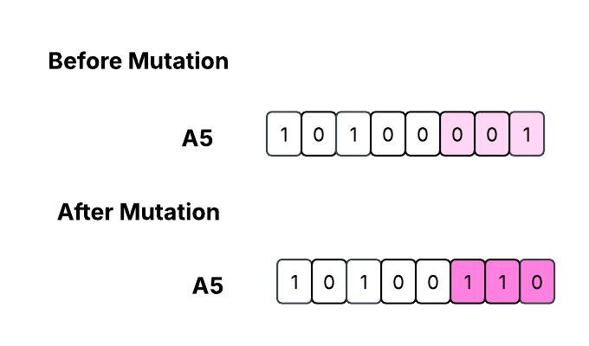
Diagrams

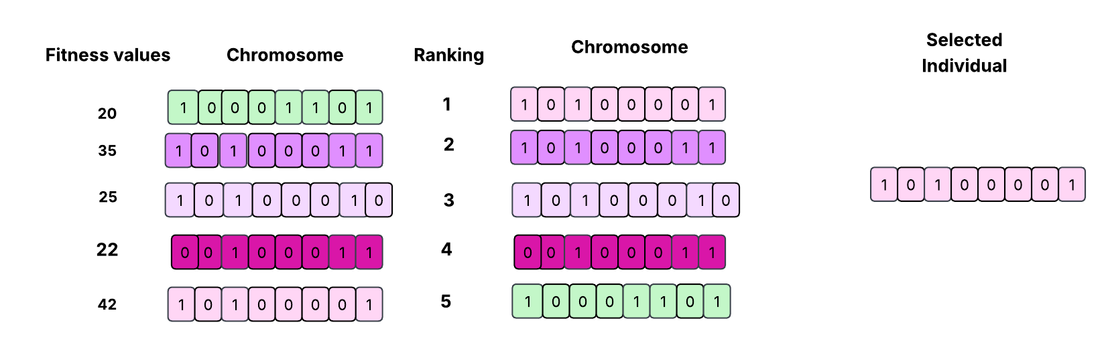
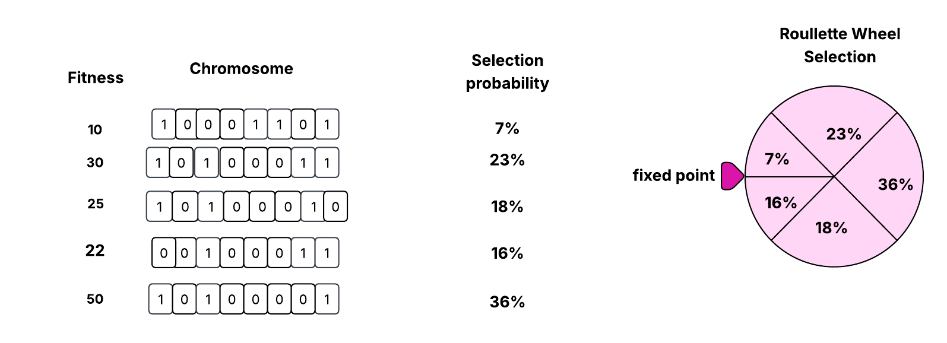

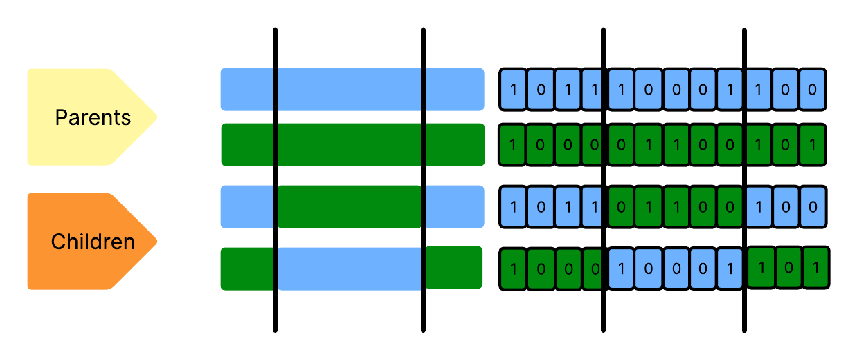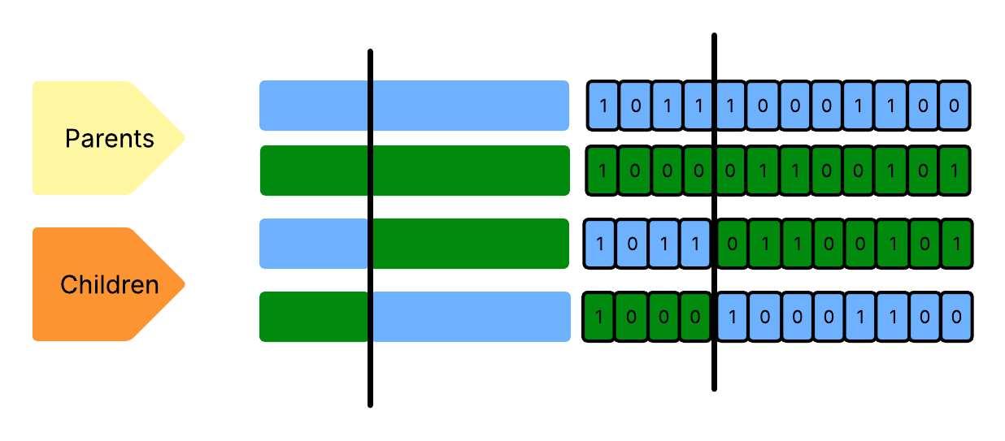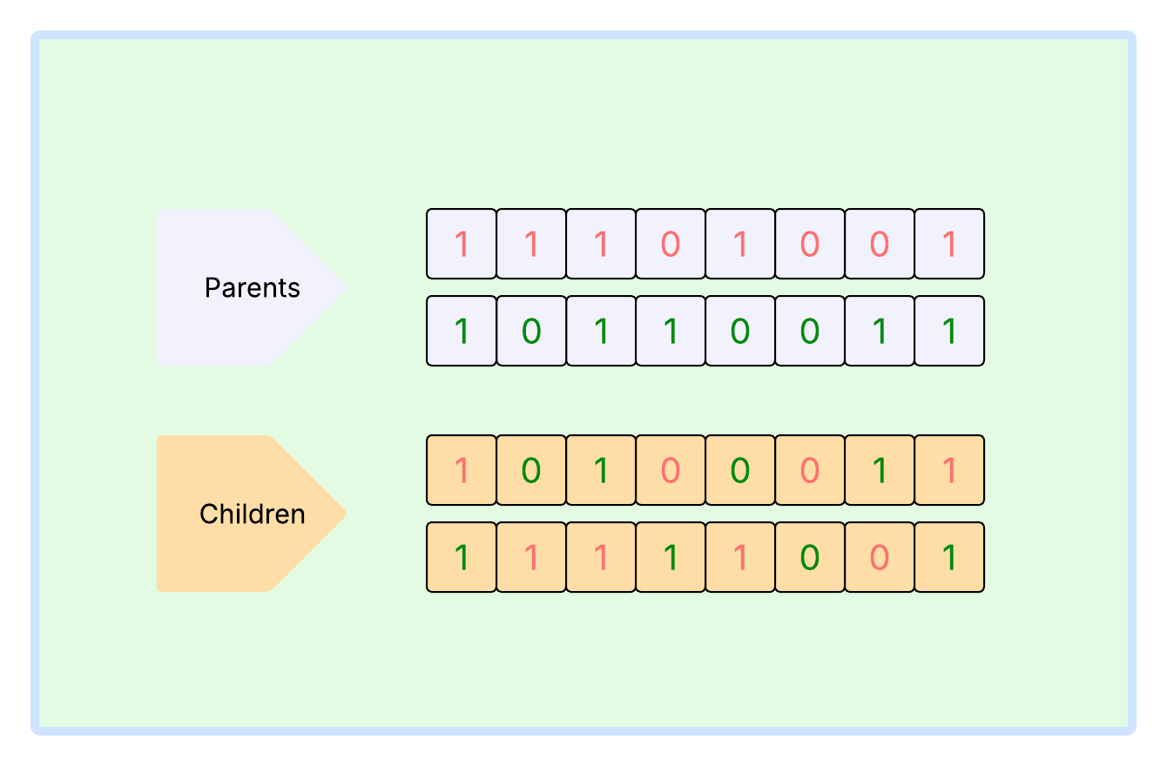

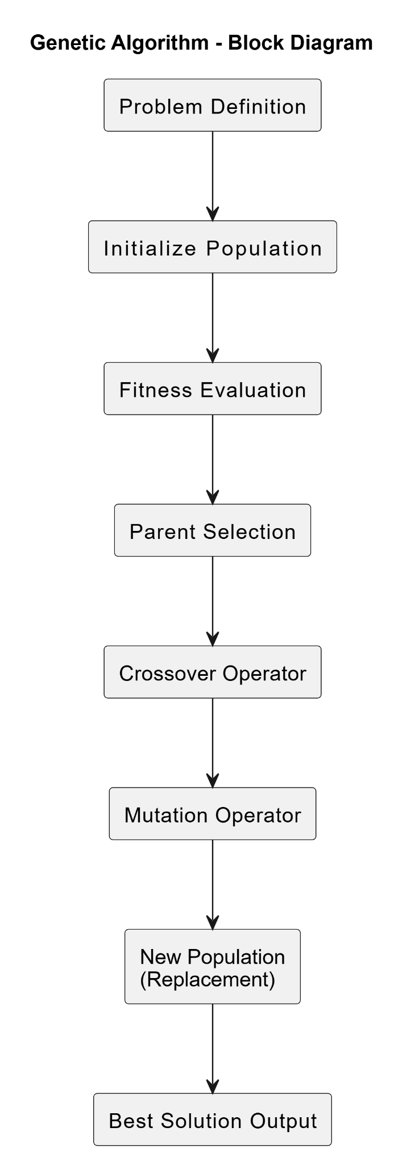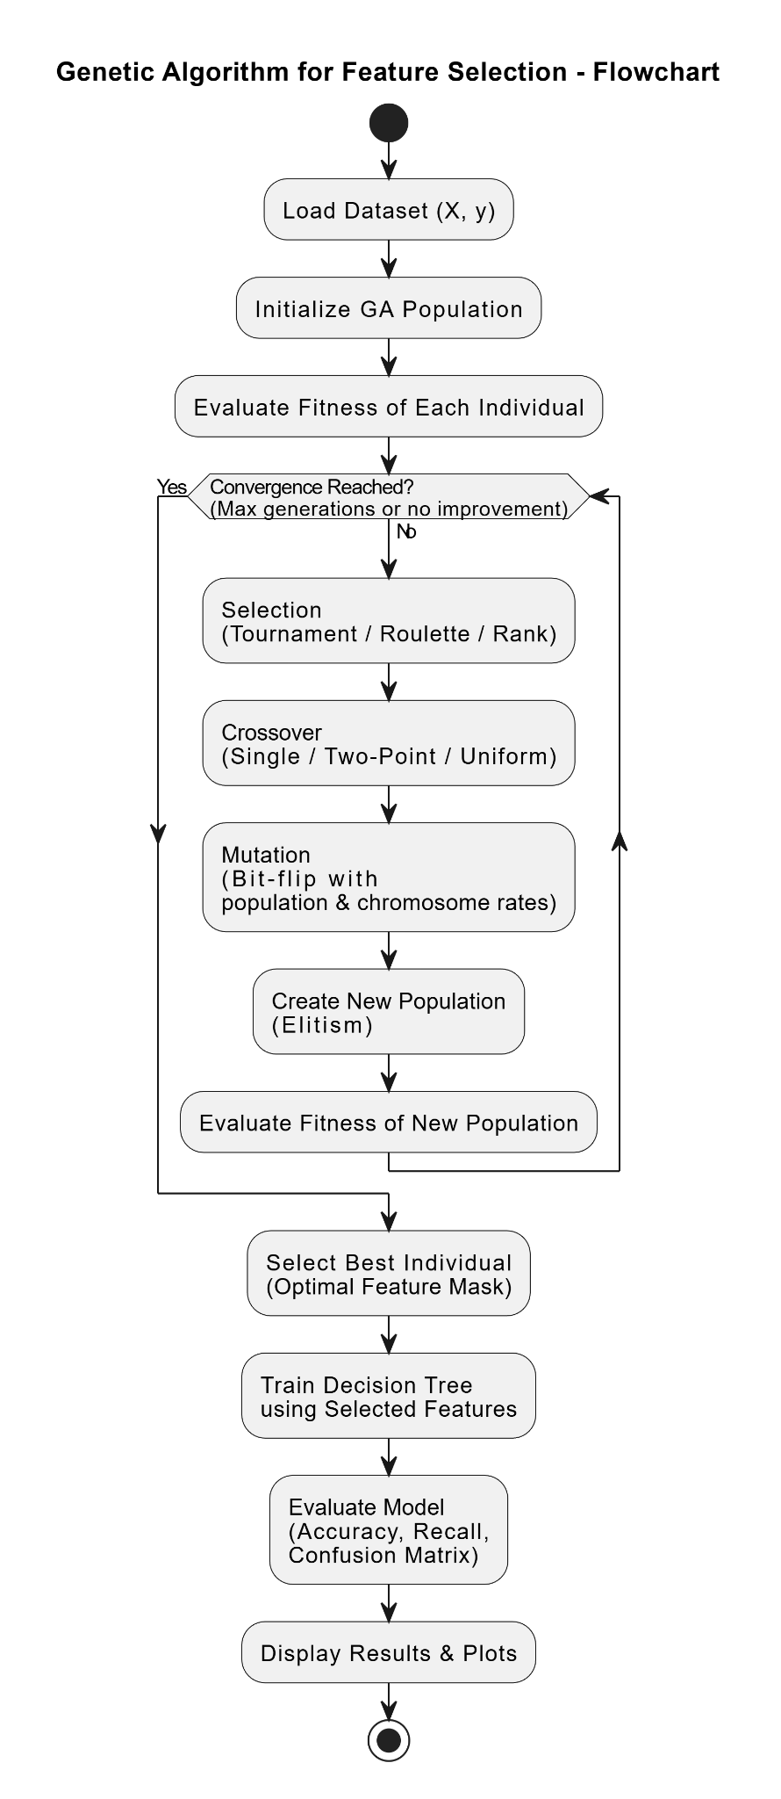

Project Shared Folder : https://shorturl.at/TAu4Q

Conclusion
Summary of Findings
- The Genetic Algorithm (GA) successfully reduced the feature set while maintaining high classification performance.
- Across multiple experiments, GA consistently identified subsets of features that achieved high accuracy (up to 97.7%) and recall (up to 98.1%), with significant feature reduction (up to 83%).
- Different selection, crossover, and mutation strategies influenced the convergence speed and quality of the final feature subset, highlighting the importance of operator choice.
Effectiveness of GA
- GA proved effective for feature selection in high-dimensional datasets, balancing accuracy and model simplicity.
- The inclusion of multiple objectives (accuracy, recall, reduction) in the fitness function allowed the algorithm to optimize both predictive performance and feature minimization.
Final Remarks
- The stochastic nature of GA means results vary per run, but overall trends are robust.
- GA provides a flexible and powerful framework for feature selection that can be adapted for different datasets and performance metrics.
- Future improvements, such as multi-objective optimization and adaptive operators, could further enhance performance and stability

References
- Taha, Z. Y. (2024). Optimizing Feature Selection with Genetic Algorithms. arXiv. https://arxiv.org/abs/xxxxxxx
- Imani, V., Sevilla-Salcedo, C., Fortino, V., & Tohka, J. (2023). Multi-Objective Genetic Algorithm for Multi-View Feature Selection. ResearchGate.
- Bansal, S. (2021). Multi-Objective Genetic Algorithm Based Deep Learning. PMC.
- MDPI. (2025). Hybrid Filter and Genetic Algorithm‑Based Feature Selection for Cancer Classification. MDPI.
- Iranian Journal of Basic Medical Sciences. Feature Selection Using Genetic Algorithm for Breast Cancer Diagnosis. Directory of Open Access Journals.
- Nature Scientific Reports. SGA-Driven Feature Selection for Improved Classification.

