MATRIX COLLEGE

OF

MANAGEMENT TECHNOLOGY

&

HEALTH

**Montreal, Quebec**



Year-end report for the project

Create a web application

And

Manual test

BAKING ACCOUNT

**420-ZT2-GX**

**Proposed by:**

**Hacheche Sara (5672186**

**Buga Diana (5642805)**

**Dorin Avram (5638874)**

**Belgouss Abderrafie (5476111)**

**Elhadji Mbargou Gueye (5416560)**

**Date of submission:**

**[**18.08.2023**]**

**Subject to:**

**Department of Computer Technology**

Create a web application

And

Manual test

**BAKING ACCOUNT**

CODE : 420-TZ1-GX

**Under the direction of:**

Hansy Ross Salvant, lead instructor of the final project

Project Supervisor

A final year project submitted

in partial response to the degree requirement

in computer technology

Matrix College of Management, Technology and Health Montreal, Quebec

**DECLARATION**

We affirm that the project work entitled **Create a web application and manual test** submitted in partial execution for the award of the diploma in computer technology is the original work carried out by us. It is not a part of any other project work subject to the award of another degree or diploma, whether at this college or another college.

Hacheche Sara (5672186

Buga Diana (5642805)

Dorin Avram (5638874)

Belgouss Abderrafie (5476111)

Elhadji Mbargou Gueye (5416560)

18.08.2023

We certify that the statement made above by the candidates is true.

Hansy Ross Salvant

**Introduction:**

In the dynamic and ever-evolving domain of software development, the harmonious fusion of theoretical insights and hands-on expertise becomes the cornerstone for crafting applications that leave a lasting impact. In the context of our academic voyage through the corridors of the Computer Science Technology – Software Testing AEC program, we stand poised to present the fruition of our endeavors in the form of the "Banking Project/ Web Creation." Within the following pages, we embark on an intricate exploration of the intricate journey that led us to conceptualize, design, and materialize a web application, seamlessly weaving together an array of technologies and methodologies.

This project, a testament to the fusion of intellect and application, serves as an opportunity for us to leverage the spectrum of knowledge and skills that have been honed and refined throughout our academic tenure. With the goal of applying theory into practice, we delve into the creation of a web application that encapsulates the quintessence of our learning. The meticulous integration of HTML, CSS, and PHP serves as the canvas on which we paint a practical masterpiece, breathing life into the conceptual framework.

As we tread the path of transforming ideas into reality, this report meticulously unravels the layers that constitute our journey. From inception to execution, we meticulously document the process of crafting an interactive web platform that not only adheres to industry standards but also resonates with the theoretical underpinnings of our curriculum. With the Banking Project/ Web Creation as our backdrop, we traverse through the realms of requirement analysis, front-end and back-end development, database integration, and testing, embodying the very essence of our educational odyssey.

By exploring each facet of our project, we offer an insight into the methodology behind the seamless fusion of HTML, CSS, and PHP. Our application's ability to validate data, interconnect databases, and offer a user-friendly interface is a testament to the expertise that we have acquired over time. As we dissect the anatomy of this project, we also unravel the multifaceted nature of software testing. Each line of code, every design element, and the intricacies of database management bear the imprint of our dedication to excellence.

In the subsequent sections of this report, we delve into the detailed architecture, design decisions, implementation strategies, and testing protocols that collectively shape the Banking Project/ Web Creation. The narrative encapsulates not just the technical dimensions but also the collaborative spirit that propels such projects forward. Assembling our collective intellect, our team has navigated through challenges, brainstormed solutions, and embraced iterations, ultimately arriving at a product that exemplifies our growth as aspiring software testing professionals.

**Project Background:**

In response to the dynamic demands of modern banking systems, this project addresses the need for a comprehensive web application that streamlines financial interactions for both customers and administrators. The web application aims to encompass a user-friendly interface, robust data validation, secure database management, and thorough testing. Drawing inspiration from the Software Requirement Specification (SRS) document provided by Guru99, our project aims to realize a functional prototype that embodies a substantial portion of the outlined requirements.

**Objectives:**

1. The primary objectives of this project are to:
2. Identify Requirements: Thoroughly understand the SRS document to gather and analyze the key requirements for the web application.
3. Technological Integration: Employ HTML, CSS, PHP, and MySQL Work Bench to develop a cohesive and functional web application.
4. Front-End Validation: Implement HTML and CSS for front-end validation to ensure data integrity and enhance user experience.
5. Back-End Connectivity: Utilize PHP to connect the web pages to a MySQL database, facilitating seamless data management.
6. The form utilizes various HTML elements like text inputs, select dropdowns, and buttons. It's also linked to an external stylesheet (style.css) for styling purposes.

One thing to note is that there's a form element with an action attribute pointing to /submit_signup. This suggests that when the user submits the form, the data will be sent to a server-side script at that URL for processing. You might need to ensure that you have a backend script that handles form submissions and processes the data accordingly.

Testing and Validation: Develop and execute manual test cases based on the identified requirements, ensuring the application's accuracy and functionality.

Documentation: Create a comprehensive documentation report that outlines the project's development, testing procedures, and results.

**Project Significance:**

This project holds paramount significance as it amalgamates various aspects of our educational journey. It entails the application of theoretical concepts gleaned from web programming, software testing, and database design courses into a tangible and functional solution. By creating a web application that caters to the intricate needs of a banking system, we aim to demonstrate our prowess in web development, data validation, and project management.

**Structure of the Report:**

This report unfolds in a systematic manner, adhering to established standards for organization and presentation. The subsequent sections encompass the project's key aspects, including the project design, implementation, testing procedures, and conclusions. By following the sequence outlined in this report, readers will gain comprehensive insights into the project's development, challenges encountered, and outcomes achieved.

A database is an organized collection of data that can be stored, managed, and accessed efficiently. Databases are used to store structured information, such as customer data, products, transactions, etc.

Within a database, tables are the fundamental structures that store the data. Each table consists of rows and columns. Each row in a table represents a specific record or entry, and each column represents an attribute or a field of information.

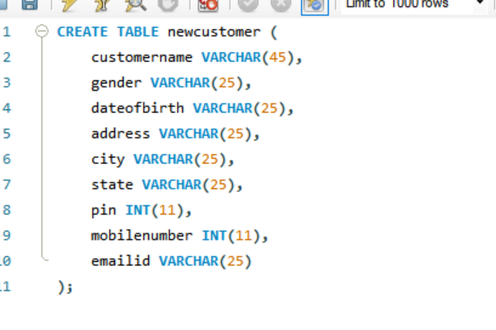

This code creates a table named "newcustomer" with columns: customername (string), gender (string), dateofbirth (string), address (string), city (string), state (string), pin (integer), mobilenumber (integer), and emailid (string).

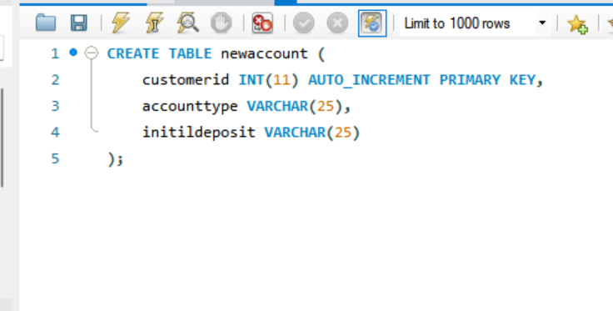

The “newaccount” table is being created to store information about customer accounts. It includes a unique customer identifier, the type of account, and details about the initial deposit made for the account.

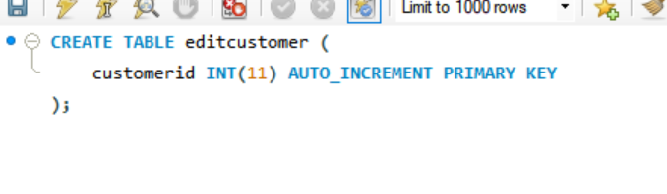

This code creates a new table named “editcustomer” with a single column.

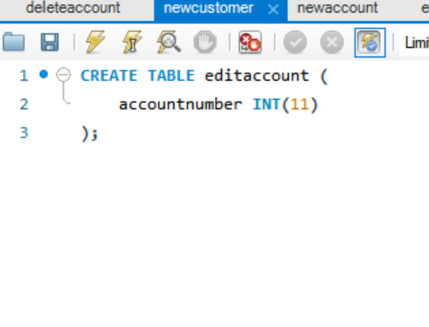

This code creates a table named “editaccount” with a single column: accountnumber: This is an integer column that can hold values up to four digits long. It’s used to store account numbers.

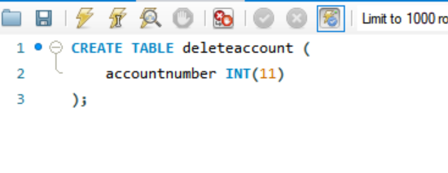

This code will create a table named “deleteaccount” with one column: accountnumber: This is an integer column used to store account numbers.

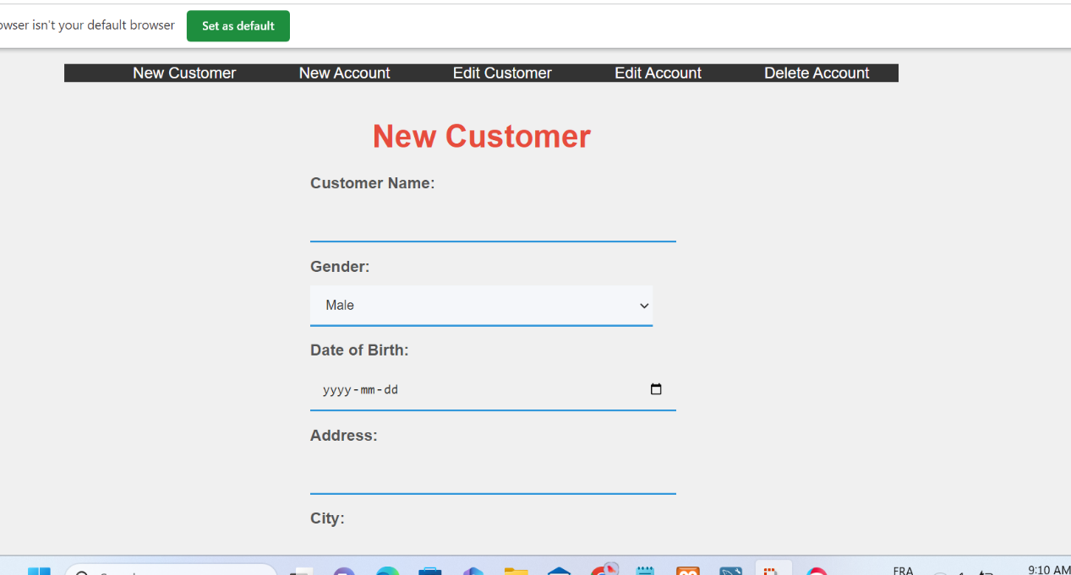

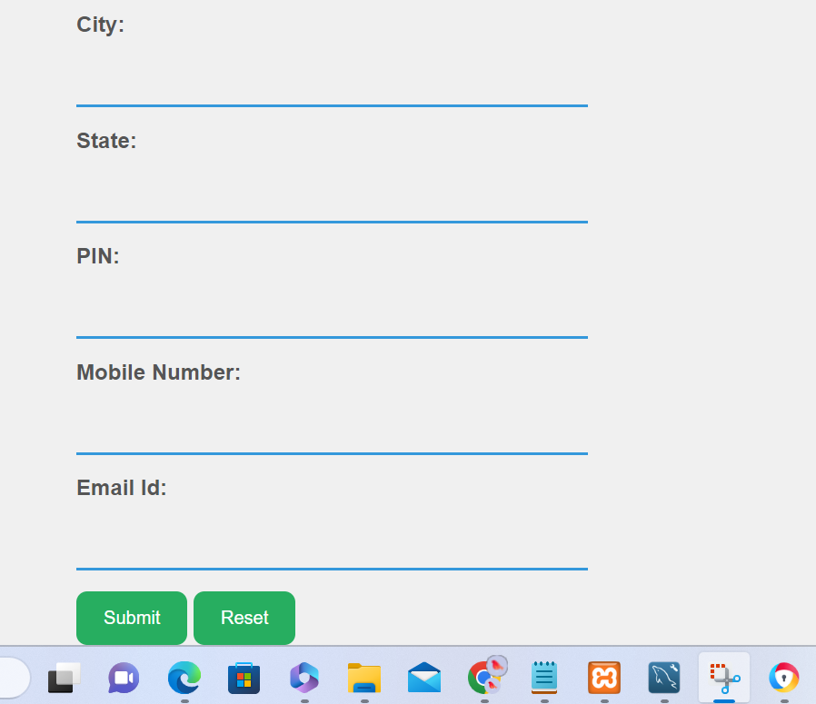

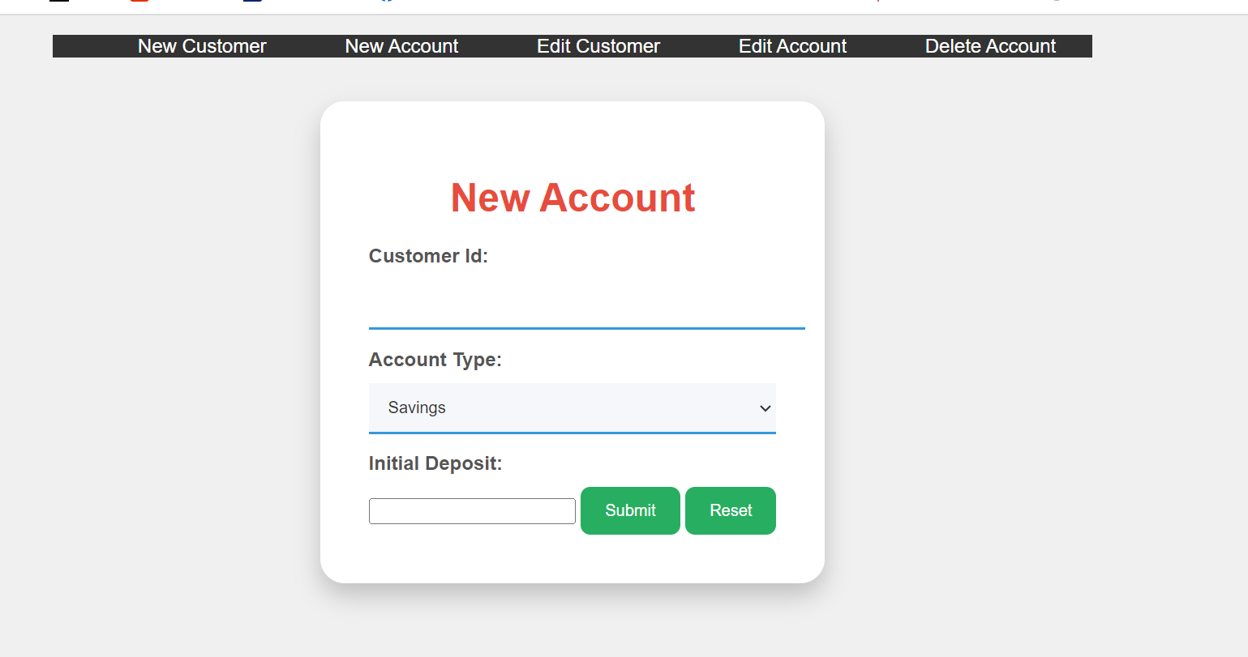

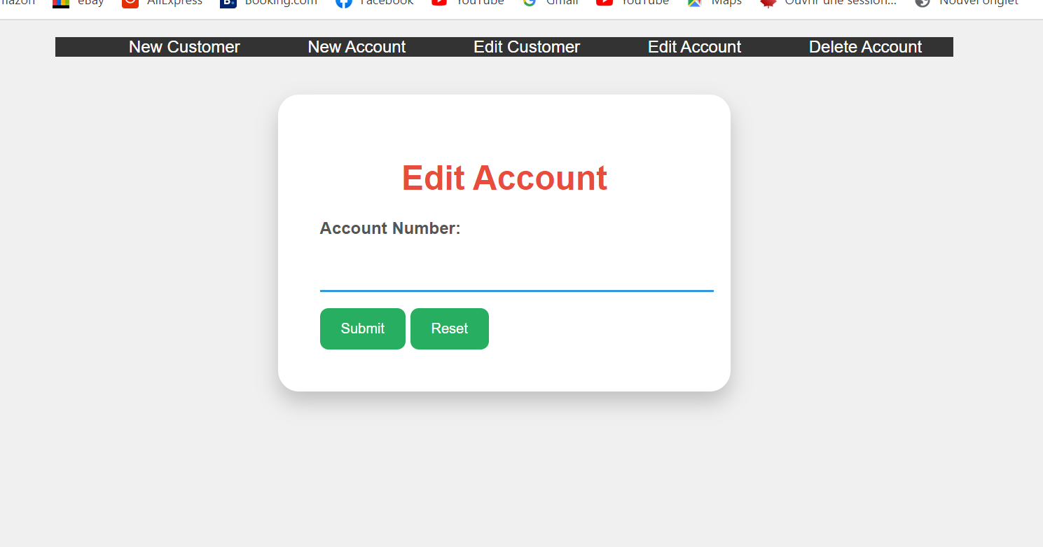

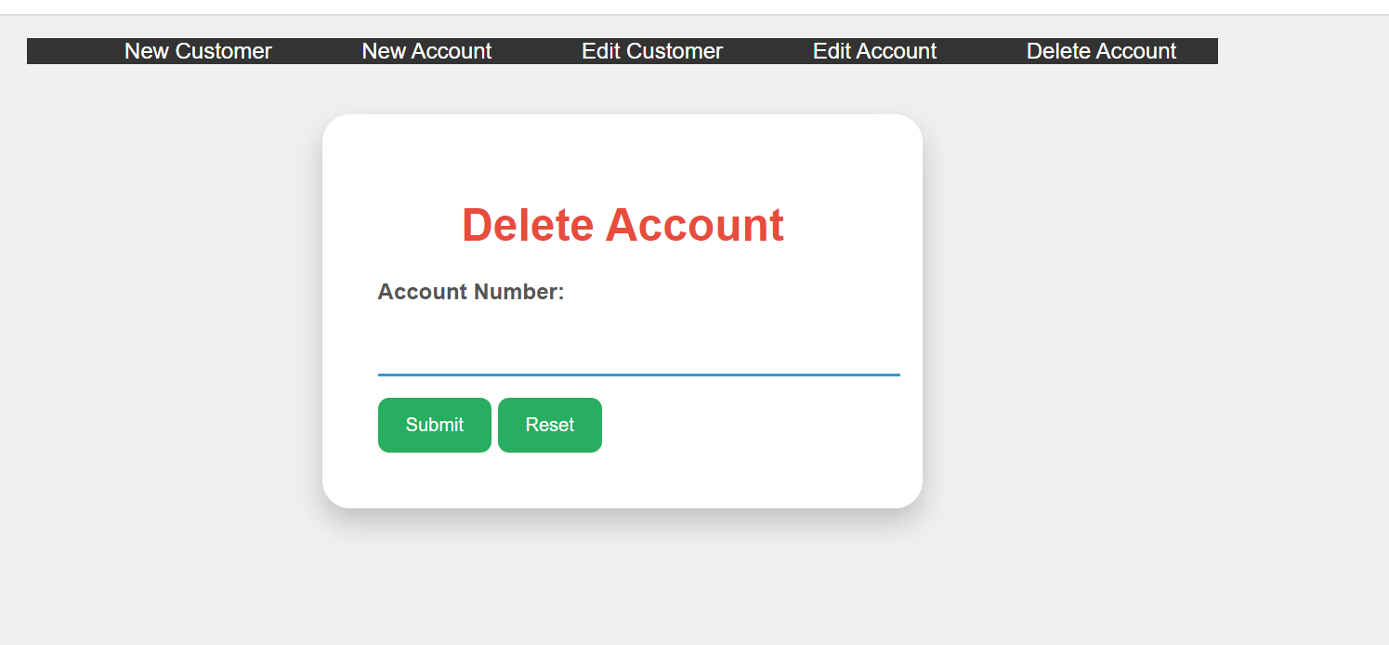

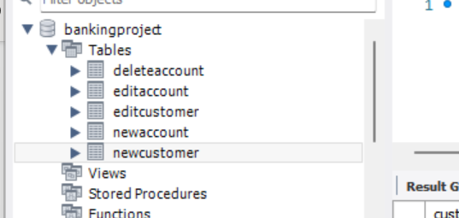

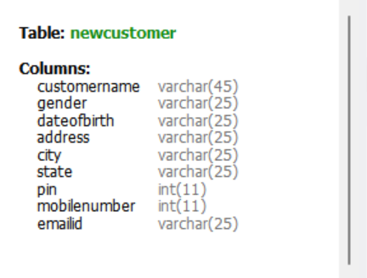

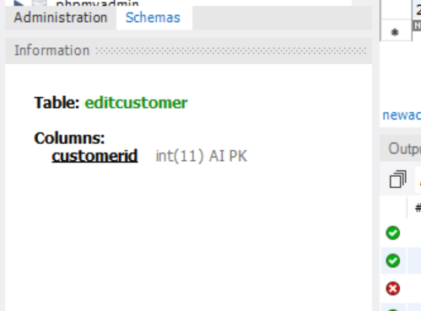

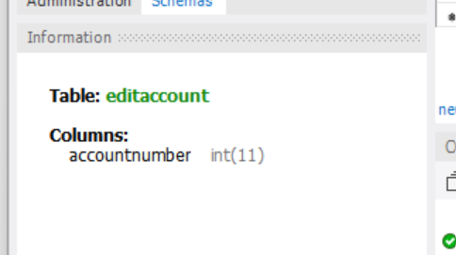

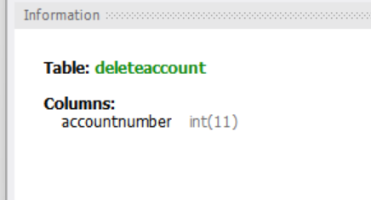

**Conclusion:**

In the grand tapestry of our software development journey, the "Banking Project/ Web Creation" stands as a remarkable embodiment of our relentless pursuit of knowledge and practical application. As we bring down the curtain on this project, we find ourselves at the intersection of theoretical expertise and hands-on experience, poised to showcase a web application that seamlessly harmonizes a multitude of technologies, rigorous testing methodologies, and unwavering adherence to industry benchmarks.

The journey through this project has been one of discovery, innovation, and perseverance. We recognize that software development is not just about lines of code or design elements; it is a holistic endeavor that encompasses problem-solving, strategic thinking, and the art of transforming conceptual visions into tangible, functional realities. In this light, our project emerges as a living testament to our dedication to excellence and the relentless pursuit of mastery in our craft.

The layers of this project reveal the careful orchestration of HTML, CSS, JavaScript, and PHP into a symphony of functionality and aesthetics. Each line of code is a testament to our meticulous attention to detail, and every design choice reflects our commitment to creating intuitive user experiences. Our application's ability to validate data inputs, connect with databases seamlessly, and render an interactive interface echoes the harmony we have achieved by interweaving our academic insights and practical skills.

Furthermore, this project provides us with an invaluable opportunity to immerse ourselves in the world of software testing. The rigorous testing protocols we have undertaken showcase not only our competence in ensuring quality and reliability but also our readiness to embrace the challenges that emerge during the development process. The real-world testing scenarios have allowed us to refine our problem-solving abilities, demonstrating that a skilled software developer is also an adept troubleshooter.

This project extends beyond just the realms of academia; it signifies our foray into the realm of industry-ready solutions. The "Banking Project/ Web Creation" is not just a culmination of our academic journey; it is an embodiment of our potential to contribute meaningfully to the software development landscape. It reflects our ability to respond to the ever-evolving demands of technology, offering solutions that not only meet but exceed the expectations of modern users.

In the broader context, this project echoes the essence of our academic program – a harmonious blend of theory and practice, a dedication to constant growth, and a commitment to embracing challenges with open arms. As we bid adieu to this endeavor, we stand poised on the brink of new horizons, armed with skills, insights, and a shared sense of accomplishment. The "Banking Project/ Web Creation" encapsulates not just a project report but a chapter in our journey of lifelong learning and innovation.