**Windows Lab Manual**

**Common First Year - Operating Systems**

s

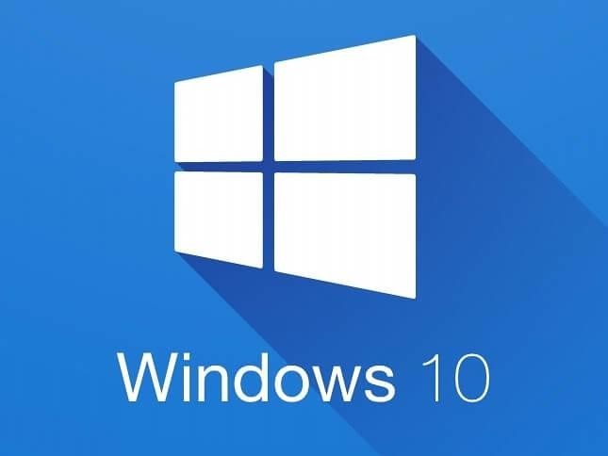

**Student Name: HACHECHE SARA**

**Lab Group: 31111 Student Number: 5672186 Lab Tutor:**

**Windows Lab 1**

**Using the File Management System in Windows 10**

**Objective:** To introduce the File Management System in Windows 10

At the end of this lab, you will be able to:

* Use the Windows Explorer file management system
* Access Windows drive by using a drive letter assigned to each storage device
* Manage Directories/Folders
* Discover file operations: operations which can be performed on files
* Discover file attributes: characteristics that describe a file
* Perform operations that can be carried out on folders/directories
* Route through the file system path
* Create desktop and keyboard shortcuts
* Examine other file managers that are available.

**Instructions**

## It is important that you complete this and other lab sheets even though you feel you are familiar with Windows 10.

**Use the Help option in Windows 10 and the internet to find out information on doing the following tasks.**

## Complete each task in this document and record the answers (in your own words).

**This completed sheet will then be useful for later use.**



**File System:**

The file system is the most visible part of the OS.

Users use the file system to store (on disk) and access their files. Windows Explorer is the file management system in Windows 7.

The file system comprises of two parts:

* A collection of files
* A directory/folder structure

In Windows, the file manager is called **‘Windows Explorer’**, or sometimes referred to as File Explorer. You can access it by clicking on this icon in your Start Menu tray.

A sample file system viewed through Windows Explorer can be seen on the next page.

## Drives:

In Windows, the disk management function of the operating system assigns a letter (drive letter) for each storage device that the operating system can see. Looking at the local machine, find out the following:

* What is the drive letter for the local disk (hard disk)? Drive letter is C
* What is the drive letter(s) for the CD/DVD drive(s)? (is there one even present?) Last drive letter is e,gd
* Plug in a USB Key, what is the drive letter for this? D
* What is the drive letter for your network account in the college system? Empty _
* What is the drive letter for your exam account in the college system? EMPTY
* Use the File Manager to navigate through the folders and files stored on the computer.

## Directories/Folders:

Are used to organize files on the drives in a manageable way. Windows uses a hierarchical directory structure.

* In a few words explain what is a hierarchical directory structure (file system)? [Online Research]

The file system contains two kinds of entities dirictories and ordinary files , dirictories are used to structure the file system and ordinary files contain useful information

Now, finish the diagram on the right which depicts the layout of the MRE Training directory structure:

**Hierarchical Struct**or

D

D1 D2 D3 D4 dem

Maware incident report

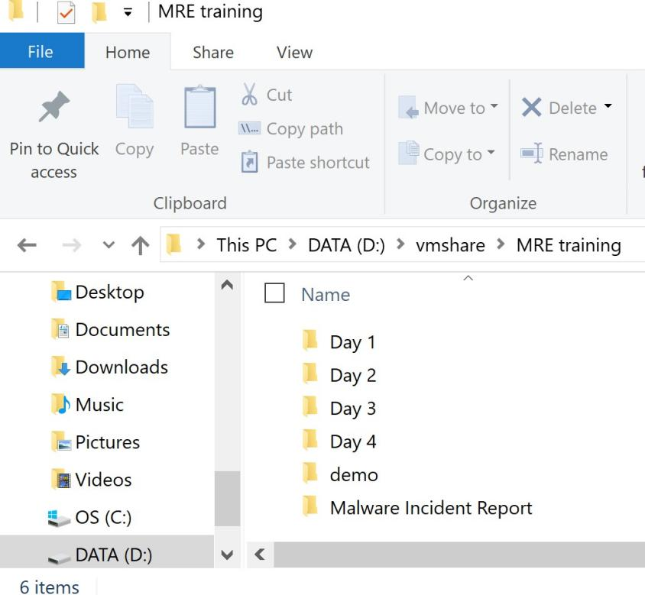

## Task 1:

Create the following directory structure in the root directory of your G: drive (or use the C: drive)

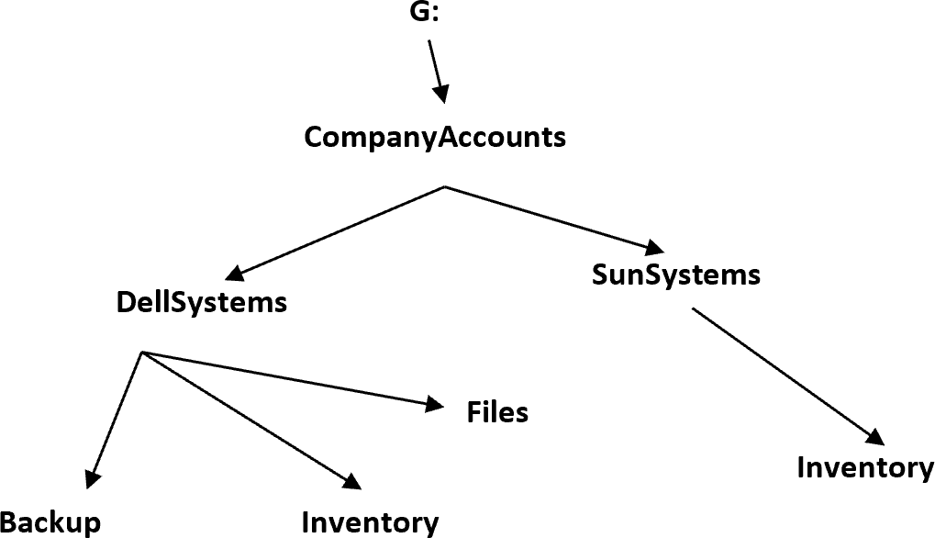

**File Operations:** What you can do to a file, examples include Create a file, Open a file etc. List 3 other operations which can be performed on files:

1)to delete a file 2)to move a file 3) to rename a file

**File Attributes:** Are properties which describe a file, examples include File name, File extension etc. List 3 other attributed of files

1)home 2)sharing 3) viewing

**Directory/Folder Operations:** What you can perform on a Directory, examples Open, Create etc. List 3 other operations which can be performed on folders:

1)changes 2) send 3) print

**Task 2:**

* Create a Word document called ***InventoryDetails*** and save it to the *Inventory* directory in the *DellSystems*

folder.

* Create an Excel Document called ***CostDetails*** and save it to the same directory.
* What extensions do these two files have? .docx, .xlsx

A file extension is an example of a file attribute/property. File extensions are **not** shown by default in Windows. To view the file extensions of files you must change one of the settings in View options. (Go to File -> View, in Windows Explorer)

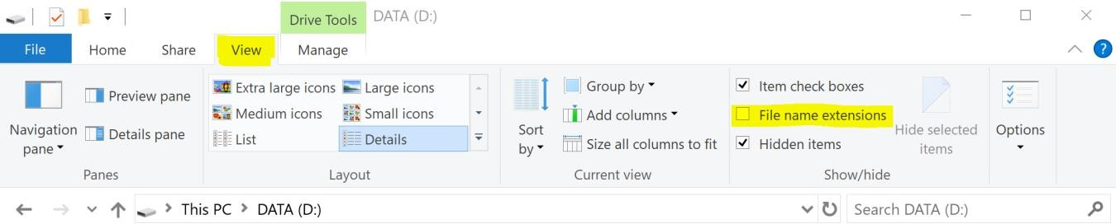

File size is another attribute. What is the file size of each of the two files?

File 1:9 KO File 2: 9KO

# Task 3:

* Open the saved files and make changes to them.
* Take a copy of the files and copy them to the folder called *Backup*.
  + File copy is an example of a file operation.
* Rename the folder *Files* in the *DellSystems* folder to *AllFiles.*
  + This is an example of a directory operation.

# Task 4:

* Delete the folder called *Backup.*
  + Can you delete it when it contains files? YES
* Move the folder called *AllFiles* to be a sub directory of *SunSystems.*
  + This is an example of another directory operation.

# Task 5:

What is the recycle bin used for? [Online Research]

It allows to offer a second chance to the files that the user has decided to erase from the mass memory of the computer

**Paths**

A Path is a route from one point in a directory structure to another point in a directory structure. For example: using the diagram on Page 4, the **full** or **absolute path** to the file InventoryDetails is:

**C:\CompanyAccounts\DellSystems\Inventory\InventoryDetails.docx**

# Task 6:

What is the full or absolute path of the folder *All Files*?

C:\companyacount\SunSystems\AllFiles

What is the full or absolute path of the file ***CostDetails?***

C:\companyacount\SunSystems\AllFiles\costdetails.xlsx

What are the full or absolute paths to the **two** folders called *Inventory*?

C:\companyacount\SunSystems\AllFiles\Inventory

C:\companyacount\SunSystems\Inventory

# Task 7:

View the contents on the G: drive, there are a number of views available for viewing the contents. List 4 of them here:

List,small icons, big icons, medium icons

Which view are you looking at now? List

Change to ‘Tiles’ view, now try ‘Details’, now change back to the original view.

# Task 8:

Sort the contents of the G: drive in alphabetical order of name. [Hint: Use ‘Views’ tab]

**Shortcut Types:** There are two types of shortcuts

**Desktop Shortcuts:** Usually represented by an icon, is a small file that points to a program, folder, document, or Internet location. Clicking on a shortcut icon takes you directly to the object to which the shortcut points.

**Keyboard Shortcuts:** a set of one or more keys. That when triggered by the user will invoke some operation. i.e. What happens when CTRL+ALT+DEL are pressed together? Its open new windiows with four tabs : **1-LOCK**

**2-CHANGE USER 3-DISCONNECT 4-TASK MANAGER 5- CANCEL**

# Task 9:

Create a shortcut to the *SunSystems* folder and place it on the desktop.

* What is a shortcut used for? It's useful for accessing software programs or directory, files more easily
* How did you do this?

Right click in the folder SunSystems, the send -->create shortcut(desktop)

Right click in the folder ***InventoryDetails*** , then choose send -->create shortcut(desktop)

* + Create a shortcut to the file ***InventoryDetails*** and place it on the desktop.

# Task 10:

Create a keyboard shortcut to the file ***InventoryDetails***.

* What is a keyboard shortcut? It's a series of one or several keys to quickly invoke a software program or perform a preprogramme
* How did you do this?

I created shortcut for this file, then I right click in this file --choose proprieties--in tab shortcut and in the short -key input I choose the key ctrl+alt+I

# Task 11:

* Checking properties of a drive.

o What capacity has the C: drive on your machine? 237 GO

How much space is used? 63,4 GO How much free space is there? 173 GO

**Now, repeat the same for your G: drive**

**Other File Manager Software:**

The Windows Explorer File Manager comes automatically with Windows but it is not the only file management software that can be used with Windows. Google search the names of some others which might be useful.

1. Total Commander

2. Shrestha Files Pro X

3. Directory Opus

# Task 12:

* Download another file manager software package called **FreeCommander** from the internet and get it working on the computer.

Is this a suitable file manager for Windows? Yes, organize and explore files on your computer

Is this software useful, more useful than Explorer?

Yes,The program has a simple and attractive user interface.its has more features than Explorer , for example comparing files , auto delete files

# Task 13:

* Remove all installed software by uninstalling it, record here how you did this:

l I write FreeCommander in the input for research, the result there are many tabs, I choose uninstall

then a new window appears Control panel \Programs\Programs and functionality

I check freeCommander then click on uninstall

## End of Windows Lab 1

**Page left intentionally blank for notes**