ASSIGNMENT # 5 SARA HACHECHE

* **1.** Taking into account the *Work Breakdown Structure* organize the next information in a mind map following the examples ***Wedding*** and ***Go to the Moon.***
* **A) *Conference:*** You have to organize a conference, then which steps do you have to follow? (Examples: *Publicity, Logistics & Speakers or lecturers*)

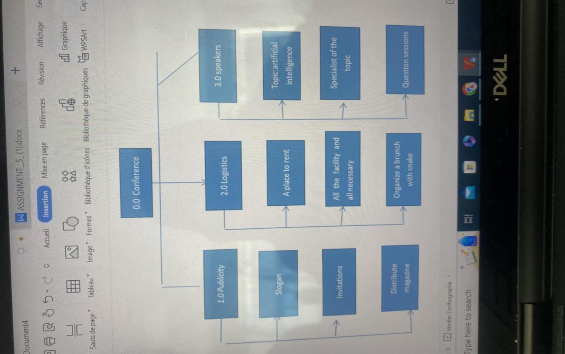

* **B)** ***Project Management:*** Taking into account the information given in the class. (Examples: *People or team, process, resources, cost, product, scope and task*)

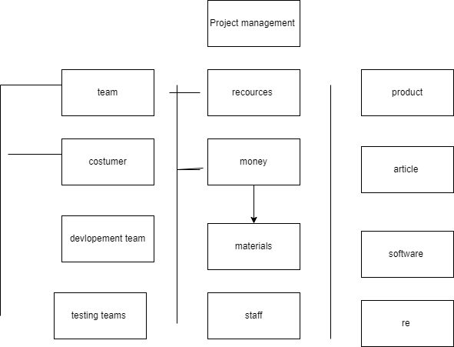

* **2. Reading:**
* Make the reading ***What Does a Project Manager Do? | Roles and Responsibilities*** and:
* **A)** Explain **with your own words** each one of the 5 *Key Responsibilities of a Project Manager* explain in the Reading. (Each in around 4 lines)

1 / Initiating : The main reasons for prioritizing your projects are Increasing profitability by spending less time on secondary projects that penalize the progress of your high value-added projects. for that it is very important in a project to make its

2/ planning is the most important thing in a project because we have time to organize everything from the first stage to the last and to save more time to complete our tasks in the project

3/Executing a project is the stage of the project where everything your team has planned is put into action. Your team goes out of its way to get projects off to a good start, and we have to execute all the instruction step by step for a good job and good result .

4/monitor and control in a project

Project control and monitoring generally results in the monitoring of ratio-type indicators comparing the forecast and the realized in terms of time, consumption, budget and resources.

5/The closeout phase of the delivery process is intended to complete the project management activities associated with the delivery phase of a project and to conduct an assessment of the project's performance against objectives and requirements.

* **B)** In a table explain **with your own words** the difference among *Project Management vs. Portfolio Management vs. Program Management*
* <https://www.northeastern.edu/graduate/blog/project-manager-responsibilities/>