14/05/2023 *INTRO TO O-O PROGRAMMING*

*SARA HACHECHE 5672186*

LAB PRACTICE Using Java programming languages

STUDENT NAME | COURSE NAME | INSTRUCTOR NAME/CLASS TIME/PERIOD

1. Using while statement write a java program that allows the user to enter an integer value below 10. By using this value, the compiler will add those values up to 10

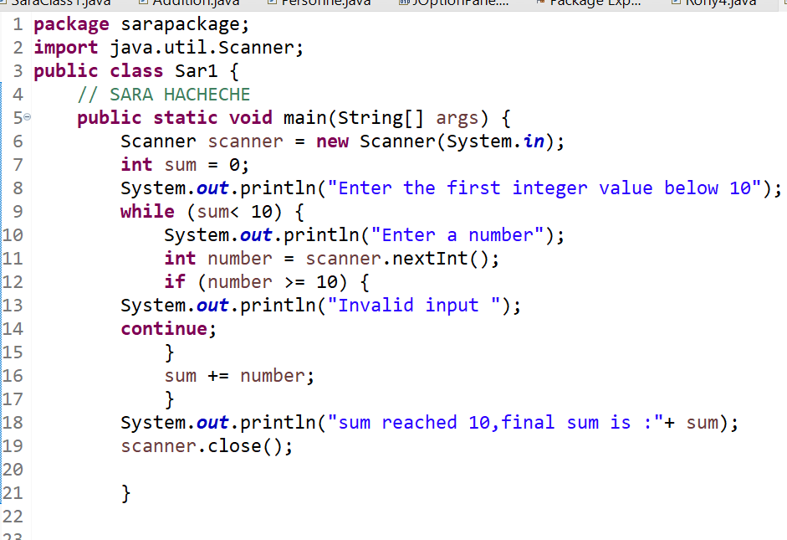

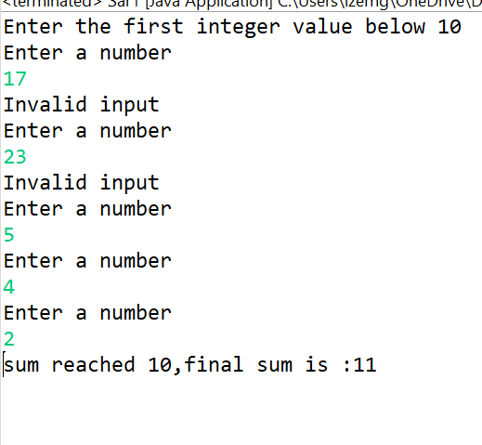

1. Using do while statement write a Java program than add numbers until the user enter zero.

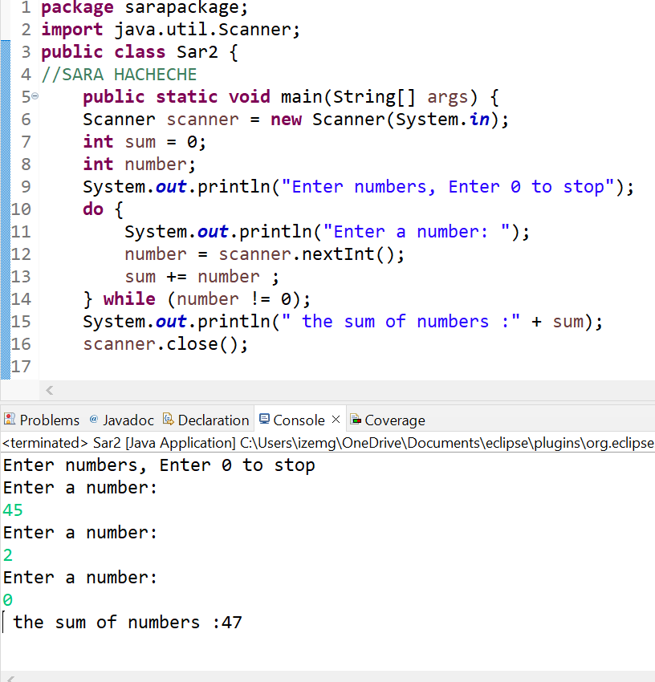

1. Using for loop statement, write a java program that allows the user to enter any integer values. Then it will calculate the sum of natural numbers up to the user entered number.

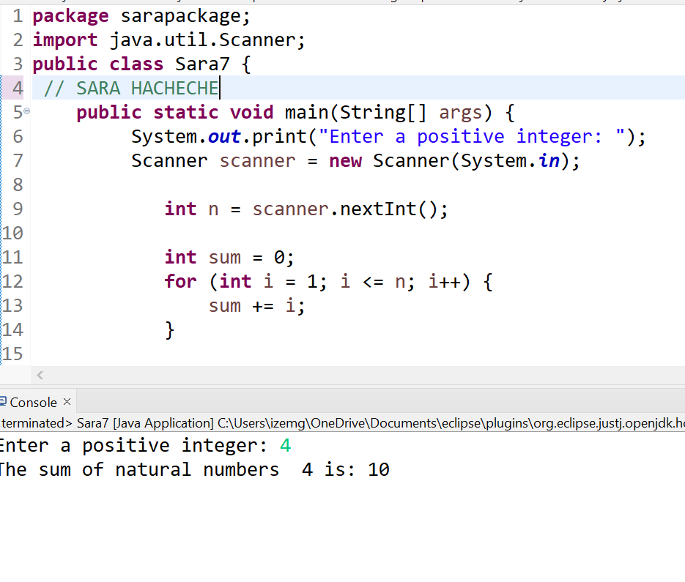

1. Using Nested for Loop statement, write a java program to print multiplication table of 9

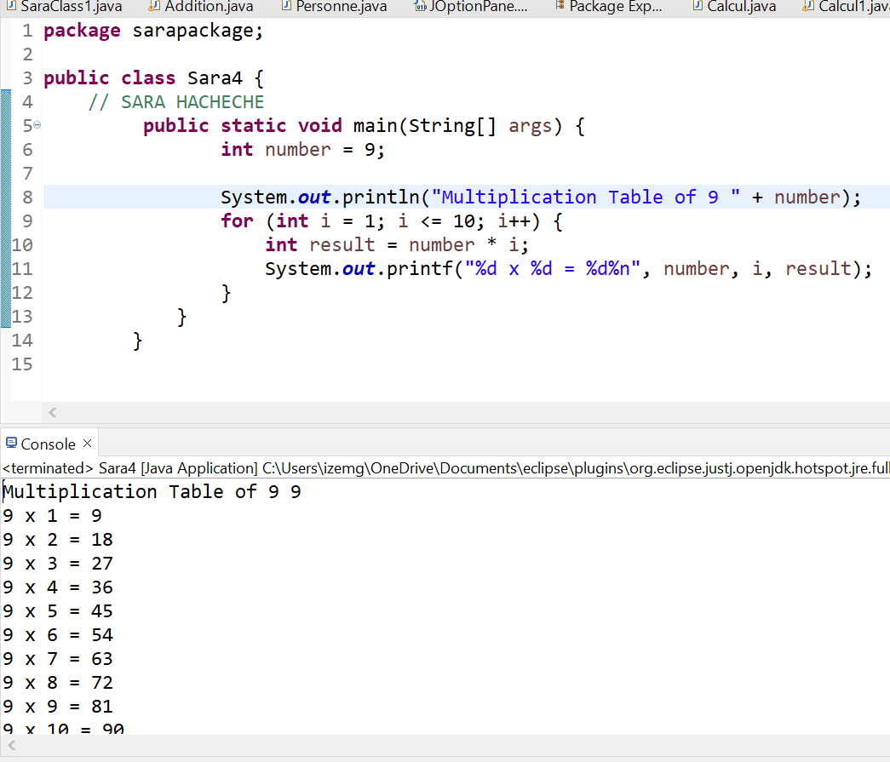

1. Using Nested for Loop statement, make a modification on the exercise 13 to print multiplication table of any number between1 to 10.

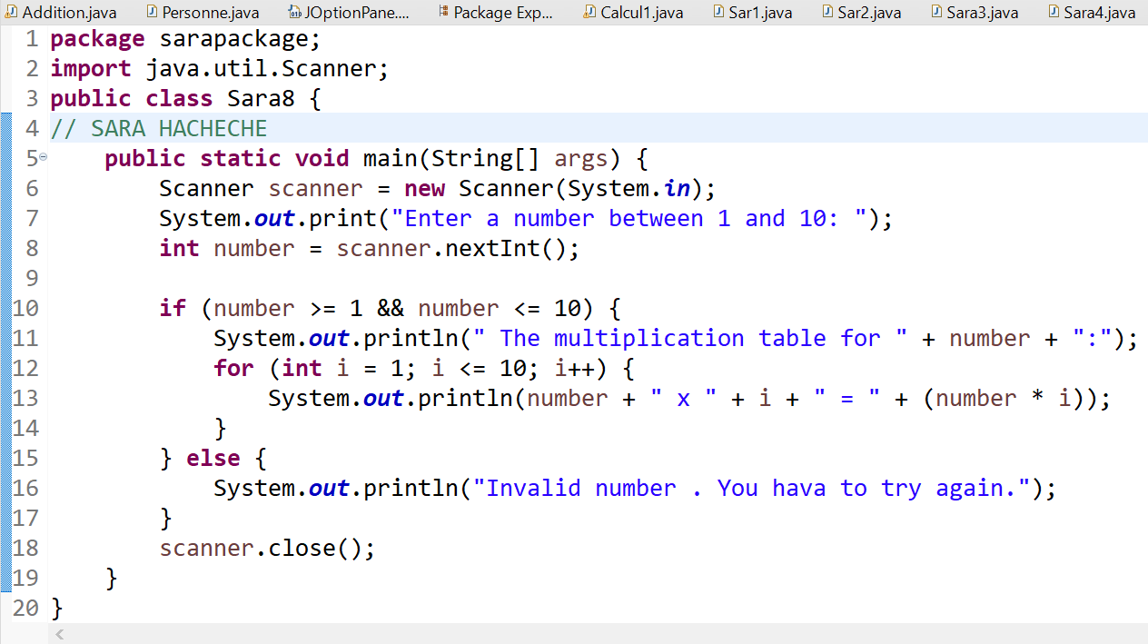

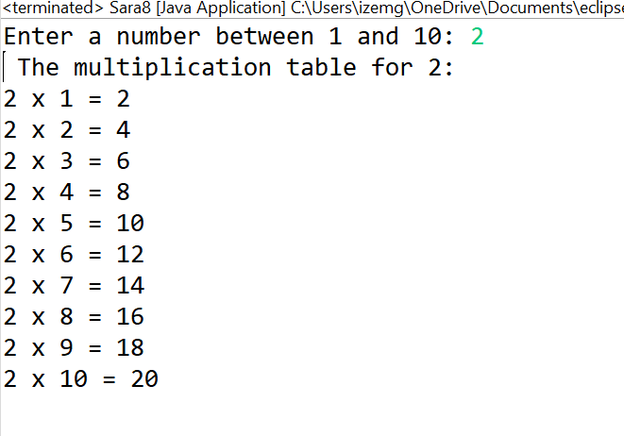

1. Now make a modification on the exercise 13 to print multiplication tables of 1 to 10.

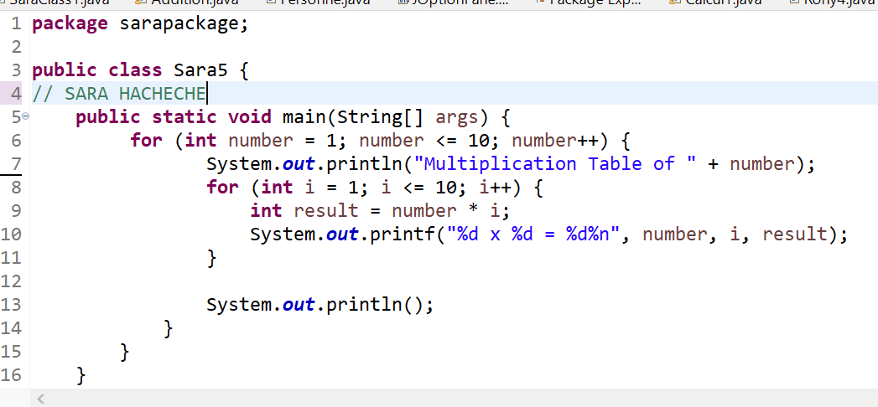

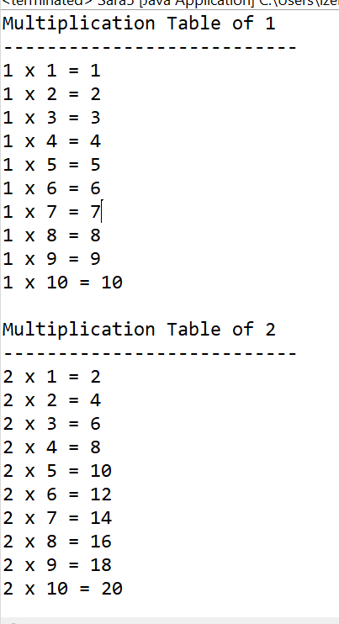

**// The program will print the multiplication tables of numbers from 1 to 10**

1. Write a java program to create a simple calculator using a DO WHILE … structure to create a menu, the program has to ask the user to enter two numbers, obtains them from the user. Create the methods sum, difference, product, division, and average to perform the actions and these methods have to return the result to print. The program needs to ask the user if they want to exit or continue in order to perform a new operation.

