http://www.matrixcollege.ca/images/matrix-logo.png

|  |  |  |
| --- | --- | --- |
|  |  | NAME |
| SARA HACHECHE |
|  | Student Id :  5672156 |
|  | DATE  2023-05-25 |
|  | Grade: |
|  | /100 % |
|  |
| Resultado de imagen para algoritmos | **Final Evaluation guidelines:**  2 elements to be evaluated  Data Structure  C++    Value: 40%  Materials allowed: Paper and pencil or pen  Time allowed: 120 minutes |
| Programming  Introduction to programming  Group of Winter 2023 | **Comments:**  **Good luck!** |

1. CGPA program provided in LEA: Convert the program into a flowchart (20 points)
2. Trace the program using one example.(40 points)

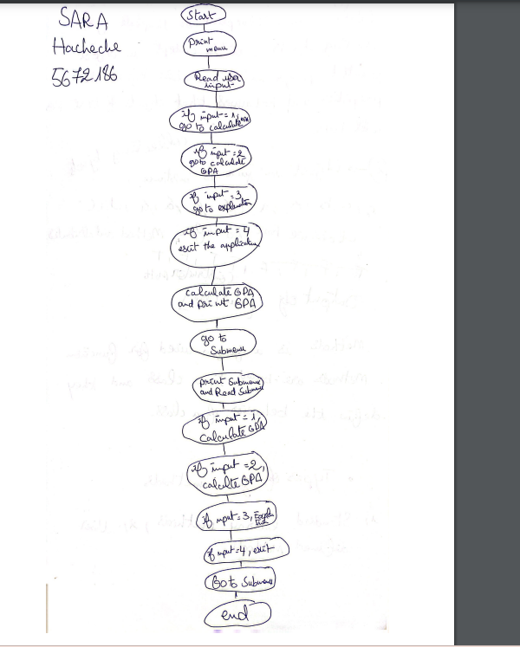

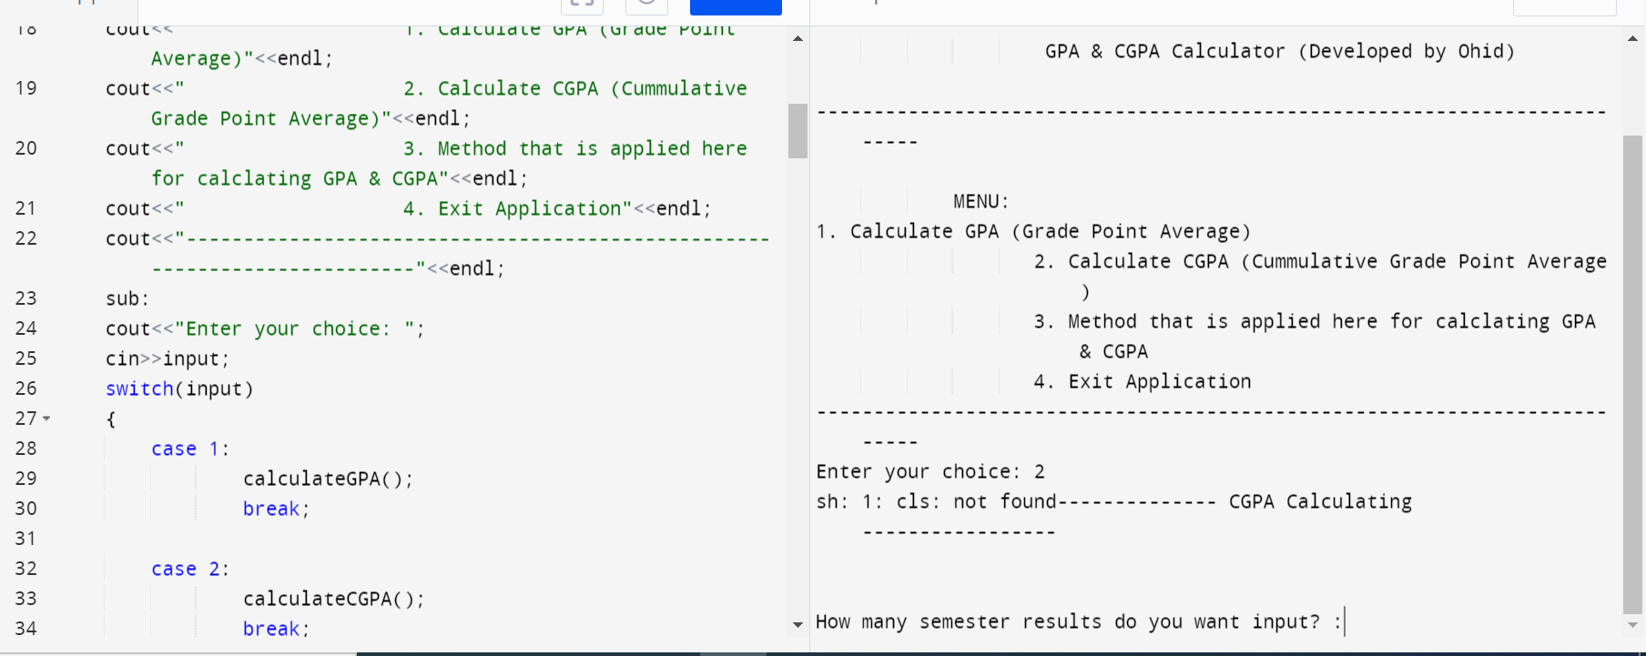

3.-A class of ten students took a quiz. The grades (integers in the range 0 to 100) for this quiz are available to you. write a program to determine the class average on the quiz.

( / 20 points )

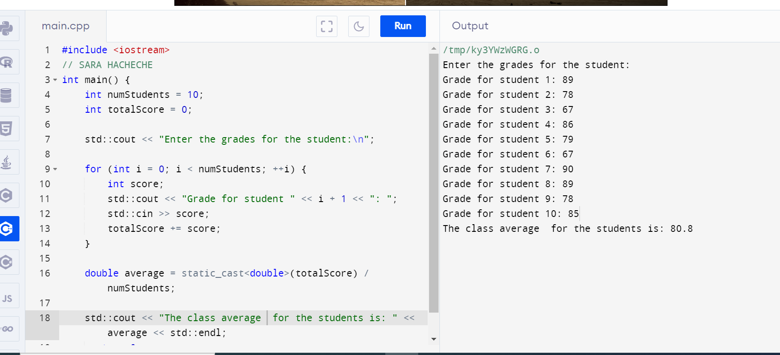

2.- Write a program that declares an array of 9 marks, whose values are then entered by the user.

( / 20 points )

