28/05/2023 *Intro to OO Programming*

Lab practice Using Java programming languages

STUDENT NAME | COURSE NAME | INSTRUCTOR NAME/CLASS TIME/PERIOD

**ASSIGNMENT No. 4**

Exercises: SARA HACHECHE 5672186

1. Create a class Student with the states (attributes): Name, address, phone number, Student ID. Also define the behavior of student as learn, perform assignment, read, attendance, do presentation (Exemple: My name is {Name}). After that create 3 instances of the class Student and present the instance (My name is .....)

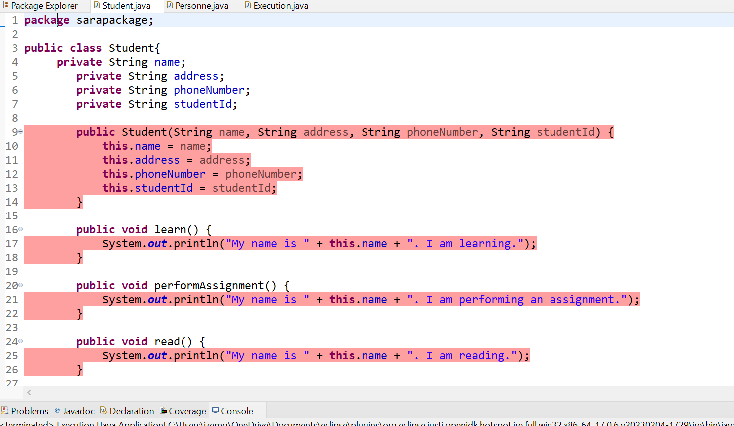

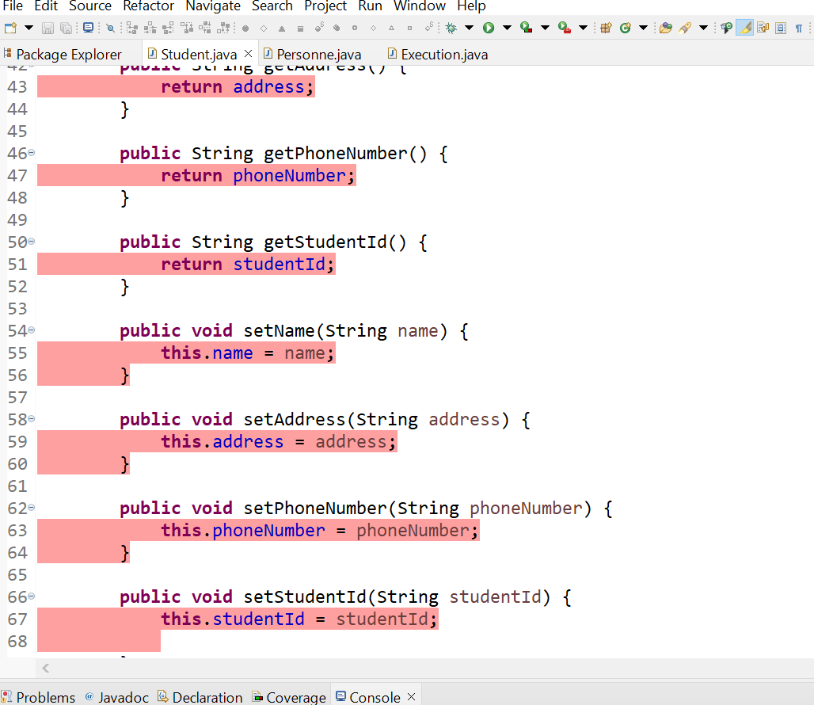

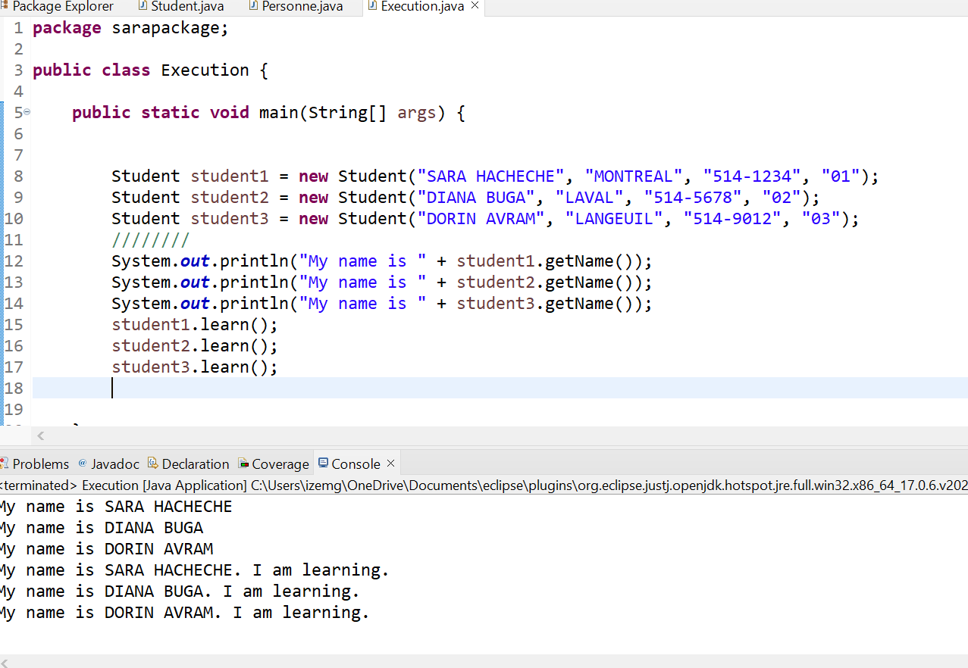

18. Create a super class called Car.

1. The Car class has the following fields and methods. ◦int speed; ◦double regularPrice; ◦String color; ◦ double getSalePrice; getSalePrice()
2. Create a sub class of Car class and name it as Truck. The Truck class has the following fields ◦intweight; and method. ◦doublegetSalePrice(); **//Ifweight>2000,10%discount.Otherwise,20%discount.**
3. Create a subclass of Car class and name it as Sedan. The Sedan class has the following fields and methods. ◦intlength; ◦doublegetSalePrice(); **//Iflength>20feet,5%discount,Otherwise,10%discount**
4. Create MyOwnAutoShop class which contains the main() method. Perform the following within the main() method.

◦Create an instance of Sedan class and initialize all the fields with appropriate values. Use super(...) method in the constructor for initializing the fields of the superclass.

◦Create two instances of the Ford class and initialize all the fields with appropriate values. Use super(...) method in the constructor for initializing the fields of the super class.

◦Create an instance of Car class and initialize all the fields with appropriate values.

Display the sale prices of all instance.

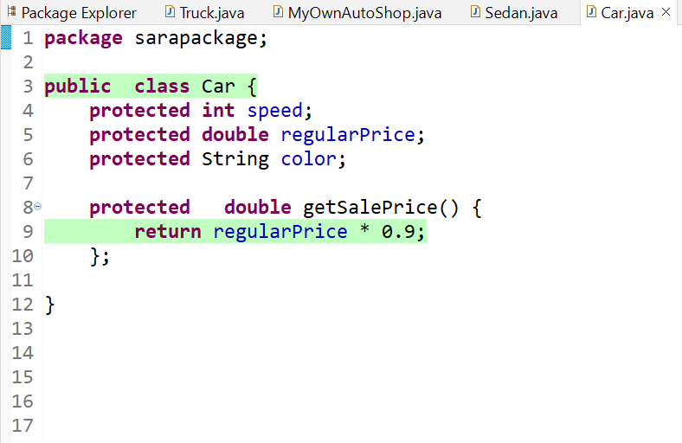

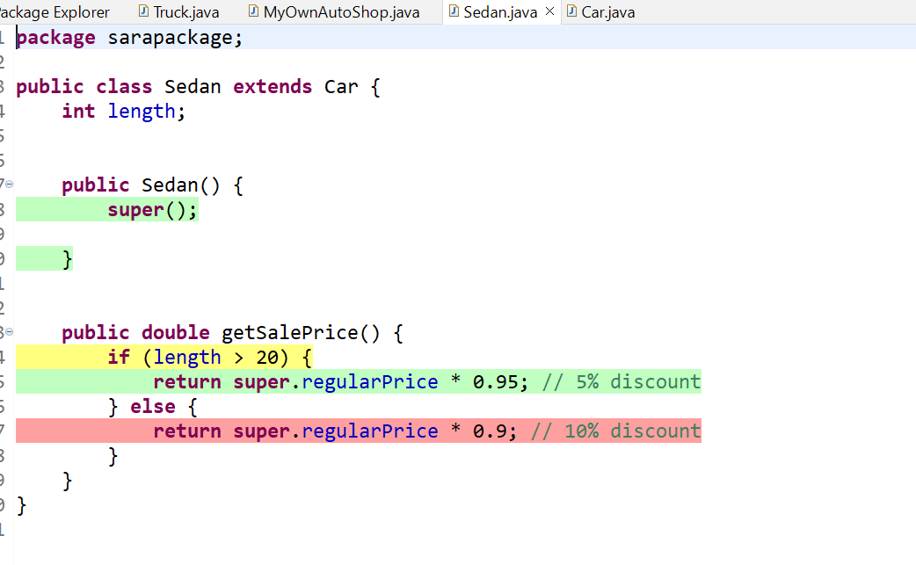

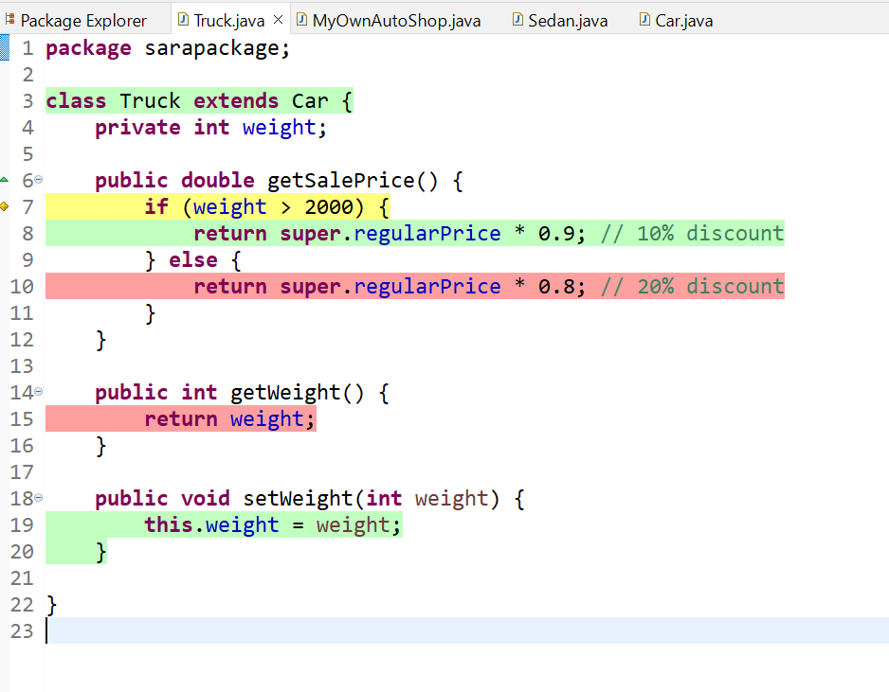

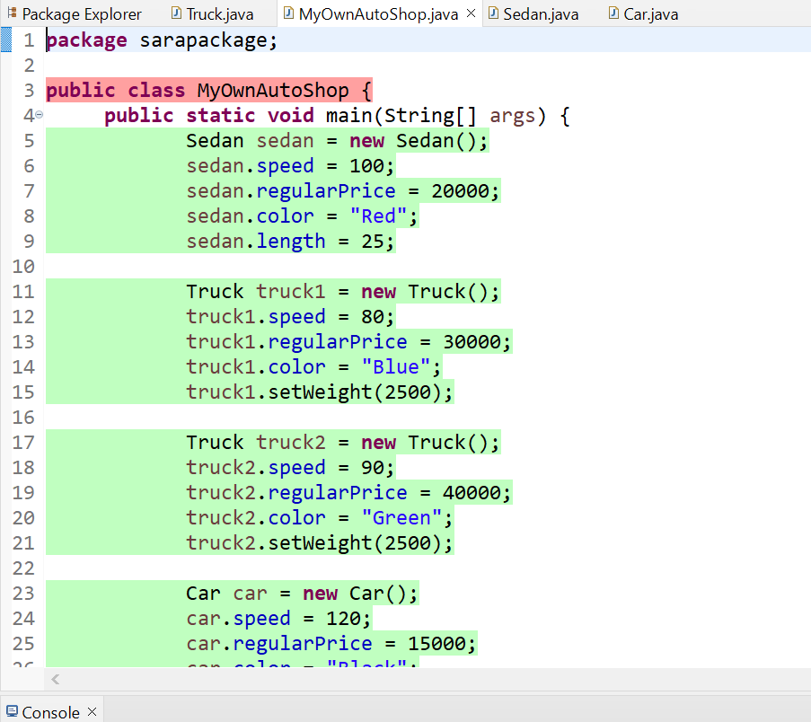

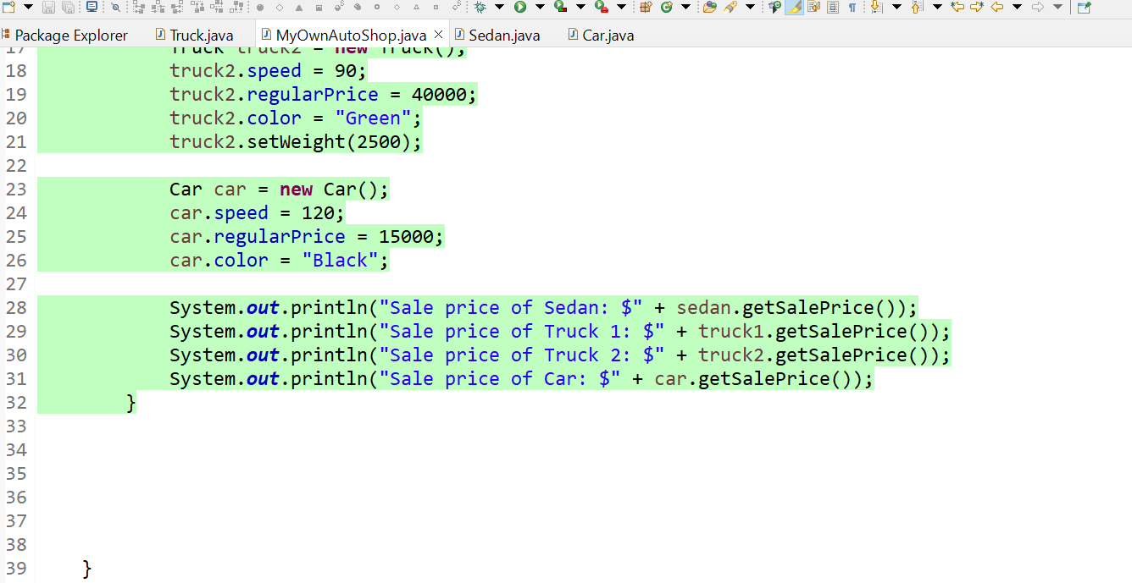

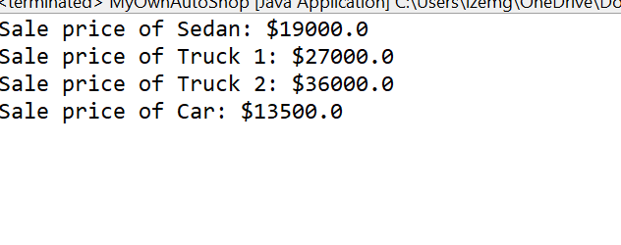

19. Create a class called Book to represent a book. A Book should include four pieces of information as instance variables‐a book name, an ISBN number, an author name and a publisher. Your class should have a constructor that initializes the four instance variables. Provide a mutator method and accessor method (query method) for each instance variable. Inaddition, provide a method named getBookInfo() that returns the description of the book as a String (the description should include all the information about the book). You should use this keyword in member methods and constructor. Write a test application named BookTest to create 5 objects for 5 elements for class Book to demonstrate the class Book's capabilities.

