29/07/2023

Sara hacheche 5672186 *aUTOMATION tESTING tools*

Lab practice Using Python and Java programming languages in Automation Testing

STUDENT NAME | COURSE NAME | INSTRUCTOR NAME/CLASS TIME/PERIOD

**ASSIGNMENT No. 2**

1. Exercise using Python

a.) Create a class named Mobile

b.) Add IEMICode, processor, make, model and color properties to the Mobile class

c.) Create a methods connectBlueTooth, sendMessage, changeColor, displayInfo in the class Mobile.

d) Write a python script that creates two instances of the class Mobile, changes their colors to Black and Pink and prints a message to the console to display the object attributes using the displayInfo method

Run the program and observe the message in Console and show it to teacher

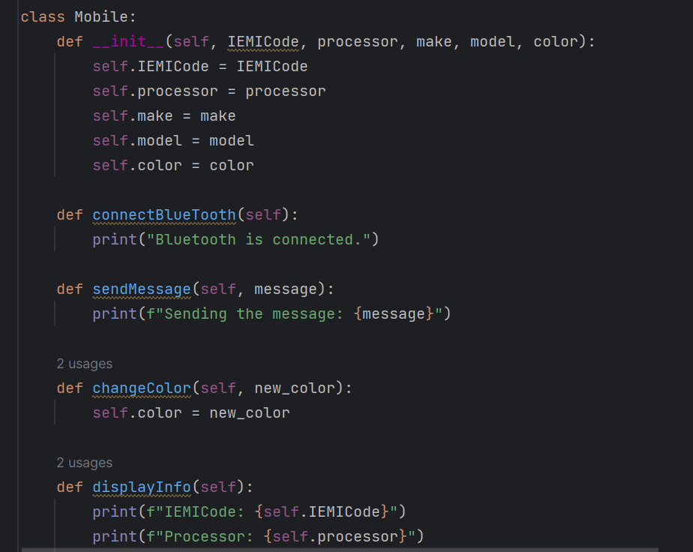

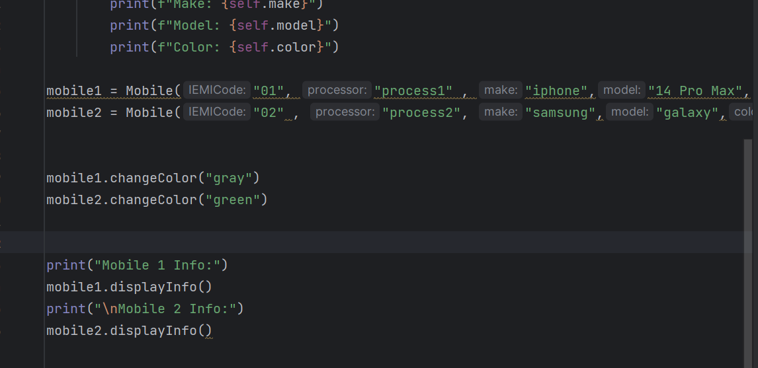

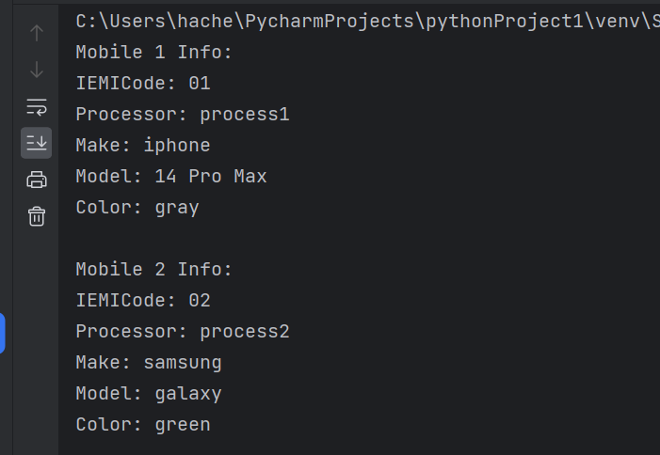

1. Exercise using Python:

Create a class Student with the states (attributes): Name, address, phone number, Student ID. Also define the behavior of student as learn, perform assignment, read, attendance, do presentation (Exemple: My name is {Name}). After that create 3 instances of the class Student and present the instance (My name is .....)

