Matrix College – Automated Software Testing Tools

**ASSIGNMENT LAB03 - XPATH**

SARA HACHECHE 5672186

1. Consider Below Html and Give 1) ABSOLUTE PATH 2) RELATIVE PATH

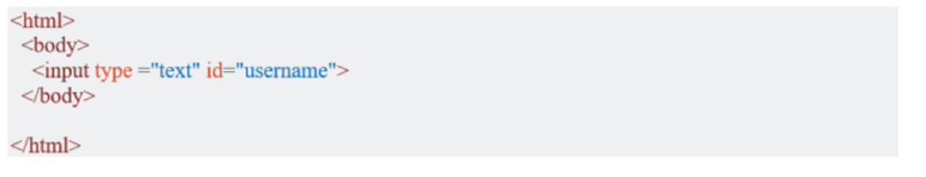

/html/body/input



/../../input

1. For this second part testing, you will use guru99 bank system as our test app, http://demo.guru99.com/V1/index.php

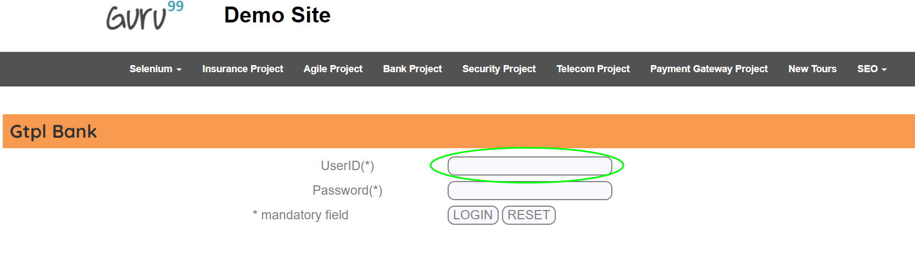

Inspect the "UserID(*)" text box using Chropath and take note of XPaths (Relative and Absolute)



//body[1]/form[1]/table[1]/tbody[1]/tr[1]/td[1]

/html[1]/body[1]/form[1]/table[1]/tbody[1]/tr[1]/td[1]