Matrix College – Automated Software Testing Tools

**ASSIGNMENT LAB03 - XPATH**

1. Consider Below Html and Give 1) ABSOLUTE PATH 2) RELATIVE PATH

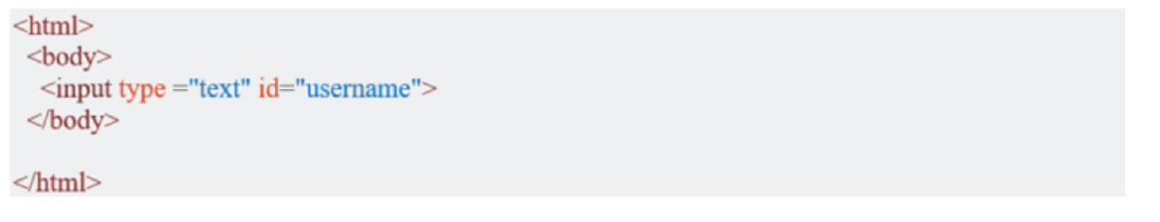



1. For this second part testing, you will use guru99 bank system as our test app, http://demo.guru99.com/V1/index.php

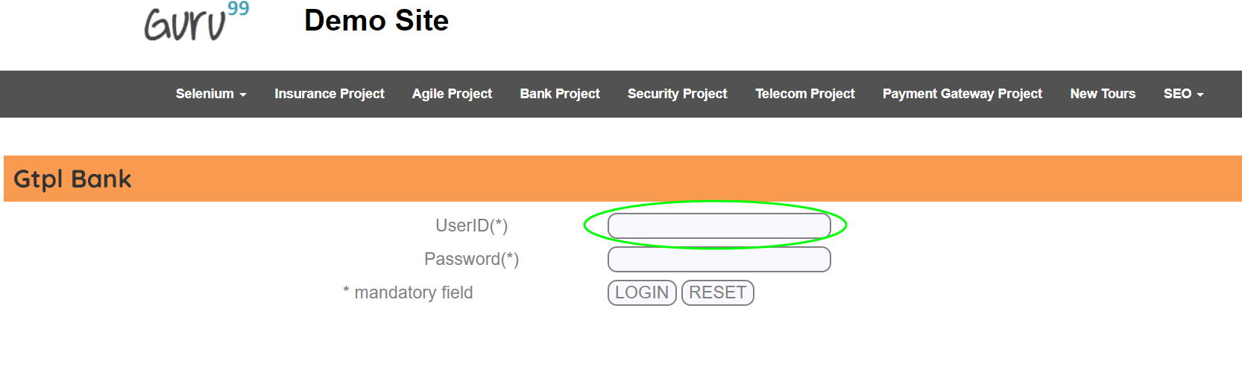

Inspect the "UserID(*)" text box using Chropath and take note of XPaths (Relative and Absolute)

