SARA HACHECHE / 5672186

1/ the types of variables

1- int

2- string

3- float

4-char

5- int

6-double

7-boolean

8-int c

2/

A- cout << "Hello Iyad!\n";

The following **cout** statement prints the text exactly

B- 2 differennt kind of c++ comments are :  
_ Single line : //

_ Multi line : /*

*/ .

C- cout << (9+1)/int(double(2));

The following code fragment prints **5.**

D- cout << double(1/2);

The following code fragment prints **0.0.**

E- cout << 1/2;

The following code fragment prints **0 .**

**3/**

The initial values of a, b, and c are 4, 2, and 5 respectively. After the first call to swap(a, b), a becomes 2 and b becomes 4. After the second call to swap(b, c), b becomes 5 and c becomes 4. Finally, the program prints the values of a, b, and c on separate lines. So, the program will output:

2

5

4

**4/**

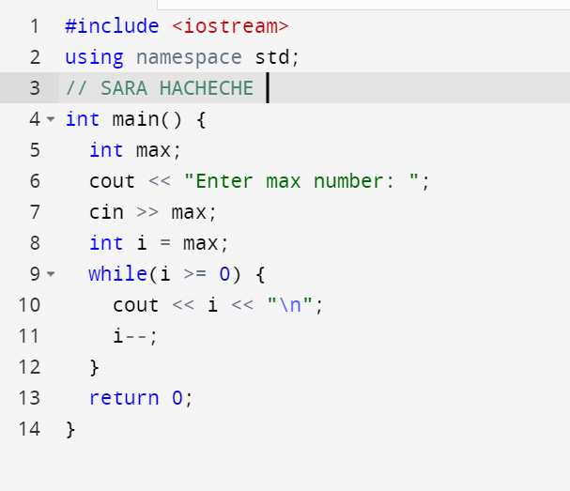

5/

In the given function, the condition **if (2 > 0)** is always true, regardless of the value of **k**. Therefore, the function will keep calling itself with the argument **k-1** until it reaches the limit of the recursion stack, which results in a stack overflow error.