## **What is Class Diagram?**

A **Class Diagram** in Software engineering is a static structure that gives an overview of a software system by displaying classes, attributes, operations, and their relationships between each other.

## **Essential elements of A UML class diagram**

Essential elements of UML class diagram are:

1. Class Name
2. Attributes
3. Operations

### **Class Name**

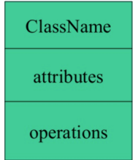

### **Attributes:**

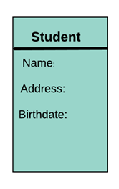

### **Relationships**

There are mainly three kinds of relationships in UML:

1. Dependencies
2. Generalizations
3. Associations

**Dependency**

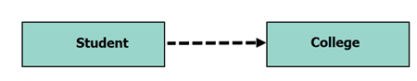

**Generalization:**

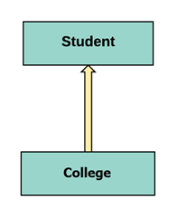

**Association:**

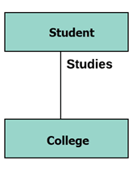

## **Example of UML Class Diagram**

Creating a class diagram is a straightforward process. It does not involve many technicalities, and now we will show you an example on eclipse .