**Hacheche Sara 5672186**

**Test case 1: (screen shot)**

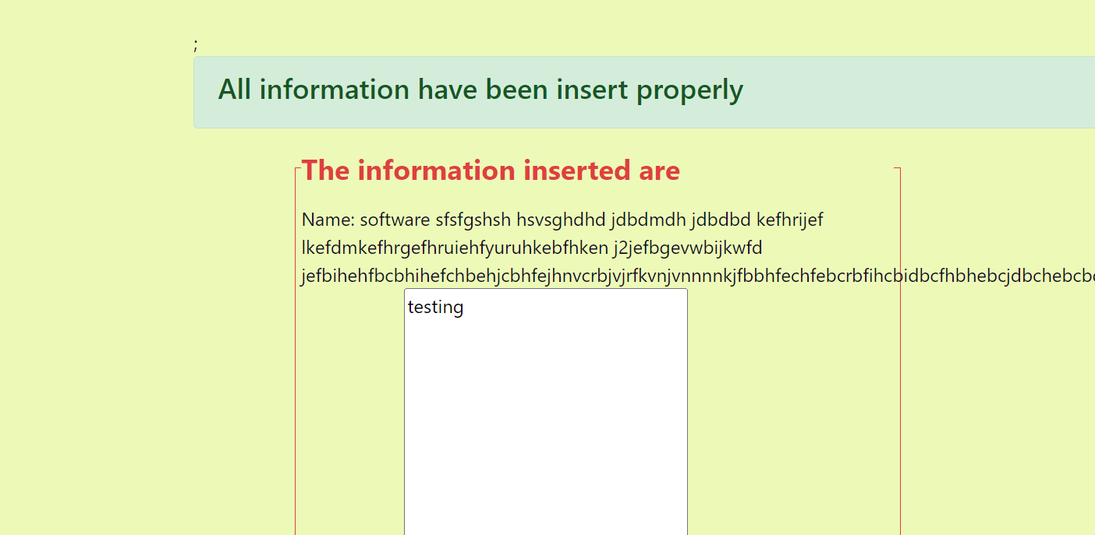

**Test case 2: (screen shot)**

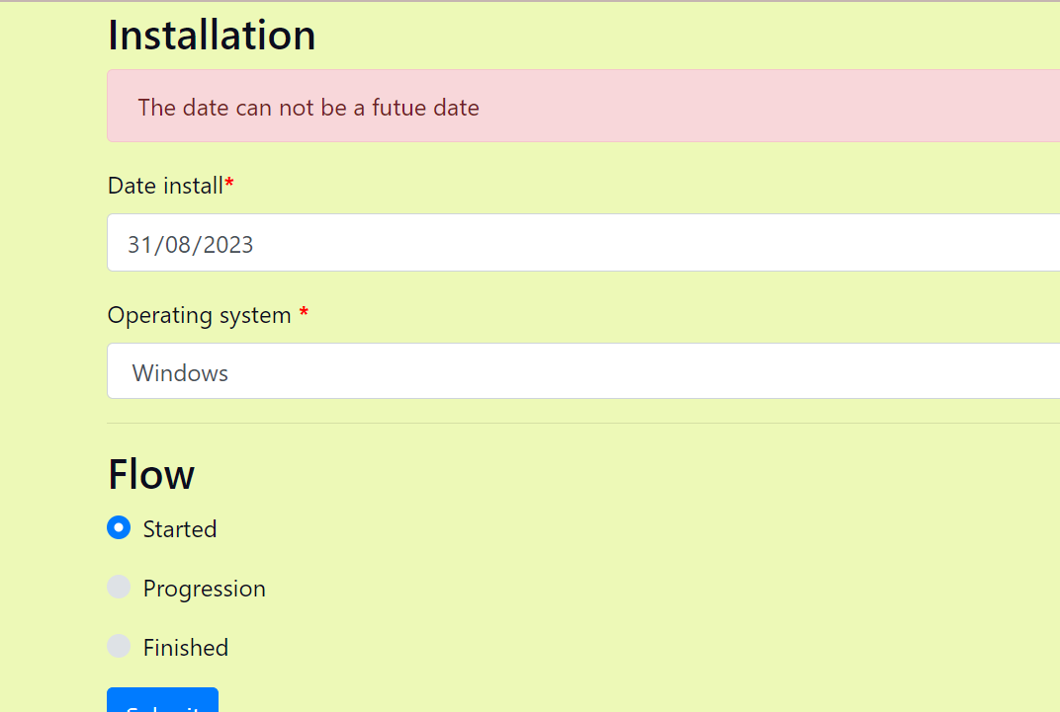

**Test case 3: (screen shot)**

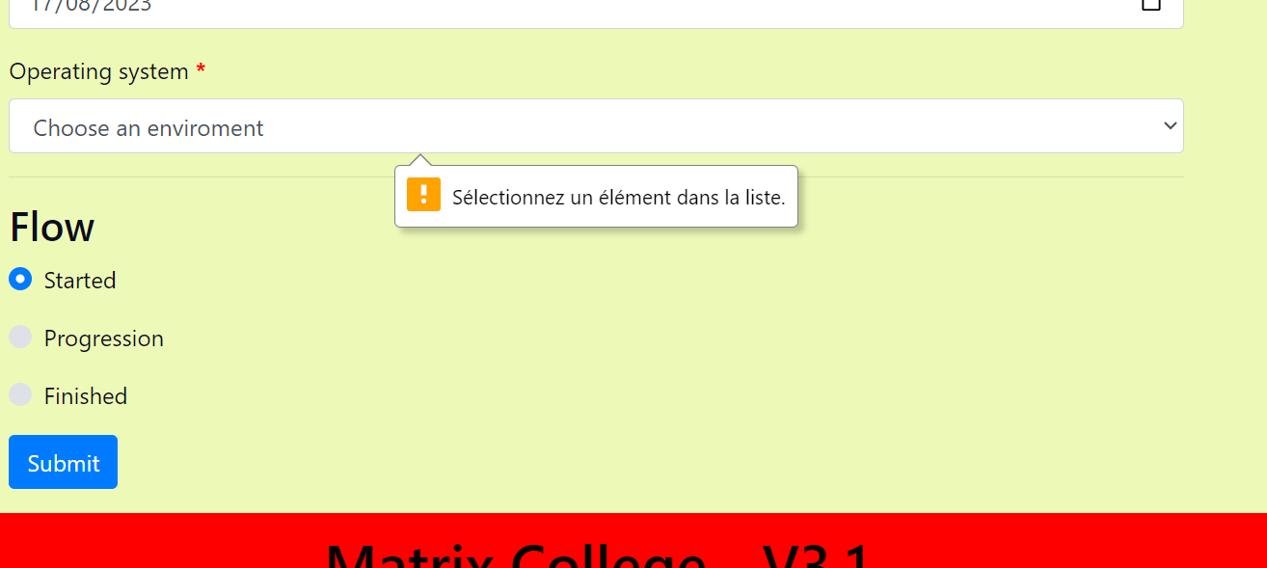

**Test case 4: (screen shot)**

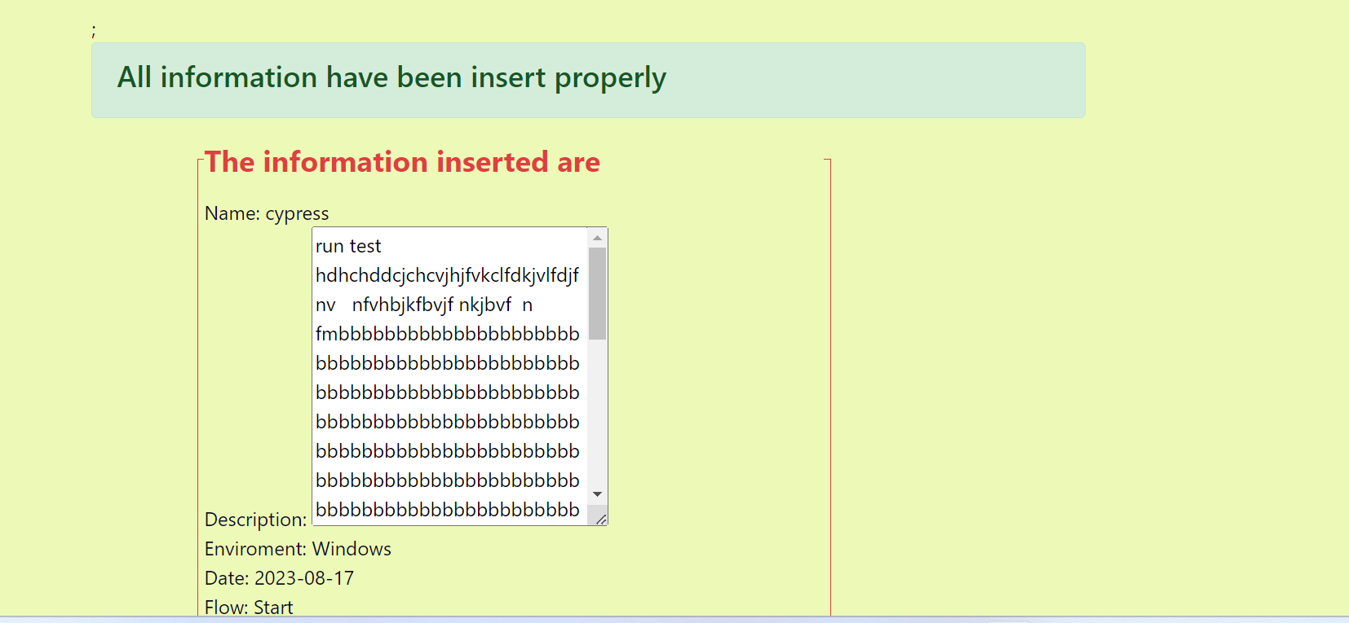

**Test case 5: (screen shot)**

