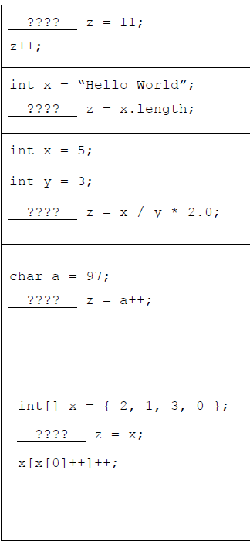  
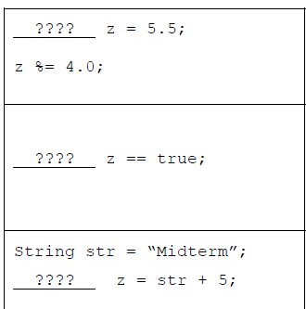

1. In the picture above (Operators and Expressions)  
     
   For each code fragment, (a) fill in the most appropriate data type in the 1st column and (b) give the value that z contains after the code has been executed in the 2nd column.

If the code would result in an error, write “ERROR” in the 1st column and give the reason for the error in the 2nd column (you do not need to write the exact error message, just a general explanation).

1. a) Write a single cout statement that prints exactly the following on the screen  
    (there are no leading or trailing spaces):   
   ’\n’ means newline   
   b) Give two examples of the two different kinds of C++ comments.   
   c) What does the following code fragment print?  
    cout << (9+1)/int(double(2));   
   d) What does the following code fragment print? cout << double(1/2);  
   e) What does the following code fragment print?  
   cout << 1/2;
2. What does the following C++ program print to the screen?   
   #include void swap(int & a, int b) {   
    int temp = a;   
   a = b;   
   b = temp;   
   }   
   int main() {  
    int a = 4; int b = 2; int c = 5; swap(a,b); swap(b,c); cout << a << ‘\n‘ << b << ‘\n‘ << c;
3. Make changes in the following program so that it uses a while loop in place of the for loop:   
   #include using namespace std;   
   int main() {   
   int max;   
   cout << "Enter max number";   
   cin >> max;   
   for(int i=max;i>=0;i--)   
   cout << i << "\n";
4. #include <iostream>

using namespace std;

int sum(int k) {

if (k > 0) {

return k + sum(k - 1);

} else {

return 0;

}

}

int main() {

int result = sum(10);

cout << result;

return 0;

}

What is the result of sum(2)