**Windows Lab 2**

**Files, File Searching and File Attributes**

**Objective:** To use the file search function in Windows 10

At the end of this lab, you will be able to perform searches based on the following:

* File attributes
* File size
* File types
* Simple search
* File compression
* Advanced Search
* Wildcards

**Instructions**

## It is important that you complete this and other lab sheets even though you feel you are familiar with Windows 10.

**Use the Help option in Windows 10 and the internet to find out information on doing the following tasks.**

**Complete each task in this document and record the answers (in your own words).**

**This completed sheet will then be useful for later use.**

**File Attributes**

Attributes or properties of a file are used to describe a file and how it is intended to be used.

File size, File name, File extension, Date created, Date modified, File type (read-only, system, hidden etc), owner etc. are all examples.

These are set automatically when the file is created and some maybe changed by the user (filename)

whilst others can’t be changed (date created).

## Task 1

Find out the file extensions for the following file types. (The first one is done).

|  |  |
| --- | --- |
| **File Type** | **Extension** |
| Word Document | *.docx* |
| Text File |  |
| Excel Document |  |
| Microsoft PowerPoint presentation |  |
| Java source file |  |
| Internet webpage |  |

# Task 2

Create a text file using notepad called **Cities.txt** with the names of the world’s 5 largest cities.

* In Windows Explorer, select the Cities.txt and press enter.
  + Which application does the file open up in?
  + Why?
* In Explorer rename the file from Cities.txt to Cities.xlsx
* In Explorer, select Cities.xlsx and press enter.
  + Which application does the file open up in?
  + What seems to be the problem?

[Research] What do the following file attributes mean in Windows and write down a brief description for each.

* Read only:
* Hidden:
* Archive:
* Compress:
* How do you set the Read-only attribute?
* Can you delete a read-only file?
* How do you get into the option that turns on/off the display of hidden files?
* Can you delete a hidden file?
* If you copy a read-only file is the copy you make also read-only?

# File Size:

One of the attributes (properties) of a file is the file size. All information on a computer is stored digitally as a binary number. An operating system abbreviates these measurements, eg 1 megabyte becomes 1MB (megabyte). Storage capacities and file sizes are measured (from lowest to highest) in:

* bits
* bytes
* kilobytes
* megabytes
* gigabytes
* terabytes

1. **bit** can be used to represent 2 pieces of data. (0 and 1)
2. **bits** can represent 4 pieces of data. (00, 01, 10, 11)
3. **bits** can represent 8 pieces of data. ( , , , , , , , ) etc.… = 23 pieces of data.
   * 8 bits can represent 28 pieces of data =

o 8 bits is called **1 byte**.

* + 1 byte could be equal to 1 character (digit, letter or symbol)
  + 10 bytes approx. 1 word
  + 100 bytes approx. 1 sentence

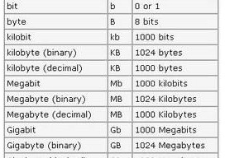

**Task 3**

Complete these:

210 bytes = **1 kilobyte** = bytes (it’s not 1000, why?? ) 210 kilobytes = **1 megabyte** = bytes

210 megabytes = **1 gigabyte** = bytes 210 gigabytes = **1 terabyte** = bytes

See the following articles for info on Bits and Bytes:

* <http://www.bettersolutionspc.com/bits-vs-bytes-whats-the-difference/>
* <http://www.athropolis.com/popup/c-comp2.htm#explanation>

# Searching

## Basic Search

The search facility on Windows is used to locate files or folders anywhere on your system using their attributes. If you know the exact details of the filename/ folder name that you are looking for, the Search option will find its location for you. The advantage of the Search is that it will also search for files / folders whereby only **partial** details are known:

Examples:

* All files that start with the letter F.
* All Word document files.
* All files less then or equal to 10 KB in size.
* All text files that start with the word report.

Look at the Search facility in Windows via Windows Explorer – it helps you locate files/directories.

For any search you will need to identify what folder and drive you want to search in and also type the search criteria in the search box.

See the diagram below, there are two arrows. The first one is pointing to the directory or folder on the drive where it is going to search for the files. In this case it is going to search from the root of the C: drive. The second arrow is pointing to the search box. It is here that you write the criteria for the search. Find these yourself:

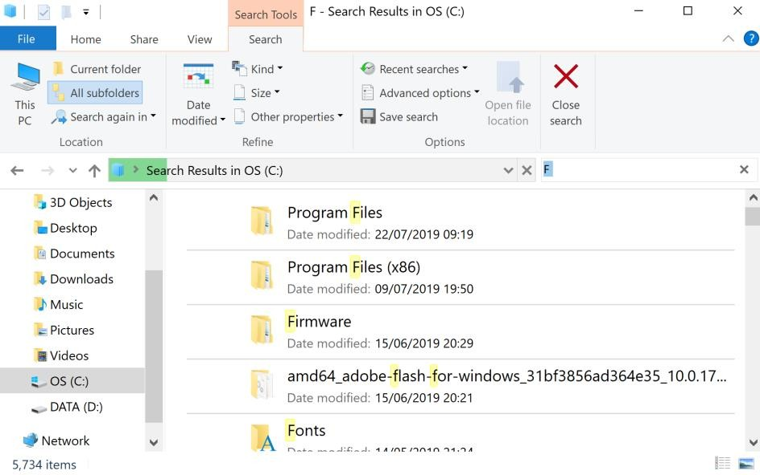

## Task 4

Using the View icon on the toolbar and change the view to Details.

* Find the file named **calc.exe** on drive C
* You may find 4 of them located on the C drive. Choose one of them:
* In which folder is it located?
* Locate the file in the folder and check how large the file is in kilobytes?
* When was it created?
* When was it modified?
* Execute this application. What does it do?

## Task 5

Complete the following table.

|  |  |  |  |
| --- | --- | --- | --- |
| 3 Kilobytes | bytes |  |  |
| 2 Megabytes | bytes | KB |  |
| 3.5 Megabyte | bytes | KB |  |
| 4.7 Gigabyte | bytes | KB | MB |
| 2.1 Terabyte | bytes | KB | MB |

* Find files which are between 1 - 16 Megabytes on the C: drive.

o What option did you choose and set in the search box?

You have used **size** as the attribute in the Search Filter.

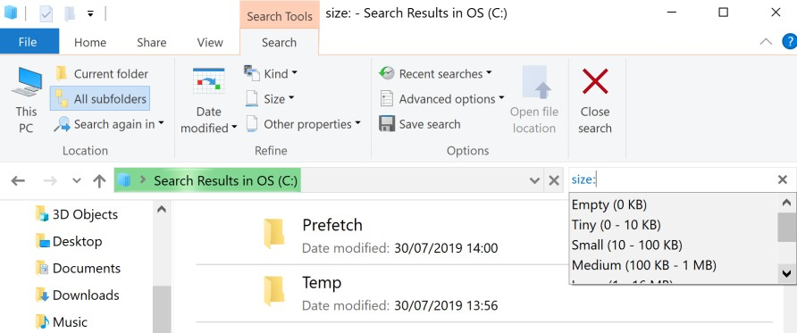

Now sort the list of files displayed in size order (largest files first and smallest files last).

* Change directory to the Program Files\Java directory on the C: drive
* What is the **parent** directory of Java?
* Change to it’s parent directory. How do you do this?

# File Compression:

Sometimes it is necessary to reduce the size of a file in order to save space or transmission time. This is known as file compression. A compressed file can always be expanded back to its original size also. Windows has a compression facility but it is also possible to download some freeware compression software to do this.

Research the names of 4 compression programs.



What does compression do with to a file?

Are there any disadvantages to file compression that you can think of?

Create a document in Paint using black & white colours only. Save this file twice.

* Once as a bitmap and call it Plain.bmp and
* Second as a Monochrome bitmap file and call it Mono.bmp

Record the size of Plain.bmp

Record the size of Mono.bmp

1. **Zip** is an example of a compression program. It should be installed on your computer in the lab. It is a free compression program very like Winzip. Compress each of the files Plain.bmp and Mono.bmp individually using the 7-Zip program. How much compression can you achieve?

Compressed size of Plain.bmp using 7-Zip

Compressed size of Mono.bmp using 7-Zip

What different file formats can you compress to e.g. zip, rar? Which of these do you think is the most efficient? Do some tests! Compare compression of files using rar and zip.

|  |  |
| --- | --- |
| **RAR Files** | **Zip files (not WinZip or 7-Zip)** |
|  |  |
|  |  |

# Advanced Search Options

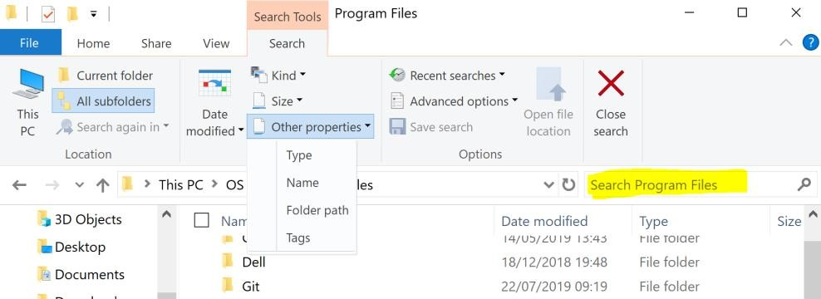

Windows will usually search for whatever you type in the Search box by looking in the file name, file contents, and file properties of all the files in the current view. Type "Summer," for example, and it will find files named "sunset in summer.jpg," files tagged with "summer," and files written by anyone named Summer. This broad approach to search usually helps you find your file quickly.

If you want to search more selectively, however, you can filter your search in the Search box by specifying which file property/attribute to search. To filter by file property, separate the name of the property and the search term with a colon, as these examples show:

|  |  |
| --- | --- |
| **Examples** | **Use this to** |
| **Name:Sunset** | Finds only files that have the word sunset in the file name. |
| **Size:<10KB** | Finds only files whose size is less than 10 KB. |
| **Modified: 05/25/2006** | Finds only files that have been modified on that date.  You can also type **Modified:2006** to find files changed at any time during that year. |
| **Type:word** | Finds only MsWord files. |

Which file properties can you use in this way? Anything you see in a folder, you can filter by any property that appears in the file list headings.

## Task 6

* + Find all files which have the word **report** in the name of the file on the C drive.
    - What file attribute are you searching under?
    - What did you type into the search box?
  + Find all files which are larger than 15 Megabytes on the C drive.
    - What file attribute are you searching under?
    - What did you type into the search box?
  + Find all files which were created in September of this year.
  + Find all Executable files (Applications) on the C: drive.

***Adding operators***

One way to refine a search is to use the operators AND, OR, and NOT. When you use these operators, **you need to type them in all capital letters**.

|  |  |  |
| --- | --- | --- |
| **Operator** | **Example** | **Use this to** |
| **AND** | tropical ***AND*** island | Find files that contain both of the words "tropical" and "island" (even if those words are in different places in the file). In the case of a simple text search, this gives the same results as typing "tropical island." |
| **NOT** | tropical ***NOT*** island | Find files that contain the word "tropical," but not "island." |
| **OR** | tropical ***OR*** island | Find files that contain either of the words "tropical" or "island." |

Search for all files in the Windows directory on the C drive that have the word **report** and **system** in the filename.

* + Write the path of the directory chosen for the search
  + Write down your search string:

Search for all files in the Windows directory on the C drive that have the word **Font** but not **Windows** in the filename.

* + Write down your search string:

**Note:** You can combine **different criteria** when carrying out a search. For example:

Search for all files in the Windows directory on the C drive whose size is **less than** 10KB and who do not have the word **Font** in the filename.

* + Write down your search string:

**More on Search:**

**How Windows treats the wildcards * and ? can be different to how you might expect it to behave in some cases. You need to examine carefully the results of the searches. Complete the following searches and examine the results.**

Search option with wildcards. A wildcard is a character that is used in search to represent one or more other characters.

The two common wildcard characters are:

**\*** : used to represent zero or more characters

**?** : used to represent exactly 1 character.

So search using **three*mice**

could represent threemice, three **blind** mice, three **hundred and one** mice, three**747**mice etc..

Search using **three?mice**

Could represent three**5**mice, three**X**mice, three**o**mice etc...

## Task 7

Create the following 6 files and save them into a folder called **Reports** on the C drive: **Monday.docx, Tuesday temp.docx, tap.txt, Thursday.txt, Fri temp.docx, ton.txt**

* + Search for all files that start with the letter ***t*** in the folder Reports
    - Write the path of the directory chosen for the search:
    - Write down your search string:

**Note:** It will return any file which has a word in the filename beginning with the letter t or it’s file extension begins

with the letter t.

* + How many files are found as a result?
  + Search for all Microsoft Word files in the folder Reports. Write down your search string.
  + How many files are found as a result?

Search for all files which have the word **day** as the last part of the file name and are Microsoft Word files in the folder Reports. For example files with names such as Monday.docx or Tuesday.docx

* + Write down your search string:
  + How many files are found as a result?

Search for all files on the **C drive** that start with the letter t and the last letter is p and have three characters in the filename.

* + Write down your search string:
  + How many files are found as a result?

## Examine the results of this search..They are not correct!!

# Number System Quiz For Binary, Decimal, And Hexadecimal

**10 Questions** |

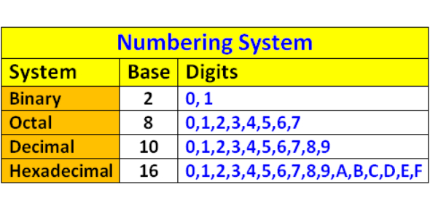

Ready for our number system quiz for Binary, Decimal, and Hexadecimal? Mathematics is a unit that is concerned with numbers. Decimals are number systems that use the digits as of 1 to 9. A decimal system can be of different bases, such as 10 or 100. What do you know of the application of decimal systems? Study of Binary, Decimal & Hexadecimal Number Systems will explain it all. Go ahead with the quiz and learn everything you need to know.

Top of Form

Bottom of Form

Questions

* **1.**Convert the binary number 11001 to decimal. The answer is:
  + A. 25
  + B. 13
  + C. 3

* **2.**Convert the decimal number 45 to binary:
  + A. 11100
  + B. 101101
  + C. 10100

* **3.** Convert the hexadecimal number B2 to binary:
  + A. 100011
  + B. 11011
  + C. 10110010

* **4.**Convert the binary number 11011 to hexadecimal:
  + A. 1A
  + B. B1
  + C. 1B

* **5.**Convert the decimal number 20 to hexadecimal:
  + A. 14
  + B. 11
  + C. 1B

* **6.**Convert the hexadecimal number 2C to decimal:
  + A. 3A
  + B. 34
  + C. 44

* **7.**Convert the binary number 10101100 to its decimal equivalent:
  + A. 162
  + B. 172
  + C. 182
  + D. 192

* **8.**Convert the decimal number 168 to binary equivalent:
  + A. 10101110
  + B. 01000100
  + C. 10101000
  + D. 11101000

* **9.**Convert the hexadecimal number 0x2301 to its binary equivalent:
  + A. 0010001100000001
  + B. 1111110011111110
  + C. 1111000011001010
  + D. 0000001111110000

* **10.**Covert the binary number 11010010 to a decimal number.
  + A. 75
  + B. 150
  + C. 210
  + D. 310

**End of Windows Lab 2**

**Page left intentionally blank for notes**