Matrix College Management, Technology and Healthcare. AEC

User Story with Design

Step 1: Create a filesystem in your Linux operating system using Linux terminal. With respective commands.

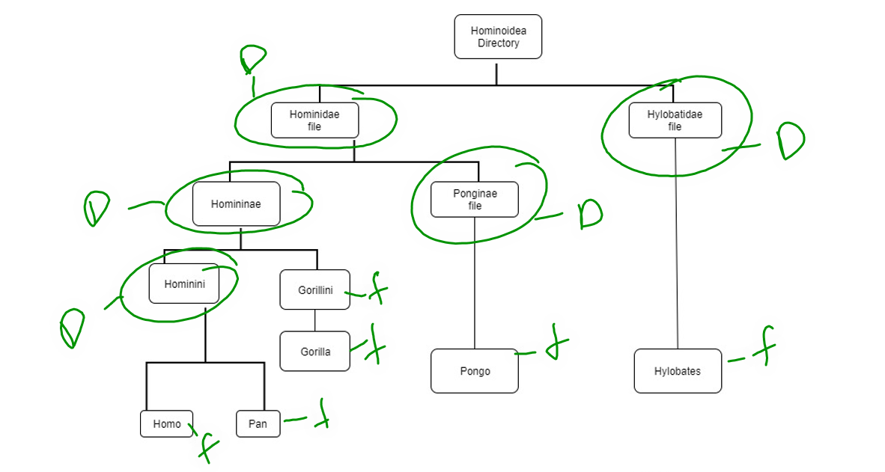

Step 2: After you compete creating above file system in your Linux operating system, now try to move and copy the file and directory as follow.

1. Move PONGO file into HYLOBATIDAE directory.
2. Copy GORILLA file into HOMININI directory and RENAME GORILLA to GORININI.
3. Copy HOMO & PAN files into PONGINAE directory.
4. Rename HYLOBATES to HUMANS AND MOVE to PONGINAE directory.
5. Rename Main director (HOMINOIDEA) to SUPER_HUMAN.