ASSIGNMENT # 7

1. Make a simple activity diagram to enroll one course at the college.
Example for the activities: A student sends a request to enroll course at college and the student fills the admission/request form
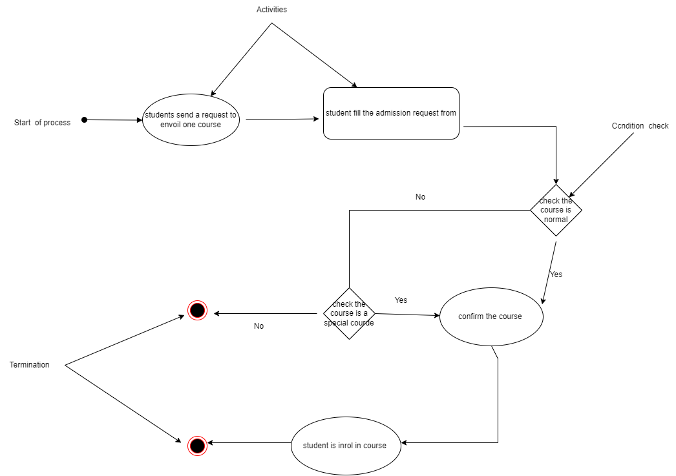
2. Analyze the last activity diagram and explain it in between 15 and 20 lines.
In the UML language, an activity diagram provides a view of the behavior of a system by describing the sequence of actions of a process. Activity diagrams are similar to information processing flowcharts in that they show the flows between actions in an activity. Activity diagrams can show simultaneous parallel flows and alternate flows.
In activity diagrams, you use activity nodes and activity edges to model the flow of command and data between actions Activities diagrams are useful in the following phases of a project
Before starting a project, activity diagrams can be created to model the main workflows.
During the requirements phase, activity diagrams can be created to illustrate the flow of events described in the use cases.
During the analysis and design phases, you can use activity diagrams to help define the behavior of operations. Generally in the UML language an activity diagram provides a view of the behavior of a system by describing the sequence of actions of a process.
A UML diagram provides a visual representation of one aspect of a system. UML diagrams illustrate quantifiable aspects of a system that can be described visually, such as relationships, behavior, structure, or functionality.
3. Make a simple Use Case Diagram, following the example in the slide # 8 Restaurant:
Student – Course
Examples to include in the diagram: Time classes, assignments, exams, etc.
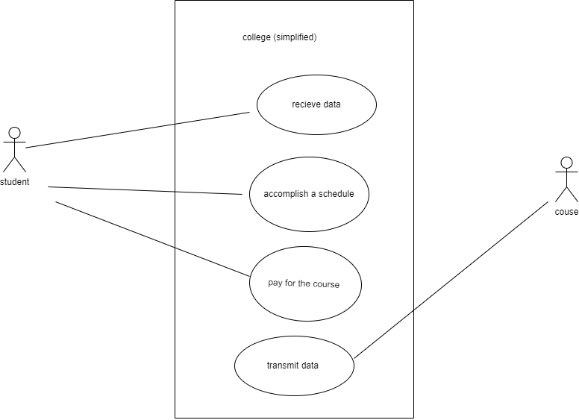
4. Make a simple Use Case Diagram, following the example in the slide # 9 Bank ATM:
Teacher / Administration – Student
Examples to include in the diagram: Send a mail to the student, receive the response from the teacher, etc., receive a bill to pay from administration, receive information about the course from administration, send a mail from administration, etc.
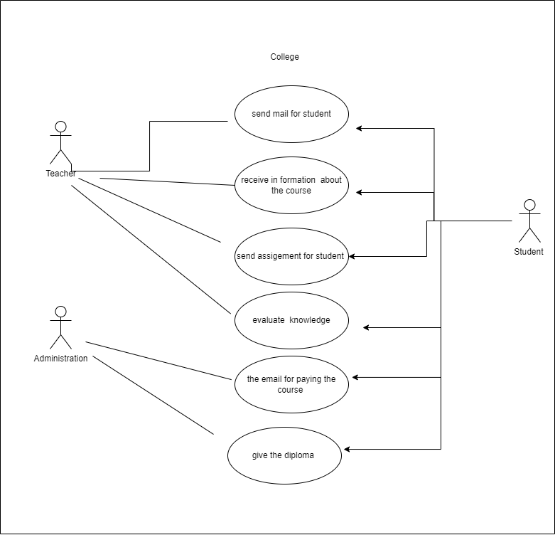
5. Make a simple Sequence Diagram, following the first example in the slide # 2 ATM:0mnivox
: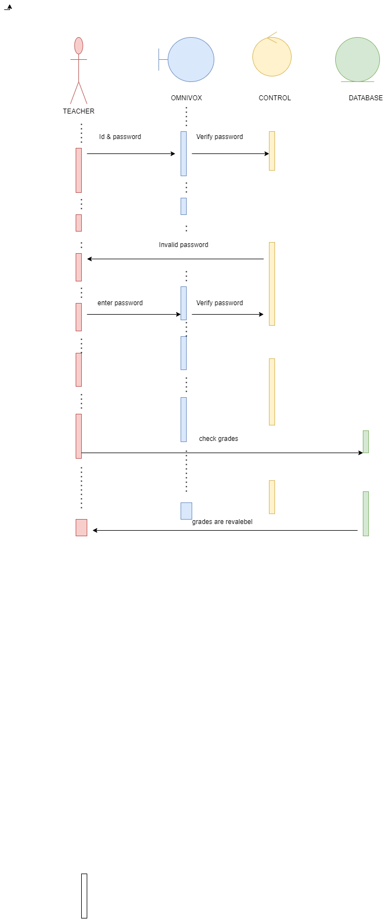

6. Make a simple Sequence Diagram with the following information:
Student / MIO / Teacher:
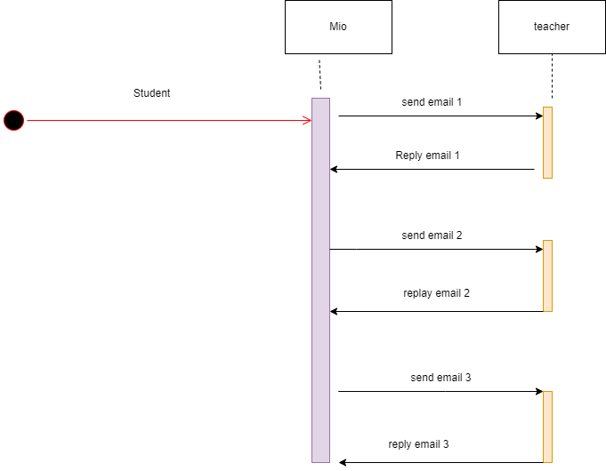
7. Explain using your own words each one of the seven Dynamic / Behavioral UML diagrams. (Please don’t copy and paste). You can make a table.
Dynamic /behavioral UML diagrams | Explanation
Activity diagram | an activity diagram provides a view of a system's behavior by describing the sequence of actions in a process. Activity diagrams are similar to information processing flowcharts in that they show the flows between actions in an activity.
Sequence diagram | The sequence diagram is used to show the interactions of objects within the framework of a scenario of a use case diagram.
State machine diagram | A state machine is a programming architecture that allows dynamic flow to states based on previous state values ​​or user input.
Timing diagram | Time diagrams are used to visually explain the various behaviors of objects in a system over a period of time
Interaction overview diagram | An object-interaction diagram is the representation of the studied object and of the interactions with the other objects of the surrounding space. It makes it possible to model the balance of the forces applied to the studied system
Comunication diagram | A communication diagram is an interaction diagram it represent a combination of information taken from Class, Sequence, and Use Case Diagrams
Deployement diagram | A deployment diagram is one that shows the runtime architecture of a system and the middleware that connects them. Deployment diagrams are typically used to visualize the physical hardware and software of a system

8. Make a simple Class Notation, following the example in the slides # 5 and 6 Student & Bank Account:
Library: (Search a book in the library). This information is for any book in the library.
Examples to include in the diagram: Attributes: Author, Book Name,
Main topic, Number of pages, etc.
Operations: Available / Not Available, Deposit for the Loan / Free Loan
Internal Use / External Use, etc.
Responsibilities: Maximum Loan Time, Extra Payment for Extra Use, etc.
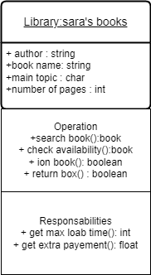
9. Make an Object Notation:
Library.
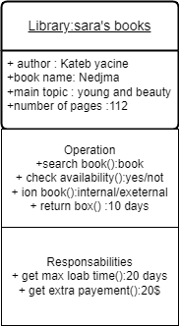
10. Make a simple Association Notation, following the example in the slide # 17 employee / account:
Student / College
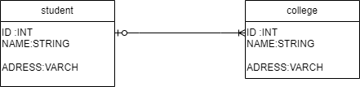
11. Multiplicity:
A) Student / college
B) Employee / Account
