**Windows Lab 6 Operating Systems s Hypervisors**

**SARA HACHECHE 5672186**

**Objective:** To install an Operating System and use a Hosted Hypervisor.

At the end of this lab, you will be able to:

* Use a hosted hypervisor
* Know how to install and configure an OS
* Use an ISO file (an archive file of an Optical Disk)
* Setup and use a proxy server
* Examine how a disk is laid out
* Edit disk partitions and create volumes

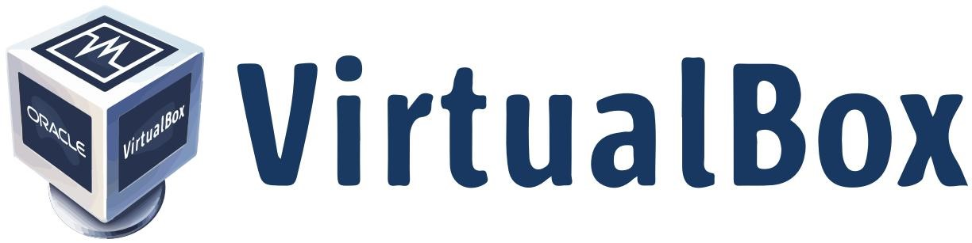

# Instructions

**It is important that you complete this and other lab sheets even though you feel you are familiar with the content.**

**Use the Help option and the internet to find out information on doing the following tasks.**

**Complete each task in this document and record the answers (in your own words).**

**This completed sheet will then be useful for later use.**

## Introduction

The local workstations in the labs have the Windows 10 Operating System installed on them. This OS is run from the hard disk (Drive C) located inside these workstations.

Virtual Box is a **software application** which allows you to run several pseudo or ‘virtual’ operating systems on one of these workstations. Virtual Box Player is an example of a **Hosted Hypervisor**.

Each workstation is a single physical computer - however we can start Virtual Box and run a number of different virtual machines on this single physical computer (the local host machine). Each virtual machine can have its own operating system (e.g. Linux, Windows, Mac OS etc.)

## Virtual Machines and how they work

Install Virtual Box on your hope Laptop or Desktop.

* Please make sure you choose Virtual Box and alternative software as the images will then not correspond ▪ We are going to install Windows 10 as a Virtual Machine

Virtual Box allows you to install another operating system on the local computer, this is also known as a virtual machine. You will use this to install another Windows operating system. We will be using 50GB of the local hard disk (C: Drive) to install the new virtual machine.

**What is happening?**

We are using Virtual Box to install another operating system onto the local computer’s hard disk. The local machine will be Windows 10 and the Virtual Machine will also be Windows 10.

* The new copy of Windows 10 runs as a virtual machine. Once installed using Virtual Box we will do some basic configuration on our newly installed operating system.
* Your new Windows 10 VM can only be booted and run through the Hypervisor (Virtual Box).

## Task 1

Explain in what a Hosted Hypervisor is: _______A hypervisor, also called a virtual machine monitor, is a process that creates and runs virtual machines. It allows a host computer to support multiple guest VMs by virtually sharing its resources, such as memory and processing_____________________________________________________________________________________________

**Install Windows 10 on Virtual Box**

|  |  |
| --- | --- |
| **Image** | **Steps** |
|  | **Start Virtual Box**   * You will get an image like this * Select the option ‘Machine’ -> ‘New’ to Create a New Virtual Machine |
|  | **Give the VM an Identifier**  ▪ Example o Win 10 |
|  | **Give the VM RAM** ▪ 2Gb in this example |
|  | **Give the VM a (virtual) Hard Disk**   * Select Virtual Disk Image * And ‘Dynamically’ Allocated |

|  |  |
| --- | --- |
|  | **Disk Capacity**   * Provide the size of the Hard Disk for the   VM   * Give the VM 50G * Click ‘create’ |
|  | **You should now see a screen similar to this.**   * You have created an empty virtual machine template that can have a Windows 10 operating system installed in it   **You now need to install Windows 10**   * Click **Start** * As this is the ‘First Boot’, the VM will boot up and look for installation media * In this instance a virtual CD-ROM |
|  | **Click the ‘Browse’ folder icon**   * Here, attach a Windows 10 ISO file to the Virtual CD/DVD ROM device * **Download the Windows 10 ISO file from**   **Blackboard and save it to a USB**   * **Due to the size of the file (>4Gb) you should do this in college** |

**You will then need to install Windows 10 to this Virtual Machine by following the prompts as requested**

**This can take anywhere from 30 minutes up to an hour (depending on the speed of your host machine)**

**The system will reboot a number of times, there are instances where you will have to be careful what options you select during the install**

**Here is a list of the common screens you will see during the install process.**

## Task 2

Proceed through the install process, as per images below/following pages

|  |  |
| --- | --- |
| **1**    Select Next | **2**  Custom Install |
| **3**    Select Next | **4**    This can take up to 30/45 minutes |

|  |  |
| --- | --- |
| **5**    System may need to reboot (a few times) | **6**    Install says ‘Just a moment’ (a lot)...  They lie - it takes a long time... |
| **7**  **Do not sign in with your Microsoft Account**  Select ‘Domain join instead’ | **8**    Create a ‘dummy’ account and password  I used the username: Student and Password: student |
| **9**    There will be a few of these data collection options, there are 8 or 9 of these questions.  I typically say no or limit the amount of data I share | **10**    Some more waiting thrown in for good measure! |

**You**

**now**

**have**

**two**

**Operating**

**Systems**

▪

Your

workstation

(

physical

PC

/Laptop

)

and

a

▪

Virtual

Win

10

OS

(

accessed

through

Virtual

Box

software)

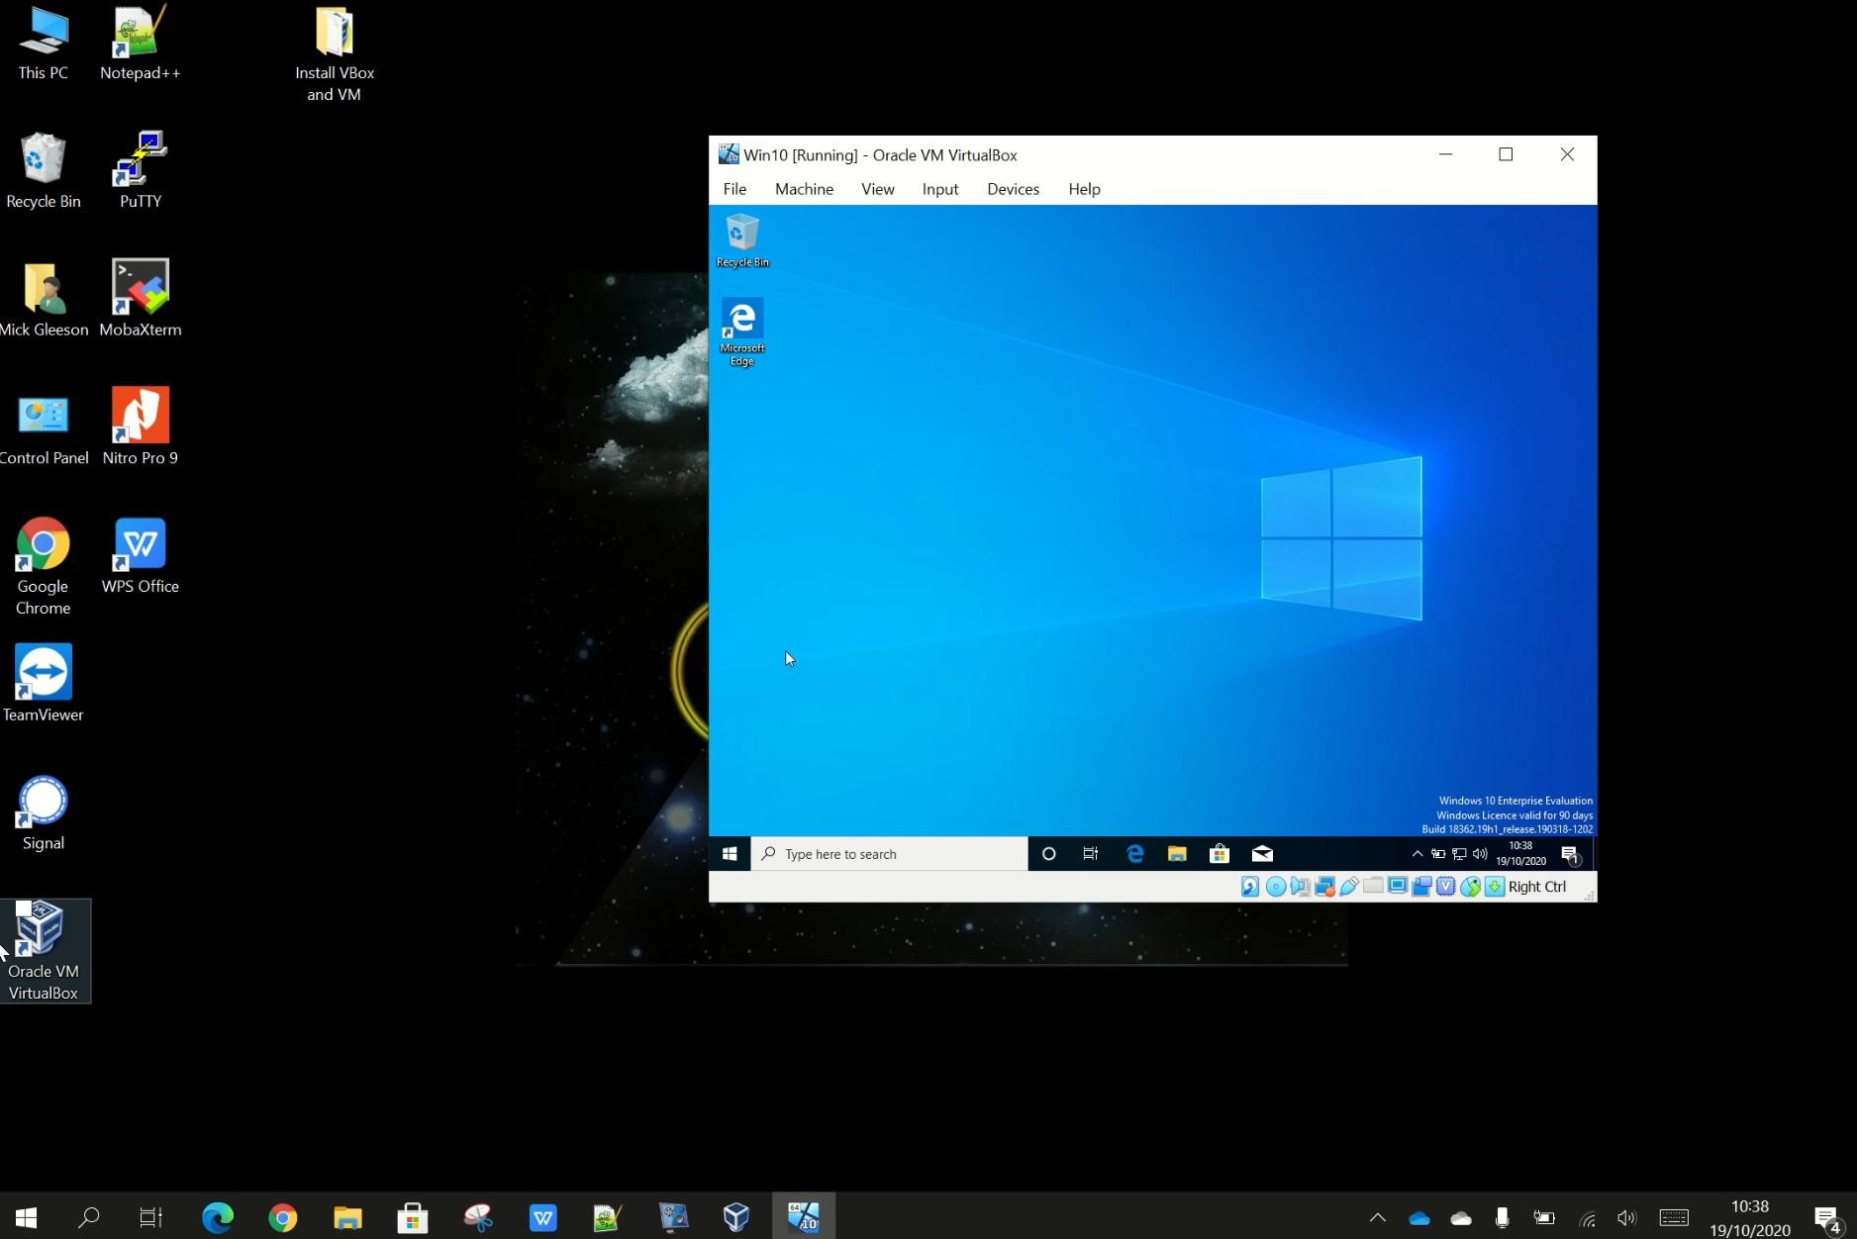

## Task 3

Imagine you have a local computer with an empty/blank C hard drive. What would you do in order to install Windows 10 or Linux etc. onto it?

__ I first install windows in my local machine after I install linux in the virtual machine

____________________________________________________________________________________________

___Compare the difference between installing an OS on a local pc versus a virtual machine ?

__ A virtual machine is an operating system or application environment that is installed on specialized software called a virtual machine monitor that emulates the underlying hardware or operating environment.

_____________________________________________________________________________________________ Compare the difference between installing an OS from an ISO image versus a CD/DVD?

_ We can install a guest operating system from a CD-ROM or an ISO image. Installing from an ISO image is generally faster and more convenient than installing from CD-ROM____ _____________________________________________________________________________________________

**Examining how your disk is laid out**

In the search bar, on the taskbar type in **diskmgmt.msc** and press enter. A screen similar to the one below will appear. Examine the data presented on the screen.

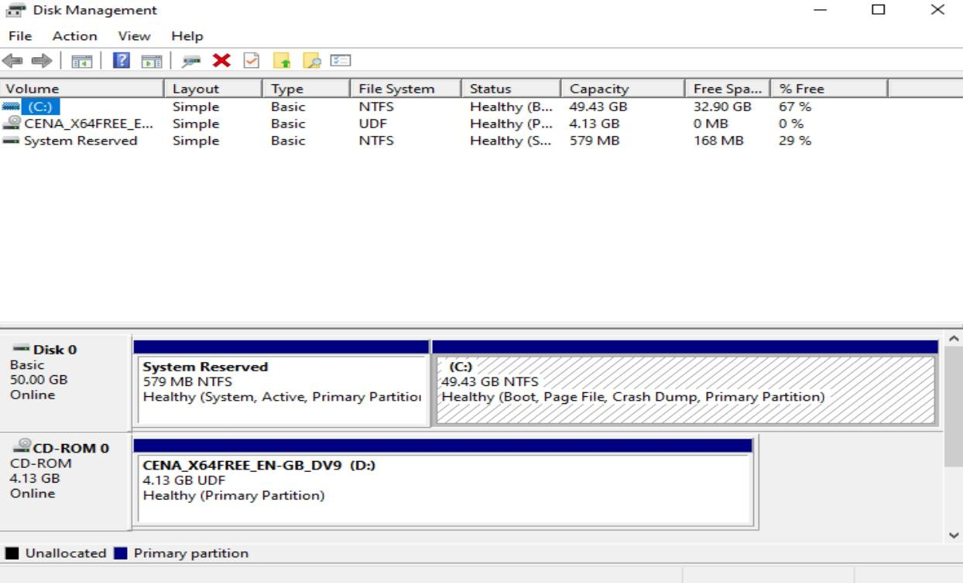

**Shrinking a Volume**

What does shrinking a volume do?

_____ the measure of each angle is preserved.

We will shrink the size of the volume to create space for a new partition. Firstly, see the instructions on how to do this from: <https://www.tenforums.com/tutorials/96288-shrink-volume-partition-windows-10-a.html#option1>

Shrink the volume as per screenshot below... what’s that in GB? 32,7GB_____________________________

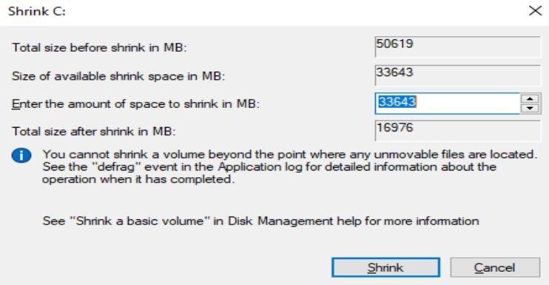

After the shrink the following screen is displayed (Note: the **unallocated space**)

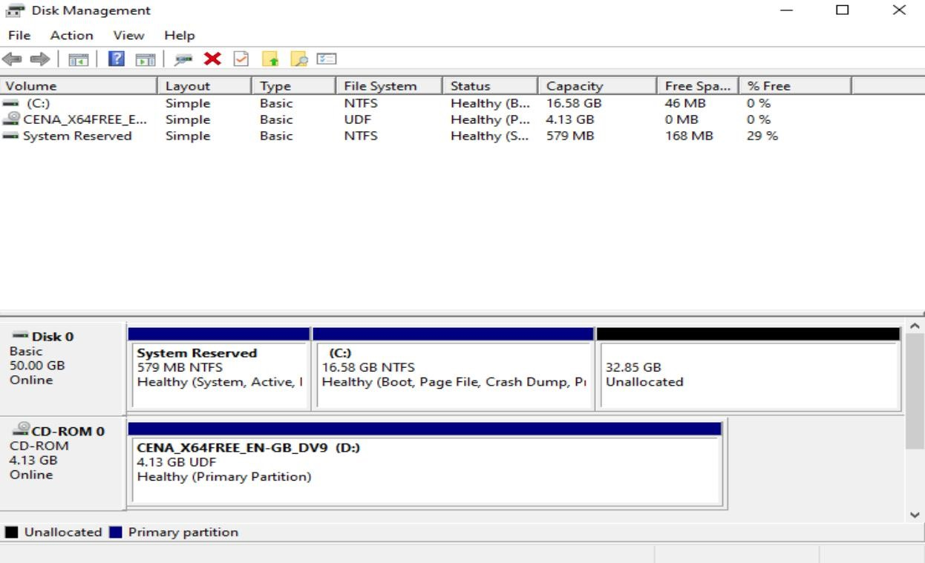

**Task 4**

Create a new volume of 33643 MB using the following link: [https://www.businessinsider.com/how-to-partition-a](https://www.businessinsider.com/how-to-partition-a-hard-drive-in-windows-10?r=US&IR=T)hard-drive-in-windows-10?r=US&IR=T

When you are creating the New Partition your can assign the letter Z to the new partition. The **file format** you choose should be **NTFS**. The **allocation unit size** should be set to **Default**. The allocation unit size could be set to one of the following:

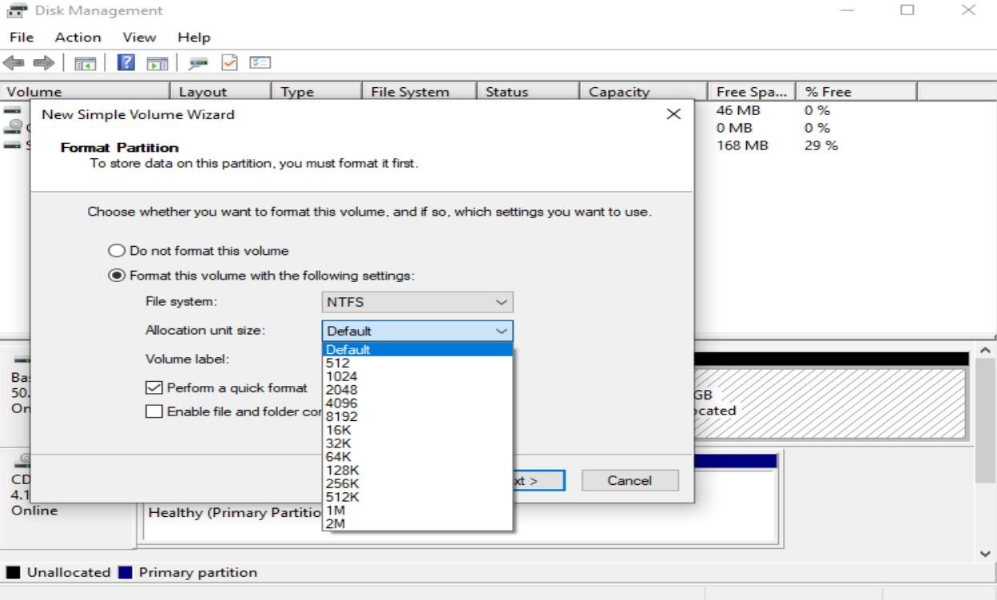

|  |
| --- |
| [Online Research] |

What is the allocation unit size and what is it used for in an operating system?

___71 GB_______ ____Summary. All file systems that are used by Windows organize your hard disk based on cluster size (also known as allocation unit size). Cluster size represents the smallest amount of disk space that can be used to hold a file. _______________________________________________________________________

Once you click next, a confirmation screen appears. Click Finish.

Now, a screen like the one below should appear:

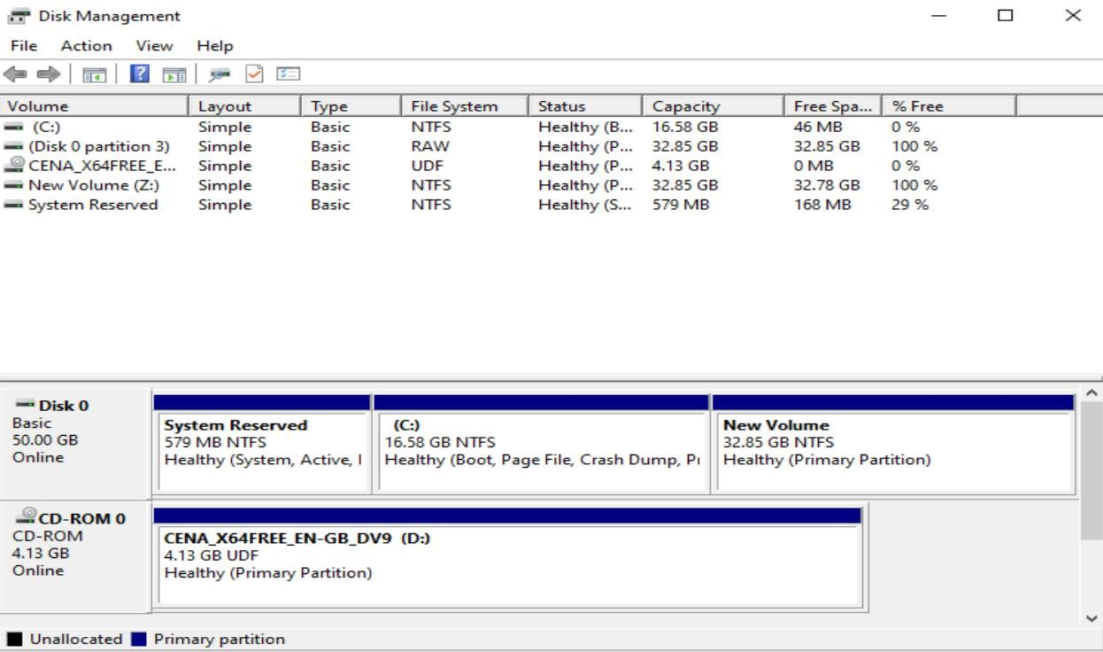

|  |
| --- |
| [Online Research] |

We asked for a 33643 MB Partition. Why does it say 32.85 GB in the screen above?

There's a difference between the partition size that is specified in MB in the installer, and the disk capacity that is shown in Windows Explorer. That difference is the size of one block or "allocation unit", which is 4KB for any NTFS volume over 2GB; and that block is the first block on the partition, to hold the boot sector of the disk (512 bytes). The rest of the block is unused, so that all blocks are "aligned" on the disk____________________________________________________________________________________________ _____________________________________________________________________________________________

## Viewing the new partition in Windows Explorer

Close all open windows… Start Windows Explorer, you should see a drive C and a Drive Z.

Right click on the drive letter for your newly formatted drive. What drive letter? __Z

Choose properties and determine the capacity as reported by Windows Explorer.

Capacity:32,8GB

What is the name of the filesystem (as reported by Windows Explorer)

File system: NTFS

What is the significance of the drive letter C or any other drive letters?

The letter-naming scheme for disk drives dates back to the early days of DOS. The letters A and B were reserved for the floppy disk drives, whereas C was assigned to main hard disk partition which had the operating system and related system files

_____________________________________________________________________________________________ **Deleting a Partition**

You can delete partitions when they are no longer needed. What will this do to the data stored there?

If you delete a partition from the hard drive, you will erase all data on it, and your drive will show as the unallocated space on the computer. You can use the unallocated space to create a new partition.

Delete your new partition. Were you able to delete it? __no

_Before the disk space of the deleted partition can be used again, you must first create another partition there.

## Formatting Your Drive

Remember, when we created a new partition above, it went through a formatting stage. Format actually means to prepare a storage medium, usually a disk, for reading and writing. A brand new hard drive cannot be used until it has been formatted.

* When you choose to run a **Full Format** on a volume (or partition), files are removed from the volume that you are formatting, and the hard disk is scanned for bad sectors. The scan for bad sectors is responsible for the majority of the time that it takes to format a volume.
* When you choose to run a **Quick Format** on a volume (or partition), format removes files from the partition, but does not scan the disk for bad sectors. Only use this option if your hard disk has been previously formatted and you are sure that your hard disk is not damaged.

There is another important difference between Full format and Quick format in Windows.

A full format will wipe clean your drive just like a new hard drive. This involves writing zeroes to every data byte on every track, obliterating any previously recorded data. This is not done in a quick format.

If you format your drive using the quick format, can the data files be recovered from the disk? __no

___________

Why? When formatting a disk, it is this allocation table that is emptied. Thus, the computer is convinced that the files are deleted since it can no longer find information on their location in the allocation table. The computer is no longer able to find them. But if we use another special software we can recovered all data

____________________________________________________________________________________

____________________________________________________________________________________________

If you format your drive using the full can the data files be recovered from the disk? Yes _________________

Why? __it possible to recover data a formatted hard disk using special data recovery tools _____________________________________________________________________________________

____________________________________________________________________________________________

Do you need to format other disks before you use them? DVDs , USB keys etc..? ____yes

Why? ___all storage device need to be formatted before use ____________________________________________________________________________________

____________________________________________________________________________________________ **Note:** To format the primary partition of your C drive you need to boot (start up) from another device.

Why? _______

it will wipe out everything on the C drive. The reason you can't format it from inside is because the current Win 7 boot files, and or XP files, are on that drive. Every version of Windows places files on the main, Disk 0 (C:\) drive no matter what other drive it is installed to.

____________________________________________________________________________________________

If you decide to upgrade and install a second hard drive, how would you format it?

In the Settings for the VM, drop the existing one, go to Storage/Add Hard Disk, give it a size, and its done._________________________________________________________________________________________ ____________________________________________________________________________________________

What is a disk image? <http://en.wikipedia.org/wiki/Disk_image>

__A disk image is a snapshot of a storage device's structure and data typically stored in one or more computer files on another storage device

What is an **iso** file? <http://www.fileinfo.com/extension/iso>

__An ISO file is a common CD or DVD disc image format based on the ISO-9660 standard. It contains an exact duplicate of data from the original disc, which includes the data saved on the disc as well as the filesystem information, such as directory structures, file attributes, and boot code. ISO files are often used for making copies of CDs and DVDs.________________________________________

____________________________________________________________________________________________

Find out how much space is the operating system using and how much space is free for other applications.

__133 GB FREE

AND 70,9 GB USED

Find out how much RAM is available on the system. 8.00 GB (7.86 GB usable)

## Partitions

|  |
| --- |
| [Online Research] |

Find out what a partition is. Use the following web site as an initial source of information.

▪ <http://en.wikipedia.org/wiki/Disk_partitioning>

Provide a brief explanation in your own words here:

Disk partitioning or disk slicing is the creation of one or more regions on secondary storage_Separating user data from system data can prevent the system partition from filling up and rendering the system unusable.________________________________________________________________________________

_____________________________________________________________________________________________

_____________________________________________________________________________________________

|  |
| --- |
| **End of Windows Lab 6**  **Page left intentionally blank for notes.** |