Assignment # 01
Name: Sara Ajmal
Reg.no: FA24B1-SE-030
Section: B
Subject: Cloud Computing
Submitted to: Sir Waqas

Task 1: Install Gitea and Push a Repository from the Ubuntu Server
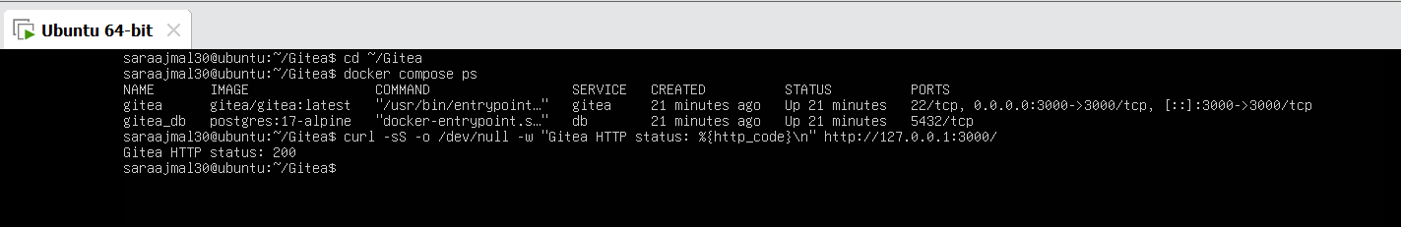
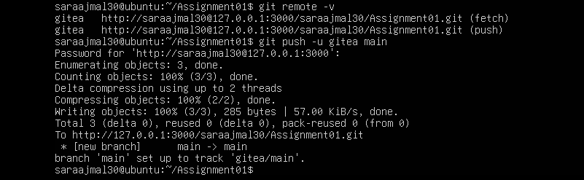
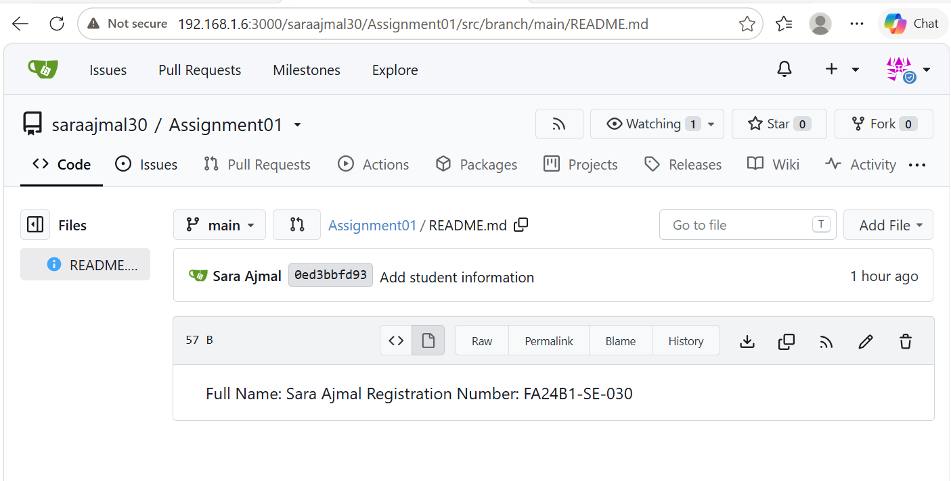
I installed Docker and Docker Compose on my Ubuntu server and started Gitea with PostgreSQL using the instructor’s compose.yaml. I then created a local repository, added a README with my name and registration number, and pushed it to Gitea using a personal access token.
Task 2: Push the Same Repository to GitHub
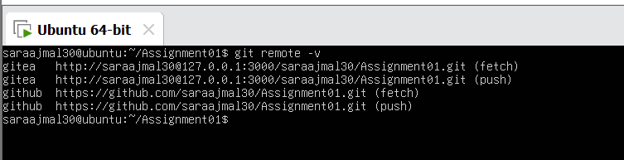
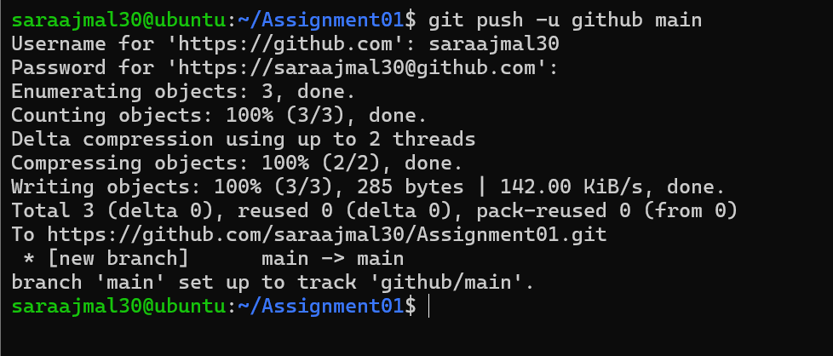
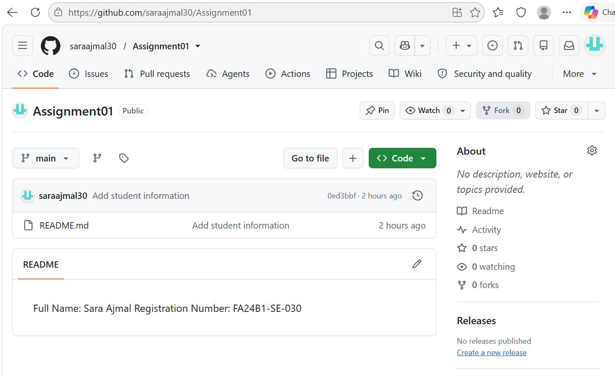
I created an empty public GitHub repository named Assignment01 and added it as a second remote called “github” next to the “gitea” remote. I then pushed the main branch to GitHub and verified the repository and README on GitHub.
Task 3: Track Three Large Files with Git LFS
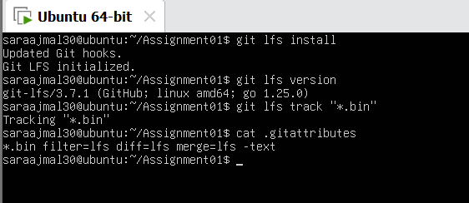
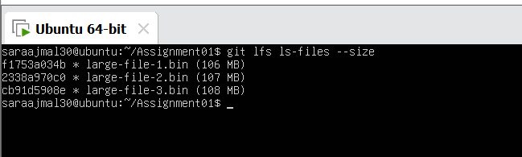
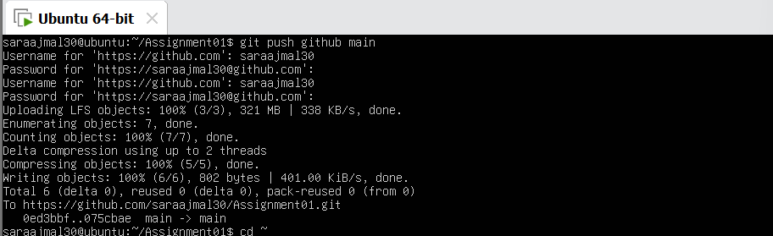
I initialized Git LFS, configured it to track *.bin files, and created three files, each larger than 100 MiB. I verified them with git lfs ls-files --size, then committed and pushed them to GitHub, where the LFS upload completed at 100% (3/3).
Task 4: Create a Portfolio or CV with GitHub Pages
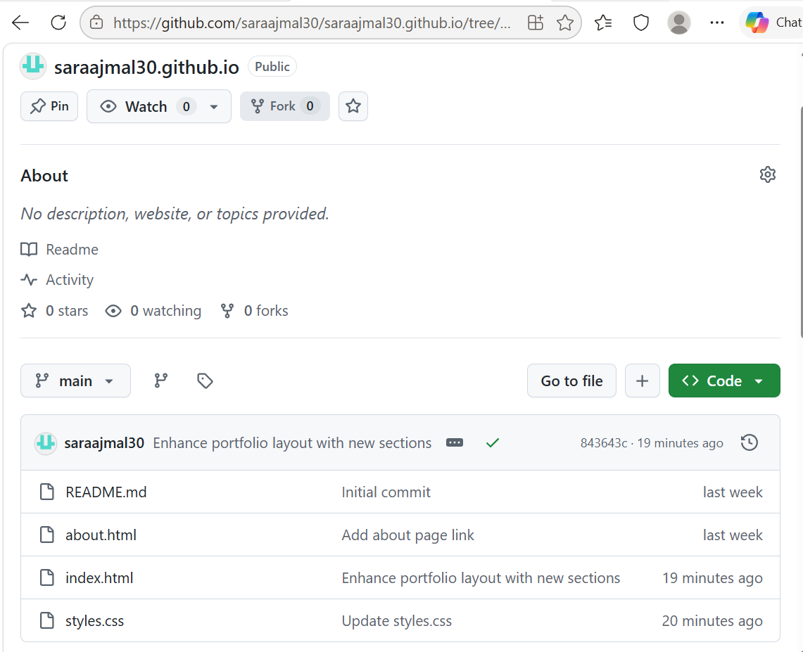
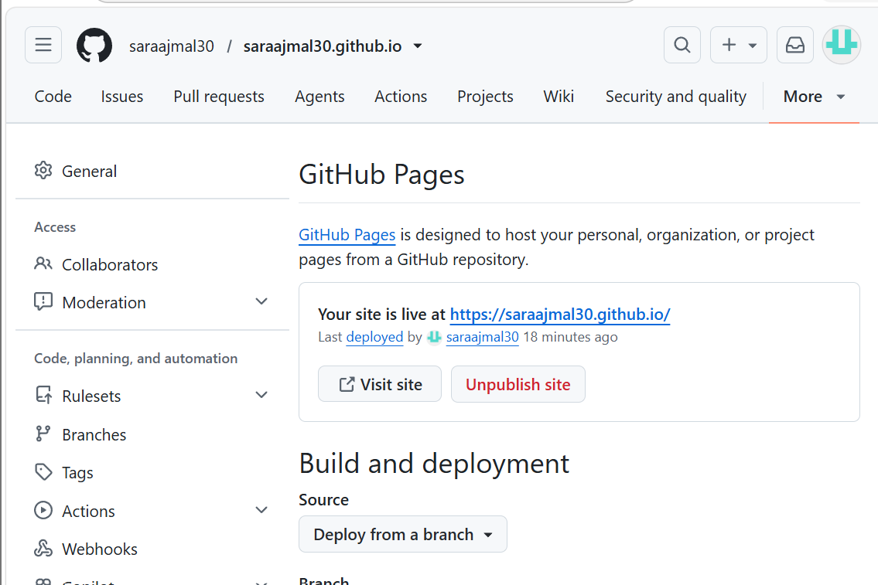
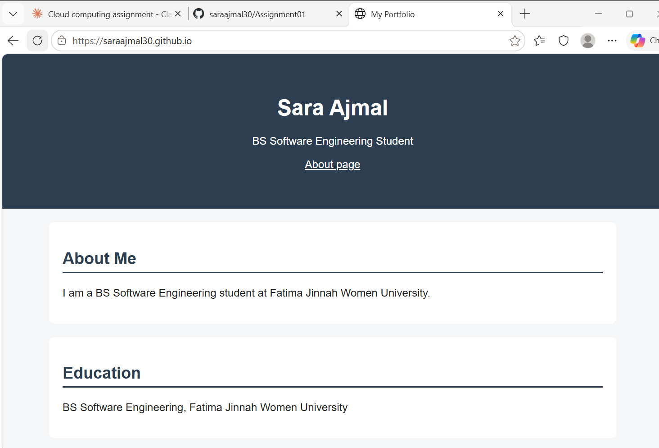
I created a portfolio using HTML and CSS (index.html and styles.css) with About Me, Education, Skills, and Projects sections, and pushed it to my public repository saraajmal30.github.io. I then enabled GitHub Pages from the main branch (root) and verified that the live site loads.

