BDA400 DATA SCIENCE TOOLS AND TECHNIQUES

Assignment 2
Technical Analysis Using R
Preliminary Stage
Student
Sara Alnaameh
Course
BDA400 - Data Science Tools and Techniques
Repository
TechnicalAnalysis
GitHub repository link
https://github.com/saraalnaamea/TechnicalAnalysis

Project Overview
This report documents Sara Alnaameh’s technical-analysis workflow in R. The script read SHOP.TO, RY.TO, and TD.TO from portfolio.txt, downloaded one year of daily Yahoo Finance data, calculated a 20-day simple moving average and descriptive statistics, and saved CSV tables and chart files under Assignment_2/outputs. The captured RStudio run completed for all three symbols, with 251 observations per symbol from November 4, 2025 through November 3, 2026.

Repository and Project Files
The assignment materials belong in an Assignment_2 subdirectory within the TechnicalAnalysis repository, as required by the course instructions.
Path | Purpose
Assignment_2/portfolio.txt | One stock symbol per line.
Assignment_2/scripts/technical_analysis.R | Functions to import stock data, calculate statistics, and write tables and charts.
Assignment_2/reports/ | This report document.
Assignment_2/screenshots/ | Student-captured setup and execution evidence.
Assignment_2/outputs/ | Created by the script: daily CSV files, a summary CSV, and one chart per ticker.

Portfolio
Sara’s portfolio contains SHOP.TO, RY.TO, and TD.TO. The script reads the symbols from portfolio.txt, so the list can be changed without editing the analysis functions.
Ticker | Market identifier
SHOP.TO | Yahoo Finance symbol
RY.TO | Yahoo Finance symbol
TD.TO | Yahoo Finance symbol

Environment Setup
The RStudio session used R 4.6.2. The successful analysis run confirms that RStudio and the required packages were available in Sara’s project environment.
- R download: https://cran.r-project.org/
- RStudio Desktop download: https://posit.co/downloads/

Evidence 1 - RStudio Environment and Version
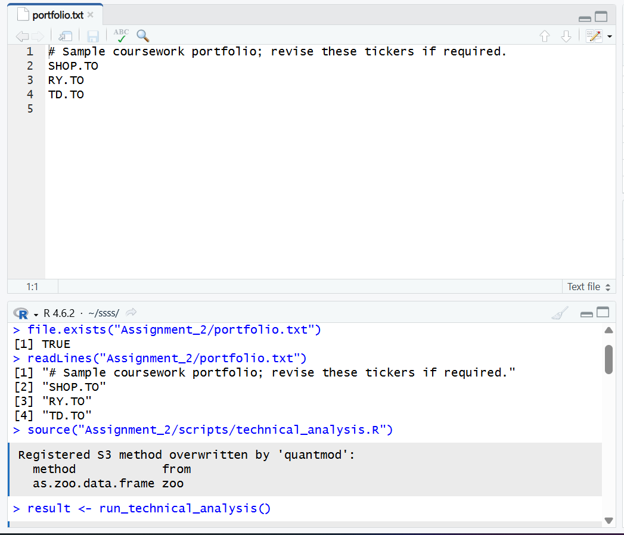
RStudio with R 4.6.2 and the corrected project root.

Package Installation and Project Configuration
The project uses quantmod to retrieve daily stock history and TTR to calculate the simple moving average; xts and zoo support the time-series data. The successful RStudio run confirms that the required packages were available in the project environment.
install.packages(c("quantmod", "TTR"), repos = "https://cloud.r-project.org")
packageVersion("quantmod")
packageVersion("TTR")
Evidence 2 - Required Packages in the Successful Run
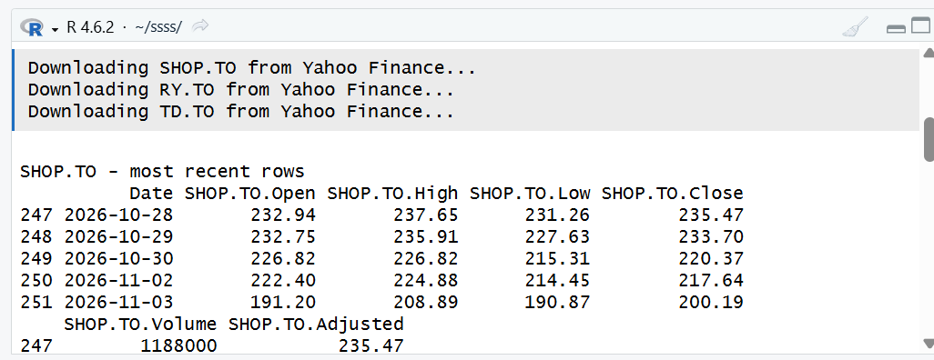
The R workflow loaded the three ticker datasets successfully.

Portfolio File
The portfolio.txt file contains one ticker per line. Blank lines and text after a # character are ignored by the reader.
SHOP.TO
RY.TO
TD.TO
Evidence 3 - Portfolio file
Sara’s portfolio.txt lists SHOP.TO, RY.TO, and TD.TO.

Import Function
read_portfolio() validates the text file and returns unique uppercase tickers. load_stock_data() requests a one-year daily history for each ticker through quantmod::getSymbols(..., src = "yahoo", auto.assign = FALSE). Each successful series is stored as its own data frame in a named list. A failed ticker produces a warning; the script stops if no series can be downloaded.

Statistics and Display
calculate_statistics() uses the adjusted closing price where available and falls back to Close if needed. The 20-day simple moving average is calculated with TTR::SMA. The mean, median, and standard deviation cover the available price observations in the selected date range. For mode, prices are rounded to two decimal places; when no rounded price repeats, the output says “No repeated value.”
Measure | Definition used
20-day moving average | Latest available simple moving average of adjusted close.
Mean and median | Descriptive summaries of adjusted close over the downloaded period.
Mode | Most frequent adjusted close rounded to two decimal places; reports no repeated value if all are unique.
Standard deviation | Sample standard deviation of adjusted close over the downloaded period.

Run the Analysis
- Install packages once using the command above.
- Set the working directory to the repository root.
- Run: Rscript Assignment_2/scripts/technical_analysis.R
- Alternatively, source the script and call run_technical_analysis().
- Review the console output and generated files in Assignment_2/outputs/
The completed run printed recent rows and summary statistics for all three tickers. It generated statistics_summary.csv, one daily-data CSV per ticker, and one adjusted-close/20-day-SMA PNG chart per ticker in Assignment_2/outputs. The screenshots below show the actual run, SHOP.TO chart, and generated file list.
Evidence 4 - Data Import and Summary Statistics
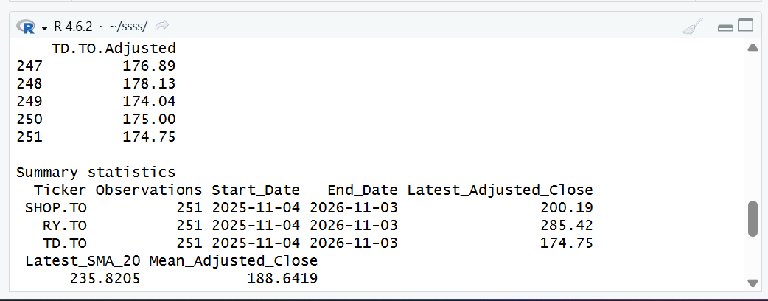
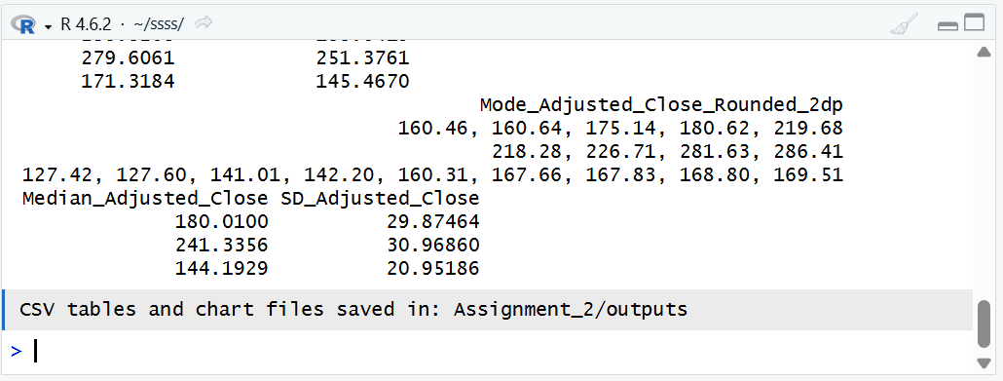
RStudio console output showing the completed summary statistics and output confirmation.

Evidence 5 - Generated SHOP.TO Chart
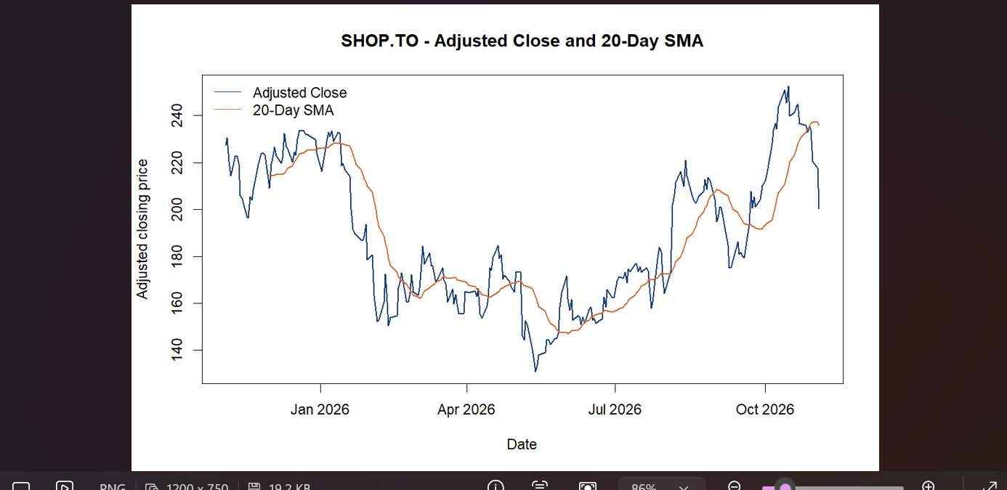
SHOP.TO adjusted close and 20-day SMA chart generated by the R script.

Documentation Evidence
The evidence below records Sara’s RStudio environment, portfolio file, successful data import and calculations, generated SHOP.TO chart, output files, and GitHub project structure. The screenshots are genuine captures from the project workflow.
Evidence 6 - GitHub Assignment Folder
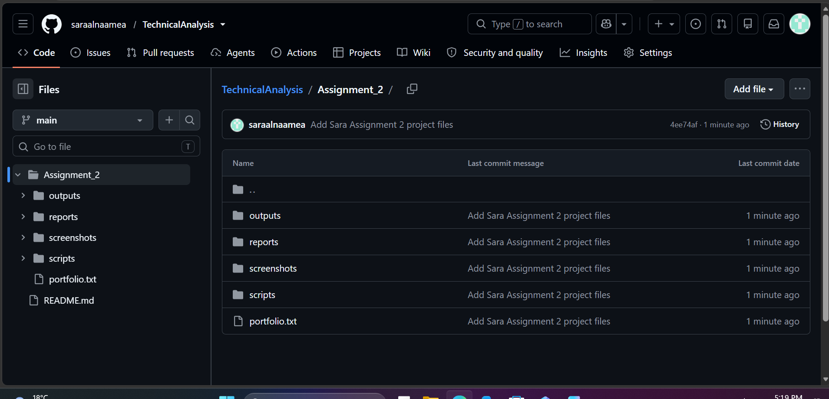
Sara’s TechnicalAnalysis repository shows the Assignment_2 project folders and portfolio file.

Evidence 7 - Generated Output Files
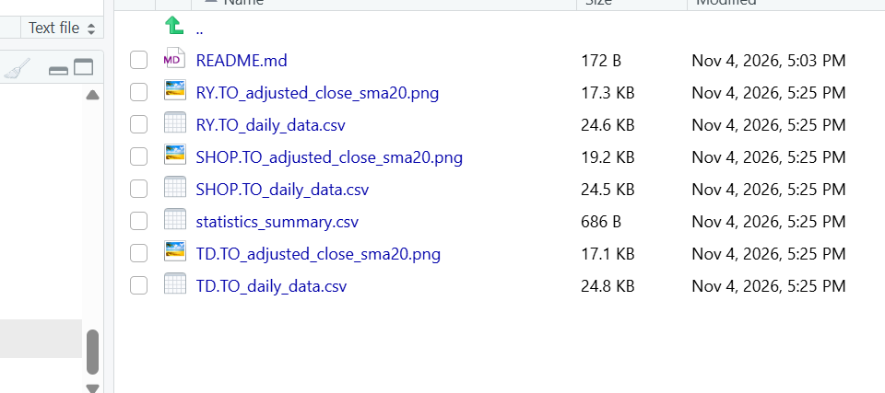
The local output folder contains three daily CSVs, three charts, and statistics_summary.csv.

Evidence 8 - GitHub Repository Root
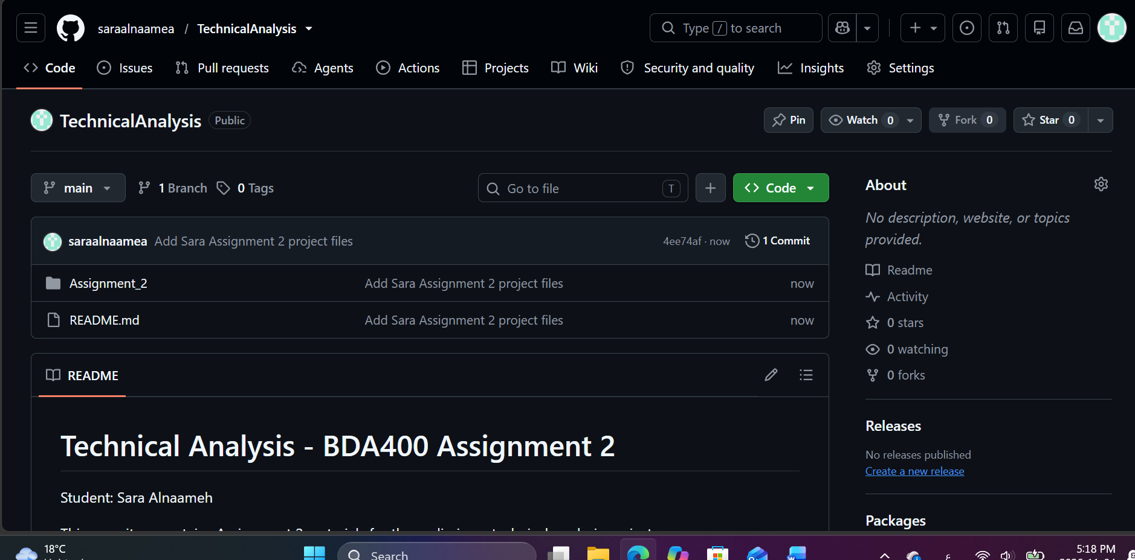
The public Sara repository contains the Assignment_2 folder and README.

Review Checklist
- Repository is named TechnicalAnalysis and contains Assignment_2/.
- portfolio.txt contains the student’s intended symbols, one per line.
- quantmod and TTR are installed and the data retrieval completed for every ticker.
- Summary, per-ticker CSV files, and charts were generated and reviewed.
- The report includes genuine screenshots of the RStudio run, portfolio, chart, output folder, and GitHub repository.
- The repository URL on the cover opens the correct student-owned repository.

References
Course materials: BDA400 Assignment 2 - Technical Analysis Using R, Preliminary Stage, supplied in the LMS.
quantmod documentation: https://search.r-project.org/CRAN/refmans/quantmod/html/getSymbols.html
TTR simple moving average documentation: https://search.r-project.org/CRAN/refmans/TTR/html/SMA.html
R download: https://cran.r-project.org/ | RStudio Desktop: https://posit.co/downloads/

