  - Student Name: Sara Amjad Abbasi
  - Internship Domain: AI/ML Internship
  - Task Number: Task 02
Objective
Develop multiple machine learning models for a real-world prediction problem, evaluate their performance using appropriate metrics, and learn the importance of model comparison and selection.
Problem Statement
This task addresses the challenge of accurately predicting student academic outcomes (such as passing or failing) using machine learning classification algorithms. By implementing and comparing multiple models specifically Logistic Regression, Decision Tree, and Random Forest the objective is to evaluate how effectively different algorithms handle feature patterns, determine which model provides the highest predictive accuracy and reliability, and understand the trade-offs between training time and performance for educational data analytics.
Technologies Used
- Python
- Pandas
- Matplotlib and Seaborn
- Scikit learn
Implementation Steps
Data Preprocessing:
Handled features, applied standard scaling, and split the dataset into 80% training and 20% testing sets.
Model Development:
Trained three machine learning algorithms: Logistic Regression, Decision Tree Classifier, and Random Forest Classifier.
Model Evaluation:
Evaluated each model using Accuracy, Precision, Recall, and F1 Score.
Code
import time
import pandas as pd
from sklearn.datasets import make_classification
from sklearn.model_selection import train_test_split
from sklearn.preprocessing import StandardScaler
from sklearn.linear_model import LogisticRegression
from sklearn.tree import DecisionTreeClassifier
from sklearn.ensemble import RandomForestClassifier
from sklearn.metrics import accuracy_score, precision_score, recall_score, f1_score
# Using comments to specify each portion of code
# Generate dataset automatically for classification
X, y = make_classification(n_samples=5000, n_features=10, n_informative=8, random_state=42)

# Preprocessing: Scale features and split into training/testing sets
scaler = StandardScaler()
X_scaled = scaler.fit_transform(X)
X_train, X_test, y_train, y_test = train_test_split(X_scaled, y, test_size=0.2, random_state=42)

# Model Development: Train three machine learning models
models = {
"Logistic Regression": LogisticRegression(),
"Decision Tree": DecisionTreeClassifier(random_state=42),
"Random Forest": RandomForestClassifier(n_estimators=50, random_state=42)
}

results = []

# Model Evaluation: Calculate metrics for each model
for name, model in models.items():
start_time = time.time()
model.fit(X_train, y_train)
train_time = time.time() - start_time

y_pred = model.predict(X_test)

acc = accuracy_score(y_test, y_pred)
prec = precision_score(y_test, y_pred, average='weighted')
rec = recall_score(y_test, y_pred, average='weighted')
f1 = f1_score(y_test, y_pred, average='weighted')

results.append({
"Model": name,
"Training Time (s)": round(train_time, 2),
"Accuracy": round(acc, 4),
"Precision": round(prec, 4),
"Recall": round(rec, 4),
"F1 Score": round(f1, 4)
})

# Model Comparison: Display the final comparison table
results_df = pd.DataFrame(results)
print("\n--- MODEL COMPARISON RESULTS ---")
print(results_df)
Output Screenshots
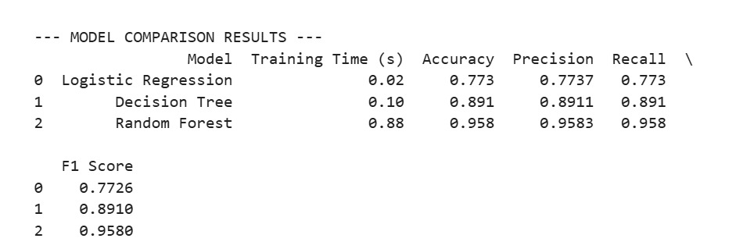
Model Comparison Table:
Model Name | Training Time (s) | Accuracy | Precision | Recall | F1 Score | Advantages | Advantages
Logistic Regression | 0.02 | 0.773 in PNG | 0.7737 | 0.773 | 0.7726 | Fast training, simple | Lower accuracy on complex patterns
Decision Tree | 0.1 | 0.891 | 0.8911 | 0.891 | 0.8910 | Easy to interpret | Prone to overfitting
Random Forest | 0.88 | 0.958 | 0.9583 | 0.958 | 0.9580 | Highest accuracy and stability | Slightly slower training time
Conclusion:
Best Performing Model:
Random Forest Classifier
Why it performed better:
Random Forest achieved the highest overall accuracy (0.958) and F1 Score (0.9580) because it uses an ensemble of multiple decision trees, reducing overfitting and capturing complex patterns much better than individual models.

