Form or Substance? Institutional Pressures and Accountability in Public-Sector Financial Reforms
[Author names, affiliations, ORCID iDs and corresponding-author details – to be completed by the authors]
Abstract
Purpose. Governments mandate accrual accounting and performance-based budgeting, yet adoption on paper often fails to change decisions. This study asks how coercive, normative and mimetic pressures push executive agencies towards substantive implementation or symbolic compliance, how these responses affect financial accountability through the usefulness of reported information, and whether the maturity of the financial information system conditions the process. Design/methodology/approach. A survey of 336 financial managers, comptrollers, budget experts and accountants in executive agencies was analysed with covariance-based structural equation modelling in which every item loads only on its own latent variable (no composites), latent interaction terms, and 2,000-draw bootstrap estimates of conditional indirect effects. Findings. Coercive pressure raised both substantive implementation (β = 0.32) and symbolic compliance (β = 0.38); normative pressure raised the former (β = 0.37) and lowered the latter (β = −0.22); mimetic pressure raised symbolic compliance only (β = 0.33). Substantive implementation increased, and symbolic compliance reduced, both the usefulness of information and accountability, and usefulness mediated part of these effects. Maturity amplified the usefulness payoff of substantive implementation and dampened the translation of coercion into symbolic compliance. The net effect of coercion was close to zero because its constructive and ceremonial routes offset one another, while normative pressure had a clear positive net effect. Originality/value. The study separates substantive from symbolic responses to the same pressures and shows when mandates translate into accountability. Practical implications. Reform agencies should supplement mandates with professional norms, monitor use rather than submission of reports, and invest in integrated, auditable systems.
Keywords: institutional theory; decoupling; accrual accounting; performance-based budgeting; public-sector accountability; information systems
JEL classification: M41; M48; H83; D73
Paper type: Research paper
1. Introduction
Over the past four decades, public-sector accounting and budgeting have been reorganised around the idea that governments should manage by information on costs, assets, liabilities and results rather than by cash and appropriations (Hood, 1991; Lapsley, 2009). Accrual accounting, internationally promoted through the International Public Sector Accounting Standards, and performance-based budgeting, which links appropriations to outputs and outcomes, are the two flagship instruments of this agenda (Pollitt & Bouckaert, 2017; Christiaens et al., 2015). Their promise is better decisions and stronger accountability to legislatures, auditors and citizens.
The evidence on delivery is mixed. Cross-country studies show that countries adopt the same standards in markedly different ways (Pina et al., 2009; Christiaens & Reyniers, 2010), and the literature on performance management documents that producing performance information is not the same as using it (Moynihan, 2008; Moynihan & Pandey, 2010; Kroll, 2015). Iran illustrates the gap. Public-sector accounting standards and performance-based budgeting have been introduced through legislation and development plans, but recent Iranian studies report partial implementation, legal and structural obstacles, and weak use of information: Ahmadi et al. (2023) estimate that performance-based budgeting is implemented at roughly 34, 26 and 31 per cent in strategic planning, cost analysis and performance management respectively, and Nourani and Akhlaghi Yazdinejad (2023) identify legal, structural and environmental bottlenecks to implementing public-sector accounting standards. Qualitative models (Pourghaffar et al., 2022; Naroui et al., 2020) map what a good system should contain, but we know little about what drives agencies to implement reforms substantively rather than ceremonially, and what each response costs or yields in accountability.
Institutional theory offers a precise language for this puzzle. Organisations facing coercive, normative and mimetic pressures adopt structures to gain legitimacy (DiMaggio & Powell, 1983), and formal adoption may be decoupled from operations (Meyer & Rowan, 1977; Bromley & Powell, 2012). Yet three gaps remain. First, empirical accounting studies rarely treat substantive implementation and symbolic compliance as two distinct outcomes of the same pressures; they tend to measure “adoption” as a single construct. Second, the mechanism linking implementation to accountability—whether reported information is actually useful to those who decide—has seldom been modelled. Third, the role of the information infrastructure in making ceremonial behaviour visible, and substantive behaviour productive, is under-theorised, despite the emphasis on integrated digital systems in public-management reform (Dunleavy et al., 2006; DeLone & McLean, 2003).
This paper addresses these gaps with a survey of financial and budget staff in Iranian executive agencies. It makes three contributions. (i) It shows that institutional pressure is not a single cause with a single effect: coercion drives both substantive and symbolic responses, normative pressure favours substance, and mimetic pressure breeds form. (ii) It identifies usefulness of reported information as the bridge from implementation to accountability and quantifies the offsetting routes that make the net effect of coercion small. (iii) It demonstrates that information-system maturity conditions both the payoff of substantive implementation and the pull of coercion towards ceremony. Methodologically, the study estimates a fully latent model with latent interactions and bootstrap conditional indirect effects instead of the summed or averaged scale scores that dominate the field.
The remainder of the paper is organised as follows. Section 2 develops the theory and hypotheses; Section 3 describes data, measures and methods; Section 4 reports results, including competing models and robustness checks; Section 5 discusses theoretical, practical and policy implications; Section 6 outlines limitations and future research. Appendices report the full instrument, measurement and structural estimates, and supplementary analyses.
2. Theory and hypotheses
2.1 Institutional pressures and organisational responses
DiMaggio and Powell (1983) distinguish three mechanisms of institutional isomorphism. Coercive pressure stems from formal and informal pressures exerted by organisations on which an agency depends, and from legal mandates; normative pressure arises from professionalisation, training and occupational networks; mimetic pressure arises when uncertainty leads organisations to imitate peers perceived as legitimate. Scott (2014) links these mechanisms to the regulative, normative and cultural-cognitive pillars of institutions. Empirically the three are correlated but not interchangeable, and research on their effects shows that their consequences differ (Mizruchi & Fein, 1999; Teo et al., 2003).
Organisations are not passive recipients. Oliver (1991) describes a repertoire of strategic responses from acquiescence to avoidance, and Kostova and Roth (2002) separate ceremonial adoption—the practice is adopted formally without understanding or commitment—from internalisation, in which employees value and use it. In public accounting, performance measures and accrual statements are particularly prone to ceremonial use because they are visible to superiors, legible as signals of modernisation, and costly to verify (Brignall & Modell, 2000; Modell, 2009). We therefore define two organisational responses. Substantive implementation is the use of programme structures, cost information and accrual statements in preparing budgets and in managerial decisions. Symbolic compliance is the production of reports and indicators mainly for submission to higher authorities, with indicators that are easy to meet and little effect on resource allocation.
2.2 Pressures and responses (H1–H5)
Coercive pressure makes non-adoption costly and behaviour observable. Where legal mandates and oversight are strong, agencies have reasons both to implement and to display implementation (DiMaggio & Powell, 1983; Oliver, 1991). Because mandates do not distinguish between the two, we expect coercion to raise both responses (H1, H2). Normative pressure operates by shaping professional identity: accountants and comptrollers who see accrual information as a mark of professional competence internalise it, which should raise substantive implementation and reduce reliance on ritual (H3, H4) (DiMaggio & Powell, 1983; Greenwood et al., 2011). Mimetic pressure, by contrast, supplies templates; imitation is cheap, copies form rather than function, and is most attractive when the agency lacks the capacity or incentive to internalise. We therefore expect mimetic pressure to raise symbolic compliance (H5) but not to promote substantive implementation, a path we estimate but do not hypothesise.
H1: Coercive pressure is positively related to substantive implementation. H2: Coercive pressure is positively related to symbolic compliance. H3: Normative pressure is positively related to substantive implementation. H4: Normative pressure is negatively related to symbolic compliance. H5: Mimetic pressure is positively related to symbolic compliance.
2.3 From implementation to usefulness and accountability (H6–H10)
Reforms create value only when information is used (Moynihan, 2008; Moynihan & Pandey, 2010). When agencies implement substantively, cost and accrual information enters budget preparation and management meetings and is therefore timely, understandable and relevant; when compliance is symbolic, reports are produced for form, are less trusted internally and are discounted by users (Kroll, 2015; Modell, 2009). We define the usefulness of reported information as the extent to which information is the basis of managerial decisions, is timely and understandable, gives a fuller picture than cash accounting and is reliable for evaluating efficiency and effectiveness. Accountability, following Bovens (2007), is a relationship in which the actor informs, justifies and accepts consequences; it is also a core input to public value (Moore, 1995; Bracci et al., 2015). Substantive implementation should strengthen accountability directly, by making deviations traceable and responsibilities clear, and indirectly, through usefulness; symbolic compliance should weaken it by providing information that cannot be verified or acted upon.
H6: Substantive implementation is positively related to usefulness of information. H7: Symbolic compliance is negatively related to usefulness of information. H8: Substantive implementation is positively related to financial accountability. H9: Symbolic compliance is negatively related to financial accountability. H10: Usefulness of information is positively related to financial accountability.
2.4 The conditioning role of information-system maturity (H11–H12)
Information-systems research holds that the benefits of information depend on system and information quality (DeLone & McLean, 2003), and digital-era governance stresses integration, reintegration of functions and transparency (Dunleavy et al., 2006). We define maturity as the integration, real-time availability and auditability of the agency's financial systems. Maturity should play two roles. First, integrated and timely data allow substantive implementation to deliver usable information; maturity should therefore strengthen the effect of substantive implementation on usefulness (H11). Second, auditable trails and traceable changes raise the cost of reporting that is detached from practice; maturity should therefore weaken the pathway from coercive pressure to symbolic compliance, because mandated reporting becomes verifiable rather than ceremonial (H12).
H11: Information-system maturity strengthens the positive effect of substantive implementation on usefulness of information. H12: Information-system maturity weakens the positive effect of coercive pressure on symbolic compliance. H13 (mediation): Institutional pressures exert indirect effects on accountability through substantive implementation and symbolic compliance, via usefulness.
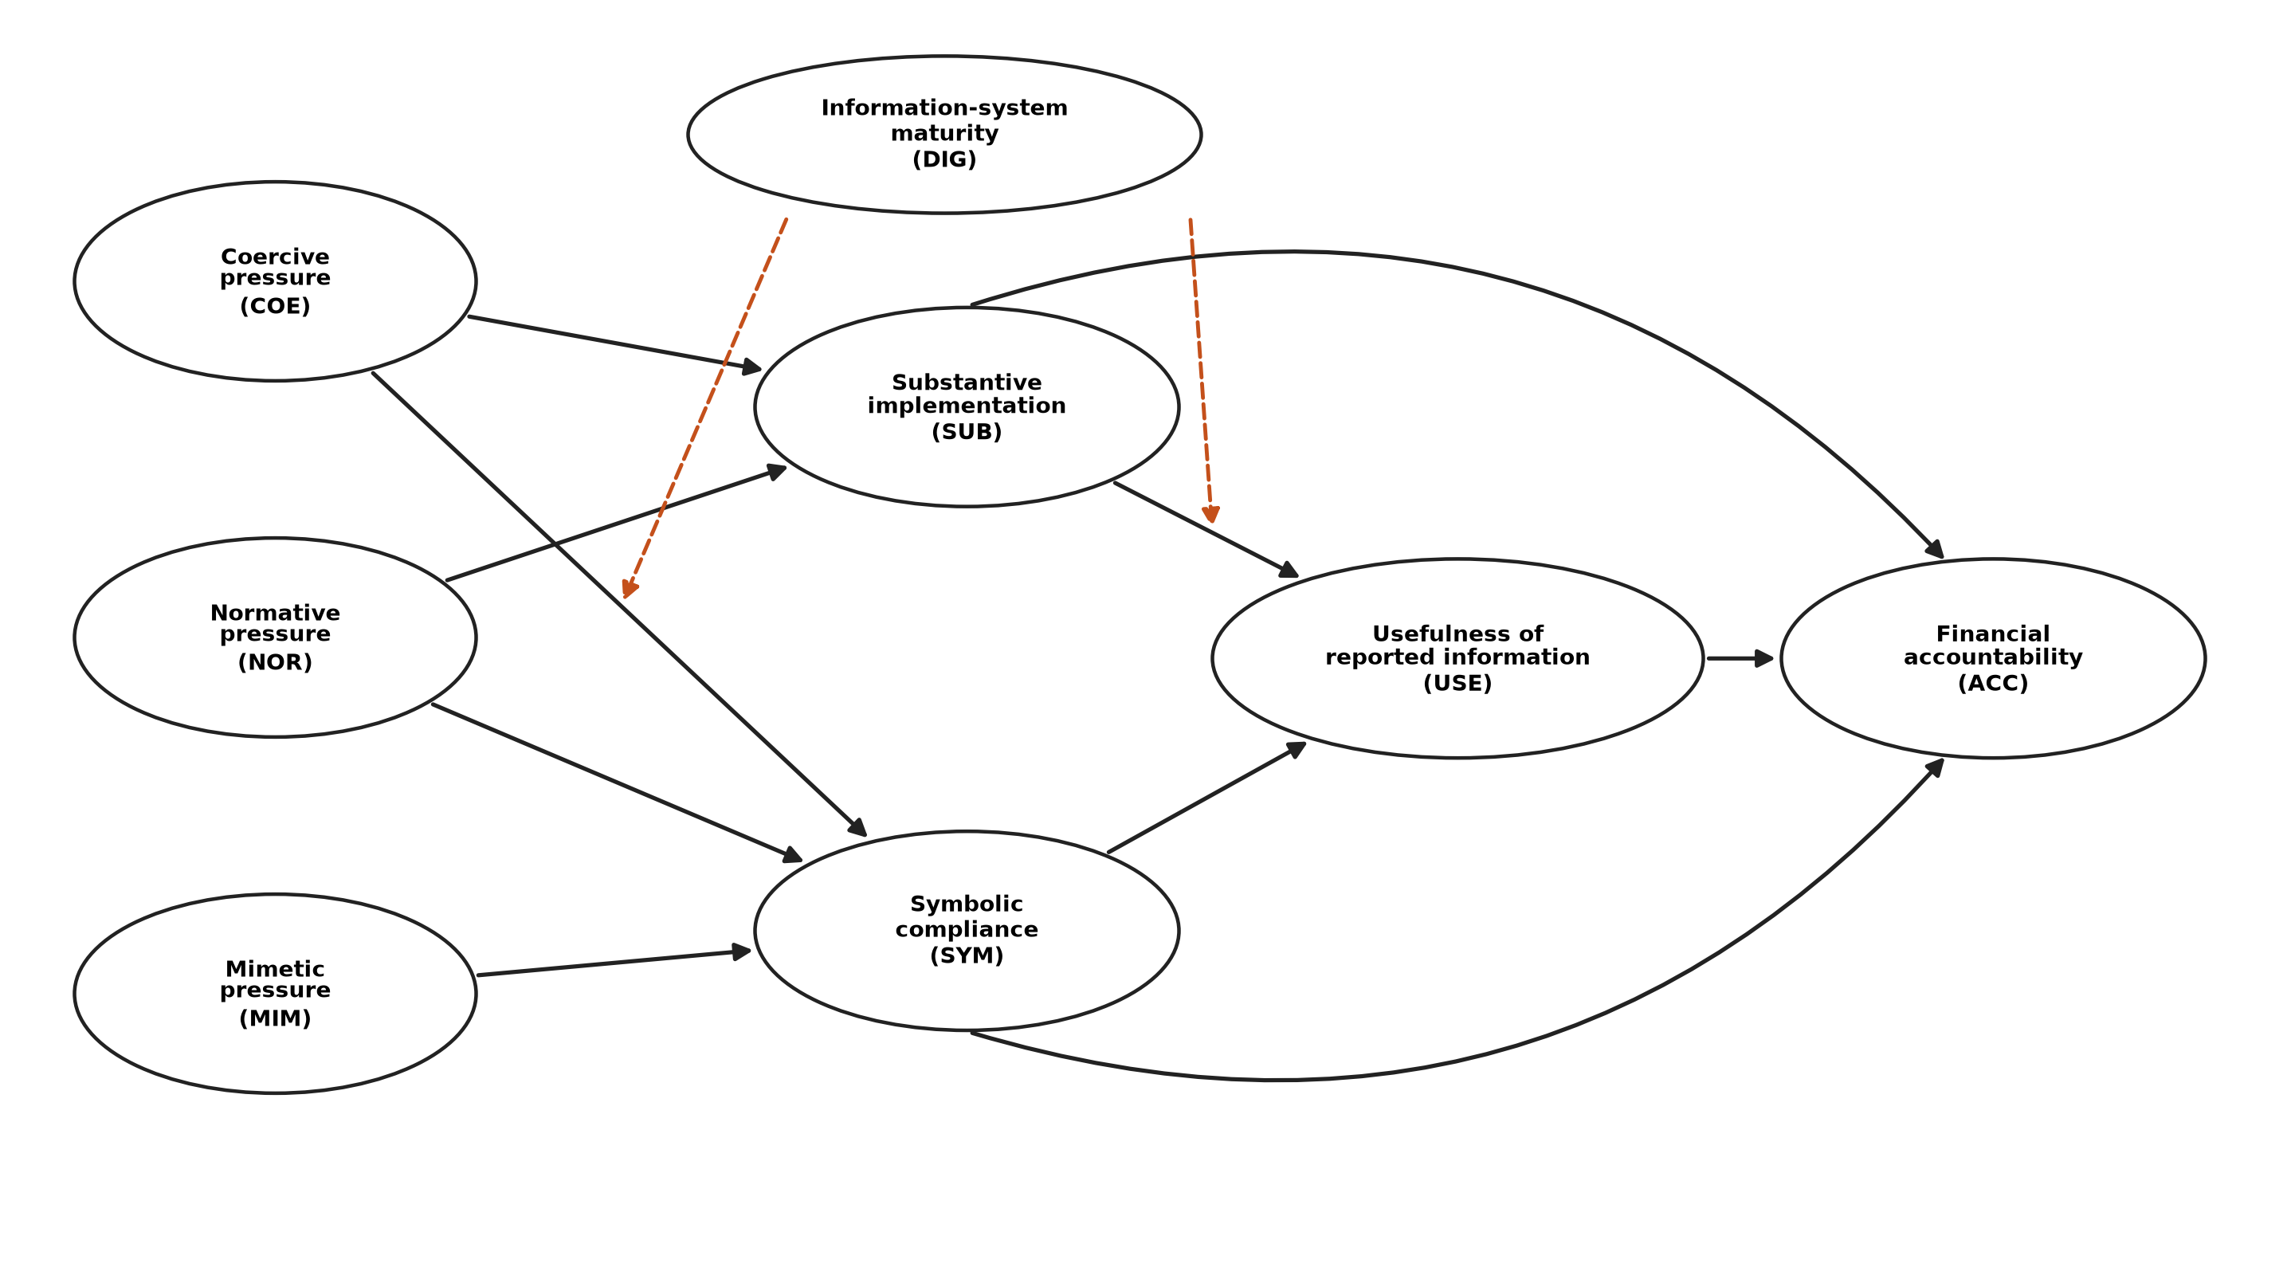
Figure 1. Conceptual model. Solid arrows: structural paths; dashed orange arrows: moderation by information-system maturity.
3. Data and method
3.1 Context, sample and procedure
The study population comprises financial managers, comptrollers, budget experts and accountants or internal auditors of executive agencies. The analysed sample has 336 respondents: 35% from ministries and national organisations, 30% from universities and health-care institutions, 18% from municipalities and local bodies and 17% from provincial offices; the mean professional experience is 13.8 years (SD = 7.0) and the mean age 45.3 years (SD = 7.3). [Sampling procedure, fieldwork period, distribution channel and response rate must be completed from the actual administration.] Respondents rated the agency in which they work; anonymity was assured and answers are analysed in aggregate.
With 116 free parameters the ratio of observations to parameters is 2.9:1, below the conventional 10:1 rule of thumb. We therefore base the adequacy of the sample on power analysis for covariance-structure models (MacCallum et al., 1996): for the degrees of freedom of the structural model, power to reject close fit (RMSEA = .05) against RMSEA = .08 exceeds .99. Because latent variables with multiple reflective indicators absorb measurement error, and the loadings are high, we regard N = 336 as adequate for the model, but we report DWLS and trimmed-sample estimates as checks.
3.2 Measures
All constructs are measured with five-point agreement items (Appendix A). Table 1 shows the origin of each scale. The three pressure scales are adapted from the institutional-pressure measures of Teo et al. (2003), re-worded for budgeting and accrual reforms; substantive implementation, symbolic compliance and accountability are researcher-developed from the literature; maturity and usefulness combine adapted and new items. No scale is a published, validated instrument in this exact form, so we provide extensive validity evidence below. Content validity was assessed with the content validity ratio and index (Lawshe, 1975; Polit & Beck, 2006) [report the number of experts and the actual CVR/CVI values]. Latent variables are never summed or averaged: every item is an indicator of its own latent variable only.
Table 1. Constructs, number of items, origin of the scales and principal sources
Construct | Items | Origin | Principal sources
Coercive pressure (COE) | 4 | Adapted | DiMaggio & Powell (1983); Teo et al. (2003)
Normative pressure (NOR) | 4 | Adapted | DiMaggio & Powell (1983); Teo et al. (2003)
Mimetic pressure (MIM) | 4 | Adapted | DiMaggio & Powell (1983); Oliver (1991); Teo et al. (2003)
Substantive implementation (SUB) | 5 | Researcher-developed | Pollitt & Bouckaert (2017); Moynihan (2008); Christiaens et al. (2015)
Symbolic compliance (SYM) | 4 | Researcher-developed | Meyer & Rowan (1977); Bromley & Powell (2012); Modell (2009)
Information-system maturity (DIG) | 4 | Adapted + new | DeLone & McLean (2003); Dunleavy et al. (2006)
Usefulness of reported information (USE) | 4 | Adapted + new | Moynihan & Pandey (2010); Kroll (2015); DeLone & McLean (2003)
Financial accountability (ACC) | 5 | Researcher-developed | Bovens (2007); Bracci et al. (2015); Moore (1995)

3.3 Estimation strategy
Models are estimated by maximum likelihood in semopy (Igolkina & Meshcheryakov, 2020). Fit is judged jointly: CFI and TLI ≥ .95, RMSEA ≤ .06 and SRMR ≤ .08 (Hu & Bentler, 1999); the χ² test is reported but, as is well known, over-rejects in samples of this size. Convergent validity uses standardized loadings, composite reliability (CR) and average variance extracted (AVE) (Fornell & Larcker, 1981); discriminant validity uses the Fornell–Larcker criterion and the heterotrait–monotrait ratio (Henseler et al., 2015). Common-method bias is probed with Harman's single-factor test, a one-factor CFA and a common-latent-factor model (Podsakoff et al., 2003). Two latent interaction terms (maturity × substantive implementation; maturity × coercive pressure) are specified with matched-pair product indicators (Marsh et al., 2004) and, as a robustness check, residual-centred indicators (Little et al., 2006). Indirect and conditional indirect effects are evaluated at −1, 0 and +1 SD of maturity with 2,000 nonparametric bootstrap draws and percentile intervals (Preacher & Hayes, 2008); indices of moderated mediation follow Hayes (2015). Latent R² equals one minus the standardized residual variance, and the effect size of an interaction is f² from the change in R². Five competing structures are compared by chi-square difference tests and fit indices.
4. Results
4.1 Descriptive checks
Item skewness ranged from −0.62 to 0.40 and excess kurtosis from −0.81 to −0.14, well within common tolerances. Mardia's multivariate kurtosis (1211 versus 1224 expected) indicated slight departure from multivariate normality, which motivates the DWLS check in Section 4.6.
4.2 Measurement model
The eight-factor confirmatory model fitted well: χ²(499) = 548.1, p = .063; CFI = 0.990, TLI = 0.989, RMSEA = 0.017, SRMR = 0.040. Standardized loadings ranged from 0.63 to 0.84 (Figure 3, Appendix A), composite reliability from 0.81 to 0.87 and AVE from 0.51 to 0.60 (Table 2), all above conventional thresholds although not at the ceiling that would suggest redundant items. The highest HTMT was 0.52, far below .85, and the square root of each AVE exceeded the corresponding inter-construct correlations (Appendix B). Harman's first factor explained 20.5% of variance; a one-factor CFA fitted poorly (CFI = 0.33) and adding a common latent factor changed fit marginally (CFI = 0.999; common variance 20%), so method variance is unlikely to drive the results. Latent variance inflation factors in all equations were below 1.30.
Table 2. Reliability and convergent validity
Construct | Items | α | CR | AVE | Loadings
Coercive pressure (COE) | 4 | 0.86 | 0.86 | 0.60 | 0.71–0.84
Normative pressure (NOR) | 4 | 0.83 | 0.83 | 0.56 | 0.62–0.81
Mimetic pressure (MIM) | 4 | 0.80 | 0.81 | 0.51 | 0.66–0.77
Substantive implementation (SUB) | 5 | 0.87 | 0.87 | 0.58 | 0.65–0.81
Symbolic compliance (SYM) | 4 | 0.83 | 0.84 | 0.56 | 0.67–0.84
Information-system maturity (DIG) | 4 | 0.83 | 0.83 | 0.55 | 0.63–0.83
Usefulness of reported information (USE) | 4 | 0.85 | 0.85 | 0.58 | 0.69–0.82
Financial accountability (ACC) | 5 | 0.87 | 0.87 | 0.58 | 0.73–0.80

4.3 Structural model
The full structural model fitted well: χ²(830) = 921.0, p = .015; CFI = 0.984, TLI = 0.982, RMSEA = 0.018, SRMR = 0.043. Figure 2 shows the standardized path coefficients and Table 3 reports unstandardized and standardized estimates with the verdict on each hypothesis.
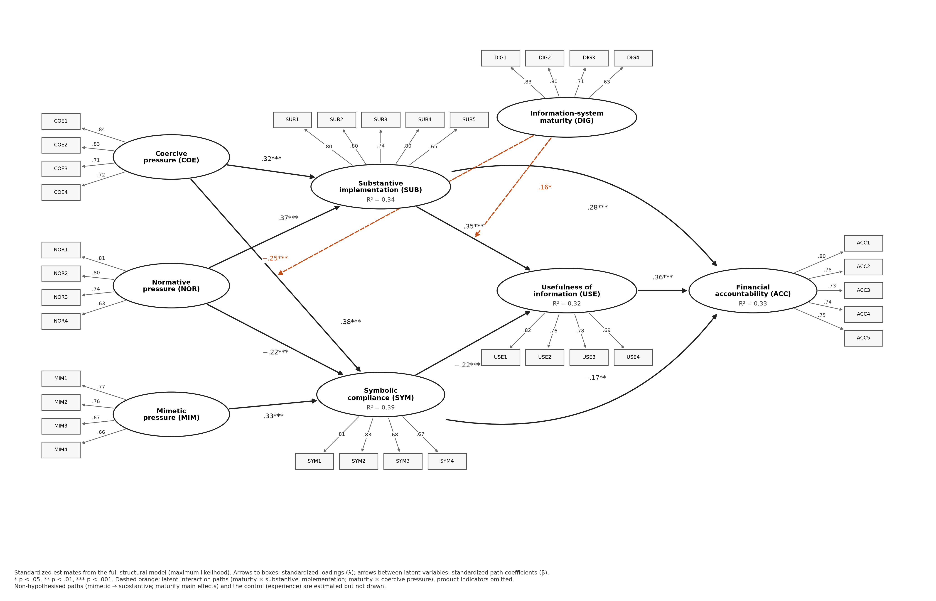
Figure 2. Estimated structural model with all 34 indicators: standardized loadings (λ) and standardized path coefficients (β), with latent R². Latent variables are ellipses, indicators are boxes; dashed orange arrows are latent interaction (moderation) terms.
Table 3. Structural estimates
Hyp. | Path | b | SE | β | p | Verdict
H1 | Coercive → Substantive implementation | 0.31 | 0.06 | 0.32 | < .001 | Supported
H2 | Coercive → Symbolic compliance | 0.38 | 0.06 | 0.38 | < .001 | Supported
H3 | Normative → Substantive implementation | 0.38 | 0.06 | 0.37 | < .001 | Supported
H4 | Normative → Symbolic compliance | −0.23 | 0.07 | −0.22 | < .001 | Supported
H5 | Mimetic → Symbolic compliance | 0.36 | 0.07 | 0.33 | < .001 | Supported
H6 | Substantive impl. → Usefulness | 0.36 | 0.06 | 0.35 | < .001 | Supported
H7 | Symbolic compliance → Usefulness | −0.22 | 0.06 | −0.22 | < .001 | Supported
H8 | Substantive impl. → Accountability | 0.27 | 0.06 | 0.28 | < .001 | Supported
H9 | Symbolic compliance → Accountability | −0.16 | 0.06 | −0.17 | .005 | Supported
H10 | Usefulness → Accountability | 0.35 | 0.07 | 0.36 | < .001 | Supported
H11 | Maturity × Subst. impl. → Usefulness | 0.18 | 0.07 | 0.16 | .013 | Supported
H12 | Maturity × Coercive → Symbolic compliance | −0.30 | 0.08 | −0.25 | < .001 | Supported
– | Mimetic → Substantive implementation | 0.08 | 0.07 | 0.07 | .245 | –
– | Maturity → Substantive implementation | 0.04 | 0.06 | 0.03 | .542 | –
– | Maturity → Symbolic compliance | −0.29 | 0.06 | −0.27 | < .001 | –
– | Maturity → Usefulness | 0.30 | 0.06 | 0.28 | < .001 | –
– | Experience → Accountability (control) | 0.03 | 0.04 | 0.04 | .442 | –

Pressures and responses. Coercive pressure raised both substantive implementation (β = 0.32, p < .001; H1) and symbolic compliance (β = 0.38, p < .001; H2). Normative pressure was the strongest predictor of substantive implementation (β = 0.37, p < .001; H3) and reduced symbolic compliance (β = −0.22, p < .001; H4). Mimetic pressure raised symbolic compliance (β = 0.33, p < .001; H5) and had no reliable effect on substantive implementation (β = 0.07, p = .245). The pattern is the signature of three different mechanisms: mandates produce activity of both kinds; professional norms push towards substance; templates push towards form.
Responses and outcomes. Substantive implementation raised the usefulness of information (β = 0.35, p < .001; H6) and accountability (β = 0.28, p < .001; H8), whereas symbolic compliance lowered usefulness (β = −0.22, p < .001; H7) and accountability (β = −0.17, p = .005; H9). Usefulness was in turn positively related to accountability (β = 0.36, p < .001; H10), which identifies it as a mechanism that carries part of the effect of both responses. Explained variance (latent R²) was 0.34 for substantive implementation, 0.39 for symbolic compliance, 0.32 for usefulness and 0.33 for accountability, which in cross-sectional organisational research indicates substantial explanatory power.
Moderation. Information-system maturity strengthened the effect of substantive implementation on usefulness (β = 0.16, p = .013; H11) and weakened the effect of coercive pressure on symbolic compliance (β = −0.25, p < .001; H12). Effect sizes were small to moderate (f² = 0.035 for usefulness and 0.103 for symbolic compliance), as is typical for interaction effects in non-experimental data. Figure 4 plots the conditional slopes: at low maturity the slope of usefulness on implementation is roughly 0.21, at high maturity 0.51; the slope of symbolic compliance on coercion falls from 0.63 to 0.12.
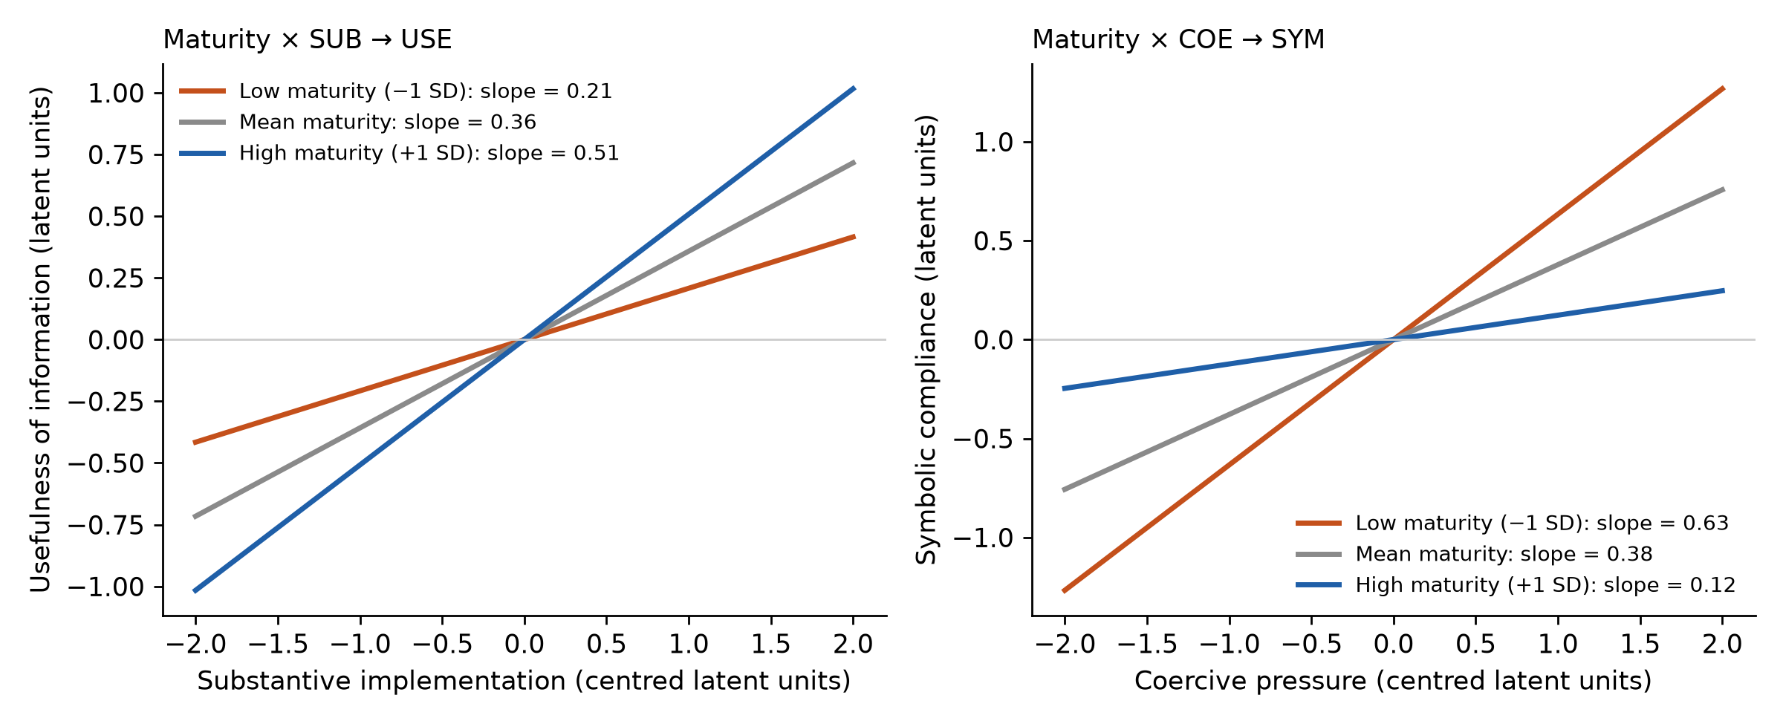
Figure 4. Conditional effects (simple slopes) of the two latent interactions at −1 SD, the mean and +1 SD of information-system maturity.
4.4 Indirect and conditional indirect effects
Table 4. Conditional indirect effects of institutional pressures on financial accountability (unstandardized; 95% bootstrap CI)
Route | Maturity −1 SD | Mean | +1 SD
Coercive pressure via substantive implementation | 0.11, 95% CI [0.05, 0.17] | 0.12, 95% CI [0.07, 0.19] | 0.14, 95% CI [0.08, 0.22]
Coercive pressure via symbolic compliance | −0.15, 95% CI [−0.24, −0.08] | −0.09, 95% CI [−0.14, −0.05] | −0.03, 95% CI [−0.07, 0.01]
Coercive pressure: total indirect effect | −0.04, 95% CI [−0.15, 0.05] | 0.03, 95% CI [−0.04, 0.11] | 0.11, 95% CI [0.04, 0.20]
Normative pressure via substantive implementation | 0.13, 95% CI [0.07, 0.21] | 0.15, 95% CI [0.09, 0.23] | 0.17, 95% CI [0.11, 0.25]
Normative pressure via symbolic compliance | 0.06, 95% CI [0.02, 0.10] | 0.06, 95% CI [0.02, 0.10] | 0.06, 95% CI [0.02, 0.10]
Normative pressure: total indirect effect | 0.19, 95% CI [0.11, 0.28] | 0.21, 95% CI [0.13, 0.30] | 0.23, 95% CI [0.15, 0.33]
Mimetic pressure via substantive implementation | 0.03, 95% CI [−0.02, 0.08] | 0.03, 95% CI [−0.02, 0.08] | 0.03, 95% CI [−0.02, 0.09]
Mimetic pressure via symbolic compliance | −0.09, 95% CI [−0.15, −0.04] | −0.09, 95% CI [−0.15, −0.04] | −0.09, 95% CI [−0.15, −0.04]
Mimetic pressure: total indirect effect | −0.06, 95% CI [−0.13, 0.01] | −0.05, 95% CI [−0.14, 0.02] | −0.05, 95% CI [−0.14, 0.03]

At mean maturity, coercive pressure had a positive indirect effect on accountability through substantive implementation (0.12, 95% CI [0.07, 0.19]) and a negative one through symbolic compliance (−0.09, 95% CI [−0.14, −0.05]); the two almost cancel, leaving a total indirect effect of 0.03, 95% CI [−0.04, 0.11]. Normative pressure had a clearly positive total indirect effect (0.21, 95% CI [0.13, 0.30]), and mimetic pressure a negative effect through symbolic compliance (−0.09, 95% CI [−0.15, −0.04]) with a total that is statistically indistinguishable from zero (−0.05, 95% CI [−0.14, 0.02]). H13 is therefore supported. Maturity changes the arithmetic of coercion: the total indirect effect of coercive pressure moves from −0.04, 95% CI [−0.15, 0.05] at low maturity to 0.11, 95% CI [0.04, 0.20] at high maturity, because both the ceremonial route weakens and the substantive route is amplified (Figure 5). Indices of moderated mediation were 0.061, 95% CI [0.024, 0.116] for the coercion–ceremony route and 0.052, 95% CI [0.007, 0.117] for the implementation–usefulness–accountability route.
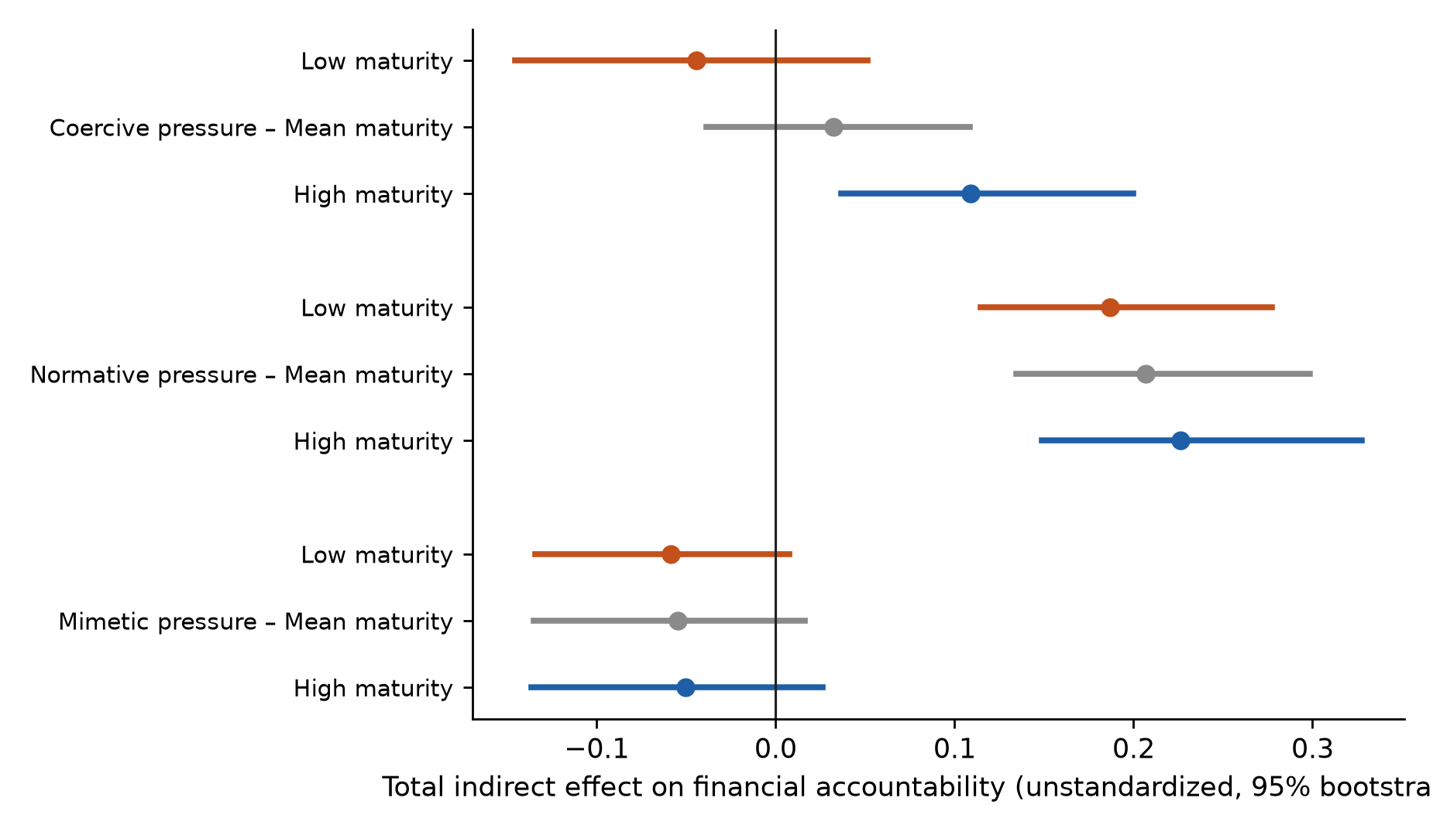
Figure 5. Total indirect effects of the three pressures on financial accountability at three levels of information-system maturity (95% bootstrap CIs).
4.5 Competing models
Table 5. Competing structural models
Model | Specification | χ² | df | CFI | RMSEA | AIC | BIC
M1 | Hypothesised model | 921.0 | 830 | 0.984 | 0.018 | 227 | 669
M2 | No moderation | 944.2 | 832 | 0.980 | 0.020 | 222 | 658
M3 | No usefulness path | 950.2 | 831 | 0.979 | 0.021 | 224 | 663
M4 | Substantive route only | 943.4 | 831 | 0.980 | 0.020 | 224 | 663
M5 | Direct effects of pressures added | 918.5 | 827 | 0.984 | 0.018 | 233 | 687

The hypothesised model fitted better than the model without moderation (M2; Δχ²(2) = 23.2, p < .001), the model without the usefulness path (M3; Δχ²(1) = 29.2, p < .001) and the substantive-route-only model (M4; Δχ²(1) = 22.4, p < .001). Adding direct paths from the three pressures to accountability (M5) did not improve fit (Δχ²(3) = 2.5, n.s.), consistent with full mediation. BIC values from the software favour the more parsimonious structures; given the large number of product-indicator parameters we rely on the nested χ² tests and the fit indices for model selection.
4.6 Robustness
Table 6. Robustness of standardized paths across estimators and subsamples
Path | Baseline | DWLS | Residual-centred | Respecified | Trimmed 5% | Experienced (≥10 yrs)
Coercive → Substantive | 0.32 | 0.33 | 0.32 | 0.32 | 0.32 | 0.28
Coercive → Symbolic | 0.38 | 0.32 | 0.38 | 0.38 | 0.39 | 0.43
Normative → Substantive | 0.37 | 0.38 | 0.37 | 0.37 | 0.37 | 0.38
Normative → Symbolic | −0.22 | −0.22 | −0.22 | −0.22 | −0.23 | −0.24
Mimetic → Symbolic | 0.33 | 0.32 | 0.33 | 0.33 | 0.33 | 0.32
Substantive → Usefulness | 0.35 | 0.38 | 0.36 | 0.35 | 0.37 | 0.31
Symbolic → Usefulness | −0.22 | −0.23 | −0.22 | −0.22 | −0.24 | −0.22
Usefulness → Accountability | 0.36 | 0.35 | 0.36 | 0.36 | 0.41 | 0.39

Estimates were stable in sign and magnitude when estimated by DWLS without interaction terms (CFI = 1.018), with residual-centred product indicators (CFI = 0.997), after adding the four largest within-construct residual correlations (ACC4–ACC5, ACC2–ACC4, ACC1–ACC2, DIG3–DIG4; CFI = 0.987), after removing the 17 most extreme multivariate observations, and in the subsample of 233 respondents with at least ten years of experience (Table 6; Appendix E).
5. Discussion
5.1 What the results say
The central result is that the same institutional pressure can feed opposite organisational behaviours. Coercion is a blunt instrument: it raises substantive implementation and symbolic compliance in comparable measure, so that the net effect on accountability is close to zero unless something else tips the balance. Normative pressure, in contrast, works almost entirely through substance, and mimetic pressure almost entirely through form. These contrasts support the view that “adoption” is an insufficient dependent variable; what matters is the quality of adoption.
Second, the usefulness of information acts as the link between implementation and accountability. When implementation is substantive, information is in use, so it is timely and trusted; when compliance is symbolic, information is discounted and accountability is weaker. This extends the literature on performance-information use to accrual and budgeting reforms and indicates that accountability gains require that the information be used for decisions, not merely produced.
Third, information-system maturity is both an amplifier and a safeguard. It amplifies the payoff of substantive implementation, as integrated and real-time data make cost and accrual information usable. It also safeguards against ceremony: as systems become integrated and auditable, the coercion–ceremony pathway weakens, because mandated reporting leaves traces that can be verified. The finding that maturity changes the sign pattern of the total indirect effect of coercion from near-zero or negative at low maturity to positive at high maturity is, in our view, the most policy-relevant result: mandates are productive when the infrastructure exists to make them verifiable.
5.2 Theoretical implications
For institutional theory in accounting (Modell, 2009; Brignall & Modell, 2000), the study offers an empirical specification of the distinction between ceremonial adoption and internalisation (Kostova & Roth, 2002) and shows that the three isomorphic mechanisms map onto this distinction differently. It supports arguments that normative professionalisation can counter decoupling (Bromley & Powell, 2012; Greenwood et al., 2011) and identifies a boundary condition—system maturity—that is rarely theorised in institutional accounts. For the accountability literature (Bovens, 2007; Bracci et al., 2015) the results suggest that information is not a sufficient condition for accountability; its effect depends on whether it is used, which is itself a function of the organisation's response to pressure.
5.3 Implications for practice and policy
Do not rely on mandates alone. Because coercion also stimulates ceremony, legal requirements should be complemented by professional norms: certification, continuing education, peer learning networks and visible leadership by professional bodies.
Monitor use, not submission. Oversight bodies can reduce ceremonial incentives by auditing the use of cost and accrual information in allocation decisions (for example, whether unit cost informed a budget request) rather than the timeliness or completeness of reports.
Invest in infrastructure as part of reform design. Integrated, real-time and auditable systems raise the payoff of substantive implementation and make ceremony costly; they should be planned with, not after, accounting reforms.
Localise templates. Where agencies copy templates from peers or consultants, the model predicts ceremonial results; standard formats should be accompanied by guidance and capacity-building to adapt them.
Design indicators for use. Performance indicators that are easy to meet signal ceremony; benchmarking against history and external standards can reduce this tendency.
6. Limitations and future research
The design is cross-sectional and based on self-reports from one respondent per agency, so causal ordering cannot be established and common-source bias, although not indicated by our tests, cannot be ruled out; matched respondent pairs, objective indicators (budget variance, performance-audit findings) and longitudinal data would strengthen inference. The scales for substantive implementation, symbolic compliance and accountability are new and need replication, cross-group invariance testing and, ideally, validation against behavioural criteria. The sample covers one country with a particular institutional configuration; comparative studies could examine whether the pressure–response mapping depends on the legal system and the development of the profession. Finally, we model two responses and one boundary condition; future work could add leadership, organisational capacity and political-administrative relations, and could test configurations of pressures (for example, synergies between coercive and normative pressures), which we examine in a companion study.
7. Conclusion
Financial reforms succeed less because they are required than because of how agencies respond to the requirement. The evidence presented here shows that coercion can yield form as readily as substance, that professional norms favour substance, that imitation favours form, and that integrated, auditable information systems both amplify the benefits of substantive implementation and limit the pull of ceremony. Reformers who want accountability rather than compliance should invest in norms, use-focused oversight and infrastructure, and not in mandates alone.
Declarations
Funding: [to be completed]. Competing interests: [to be completed]. Ethics: Informed consent and ethics approval details of the survey must be stated here. Data and code availability: The questionnaire, the analysis script (Python, semopy) and a Colab notebook accompany this manuscript; the dataset is available from the authors on reasonable request. Acknowledgements: [to be completed].
References
Ahmadi, G., Nazemi, A., & Namazi, N. R. (2023). Identification of structures that affect performance-based budgeting with emphasis on actor network theory. Journal of Accounting Advances, 14(2), 1–37. https://doi.org/10.22099/JAA.2023.45244.2286 (in Persian)
Bovens, M. (2007). Analysing and assessing accountability: A conceptual framework. European Law Journal, 13(4), 447–468. https://doi.org/10.1111/j.1468-0386.2007.00378.x
Bracci, E., Humphrey, C., Moll, J., & Steccolini, I. (2015). Public sector accounting, accountability and austerity: More than balancing the books? Accounting, Auditing & Accountability Journal, 28(6), 878–908. https://doi.org/10.1108/AAAJ-06-2015-2089
Brignall, S., & Modell, S. (2000). An institutional perspective on performance measurement and management in the “new public sector”. Management Accounting Research, 11(3), 281–306. https://doi.org/10.1006/mare.2000.0136
Bromley, P., & Powell, W. W. (2012). From smoke and mirrors to walking the talk: Decoupling in the contemporary world. Academy of Management Annals, 6(1), 483–530. https://doi.org/10.5465/19416520.2012.684462
Christiaens, J., Reyniers, B., & Rollé, C. (2010). Impact of IPSAS on reforming governmental financial information systems: A comparative study. International Review of Administrative Sciences, 76(3), 537–554. https://doi.org/10.1177/0020852310372450
Christiaens, J., Vanhee, C., Manes-Rossi, F., Aversano, N., & Van Cauwenberge, P. (2015). The effect of IPSAS on reforming governmental financial reporting: An international comparison. International Review of Administrative Sciences, 81(1), 158–177. https://doi.org/10.1177/0020852314546580
DeLone, W. H., & McLean, E. R. (2003). The DeLone and McLean model of information systems success: A ten-year update. Journal of Management Information Systems, 19(4), 9–30. https://doi.org/10.1080/07421222.2003.11045748
DiMaggio, P. J., & Powell, W. W. (1983). The iron cage revisited: Institutional isomorphism and collective rationality in organizational fields. American Sociological Review, 48(2), 147–160. https://doi.org/10.2307/2095101
Dunleavy, P., Margetts, H., Bastow, S., & Tinkler, J. (2006). New public management is dead—long live digital-era governance. Journal of Public Administration Research and Theory, 16(3), 467–494. https://doi.org/10.1093/jopart/mui057
Fornell, C., & Larcker, D. F. (1981). Evaluating structural equation models with unobservable variables and measurement error. Journal of Marketing Research, 18(1), 39–50. https://doi.org/10.1177/002224378101800104
Greenwood, R., Raynard, M., Kodeih, F., Micelotta, E. R., & Lounsbury, M. (2011). Institutional complexity and organizational responses. Academy of Management Annals, 5(1), 317–371. https://doi.org/10.1080/19416520.2011.590299
Hayes, A. F. (2015). An index and test of linear moderated mediation. Multivariate Behavioral Research, 50(1), 1–22. https://doi.org/10.1080/00273171.2014.962683
Henseler, J., Ringle, C. M., & Sarstedt, M. (2015). A new criterion for assessing discriminant validity in variance-based structural equation modeling. Journal of the Academy of Marketing Science, 43(1), 115–135. https://doi.org/10.1007/s11747-014-0403-8
Hood, C. (1991). A public management for all seasons? Public Administration, 69(1), 3–19. https://doi.org/10.1111/j.1467-9299.1991.tb00779.x
Hu, L., & Bentler, P. M. (1999). Cutoff criteria for fit indexes in covariance structure analysis: Conventional criteria versus new alternatives. Structural Equation Modeling, 6(1), 1–55. https://doi.org/10.1080/10705519909540118
Igolkina, A. A., & Meshcheryakov, G. (2020). semopy: A Python package for structural equation modeling. Structural Equation Modeling, 27(6), 952–963. https://doi.org/10.1080/10705511.2019.1704289
Kostova, T., & Roth, K. (2002). Adoption of an organizational practice by subsidiaries of multinational corporations: Institutional and relational effects. Academy of Management Journal, 45(1), 215–233. https://doi.org/10.5465/3069293
Kroll, A. (2015). Drivers of performance information use: Systematic literature review and directions for future research. Public Performance & Management Review, 38(3), 459–486. https://doi.org/10.1080/15309576.2015.1006469
Lapsley, I. (2009). New public management: The cruellest invention of the human spirit? Abacus, 45(1), 1–21. https://doi.org/10.1111/j.1467-6281.2009.00275.x
Lawshe, C. H. (1975). A quantitative approach to content validity. Personnel Psychology, 28(4), 563–575. https://doi.org/10.1111/j.1744-6570.1975.tb01393.x
Little, T. D., Bovaird, J. A., & Widaman, K. F. (2006). On the merits of orthogonalizing powered and product terms: Implications for modeling interactions among latent variables. Structural Equation Modeling, 13(4), 497–519. https://doi.org/10.1207/s15328007sem1304_1
MacCallum, R. C., Browne, M. W., & Sugawara, H. M. (1996). Power analysis and determination of sample size for covariance structure modeling. Psychological Methods, 1(2), 130–149. https://doi.org/10.1037/1082-989X.1.2.130
Marsh, H. W., Wen, Z., & Hau, K.-T. (2004). Structural equation models of latent interactions: Evaluation of alternative estimation strategies and indicator construction. Psychological Methods, 9(3), 275–300. https://doi.org/10.1037/1082-989X.9.3.275
Meyer, J. W., & Rowan, B. (1977). Institutionalized organizations: Formal structure as myth and ceremony. American Journal of Sociology, 83(2), 340–363. https://doi.org/10.1086/226550
Mizruchi, M. S., & Fein, L. C. (1999). The social construction of organizational knowledge: A study of the uses of coercive, mimetic, and normative isomorphism. Administrative Science Quarterly, 44(4), 653–683. https://doi.org/10.2307/2667051
Modell, S. (2009). Institutional research on performance measurement and management in the public sector accounting literature: A review and assessment. Financial Accountability & Management, 25(3), 277–303. https://doi.org/10.1111/j.1468-0408.2009.00478.x
Moore, M. H. (1995). Creating public value: Strategic management in government. Cambridge, MA: Harvard University Press.
Moynihan, D. P. (2008). The dynamics of performance management: Constructing information and reform. Washington, DC: Georgetown University Press.
Moynihan, D. P., & Pandey, S. K. (2010). The big question for performance management: Why do managers use performance information? Journal of Public Administration Research and Theory, 20(4), 849–866. https://doi.org/10.1093/jopart/muq004
Naroui, A., Momeni, A., & Gerd, A. (2020). Developing and evaluating an optimal model of the accrual accounting system in the public sector (case study: Managers and comptrollers of executive agencies). Governmental Accounting, 6(2), 47–60. https://doi.org/10.30473/gaa.2020.54322.1403 (in Persian)
Nourani, H., & Akhlaghi Yazdinejad, E. (2023). Presenting a model for solving the challenges and bottlenecks of public sector accounting standards using grounded theory. Governmental Accounting, 9(18), 151–168. (in Persian)
Oliver, C. (1991). Strategic responses to institutional processes. Academy of Management Review, 16(1), 145–179. https://doi.org/10.5465/amr.1991.4279002
Pina, V., Torres, L., & Yetano, A. (2009). Accrual accounting in EU local governments: One method, several approaches. European Accounting Review, 18(4), 765–807. https://doi.org/10.1080/09638180902863792
Podsakoff, P. M., MacKenzie, S. B., Lee, J.-Y., & Podsakoff, N. P. (2003). Common method biases in behavioral research: A critical review of the literature and recommended remedies. Journal of Applied Psychology, 88(5), 879–903. https://doi.org/10.1037/0021-9010.88.5.879
Polit, D. F., & Beck, C. T. (2006). The content validity index: Are you sure you know what's being reported? Critique and recommendations. Research in Nursing & Health, 29(5), 489–497. https://doi.org/10.1002/nur.20147
Pollitt, C., & Bouckaert, G. (2017). Public management reform: A comparative analysis – into the age of austerity (4th ed.). Oxford, UK: Oxford University Press.
Pourghaffar, J., Mohammadzadeh Salteh, H., Zeinali, M., & Mehrani, S. (2022). Performance-based budgeting model with a real time financial reporting approach in Iran public sector. Governmental Accounting, 8(2), 21–36. https://doi.org/10.30473/gaa.2022.61861.1528 (in Persian)
Preacher, K. J., & Hayes, A. F. (2008). Asymptotic and resampling strategies for assessing and comparing indirect effects in multiple mediator models. Behavior Research Methods, 40(3), 879–891. https://doi.org/10.3758/BRM.40.3.879
Scott, W. R. (2014). Institutions and organizations: Ideas, interests, and identities (4th ed.). Thousand Oaks, CA: Sage.
Teo, H. H., Wei, K. K., & Benbasat, I. (2003). Predicting intention to adopt interorganizational linkages: An institutional perspective. MIS Quarterly, 27(1), 19–49. https://doi.org/10.2307/30036518

Appendix A. Instrument, origin of each scale and standardized loadings
Response format: 1 = strongly disagree … 5 = strongly agree for all items. Loadings (λ) are standardized estimates in the full structural model. The Persian original of each item, scoring notes and the validation protocol are provided in the accompanying questionnaire file.
Coercive pressure (COE) – origin: Adapted; sources: DiMaggio & Powell (1983); Teo et al. (2003)
Code | Item | λ
COE1 | Higher-level laws and regulations oblige our agency to implement accrual accounting and performance-based budgeting. | 0.84
COE2 | Oversight bodies and higher authorities closely supervise the implementation of these reforms. | 0.83
COE3 | Failing to implement these reforms has legal or administrative consequences for the agency. | 0.71
COE4 | Issued directives and circulars specify precisely how the reforms must be implemented. | 0.72

Normative pressure (NOR) – origin: Adapted; sources: DiMaggio & Powell (1983); Teo et al. (2003)
Code | Item | λ
NOR1 | The public-sector accounting and auditing profession regards implementing accrual accounting as a professional norm. | 0.81
NOR2 | Training courses and professional gatherings promote the implementation of these reforms. | 0.80
NOR3 | Experienced colleagues and comptrollers consider careful implementation a professional value. | 0.74
NOR4 | In academic and professional forums, compliance with public-sector accounting standards is considered desirable. | 0.63

Mimetic pressure (MIM) – origin: Adapted; sources: DiMaggio & Powell (1983); Oliver (1991); Teo et al. (2003)
Code | Item | λ
MIM1 | Successful similar agencies have implemented the reforms and we follow their example. | 0.77
MIM2 | When unsure how to implement, we take the method of peer agencies as our model. | 0.76
MIM3 | We mostly use ready-made formats and reports from consultants or common software. | 0.67
MIM4 | We worry that if we do not act like other agencies we will be seen as lagging. | 0.66

Substantive implementation (SUB) – origin: Researcher-made; sources: Pollitt & Bouckaert (2017); Moynihan (2008); Christiaens et al. (2015)
Code | Item | λ
SUB1 | The agency's budget figures are prepared on the basis of programmes and performance indicators. | 0.80
SUB2 | The agency calculates the full cost of activities and services. | 0.80
SUB3 | Accrual financial statements are prepared regularly with a defined control process. | 0.74
SUB4 | Financial and performance reports are reviewed in management meetings and corrective action follows. | 0.80
SUB5 | Financial staff and programme managers understand the concepts of these reforms and apply them in daily work. | 0.65

Symbolic compliance (SYM) – origin: Researcher-made; sources: Meyer & Rowan (1977); Bromley & Powell (2012); Modell (2009)
Code | Item | λ
SYM1 | Most performance-budget reports are prepared mainly for submission to higher authorities. | 0.81
SYM2 | Performance indicators are set so that they are easily achieved. | 0.83
SYM3 | In practice, the formal implementation of these reforms has no effect on how resources are allocated and spent. | 0.68
SYM4 | Accrual information is mostly prepared to complete forms and meet requirements rather than for management. | 0.67

Information-system maturity (DIG) – origin: Adapted + new; sources: DeLone & McLean (2003); Dunleavy et al. (2006)
Code | Item | λ
DIG1 | The agency's financial systems are integrated and data are transferred without re-entry. | 0.83
DIG2 | Financial and performance information is available to managers online. | 0.80
DIG3 | The systems preserve a trail of entries and changes (auditability). | 0.71
DIG4 | Staff have received the training needed to use the systems effectively. | 0.63

Usefulness of reported information (USE) – origin: Adapted + new; sources: Moynihan & Pandey (2010); Kroll (2015); DeLone & McLean (2003)
Code | Item | λ
USE1 | Reported information is the basis of managerial decisions (allocation and prioritisation) in the agency. | 0.82
USE2 | Reports are timely and understandable. | 0.76
USE3 | Accrual information gives a fuller picture of the agency's financial position than the cash basis. | 0.78
USE4 | Reported information is reliable for evaluating the efficiency and effectiveness of programmes. | 0.69

Financial accountability (ACC) – origin: Researcher-made; sources: Bovens (2007); Bracci et al. (2015); Moore (1995)
Code | Item | λ
ACC1 | The agency provides or publishes financial and performance information for stakeholders (legislature, oversight bodies, citizens). | 0.80
ACC2 | Managers explain results and deviations to oversight bodies. | 0.78
ACC3 | When the budget is exceeded, responsibility is assigned and corrective action is pursued. | 0.73
ACC4 | Audit and inspection findings are followed up and resolved within a reasonable time. | 0.74
ACC5 | Information provided by the agency can be verified. | 0.75

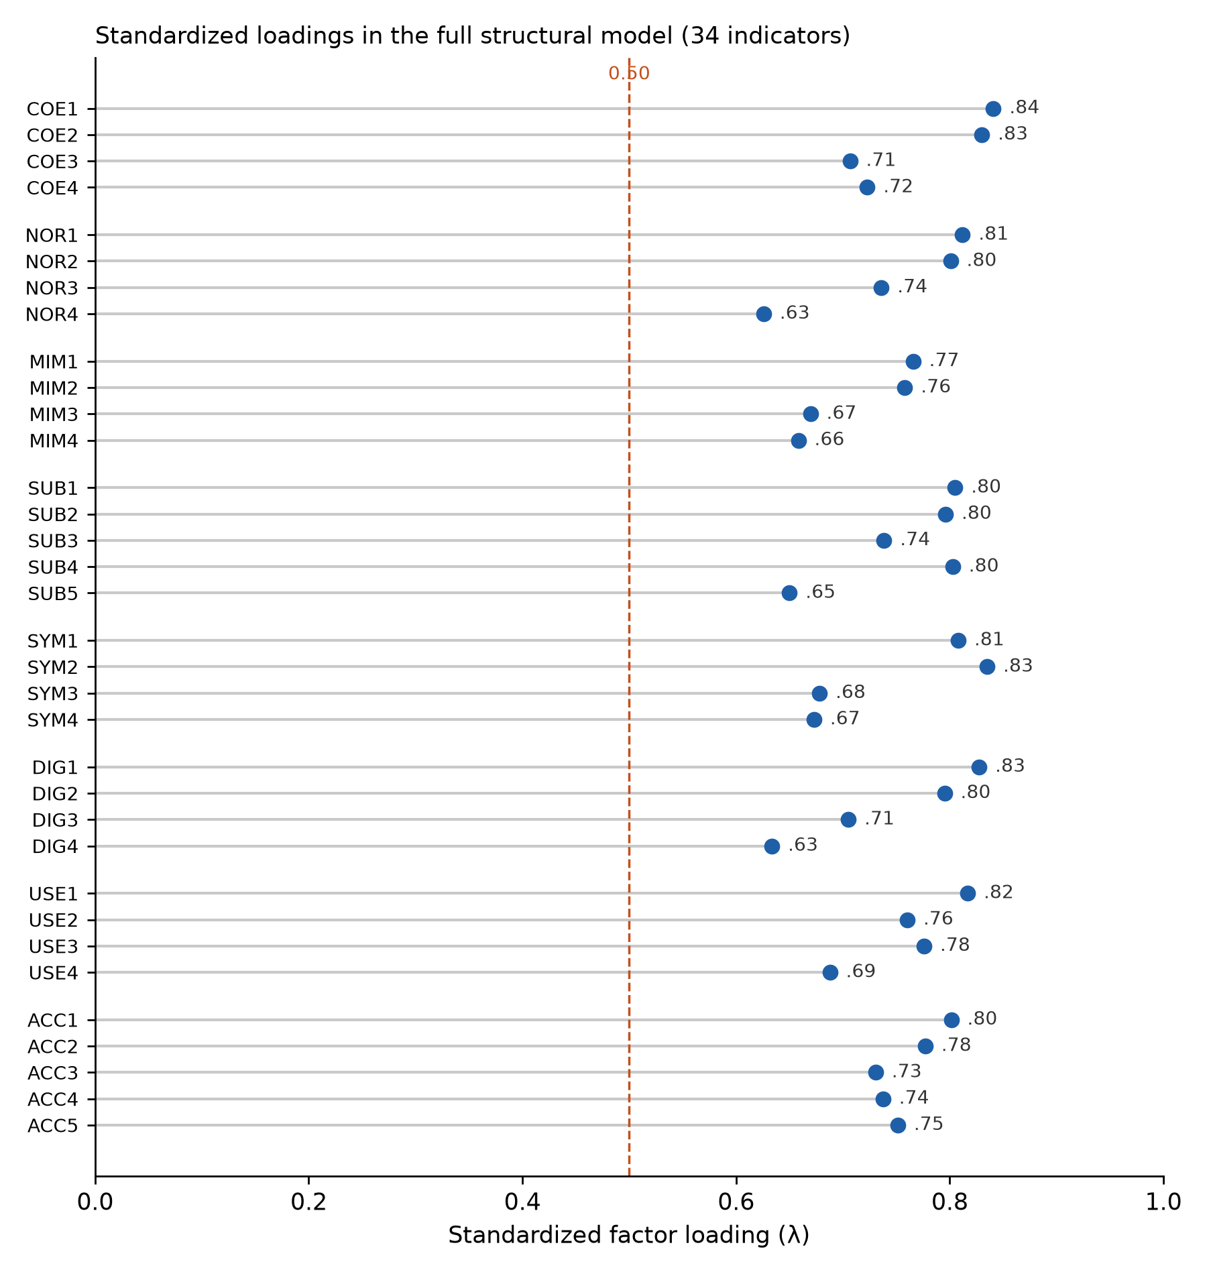
Figure A1. Standardized factor loadings of the 34 indicators in the full structural model.
Appendix B. Latent correlations and discriminant validity
Table B1. Latent correlations (CFA; diagonal = √AVE)
 | COE | NOR | MIM | SUB | SYM | DIG | USE | ACC
COE | 0.78 | 0.22 | 0.32 | 0.43 | 0.42 | 0.12 | 0.12 | 0.15
NOR | 0.22 | 0.75 | 0.33 | 0.47 | −0.02 | 0.07 | 0.17 | 0.20
MIM | 0.32 | 0.33 | 0.71 | 0.31 | 0.35 | 0.08 | 0.11 | 0.11
SUB | 0.43 | 0.47 | 0.31 | 0.76 | 0.03 | 0.10 | 0.38 | 0.40
SYM | 0.42 | −0.02 | 0.35 | 0.03 | 0.75 | −0.22 | −0.28 | −0.26
DIG | 0.12 | 0.07 | 0.08 | 0.10 | −0.22 | 0.74 | 0.37 | 0.19
USE | 0.12 | 0.17 | 0.11 | 0.38 | −0.28 | 0.37 | 0.76 | 0.51
ACC | 0.15 | 0.20 | 0.11 | 0.40 | −0.26 | 0.19 | 0.51 | 0.76

Table B2. Heterotrait–monotrait ratios (HTMT)
 | COE | NOR | MIM | SUB | SYM | DIG | USE | ACC
COE | – | 0.22 | 0.34 | 0.44 | 0.40 | 0.13 | 0.14 | 0.16
NOR | 0.22 | – | 0.33 | 0.47 | 0.05 | 0.09 | 0.18 | 0.20
MIM | 0.34 | 0.33 | – | 0.31 | 0.36 | 0.10 | 0.12 | 0.11
SUB | 0.44 | 0.47 | 0.31 | – | 0.06 | 0.13 | 0.38 | 0.40
SYM | 0.40 | 0.05 | 0.36 | 0.06 | – | 0.24 | 0.28 | 0.28
DIG | 0.13 | 0.09 | 0.10 | 0.13 | 0.24 | – | 0.37 | 0.19
USE | 0.14 | 0.18 | 0.12 | 0.38 | 0.28 | 0.37 | – | 0.52
ACC | 0.16 | 0.20 | 0.11 | 0.40 | 0.28 | 0.19 | 0.52 | –

Appendix C. Complete structural estimates with confidence intervals
Table C1. Unstandardized estimates (Wald 95% CI) and standardized coefficients
Path (outcome ← predictor) | b | SE | 95% CI | β
SUB ← COE | 0.307 | 0.058 | [0.193, 0.422] | 0.320
SUB ← NOR | 0.381 | 0.065 | [0.254, 0.507] | 0.370
SUB ← MIM | 0.077 | 0.066 | [−0.053, 0.208] | 0.073
SUB ← DIG | 0.035 | 0.058 | [−0.078, 0.149] | 0.033
SYM ← COE | 0.379 | 0.062 | [0.257, 0.500] | 0.384
SYM ← NOR | −0.234 | 0.066 | [−0.363, −0.105] | −0.222
SYM ← MIM | 0.359 | 0.074 | [0.214, 0.503] | 0.332
SYM ← DIG | −0.294 | 0.063 | [−0.417, −0.171] | −0.272
SYM ← INTC | −0.304 | 0.079 | [−0.458, −0.149] | −0.249
USE ← SUB | 0.358 | 0.061 | [0.239, 0.477] | 0.352
USE ← SYM | −0.217 | 0.060 | [−0.334, −0.100] | −0.219
USE ← DIG | 0.304 | 0.065 | [0.177, 0.432] | 0.284
USE ← INTS | 0.178 | 0.072 | [0.038, 0.319] | 0.156
ACC ← SUB | 0.273 | 0.062 | [0.151, 0.395] | 0.278
ACC ← SYM | −0.162 | 0.058 | [−0.275, −0.049] | −0.170
ACC ← USE | 0.346 | 0.065 | [0.219, 0.474] | 0.359
ACC ← exp | 0.034 | 0.044 | [−0.052, 0.120] | 0.039

Appendix D. Moderated-mediation indices and conditional effects
Table D1. Indices of moderated mediation, conditional effects of substantive implementation and standardized total indirect effects
Quantity | Estimate | 95% bootstrap CI | CI excludes 0
SUB_USE_ACC_low | 0.072 | [0.004, 0.150] | Yes
SUB_all_low | 0.345 | [0.209, 0.483] | Yes
SUB_USE_ACC_mean | 0.124 | [0.073, 0.192] | Yes
SUB_all_mean | 0.397 | [0.275, 0.525] | Yes
SUB_USE_ACC_high | 0.176 | [0.098, 0.278] | Yes
SUB_all_high | 0.449 | [0.318, 0.589] | Yes
imm_COE_SYM | 0.061 | [0.024, 0.116] | Yes
imm_COE_SUB | 0.016 | [0.002, 0.039] | Yes
imm_NOR_SUB | 0.020 | [0.003, 0.045] | Yes
imm_MIM_SUB | 0.004 | [−0.003, 0.014] | No
imm_SUB_ACC | 0.052 | [0.007, 0.117] | Yes
std_COE_tot | 0.034 | [−0.043, 0.114] | No
std_NOR_tot | 0.205 | [0.137, 0.281] | Yes
std_MIM_tot | −0.053 | [−0.126, 0.016] | No

Appendix E. Measurement-model checks and full robustness fit
Table E1. Fit statistics across specifications
Specification | χ² | df | CFI | TLI | RMSEA | SRMR
Eight-factor CFA | 548.1 | 499 | 0.990 | 0.989 | 0.017 | 0.040
One-factor CFA | 3921.9 | 527 | 0.330 | 0.287 | 0.139 | 0.153
CFA + common latent factor | 471.4 | 465 | 0.999 | 0.998 | 0.006 | 0.030
Structural model (baseline) | 921.0 | 830 | 0.984 | 0.982 | 0.018 | 0.043
DWLS, no interactions | 363.7 | 541 | 1.018 | 1.020 | 0.000 | 0.042
Residual-centred indicators | 847.7 | 830 | 0.997 | 0.997 | 0.008 | 0.042
Respecified (4 residual correlations) | 896.9 | 826 | 0.987 | 0.986 | 0.016 | 0.043
Trimmed 5% | 943.3 | 830 | 0.979 | 0.978 | 0.021 | 0.045
Experienced subsample | 972.3 | 830 | 0.965 | 0.961 | 0.027 | 0.051

