CT4101 Machine Learning
Portfolio Project: Final Report

Recognising everyday activities from lower back and thigh-mounted accelerometers in free-living conditions
Sara Bartolo
Student ID: 26231906
MSc Health Data Science
University of Galway
Repository: https://github.com/sarabartolo/harth-free-living-activity-recognition.git

Introduction

Physical activity and sedentary behaviour are linked to long-term health. Increasing physical activity and reducing sedentary behaviours are associated with many health benefits, including lower risk of all-cause and cardiovascular disease mortality, prevention of hypertension, and better mental health, cognitive health and sleep (Bull et al., 2020).
Measuring these behaviours is difficult. Self-reported activity often differs from device-measured activity (Prince et al., 2008), so wearable accelerometers that record movement continuously are increasingly used in research (Migueles et al., 2017). However, the raw signal has to be classified into activities such as sitting or walking, which is where machine learning is used. Many activity recognition models are trained on data collected in a lab, and their accuracy can drop considerably when they are used in daily life (Gyllensten and Bonomi, 2011). Free-living datasets are closer to real use but are harder to collect and to work with, because activities are shorter, transitions are more frequent and the data is noisier (Logacjov et al., 2021).
This project uses the HARTH dataset, recorded with thigh and lower-back accelerometers in free-living conditions (Logacjov et al., 2021). The aim was to determine whether a machine learning model trained on some participants can correctly classify the activities of participants it has not seen.

Data

Dataset

HARTH (Human Activity Recognition Trondheim, version 1.2) was obtained from the UCI Machine Learning Repository under a CC BY 4.0 licence (Logacjov et al., 2021). Twenty-two healthy adults aged 25 to 68 wore two triaxial accelerometers, on the lower back and the right front thigh, for about one to two and a half hours while going about their day. The sensors recorded at 50 Hz with a range of ±8 g. Activities were labelled by watching video recorded at the same time, giving 12 labels (Logacjov et al., 2021).

Data audit

All 22 participant files were checked for structure, missing values, duplicates, gaps and extreme values. The dataset contains about 35 hours of recordings across 12 activity labels, with individual recordings ranging from about 46 minutes to 2 hours 23 minutes. There were no missing values and no duplicate timestamps.
A few issues were found. One participant (S006) was recorded at 100 Hz, while all others were at recorded or downsampled to 50 Hz. Rows therefore represent different amounts of time, so activity amounts were compared in minutes instead of row counts. Three files had an extra column of row numbers (index in S015 and S021, Unnamed: 0 in S023). All files contained gaps in the timestamps, most of them longer than one second. The sensors were set to a range of ±8 g (Logacjov et al., 2021), and 188 readings reached this limit, almost all during walking or running. These were treated as real high-impact movement and kept.
The activity labels are strongly imbalanced (Figure 1). Sitting makes up 44.4% of the recorded time, followed by walking (18.9%) and standing (11.4%). Stairs (2.3%) and the cycling subtypes other than sitting cycling (1.6%) have very little data. Some activities are also predominantly from a few participants, with over half of all running comes from S027, and most cycling from S009 and S026.

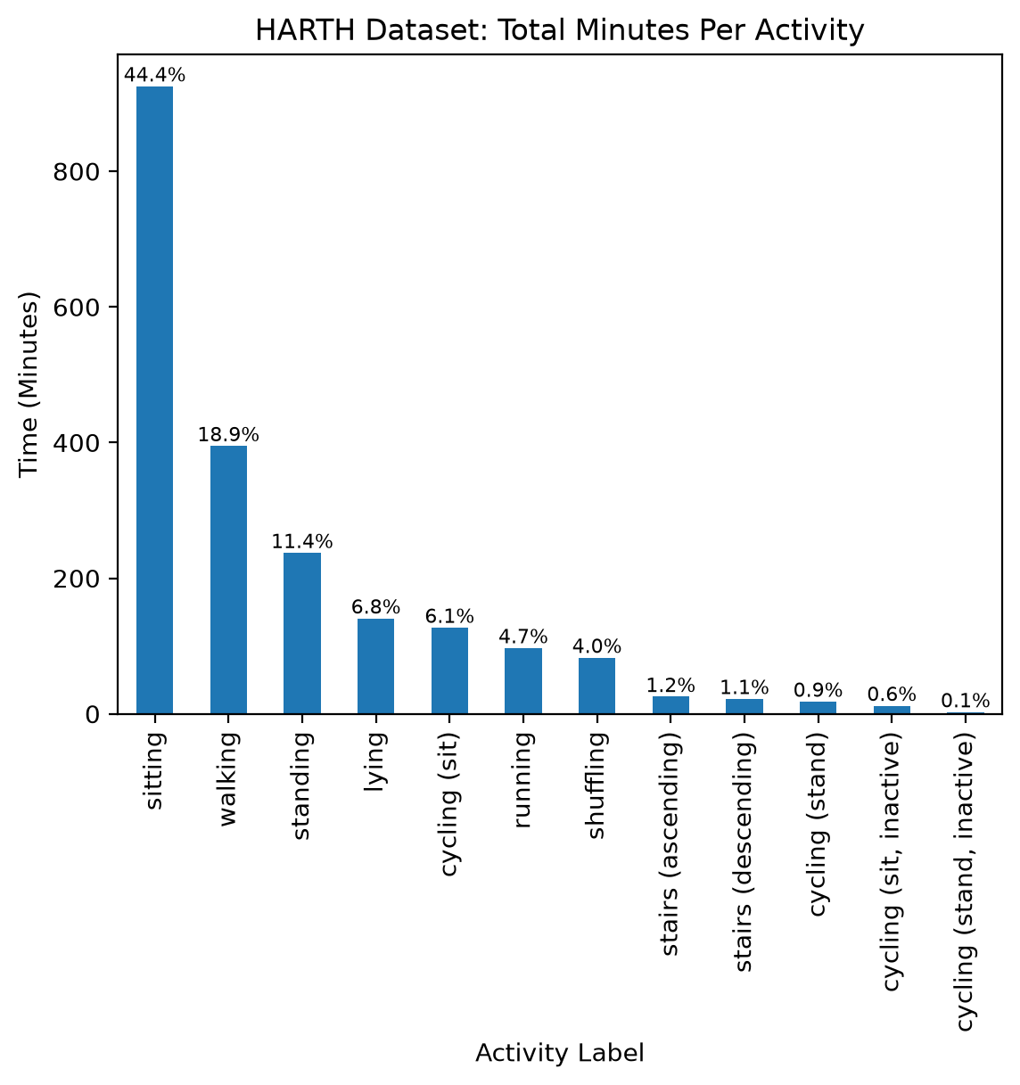
Figure 1. Total minutes per activity across all 22 participants, using the original 12 HARTH labels. Percentages show each activity’s share of the total recorded time.

Methods

Cleaning and resampling

The original 12 labels were reduced to 8. Ascending and descending stairs were merged into one, and sitting and standing cycling were also merged because each activity had too little data. The two inactive cycling labels were dropped because there was only about 15 minutes of data in total were, and because sitting or standing still on a bike is likely to look like ordinary sitting or standing to the sensors, merging them into cycling would add label noise.
Each participant’s file was cleaned in the same way, using reusable functions in src/preprocessing.py. Only the timestamp, sensor and label columns were kept, labels were mapped to the 8 classes, and S006 was resampled from 100 Hz to 50 Hz by keeping every second row. This kept the time spent in each activity the same, although no filter was applied before resampling.
Recordings were then split into continuous blocks wherever the time between two rows was more than 1.5 times that participant’s normal step. The margin avoids treating very small timestamp rounding errors as gaps. Each block was cut into non-overlapping 1-second windows of 50 samples, following Logacjov et al. (2021), and incomplete windows at the end of each block were removed, so no window crosses a gap. Windows containing more than one activity were also removed (5,530 of 123,916 windows, 4.5%), because labels around transitions are the least reliable. This left 118,386 windows.
Features

For each window, the mean, standard deviation and range were calculated for the six axes and for each sensor’s vector magnitude, √(x² + y² + z²), giving 24 features. The means capture posture, since a still sensor mainly measures gravity and so shows which way the thigh or back is pointing. The standard deviation and range capture how much the body is moving. The vector magnitude captures overall movement regardless of how the sensor was attached.

