Protein language models lose their advantage on the genes where IVF fails
Methods and Results

Methods
The analysis is implemented as a six-step pipeline of numbered Python scripts sharing two modules. Each step writes its output to disk in JSONL, so every intermediate is inspectable and any step can be rerun without repeating the ones before it. All data are public and no synthetic or simulated data enter the analysis at any point.

common.py — gene panels, metrics and shared utilities
This module defines the two gene panels under comparison. The oocyte panel comprises 18 maternal-effect and IVF-failure genes: TUBB8, PATL2, WEE2, PADI6, NLRP5, TLE6, ZP1, ZP2, ZP3, ZP4, KHDC3L, NLRP7, TRIP13, CDC20, BTG4, PANX1, REC114 and MEI1. These genes are expressed predominantly in the oocyte and early embryo, and their clinical phenotypes (oocyte maturation arrest, fertilisation failure, early embryonic arrest) are largely observable only in the context of assisted reproduction. The control panel comprises 10 deeply conserved, heavily sequenced disease genes: BRCA1, BRCA2, CFTR, TP53, MLH1, PTEN, LDLR, MSH2, ATM and RB1. These serve as the reference ceiling, since protein language models are known to perform well on them.
The module also implements the evaluation metrics. AUROC is computed by rank sum with explicit tie handling, returning a null value when either class is absent rather than silently producing a degenerate score. Confidence intervals are obtained by class-stratified bootstrap: positives and negatives are resampled separately with replacement so that neither class can vanish from a resample, which is a real risk at the sample sizes involved here. This stratification is what makes intervals meaningful for genes with only a handful of pathogenic variants.

00_fetch_clinvar.py — pathogenic variants (positives)
This step downloads the ClinVar variant_summary release (approximately 440 MB, cached locally after the first run) and extracts the positive class. Records are filtered to the GRCh38 assembly and to single nucleotide variants. The protein consequence is parsed from the ClinVar Name field using a regular expression matching the three-letter HGVS protein notation; records without a parseable missense change, or involving stop or selenocysteine codons, or synonymous at the protein level, are discarded. Clinical significance strings are mapped to four classes (pathogenic, benign, conflicting, uncertain), with conflicting interpretations excluded. Duplicate variants arising from annotation against multiple transcripts are collapsed.
The step also reports per-gene class counts, and these motivate the design of the next step. TUBB8, the flagship oocyte maturation arrest gene, has 42 pathogenic missense variants in ClinVar and zero benign ones. NLRP5 and ZP4 have the reverse problem, with benign variants but no pathogenic ones. Several other oocyte genes have fewer than fifteen labelled variants in total. A within-ClinVar positive-versus-negative comparison is therefore impossible for the genes of greatest interest.

01_fetch_gnomad.py — population variants (negatives)
Negatives are drawn from gnomAD r4 through its public GraphQL API, queried one gene at a time with retry and backoff. For each gene, missense variants are retained and the maximum allele frequency across the genome and exome call sets is taken. Variants at or above a frequency floor, set by default to 1e-4, are labelled putatively benign. The reasoning is standard in the variant effect predictor benchmarking literature: a missense change carried by many apparently healthy individuals at appreciable frequency is unlikely to cause a severe, highly penetrant phenotype.
This yields 1,043 population variants across the 28 genes, including 41 for TUBB8, which converts a gene with no usable negatives into one with a nearly balanced comparison. The frequency floor is exposed as a command-line argument so that the sensitivity of the conclusion to this choice can be tested directly, which is reported in the Results.

02_build_dataset.py — sequences, validation and merging
Canonical human protein sequences are retrieved from the UniProt REST API, restricted to reviewed entries for the exact gene symbol in Homo sapiens, taking the longest isoform where several reviewed entries exist. The positive and negative sets are then merged and every variant is validated against its sequence: the position must lie within the sequence and the stated wild-type residue must match the residue actually present. Variants failing either check are dropped and the per-gene drop rate is reported.
This validation step is not cosmetic. ClinVar and gnomAD annotate against RefSeq transcripts, while UniProt canonical may be a different isoform, so a mismatch indicates that the coordinate systems disagree and that the variant cannot be scored reliably. Observed drop rates were low for most genes (zero for the majority) but reached 13 percent for TUBB8 and 25 percent for PATL2. A threshold is applied so that any gene losing more than half its variants is flagged for isoform inspection; no gene triggered this in the final run.
Finally, variants appearing in both the pathogenic and the population set are genuinely ambiguous, and are removed from both rather than allowing the label to depend on file ordering. Eighteen variants were removed on this basis. The resulting scoring set contains 3,277 variants, comprising 2,321 pathogenic and 956 population variants, of which 14 of the 28 genes carry at least five variants in each class.

03_score_esm.py — zero-shot scoring and baseline
Each variant is scored with ESM-2 (650M parameters, facebook/esm2_t33_650M_UR50D) in a zero-shot setting, with no training or fine-tuning on any variant label. The score is the log-likelihood ratio at the mutated position, that is, the model log-probability of the mutant residue minus that of the wild-type residue given the surrounding sequence. Scores are negated so that higher values indicate greater predicted pathogenicity, which orients the AUROC conventionally.
Two scoring variants are implemented. Under wt-marginals, a single forward pass over the unmodified sequence supplies the log-probabilities at every position, so one pass per sequence suffices. Under masked-marginals, the variant position is replaced with the mask token and a separate forward pass is run for each position, which is more faithful to the masked language modelling objective but proportionally more expensive. Both were run and are compared in the Results. Proteins longer than the 1,022-residue context are handled by cropping to a window centred on the variant, with the window offset tracked so that positions remain correct.
A BLOSUM62 substitution score is computed for every variant in the same pass and serves as the baseline. This choice is deliberate: BLOSUM62 is a fixed amino acid substitution matrix published in 1992 that encodes no gene-specific or organism-specific information whatsoever. It therefore provides a floor that is, by construction, equally uninformed about both panels. Any panel difference specific to ESM-2 and absent in BLOSUM62 cannot be explained by the oocyte panel simply being noisier or more weakly labelled.

04_evaluate.py — AUROC, intervals and the panel gap
AUROC is computed per gene for both scorers, with class-stratified bootstrap intervals over 2,000 resamples. Genes with fewer than five variants in either class are reported for completeness but excluded from panel summaries, since their intervals span most of the unit interval and would add noise rather than information.
Panel means use a two-level bootstrap. Genes are resampled with replacement first, and then variants within each resampled gene, because the unit of generalisation is the gene and not the individual variant. Treating variants as the only source of uncertainty would understate the interval substantially when only four genes contribute. The difference between panels is estimated the same way, producing a direct interval on the control-minus-oocyte gap for each scorer, which is the quantity of interest.

05_figures.py — figures
Figures are generated with matplotlib at 200 DPI on white backgrounds with a serif typeface and a gradient palette. Three are produced: per-gene AUROC with intervals, panel means alongside the gap intervals, and score distributions for the genes with the most data in each panel.

Results

Dataset composition
After sequence validation, 3,277 variants were available for scoring across the 28 genes. Fourteen genes carried at least five variants in each class and entered the panel summaries: four from the oocyte panel (TUBB8, PADI6, PATL2, NLRP7) and ten from the control panel. The asymmetry is itself informative. The control panel contributes hundreds of pathogenic variants per gene, reflecting decades of clinical sequencing, whereas the oocyte panel contributes between five and thirty-eight, reflecting how recently and how narrowly these genes have been studied.

Per-gene discrimination
Table 1 reports AUROC for every included gene under both scorers, and Figure 1 displays the same values with their intervals. The separation between panels is visible without any statistical test: all ten control genes have ESM-2 AUROC above 0.76 and their intervals lie entirely above chance, whereas all four oocyte genes fall between 0.577 and 0.650 with intervals that either touch or cross the chance line.
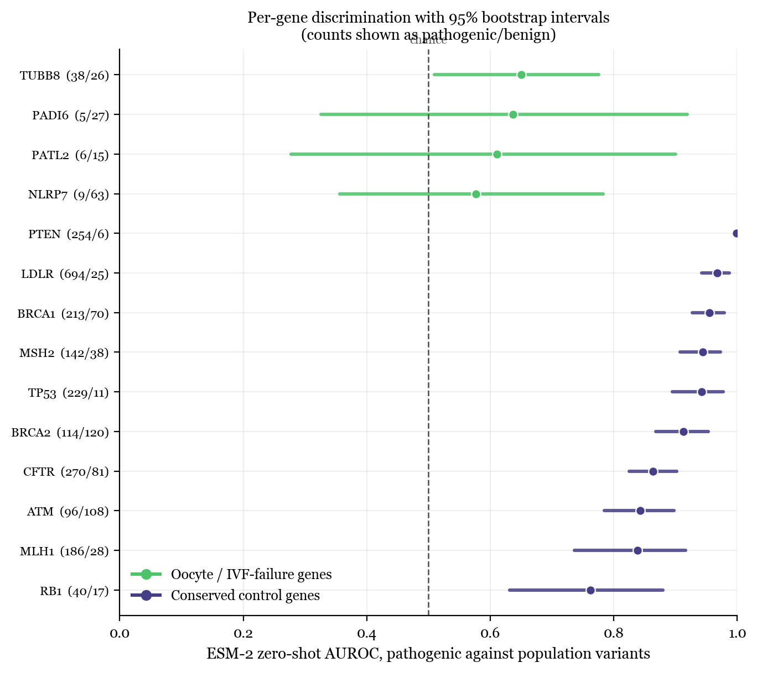
Figure 1. Per-gene ESM-2 AUROC with 95 percent bootstrap intervals. Counts are shown as pathogenic/benign. Oocyte genes in green, conserved controls in purple.
Table 1. Per-gene AUROC for ESM-2 and the BLOSUM62 baseline, with 95 percent class-stratified bootstrap intervals. Oocyte panel rows are shaded.
Gene | Panel | Path. | Benign | ESM-2 AUROC [95% CI] | BLOSUM62 AUROC [95% CI]
TUBB8 | oocyte | 38 | 26 | 0.650 [0.509, 0.775] | 0.539 [0.395, 0.689]
PADI6 | oocyte | 5 | 27 | 0.637 [0.326, 0.919] | 0.748 [0.556, 0.904]
PATL2 | oocyte | 6 | 15 | 0.611 [0.278, 0.900] | 0.572 [0.350, 0.811]
NLRP7 | oocyte | 9 | 63 | 0.577 [0.356, 0.783] | 0.531 [0.354, 0.706]
PTEN | control | 254 | 6 | 0.999 [0.994, 1.000] | 0.738 [0.625, 0.858]
LDLR | control | 694 | 25 | 0.967 [0.942, 0.987] | 0.789 [0.702, 0.863]
BRCA1 | control | 213 | 70 | 0.955 [0.927, 0.979] | 0.724 [0.653, 0.791]
MSH2 | control | 142 | 38 | 0.944 [0.908, 0.972] | 0.889 [0.832, 0.939]
TP53 | control | 229 | 11 | 0.942 [0.894, 0.977] | 0.750 [0.610, 0.874]
BRCA2 | control | 114 | 120 | 0.912 [0.868, 0.953] | 0.712 [0.651, 0.775]
CFTR | control | 270 | 81 | 0.864 [0.825, 0.902] | 0.664 [0.593, 0.733]
ATM | control | 96 | 108 | 0.843 [0.784, 0.897] | 0.616 [0.540, 0.697]
MLH1 | control | 186 | 28 | 0.838 [0.737, 0.916] | 0.681 [0.565, 0.788]
RB1 | control | 40 | 17 | 0.762 [0.631, 0.879] | 0.508 [0.360, 0.665]

TUBB8 is the best-powered oocyte gene, with 38 pathogenic and 26 population variants, and reaches 0.650 with an interval of [0.509, 0.775]. The lower bound sits just above chance. The remaining three oocyte genes have wide intervals reflecting their small positive counts, and none of them individually establishes anything. The panel-level analysis that follows is therefore the appropriate level at which to read this result.

The panel gap and why the baseline matters
Averaged over included genes, ESM-2 reaches 0.903 (95 percent CI 0.851 to 0.946) on the control panel and 0.619 (0.486 to 0.741) on the oocyte panel. The gap is 0.284 with an interval of [0.153, 0.420], which excludes zero.
Taken alone, this would be an ambiguous finding. A model performing worse on one gene set is consistent with the model having a genuine blind spot, but equally consistent with that gene set simply having noisier labels, weaker ascertainment, or harder variants. The BLOSUM62 baseline discriminates between these explanations. It reaches 0.707 (0.639 to 0.773) on controls and 0.598 (0.476 to 0.733) on oocyte genes, a gap of 0.109 with an interval of [-0.034, 0.250] that crosses zero. A scorer carrying no gene-specific information at all shows no detectable panel difference.
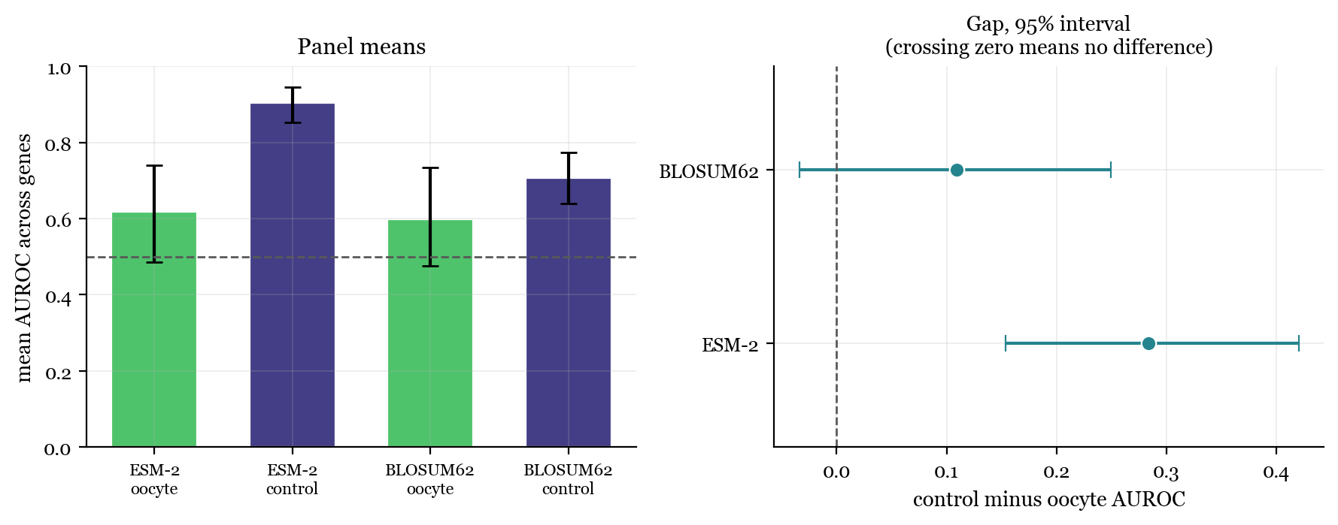
Figure 2. Left: mean AUROC per panel for both scorers. Right: the control minus oocyte gap with 95 percent bootstrap intervals. ESM-2 loses 0.284; BLOSUM62 shows no detectable difference.
The clearest way to state the result is as the advantage that the language model provides over the substitution matrix. On control genes that advantage is +0.196 AUROC. On oocyte genes it is +0.021. A model with 650 million parameters, trained on hundreds of millions of protein sequences, delivers approximately two hundredths of an AUROC over a fixed substitution matrix from 1992 on the genes where IVF fails. Whatever ESM-2 has learned that makes it useful on BRCA1 and LDLR does not transfer to TUBB8 and NLRP7.
This is consistent with the mechanism proposed at the outset. Protein language models learn from patterns of conservation across evolutionary time. TUBB8 is primate-specific and expressed only in oocytes and early embryos; the oocyte panel more broadly consists of rapidly evolving, lineage-restricted maternal-effect genes. The evolutionary signal these models depend on is thin or absent for precisely this gene class, and the results are what that account predicts.

Score distributions
Figure 3 shows why the summary statistics take the values they do. For BRCA2 and ATM the pathogenic and population score distributions are visibly displaced, with pathogenic variants concentrated at higher scores. For TUBB8 the two distributions overlap across most of their range, with only a modest rightward shift among pathogenic variants, and for NLRP7 they are almost superimposed. The failure is not a calibration offset that a threshold adjustment could repair; the model is not separating the classes in the first place.
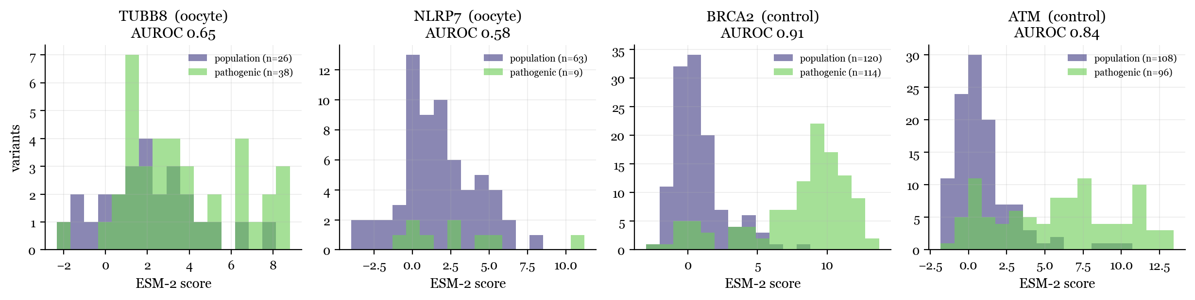
Figure 3. ESM-2 score distributions for pathogenic and population variants, for the two best-powered genes in each panel.

Robustness
Three checks were run. First, leave-one-out across the four oocyte genes gives gaps of 0.267 (dropping NLRP7), 0.280 (PATL2), 0.293 (PADI6) and 0.302 (TUBB8). No single gene drives the result, and notably the gap widens rather than collapses when TUBB8, the best-powered gene, is removed.
Second, the two scoring methods agree closely. The primary analysis uses masked-marginals and gives a gap of 0.284 [0.153, 0.420]; wt-marginals gives 0.286 [0.149, 0.435]. Panel means differ by roughly one hundredth of an AUROC between methods. The conclusion does not depend on the scoring approximation.
Third, the definition of the benign class was tightened from an allele frequency floor of 1e-4 to 1e-3. This preserves the direction, with a gap of 0.160, but the interval widens to [0.004, 0.328] and its lower bound nearly touches zero. The cause is mechanical: the stricter floor reduces the negative set from 1,043 to 299 variants, PTEN loses all its negatives, and MSH2, TP53 and RB1 fall below the inclusion threshold, leaving only three oocyte and six control genes. The advantage-over-baseline pattern is nonetheless preserved (+0.152 on controls versus +0.030 on oocyte genes). This check is reported as consistent with the primary analysis rather than as independent confirmation of it.

Limitations
Four oocyte genes clear the inclusion threshold and three of them carry fewer than ten pathogenic variants, so the oocyte panel mean rests on limited data even though the leave-one-out check indicates it is not driven by any single gene.
Ascertainment differs systematically between the panels. Control gene variants have accumulated through decades of large-scale clinical sequencing, whereas oocyte gene variants come from small infertility cohorts, often reported alongside functional validation in individual families. The BLOSUM62 control addresses the most direct form of this objection, since a difference in label quality alone should degrade both scorers, but it does not exclude subtler forms, such as pathogenic variants in the oocyte panel being enriched for effects that sequence context cannot capture.
Finally, the negative class is defined by population frequency rather than by demonstrated benignity. For recessive conditions a pathogenic allele can persist at appreciable frequency in the population, and some genes in the oocyte panel are inherited recessively. This would tend to add label noise to the negative class for those genes specifically, and remains a limitation of the design.

