Buyume ML Assignment

**Signals:**

1. Acne Detection
2. Detect Oiliness on face
3. Make a UV filter

**(UV filter)**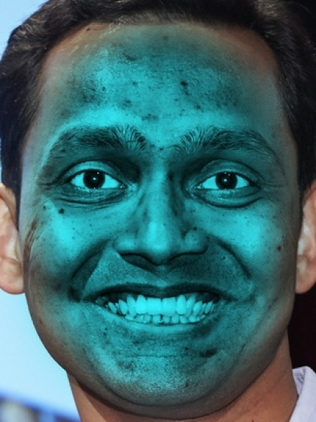

**Problem Statement:**

Choose any one signal.

input= any 3 to 4 face images

**Your script should account for multiple images output,when you test on your face images 3 or 4 at least, the scores should not vary too much or should show less deviation in those input images. Use image processing only.**

When you are done share the colab link on this mail.

**(**[rashidali@buyume.io](mailto:rashidali@buyume.io)**)**

There are certain libraries of image processing such as opencv, scikit-image, pillow etc.

(Note: Signal must be applied only on face)

Opencv: https://docs.opencv.org/4.x/index.html