# Final-Project-Tableau

## Project/Goals

In this project we are working with data from Canadian Open Data portal. The files in the folder are:

Weekly earnings from 1.1.2001 to 15.4.2015 (weekly_earnings - CSV)

Housing constructions from 1955 to 2019 (real_estate_numbers - CSV)

House prices from 1.1.2005 to 1.9.2020 (real_estate_prices - EXCEL)

Housing_price_index from November 1979 to September 2020

Office_realestate_index from November 1979 to September 2020

Consumer index from November 1979 to September 2020

Project goals are to find trends of house prices across Canada. And also comparing those trends with actual benchmarks. We also compared office prices with house prices to see which one is getting expensive faster. Then also to find trend of house prices with earning. And what year people spend more of their earnings. And also how economic crisis affected housing market and earnings and house construction as well..

## Process

### (your step 1)

First step was to pick an option to work with. I picked option 1. Then through Tableau, I connected to all data sources and also refined where needed.

### (your step 2)

Find trend of house prices across Canada using table housing_price_index. then Compared trend after 2005 with actual benchmark prices in table real_estate_prices to see if there were any differences. A comparison was also done to see if office prices are getting expensive faster. Next step is to create a heat map. And also to see if there was any price difference between districts is increasing. A Comparison of trend of house prices with earnings was done.

## Results

I Picked option 1. Overtime house prices are increasing in Canada. With this analysis, found out that office prices are increasing as compared to house prices. And also earning is not going up at the same pace as house prices. In recent years it getting tough to afford houses with the speed prices is increasing.

Here are some visuals from the project:

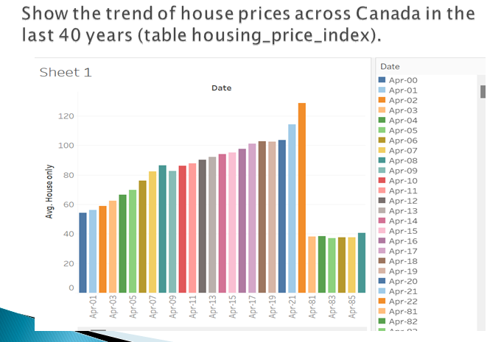

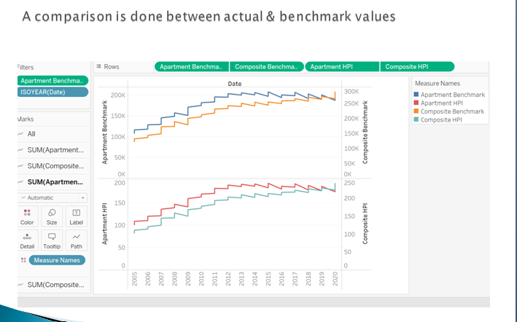

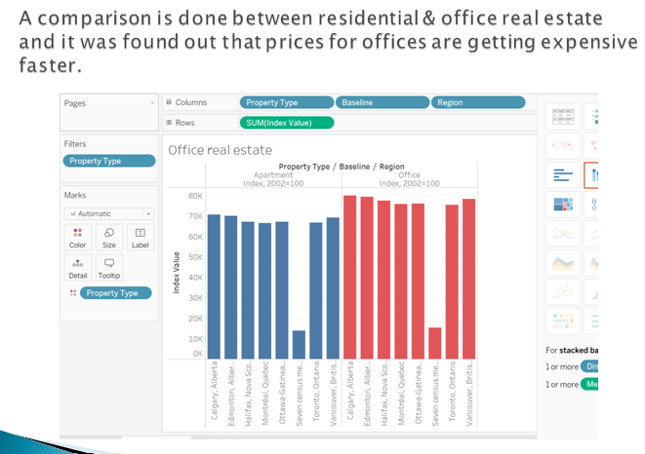

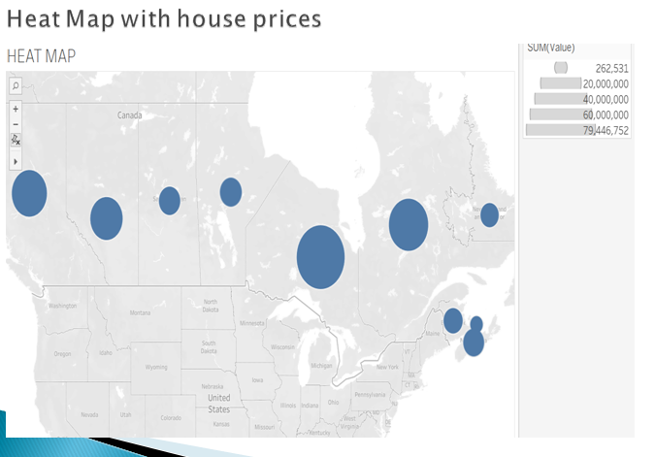

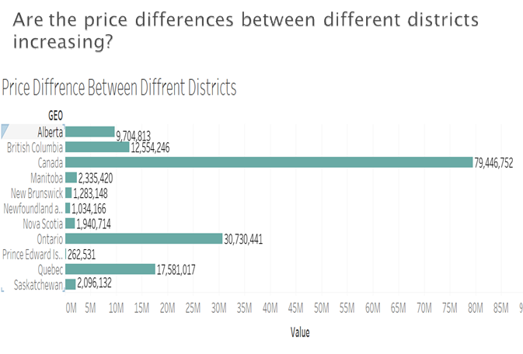

## Challenges

It was challenge to extract earning file.

## Future Goals

I will explore more options to get more dynamic house data.