Tonsil swabs & FMDV detection:
Overview:
- Nearly all juvenile buffalo (< 3 years) sampled are testing positive for FMDV with RT qPCR on tonsillar swabs (726/778, 93%) during their first capture.
- Age-infection curves show high prevalence of infection at the youngest age classes (0.6-1.5years) across the length of KNP, with a slight decrease in odds of infection ~2 years of age. Spatial patterns only arise after 2 years, where odds of infection are higher in the southern portion of the park.
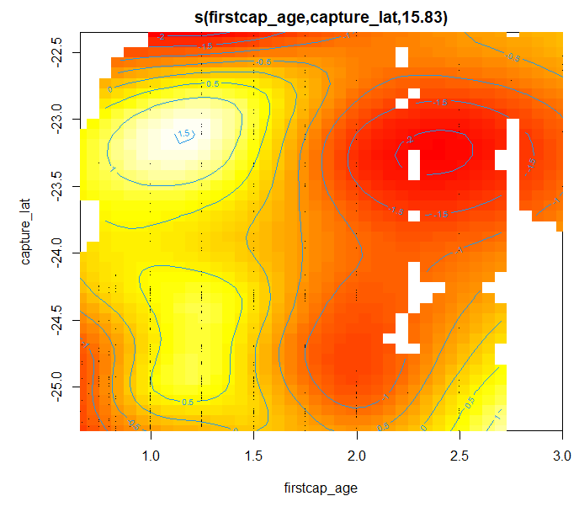
- Longitudinal sampling of 71 individuals show that most animals are retaining detectable FMDV in tonsils across years. We found Ct values remained positive in 58 animals (81.7%). We found two instances of animals oscillating between positive and negative Ct values, one animal going from negative to positive, and one animal which remained negative across three sampling periods. Nine animals went from positive to negative, although only one animal had two negative tests in a row.
Methods:

Results:

