Stochastic FMDV re-infection model:
- Although among the most widely studied animal pathogens, very little is understood about the persistence dynamics of foot-and-mouth disease virus (FMDV) in endemic regions. Persistence in livestock is likely determined by host density, movements between herds, and incomplete immunity that prevents long-term resistance to re-infection.
- African buffalo, Syncerus caffer, is the only known wildlife reservoir of FMDV and contributes to persistent outbreaks in livestock in sub-Saharan Africa. FMDV can persist in even isolated buffalo herds for decades, although causing very little clinical disease. However, the mechanisms driving persistence across FMDV serotypes is not fully understood.
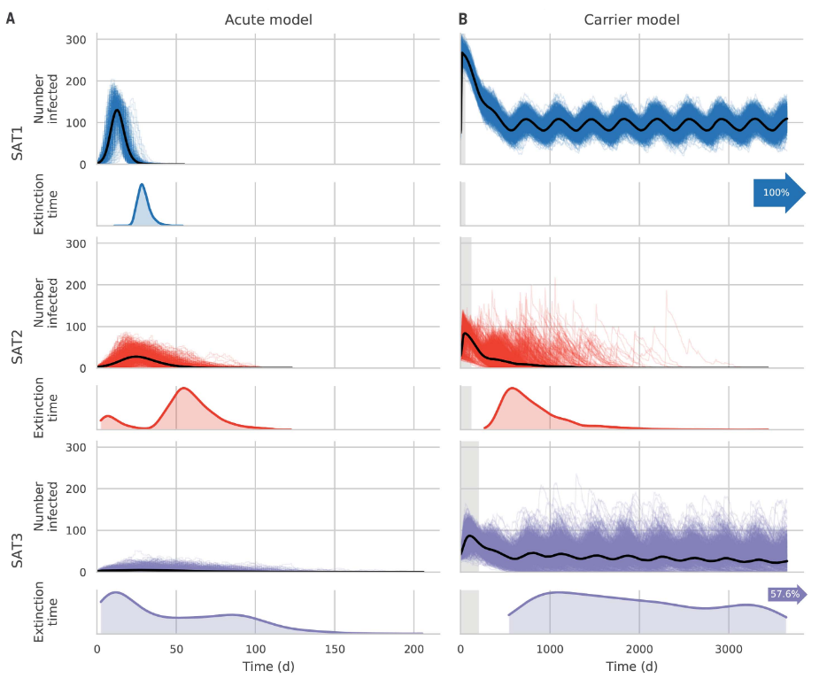
- Previous work in African buffalo suggests that persistence is driven by complex host-pathogen interactions, including the development of persistently infected ‘carriers’ and the waning of immune protection (Jolles et al., 2021, Reyes Grimaldo 2024).
Lost-immunity model (Reyes Grimaldo 2024)
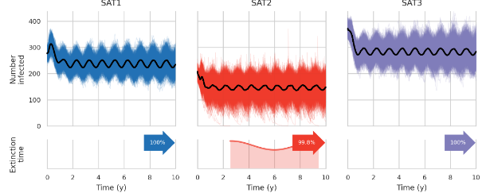
Waning immunity leaves individuals susceptible to reinfection, and observational studies show that the host-virus dynamics of reinfections are different from primary infections, leading to age-structured patterns of carrier, recovered, and susceptible hosts (Dugovich et al. in prep).
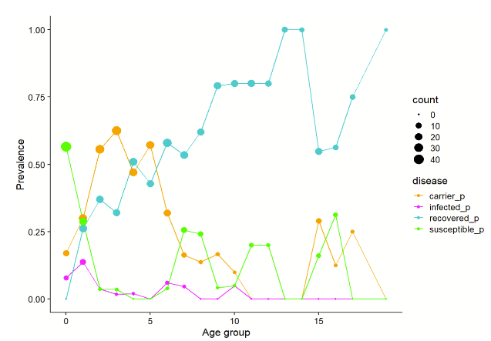
- Building from the approach in Chiwira et al. in prep, we use a stochastic modelling framework with empirically derived transition rates to explore the effects of re-infection dynamics on persistence of FMDV within a simulated buffalo herd. Specifically, we explore the effects of variable carrier probability and length of antibody protection in primary vs. re-infections on the probability of persistence within a buffalo herd, matching outcomes to field observations.
Goals & current status:
- Demonstrate the simplified model, which excludes explicit age & sex demographics, seasonal birth pulse, exposure period, and uses exponential vs gamma distributions, retrieves same outcomes as models in Jolles et al. 2021
  - First run: NOT the same results. Getting ~10% persistence in SAT2 and 96% persistence in SAT3. Confirmed that not due to lack of exposure period. Talking to Jan about which order/direction he thinks is interesting to start testing…first instinct would be birth pulse, but they found little effects of changing the birth pulse originally
- Add reinfection dynamics--probabilities of carrier state, time spend in carrier state, and time to loss of antibodies is different for first infection and 2+ infections
  - SAT1 estimatable form cohort study, but not SAT2 & SAT3. Waiting to see if SATs 2 &3 can be estimated from new study data (at least pr(Carrier), don’t expect length(Carrier)).

