Q1: Does this simplified model (excluding age, sex, exposed class, and gamma > exponential rates) retrieve the same outcomes as the Jolles et al. 2021 model?
Simplified model outputs:
SAT1: 100% persistence
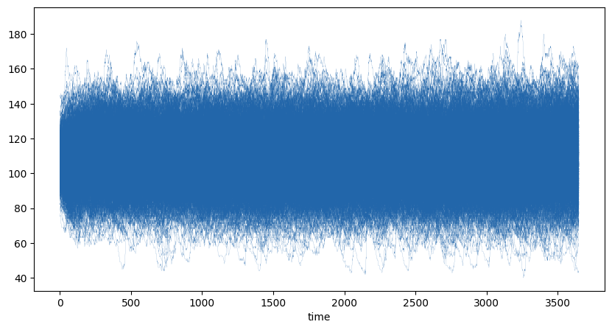

SAT2: 10% persistence (101 simulations); avg time to extinction: 1,447 days
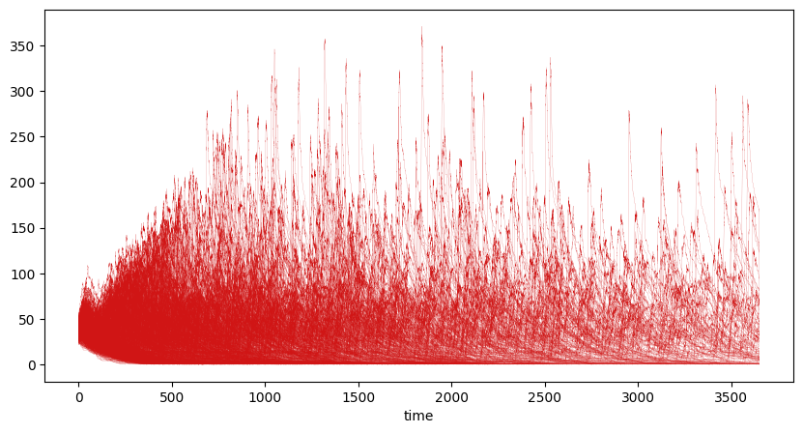
SAT3: 97% persistence (967 simulations); avg time to extinction: 2,270 days
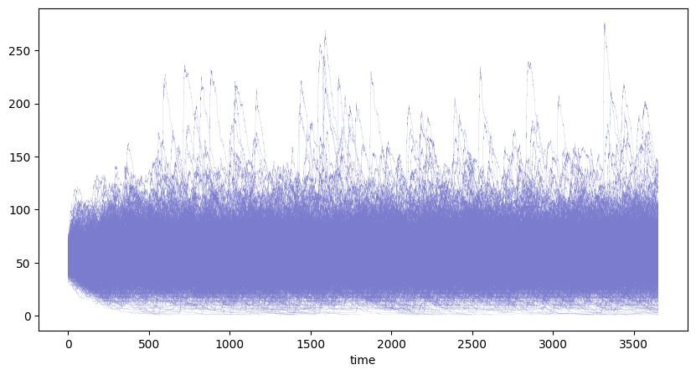

Reminder of Jolles et al. 2021 results:


