Systems-Level Insights into Bronchopulmonary Dysplasia from Meta-Analysis of Genome-Scale Studies

Chris Happs^{1,2}*, Prerna Khanna^{1,2}*, Charlotte Scoynes², Nelly Muriungi¹, Akira Alexander¹, Joshua Rogers¹, Elizabeth Lake^{1,2}, Maximilian Pickup^{1,2}, Nicholas Parkinson¹, Jonathan Millar², Kenneth Baillie^{1,2}, Sara Clohisey Hendry^{1,2}

Running title: MAIC analysis of Bronchopulmonary Dysplasia
ABSTRACT

Background
Despite marked improvements in survival following preterm birth, the incidence of bronchopulmonary dysplasia (BPD) continues to rise. BPD remains the most prevalent complication of prematurity and carries the risk of long-term morbidity. Characterising the cellular and molecular mechanisms driving disease progression is critical for informing clinical management and improving outcomes. To this end, we conducted a meta-analysis of genome-scale studies to identify molecular pathways implicated in BPD progression in both human cohorts and animal models.

Methods
Gene lists associated with BPD in humans, and in rodent models, were extracted from systematically identified genome-scale studies. These gene lists were subsequently analysed using the meta-analysis by information content (MAIC) algorithm, which integrates multiple datasets to generate a single aggregated, ranked gene list based on the cumulative strength of evidence for each gene. Comparative analyses were then performed between the human and rodent BPD datasets, as well as between the human BPD dataset and our previously generated Acute Respiratory Distress Syndrome MAIC dataset.

Results
Across all analyses, a consistent enrichment of genes involved in leukocyte-mediated antigen presentation and lymphocyte development and activation was observed, suggesting a shift from acute innate immune injury toward a more sustained lymphoid-driven inflammatory process during BPD progression. Comparative analyses revealed limited overlap between BPD and ARDS gene sets, suggesting divergent disease mechanisms, while still highlighting shared immune activation pathways. Human–rodent comparisons showed divergence in tissue remodelling signatures, likely reflecting differences in sample sources, yet converged on key conserved signals such as IL1R2, implicating common inflammatory regulatory mechanisms.

Conclusions
MAIC effectively identifies conserved molecular signatures in BPD highlighting lymphoid lineage signatures that are not readily apparent in the primary data. These signatures highlight key processes involved in antigen presentation and T cell activation and development during the progression of bronchopulmonary dysplasia.

Key words: Bronchopulmonary Dysplasia; Acute Respiratory Distress Syndrome; adaptive immunity; T cells; lymphoid cells; leukocyte cells.

Background

Bronchopulmonary dysplasia (BPD), a chronic lung disease, is one of the most common complications of preterm birth, affecting up to 30% of preterm infants born before 32 weeks gestational age (GA) (1), (2,3). Antenatal and postnatal factors disrupt the developing lung leading to decreased alveolarisation, larger alveoli, irregular pulmonary vessels, and fibrotic tissue (4,5). The effects of BPD can be life-long; individuals with BPD are more likely to require rehospitalisation during their childhood and to have limited lung function compared to those born preterm without BPD (6–9).

Understanding the molecular mechanisms that contribute to BPD could aid in risk prediction, developing targeted therapies, and understanding disease mechanisms. The heterogeneity of the disease has hampered efforts to identify reliable, consistent biomarkers and causative genes associated with disease progression. Alongside evidence from twin studies pointing to a possible heritable component in BPD some putative genetic candidates have been identified (e.g. SPOCK2, CRP) (12,13) though no gene has been significantly associated with the development of BPD by genome-scale studies such as Genome Wide Association Studies (GWAS) or exome sequencing . Recently, transcriptomic data has been used to identify four endotypes of BPD, distinguished by T helper cell and T cell signalling (17).

Comparative analyses across species can provide valuable insights into common mechanisms while also highlighting potential species-specific responses across models. Rodent models have been widely employed to study the pathophysiology of BPD and have concentrated primarily on hyperoxia-induced lung injury, mimicking the impaired alveolar development and inflammation observed in preterm infants (18). Anatomical and physiological differences have prevented in-depth research of ventilator induced lung injury in this model.

By integrating heterogeneous data sources, we can gain new perspectives. We conducted two concurrent systematic reviews of the BPD literature, focusing on genome-scale studies in humans and animal models. Results were extracted from identified studies, where possible, and analysed using the Meta Analysis by Information Content (MAIC) algorithm. This is a previously described algorithm that uses data-driven gene list weightings to produce a comprehensive ranked list of genes associated with the trait of interest .

Our findings show that genes associated with development and maintenance of adaptive immune cells feature prominently, suggesting that adaptive-lineage cells may play a larger role in BPD pathogenesis, and potentially a wider role in ventilator associated lung injury, than previously appreciated.

Methods

Systematic review
The systematic review and meta-analysis protocol was registered with the International Prospective Register of Systematic Reviews (PROSPERO; CRD42022306270, CRD42024550229). The review is reported in compliance with the Preferred Reporting Items for Systematic Reviews and Meta-Analyses (PRISMA) guidelines. (23)

Search strategy and selection criteria
A detailed description of our search strategy and eligibility criteria is provided in the Supplementary Methods. Briefly, we searched MEDLINE, Embase without language restrictions on 24/05/2024. We included human genome-scale studies reporting associations between genes, transcripts, or proteins. For human studies we accepted any contemporaneous BPD definition. For rodent studies, author defined BPD study groups were accepted. We excluded candidate in vivo or in vitro studies (< 50 genes/proteins), candidate gene associations, and studies with <5 patients per arm. Following deduplication, titles were initially screened using Screenatron. (24)

Abstracts were then screened against eligibility criteria, this included organising the studies into separate collections of human and animal studies, with an independent author resolving inconsistencies. Full texts were retrieved and analysed for inclusion before extraction of gene lists for inclusion in MAIC. Input lists were processed as previously described. (20,22,25) Briefly, lists were considered ranked if metrics of statistical significance (p-value) and/or fold change (FC) were reported. These lists were ordered by p-value/false discovery rate (low to high) then, where applicable, by absolute fold change or effect size (high to low). Gene names were converted to HGNC gene symbols (or Ensembl/Refseq symbols if no HGNC symbol). Rodent data was mapped to human ortholog symbols using custom scripts to allow for comparison with the human MAIC results.

MAIC
The MAIC algorithm has previously been described in detail. (19–22,25) A full description and the source code is available at https://baillielab.net/maic. We implemented pymaic v0.2 in Python v3.9 and used Technique to categorise input lists. MAIC combines both ranked and unranked lists, of unknown quality, to build a comprehensive ranked list of entities according to 4 basic assumptions.1. There is a set of true positives (genes implicated in BPD), 2. A gene is more likely to be a true positive if it appears in datasets from more than one source, 3. A gene is more likely to be a true positive if it appears in datasets with a higher proportion of replicated genes. 4. A gene is more likely to be a true positive if it appears in datasets from multiple methods or modalities.

Functional analyses and tissue expression
All enrichment and over-representation analyses were implemented using clusterProfiler (v4.0) (26) in R (v4.5.1) and visualised using functions in that package. All code is available at https://github.com/baillielab/bpd_maic. Redundancy of enriched GO terms was removed using the simplify function. Hypergeometric tests were implemented with the 1-phyper function in R. Gene overlaps were visualised using ggvenn. We conducted cell-type specific enrichment analysis using WebCSEA (27) and extracted the top 20 general cell types for each query. The Drug Gene Interaction Database (DGIdb) was queried for each ranked gene .

Protein-protein Interaction Network
Prioritised genes were analysed using the online tool STRING (https:// string-db.org) to determine potential protein-protein interactions (PPI). For humans 919 genes were mapped, for rodents 1726. A PPI network was constructed using the MCL (Markov Clustering) algorithm, with an inflation parameter of 3 and focused on high confidence (interaction score of >= 0.7) interactions. While network graphs represent evidence from all active interaction sources, only coexpression interactions are displayed. The network was exported and hub genes subsequently identified using CytoHubba 0.1 implemented in CytoScape 3.10.3. The overlap of the top 100 ranked genes, ranked using 5 common algorithms (MCC, MNC, Degree, EPC and DMNC), was used to evaluate hub genes.

Results

Systematic review
We first conducted a systematic review of studies that reported associations between genes, transcripts, or proteins, and the development of BPD in humans or the study of BPD in non- human mammalian models (Supplementary Methods). We did not restrict the search terms to a specific definition of BPD; however, the timeline of genome-scale studies results in an indirect emphasis on more recent BPD definitions (3). Our search yielded 4450 unique citations that were evaluated for inclusion (Supplementary Figures 1 and 2). For full text evaluation we retrieved 76 articles for human studies and 118 for mammalian studies, without overlap. Although large, non-human mammalian models are used to explore BPD, (29,30) we did not identify any that met our inclusion criteria (Supplementary Tables 1 and 2) and further analysis therefore focused on rodent models, such as mice and rats.

Meta-Analysis by Information Content of human genome-scale Bronchopulmonary Dysplasia studies
From 76 human studies, 21 met our eligibility criteria (Supplementary Figure 1, Table 1), yielding 31 gene lists (23 ranked and 8 unranked) employing 5 experimental techniques (Supplementary Table 3). The included studies represented 4358 infants (cases = 2247, controls = 2111). While

Table 1
Study | Technique | Tissue | BPD Definition
Ahmed et al., (31) | MassSpec | Oral | Resp. Supp at 36 weeks GA
Ambalavanan et al., (15) | GWAS | Blood | Resp. Supp at 36 weeks GA
Bhattacharya et al., (32) | Microarray | Lung | Resp. Supp at 36 weeks GA
Bhattacharya et al., (33) | RNAseq | Blood | Resp Supp at 3,6,9,12 months
Da paepe et al., (34) | Microarray | Lung | Ventilator dependent for entire lifespan
Dai et al., (35) | ExomeSeq | Blood | Rest Supp on 1st day of life, <32 weeks GA
Fulton et al., (36) | Microarray | Tracheal aspirates | Resp. Supp at 36 weeks GA
Gong et al., (37) | Microarray | Blood | Resp. Supp at 36 weeks GA
Hadchouel et al., (12) | GWAS | UCB | Resp. Supp at 36 weeks GA
Hamvas et al., (38) | ExomeSeq | Saliva | Resp. Supp at 36 weeks GA
Li et al., (39) | ExomeSeq | Blood | Resp. Supp at 36 weeks GA
Luo et al., (40) | ExomeSeq | Oral | Resp. Supp at 36 weeks GA
Oji Mmuo et al., (41) | RNAseq | Tracheal aspirates | Resp. Supp at 36 weeks GA
Pietrzyk et al., (42) | Microarray | Blood | Resp. Supp and birth <32 weeks GA
Siddaiah et al., (43) | RNAseq | Tracheal aspirates | Resp. Supp at 36 weeks GA
Torgerson et al., (16) | GWAS | N/A | Resp. Supp at 36 weeks GA
Tsotakos et al., (44) | RNAseq | Cultured cells - A549 | NA - cultured cells
Wang et al., (14) | GWAS | Blood | Resp. Supp at 36 weeks GA
Windhorst et al., (45) | Microarray | UCB | O₂ >21% for 28 days by 36 weeks
Yuon Chou et al., | RNAseq | UCB | Resp. Supp at 36 weeks GA
Zasada et al., (46) | MassSpec | UCB | Resp. Supp at 36 weeks GA

Table 1: Characteristics of studies included in Human BPD MAIC analysis. UCB = Umbilical Cord Blood. GA = Gestational age. Resp. Supp = Respiratory support. Oral = Oral mucosa.

the definition of BPD varied between studies, over two-thirds of studies, (71.4%, 15/21), used receipt of respiratory support at 36 weeks GA (Table 1). All but a single study used primary tissue or blood (44). MAIC collated and ranked 8017 unique genes across the datasets (Supplementary Table 4), and the top 25 are shown here (Figure1A; Top 100 in Supplementary Figure 3A). A single gene was supported by evidence from 4 experimental techniques (RASGRP3, rank = 1). Few genes (n = 53 genes, 0.6%) were supported by >=3 methods while 745 genes (9.74%) were supported by more than 1 method. In the top 10 ranked genes we observe immune regulation (RASGRP3, CD2, GPA33, IL1R2, CD177) and extracellular structure (CHIT1, RCAN3, LRRN3, FBN1). Additionally, a subunit of foetal haemoglobin, HGB1, features. Although the top hit (RASGRP3) is supported by data from GWAS experiments, the methodology overall contributed very little information content to the top ranked genes (Supplementary Figure 3B). Cell type–specific enrichment analysis indicates that the gene rankings are most strongly driven by cells of the lymphoid lineage (Supplementary Figure 4).

Enrichment analyses of Human BPD MAIC gene set
Multiple aspects of T cell activation were highlighted by gene set enrichment analysis (GSEA) of the gene set using the Reactome database (Figure 1B), alongside signals from various aspects of immunity and were supported by searches of other databases (See Supplementary materials). The signal was primarily driven by a core set of 23 genes (Supplementary Figure 3C), which the Markov Cluster Algorithm (MCL) partitioned into two distinct modules (Figure 1C): one linked to carbohydrate digestion and absorption and a second associated with CD3 and TCR zeta-chain phosphorylation. The latter constituted the substantially larger module, encompassing multiple T cell receptor components as well as several elements of the HLA complex.

We prioritised 945 genes for further investigation (Supplementary Figure 3D), as previously described and of these 310 (38%) were identified as druggable (Supplementary Materials), according to The Druggable Genome (28). We performed Over-representation Analysis (ORA), on the prioritised gene set. The Reactome database replicated much of the signal observed in the GSEA (Supplementary Materials). We grouped ORA results from the Gene Ontology database (encompassing all ontologies) first based on semantic similarity, and then based on function (Figure 1C) (26) which reveals an over-representation of immune system processes associated with lymphoid-mediated immunity, particularly regulation of T cell activation.

Protein-protein Interaction network of Human BPD MAIC gene set
We created a protein-protein interaction (PPI) network using the prioritised gene set. Clustering of this network using MCL identified 25 clusters with >=5 members. The 7 largest clusters contained >=10 members (Supplementary Figure 5 A-E shows the top 5 clusters). Separately, using previously reported methods (Millar et al., 2024), we identified 32 hub proteins likely to play central roles in the broader PPI network (Supplementary Figure 5 F). MCL clustering of this hub revealed three major clusters related to lymphocyte function, corresponding to activation (red, blue), receptor regulation (blue), and immunoglobulins (green) (Figure 1E). Overall, our MAIC analysis identified a robust lymphoid cell signature across a diverse range of human genome-scale studies of BPD.

Comparative analysis with ARDS MAIC gene set
Acute lung injury caused or worsened by mechanical ventilation during treatment is a feature of BPD in neonates and Acute Respiratory Distress Syndrome (ARDS) in adults and children. We wished to identify both shared and distinct factors underlying each syndrome. We evaluated the human BPD MAIC dataset against our previously generated ARDS MAIC analysis .

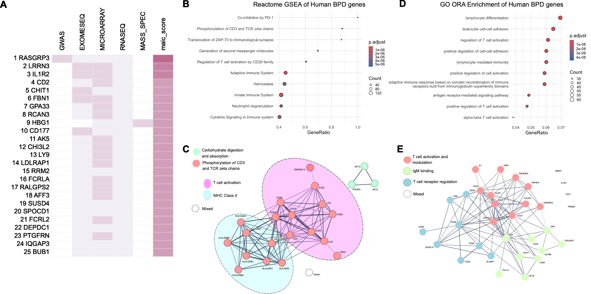
Figure 1: Meta-analysis by information content of human genome-scale Bronchopulmonary Dysplasia (BPD) studies.
A) Heatmap of top 25 genes ranked by MAIC score and indicating the source of the data. B) Gene set enrichment analysis (GSEA) of the human BPD gene set against the Reactome database. Size of circle represents the number of genes in the pathway. The colour is reflective of adjusted p-value (p.adjust) as indicated in the legend. The Gene Ratio reflects the proportion of input genes involved in each pathway. C) A core set of 23 proteins clustered using MCL (Markov clustering) resulting in 2 clusters: carbohydrate digestion and absorption (green) and phosphorylation of CD3 and t cell receptor zeta chains. The second manually annotated cluster has features of MHC signalling (blue) and T cell activation (purple). D) Over-representation analysis (ORA) of Gene Ontology (GO) terms across all ontologies for prioritised human BPD genes. The colour is reflective of adjusted p-value (p.adjust) as indicated in the legend. The Gene Ratio reflects the proportion of input genes involved in each pathway. E) A protein-protein interaction network of 32 hub proteins clustered using MCL clustering. Clusters are coloured and named according to the legend, pathway names have been manually annotated for clarity.

Focusing on the prioritised genes from both datasets, ORA highlighted shared pathology relating to regulation of T cell activation alongside leukocyte cell activation (Figure 2A). There were 112 genes that overlapped in the prioritised gene set lists, (Figure 2B). This overlap was found to be significant (p<0.005) and occurred primarily toward the top of the ranked lists (Supplementary Figure 6A). Over-representation analysis further highlighted leukocyte-mediated immunity, lymphocyte-mediated immunity, and positive regulation of both T cells and type II interferon in the overlapping genes (Figure 2C). A PPI network focused on the overlap between datasets identifies 6 clusters of >=3 genes (Figure 2D), the largest of which (red) reflects the lymphocyte signal seen elsewhere in our analysis.

Meta-Analysis by Information Content of genome-scale rodent Bronchopulmonary Dysplasia studies
From 20 eligible rodent BPD studies (Supplementary Figure 2, Table 2) we extracted and analysed 35 gene lists (28 ranked and 7 unranked), employing 5 experimental techniques (Supplementary Table 3). Of these studies, 13 used mice models and 7 used rat models. To enable cross-species comparisons, we mapped the genes from both species to their human ortholog symbols as part
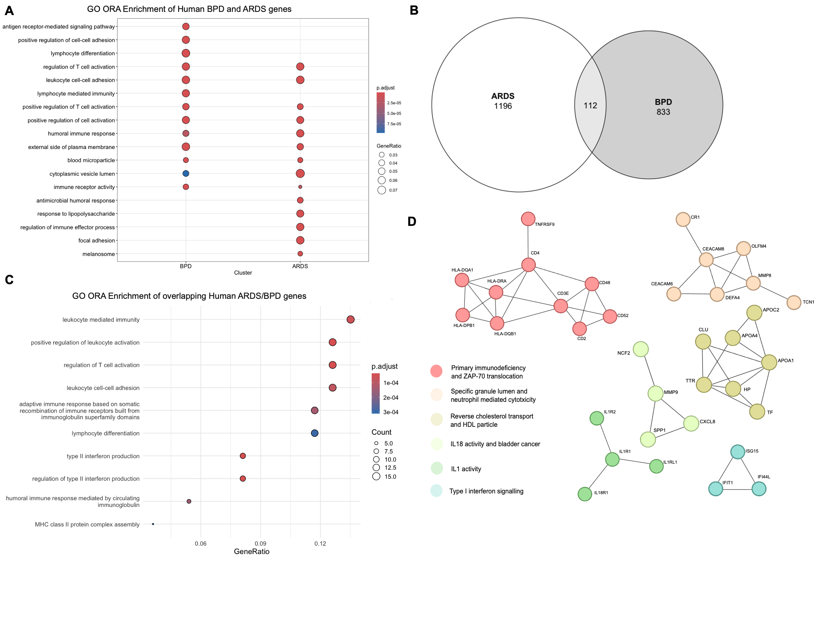
Figure 2: Comparison of analyses between Acute Respiratory Distress Syndrome (ARDS) and Bronchopulmonary Dysplasia (BPD).
A) The top 10 significantly over-represented terms from over-representation analysis (ORA) of Gene Ontology (GO) terms across all ontologies for prioritised BPD (left) and ARDS (right) genes demonstrating overlap. The colour is reflective of adjusted p-value (p.adjust) as indicated in the legend. The size of the circle reflects the Gene Ratio. B) Euler plot showing overlap of prioritised genes between BPD and ARDS MAIC analyses. C) Over-representation analysis (ORA) of GO terms across all ontologies for ARDS/BPD overlap genes. Size of circle represents the number of genes in the pathway. The colour is reflective of adjusted p-value (p.adjust) as indicated in the legend. The Gene Ratio reflects the proportion of input genes involved in each pathway. D) A protein-protein interaction network prioritised proteins that are shared between ARDS and BPD gene sets, clustered using MCL (Markov) clustering. Clusters are coloured and named according to the legend.

of the MAIC workflow. The majority (17/20; 85%) of studies modelled BPD by exposing neonatal pups to a hyperoxic environment, though the approaches differed. For example, there was variation in the timeframe of hyperoxia (from 3 days to 14 days), recovery in room air (0 days to 57 days), continuous versus intermittent hyperoxia, and the percentage oxygen (70 – 100%) used across the studies. Other methods to model BPD included lipopolysaccharide (LPS) treatment
Table 2
Study | Technique | Animal | Tissue | Method
Al Mudares et al., (47) | RNAseq | Mouse | Whole lung | Hyperoxia
Bao et al., (48) | Microarray | Mouse | Whole lung | Hyperoxia
Bhaskaran et al., (49) | Microarray | Rat | Whole lung | Hyperoxia
Bhattacharya et al., (33) | RNAseq | Mouse | Whole lung | Hyperoxia
Chao et al., (50) | Microarray | Mouse* | Whole lung | Hyperoxia
Chen et al., (51) | DNA Methylation | Rat | Whole lung | Hyperoxia
Cheng et al., (52) | RNAseq | Rat | Right lung lobe | Hyperoxia
Coarfa et al., (53) | RNAseq | Mouse | Whole lung | Hyperoxia
Dénervaud et al., (54) | RNA microarray | Rat | Whole lung | Hyperoxia
Na Dong et al., (55) | RNAseq | Rat | Whole lung | Hyperoxia
Dravet Gounot et al., (56) | RNAseq | Rat | Whole lung | Induced IUGR
El Saie et al., (57) | Mass Spec | Mouse | Whole lung | Hyperoxia
Hurskainen et al., (18) | scRNAseq | Mouse | Whole lung | Hyperoxia
Natarajan et al., (58) | Microarray | Mouse* | Whole lung | Hyperoxia
Nichols et al., (59) | QTL analysis | Mouse | Whole lung | NA
Nitkin et al., (60) | RNAseq | Mouse | Whole lung | LPS treated
Rao et al., (61) | RNAseq | Mouse* | Whole lung | Hyperoxia
Revhaug et al., (62) | Microarray | Mouse | Whole lung | Hyperoxia
Scaffa et al., (63) | scRNAseq | Mouse | Whole lung | Hyperoxia
Shrestha et al., (64) | Microarray | Rat | Whole lung | Hyperoxia

Table 2: Characteristics of studies included in Rodent BPD MAIC analysis. Techniques are outlined in supplementary table X. Mouse* = Mouse line with specific mutation. NA = No treatment. IUGR = Intrauterine growth restriction. LPS = Lipopolysaccharide.

(1 study) and induced IUGR through maternal diet (1 study). MAIC collated 7637 genes across all datasets (Figure 3A; Supplementary Table 5; Top 100 in Supplementary Figure 7A) and the top 3 genes were supported by evidence from >=4 experimental techniques (RAC2, CXCR2, IL1R2). One in five genes were supported by more than 1 method (n = 1597, 20.91%), with 141 genes (1.85%) supported by >=3 methods. Immune processes are broadly highlighted within the top ten genes (RAC2, CXCR2, IL1R2, CCDC3, PTGS2). Notably, IL1R2 appears among the top 10 results in both human (rank = 3) and rodent (rank = 3) BPD MAIC analyses. Gene rankings are strongly driven by fibroblast cells, with far less emphasis on the lymphoid cells seen in the human dataset, according to cell type–specific enrichment analysis (Supplementary Figure 8).

Enrichment analyses of Rodent BPD MAIC gene set
Gene set enrichment analysis of the rodent MAIC gene set, using the Reactome database, indicates strong signals for mRNA and translation associated pathways (Figure 3B). Analysis of the ranked genes contributing to this signal shows a cluster of lower ranked genes (rank >2500)
that drive these signals (Supplementary Figure 7C). To fully exploit the power of MAIC, we prioritised the top 1783 genes from the rodent BPD gene set for further investigation (Supplementary Figure 7D). Over-representation analysis revealed a significant overrepresentation of pathways related to leukocyte cell migration and activation, and extracellular matrix organisation (Figure 3C). An MCL clustered PPI network identified 55 clusters with >=5 members (the top 5 are shown in Supplementary Figure 9). The 21 largest clusters contained >=10 members. Among these, we found programs associated with the adaptive immune response and mitosis. Using the PPI network we identified 13 hub genes, including FC gamma receptors (FCGR1A, FCGR2A, FCGR2B) and lymphocyte markers (CD3E, CD2), suggested as being central to the wider network in rodent models of BPD (Figure 3D).
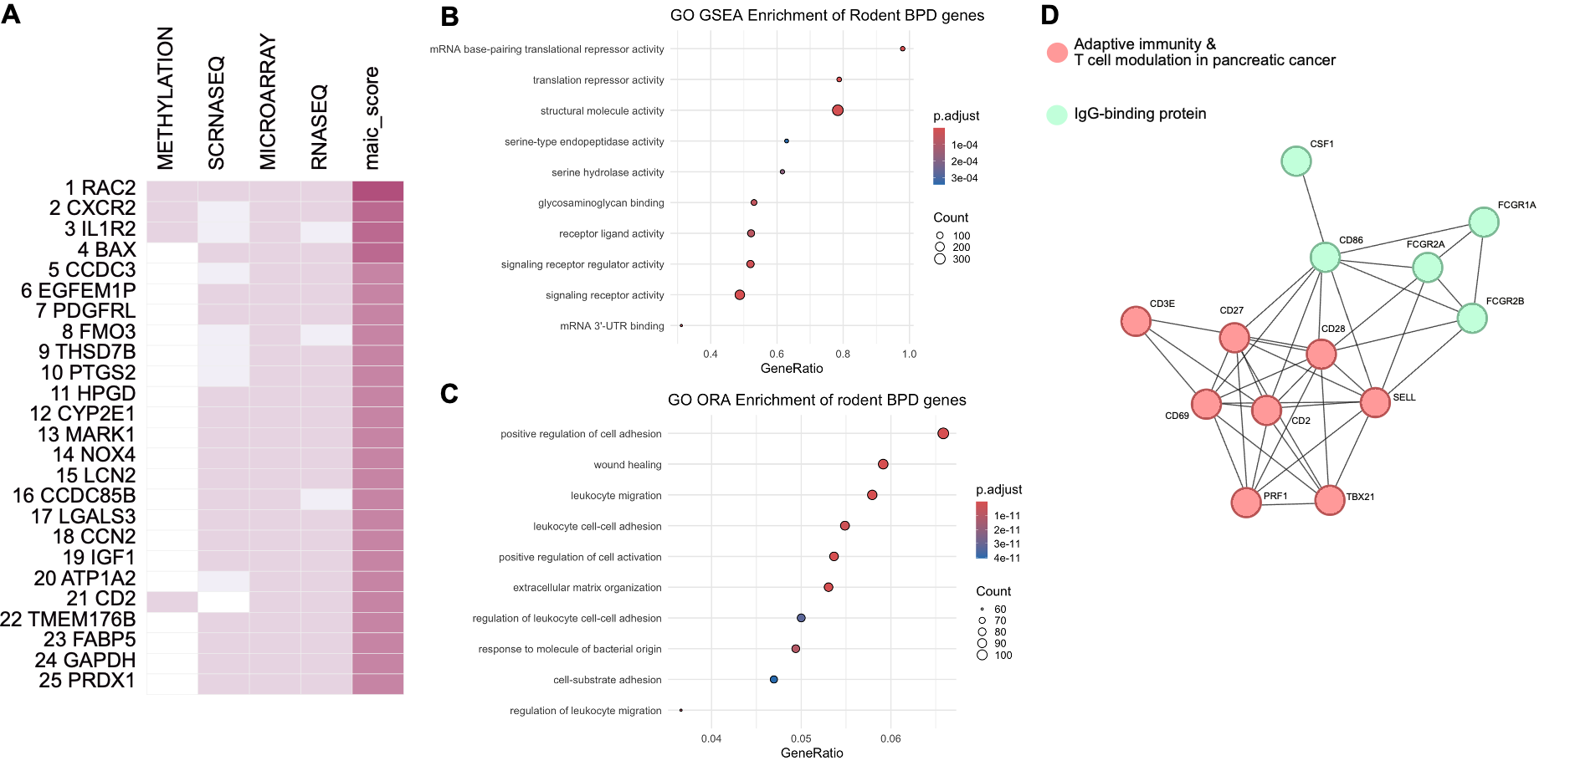
Figure 3: Meta-analysis by information content of rodent genome-scale Bronchopulmonary Dysplasia (BPD) studies.
A) Heatmap of top 25 genes ranked by MAIC score and indicating the source of the data. B) Gene set enrichment analysis (GSEA) of the rodent BPD gene set. Size of circle represents the number of genes in the pathway. The colour is reflective of adjusted p-value (p.adjust) as indicated in the legend. The Gene Ratio reflects the proportion of input genes involved in each pathway. C) Over-representation analysis (ORA) Gene Ontology terms across all ontologies for prioritised rodent BPD genes. The colour is reflective of adjusted p-value as indicated in the legend. The Gene Ratio reflects the proportion of input genes involved in each pathway. D) A protein-protein interaction network (PPI) of 13 hub proteins clustered using MCL clustering. Relevant pathways are shown in the legend.

Comparative analysis of Human and Rodent BPD MAIC gene sets
Over-representation analysis showed that while the lymphoid signal observed in humans above was seen in the rodent gene set, we also saw the role of the extracellular matrix and wound healing highlighted (Figure 4A). The gross overlap between the two parallel MAIC analyses carried out in this study was not shown to be significant by hypergeometric test (p>0.5) (Supplementary Table 6). However, focusing on the prioritised genes from both gene sets indicated the overlap of 163 genes (Figure 4B) was significant (Supplementary Table 6). and occurred mostly toward the top of the prioritised lists (Supplementary Figure 6B). Over-representation analysis of shared human and rodent BPD genes showed further enrichment of lymphocyte pathways from prior analyses and additionally supported the neutrophil degranulation and leukocyte associated pathways previously seen (Figure 4C).
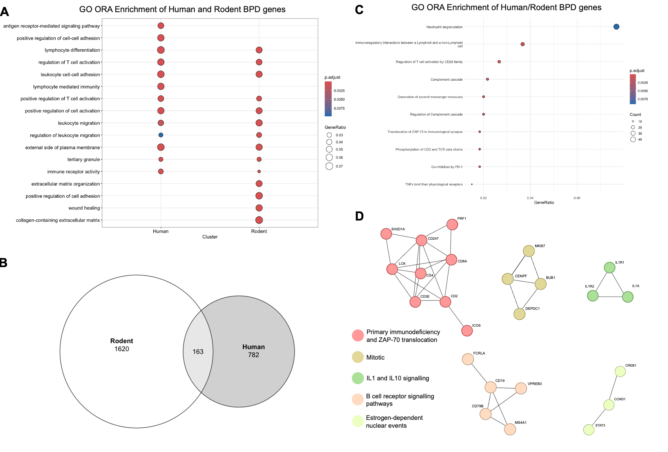
Figure 4: Comparison of MAIC analyses between human and rodent Bronchopulmonary Dysplasia (BPD) datasets.
A) The top 10 significantly over-represented terms from over-representation analysis (ORA) of Gene Ontology (GO) terms across all ontologies for prioritised Human (left) and Rodent (right) BPD genes demonstrating overlap. The colour is reflective of adjusted p-value (p.adjust) as indicated in the legend. The size of the circle reflects the Gene Ratio. B) Euler plot showing overlap of prioritised genes between Human and Rodent BPD MAIC analyses. C) Over-representation analysis (ORA) of GO terms across all ontologies for Human/Rodent overlap BPD genes. Size of circle represents the number of genes in the pathway. The colour is reflective of adjusted p-value (p.adjust) as indicated in the legend. The Gene Ratio reflects the proportion of input genes involved in each pathway. D) A protein-protein interaction network (PPI) of 24 proteins that are shared between Human and Rodent BPD gene sets, clustered using MCL clustering. This results in 4 clusters, coloured and named according to the legend.

An MCL-clustered PPI network of the overlapping genes between the prioritised sets revealed five distinct clusters (Figure 4D). These clusters prominently featured T cell receptor–associated genes, including those linked to primary immunodeficiency and ZAP-70 translocation, as well as genes involved in mitosis. The PPI network also highlighted B-cell receptor signalling pathways which was absent from either dataset when analysed independently, alongside IL-1 signalling, which was shared across both datasets.

Discussion
The clinical and biological heterogeneity of BPD presents challenges for identifying the molecular processes that drive progression of the disease. To address this, we applied a validated in silico approach to systematically integrate and prioritise existing genome-scale BPD datasets from both human and rodent studies. Further to this, we compared our human BPD MAIC results to our previously generated ARDS MAIC dataset.

A recurring theme across all three gene sets is the enrichment of genes associated with leukocyte-mediated antigen presentation and lymphocyte development and activation. This may represent a genuine biological difference occurring over the disease time course. While the leukocyte signal characterises the acute, innate driven injury phase, as BPD continues a prolonged course it involves a broader and more protracted inflammatory process where the cells of the lymphoid lineage play a pivotal, and potentially damaging role.

Evidence for a lymphocyte-related signal is present within the BPD literature. A recent study of potential transcriptomic endotypes in BPD focused on the Pietrzyk dataset included in our analysis (17,42) and identified 4 potential endotypes underlying BPD progression. T helper 17 (Th17) differentiation emerged as the most significant pathway distinguishing the BPD endotypes. CD4+ T cells were shown to be reduced in infants who develop BPD (65). It has also been observed that frequencies of populations of CD4+ T cells are increased preceding the development of BPD (66). In adults with a history of BPD, a lower CD4/CD8 ratio has been measured. Collectively, these independent observations and our integrated results establish a central role for T cells in the progression and of BPD.

Comparison of the BPD and ARDS MAIC analyses showed that 12% of the prioritised BPD gene set overlapped with the ARDS gene set. This modest overlap demonstrates that despite shared aetiologies and sample types, there is divergence in underlying disease mechanisms. However, our comparative analysis of the ARDS and BPD gene sets further underscored the involvement of lymphoid cells in ventilator-associated injury, with enrichment of pathways related to leukocyte activation, antigen presentation, and innate–adaptive immune crosstalk. Notably, pathways associated with lymphocyte differentiation were absent in ARDS.

The primary goal of carrying out parallel MAIC analyses between human and animal model BPD studies was to identify core conserved disease mechanisms and differentiate these from species-specific responses to injury in animal models. The rodent MAIC analysis showed a more pronounced focus on pathways associated with extracellular matrix remodelling, and wound healing (Figure 4A). This divergence is multifactorial but may be influenced by the sample source bias inherent in the existing literature. Over half of the human studies used circulating blood samples (52.4%), which is ideal for capturing systemic immune and biomarker signals. Conversely, 95% of the included rodent studies used whole lung tissue, directly capturing the local pathology and the extensive tissue remodelling inherent to the structural component of BPD. Two of our included human studies use lung tissue as their sample source, restricting a tissue-specific cross-species comparison using MAIC.

Despite the difference in their systemic and local pathologies, there is notable convergence in the human and rodent signals. This is demonstrated by the shared presence of Interleukin-1 Receptor Type 2 (IL1R2) in the top ranked genes of the human (rank = 3) and rodent (rank = 3) datasets. IL1R2 is upregulated in acute hypoxia, (68) and functions as a decoy receptor, acting as a crucial endogenous brake on the potent pro-inflammatory signalling cascade initiated by Interleukin-1 (IL-1) . The preterm lung is uniquely vulnerable to hypoxia, which can trigger a dangerous, self-amplifying cycle of injury and inflammation (70). IL-1 antagonism has been shown to confer protection in rodent models of BPD, (71,72) suggesting that IL1R2 exerts a protective role as an anti-inflammatory ‘brake’ protein in this context.

This study is based on the published literature and is intended to capture the current state of genome-scale BPD research. It is subject to several limitations. Firstly, blood is among the least invasive and most practical biological samples to collect in the Neonatal Intensive Care setting. As detailed above, this difference in sample source for human and rodent data represents a primary limitation on direct comparability and interpretation of tissue-specific pathology. We considered performing a subgroup MAIC analysis restricted to human lung tissue to allow for direct comparison with the rodent data; however, only two human studies were available. Application of the MAIC algorithm to a set of two studies would not yield statistically meaningful results, and alternative methods would need to be used to address this limitation. Second, owing to experimental design constraints, the rodent BPD models included in this analysis may be disproportionately weighted toward the effects of hyperoxia on the developing lung, rather than capturing the full complexity of the disease. Third, inherent limitations of cross-species genetic analyses arise from imperfect gene mapping and the absence of direct gene counterparts between species. Finally, MAIC does not account for direction of effect, thus we are limited on how much we can infer about specific mechanisms.

Conclusions
In summary, MAIC offers a validated, integrative strategy capable of navigating the substantial clinical and molecular heterogeneity that characterises BPD. Through this framework, we defined sets of consensus genes across diverse genome-scale datasets. Notably, the aggregated signal is concentrated within lymphoid lineage signatures and underscores key processes involved in antigen presentation, T cell activation and development.

List of abbreviations

ARDS: Acute Respiratory Distress Syndrome.
BPD: Bronchopulmonary Dysplasia.
ExomeSeq: Exome Sequencing.
GA: Gestational Age.
GO: Gene Ontology.
GSEA: Gene Set Enrichment Analysis.
GWAS: Genome-Wide Association Study.
IUGR: Intrauterine Growth restriction.
LPS: Lipopolysaccharide.
MAIC: Meta-Analysis of Information Content.
MassSpec: Mass Spectrometry.
MCL: Markov Clustering.
Oral: Oral mucosa.
ORA: Over-Representation Analysis.
PPI: Protein-Protein Interaction.
QTL: Quantitative Trait Loci.
Resp. Supp: Respiratory Support.
RNAseq: Ribonucleic Acid Sequencing.
scRNASeq: Single-cell RNAseq.
UCB : Umbilical Cord Blood.

References
1. Neonatal Data Analysis Unit (NDAU). Neonatal Health Intelligence Tool. 2021. Available: https://www.imperial.ac.uk/neonatal-data-analysis-unit/neonatal-data-analysis-unit/neonatal-data-visualisations/.
2. Isayama T, Lee SK, Yang J, Lee D, Daspal S, Dunn M, et al. Revisiting the Definition of Bronchopulmonary Dysplasia: Effect of Changing Panoply of Respiratory Support for Preterm Neonates. JAMA Pediatr [Internet]. 2017 Mar 1 [cited 2024 June 11];171 (3):271. Available from: http://archpedi.jamanetwork.com/article.aspx?doi=10.1001/jamapediatrics.2016.4141
3. Jensen EA, Dysart K, Gantz MG, McDonald S, Bamat NA, Keszler M, et al. The Diagnosis of Bronchopulmonary Dysplasia in Very Preterm Infants. An Evidence-based Approach. Am J Respir Crit Care Med [Internet]. 2019 Sept 15 [cited 2024 June 8];200 (6):751–9. Available from: https://www.atsjournals.org/doi/10.1164/rccm.201812-2348OC
4. Gilfillan M, Bhandari A, Bhandari V. Diagnosis and management of bronchopulmonary dysplasia. BMJ [Internet]. 2021 Oct 20 [cited 2024 June 12];n1974. Available from: https://www.bmj.com/lookup/doi/10.1136/bmj.n1974
5. Thébaud B, Goss KN, Laughon M, Whitsett JA, Abman SH, Steinhorn RH, et al. Bronchopulmonary dysplasia. Nat Rev Dis Primer [Internet]. 2019 Nov 14 [cited 2024 June 16];5 (1):78. Available from: https://www.nature.com/articles/s41572-019-0127-7
6. Greenough A. Measuring respiratory outcome. Semin Neonatol [Internet]. 2000 May [cited 2024 June 12];5 (2):119–26. Available from: https://linkinghub.elsevier.com/retrieve/pii/S1084275699900064
7. Greenough A. Bronchopulmonary dysplasia – Long term follow up. Paediatr Respir Rev [Internet]. 2006 Jan [cited 2024 June 12];7:S189–91. Available from: https://linkinghub.elsevier.com/retrieve/pii/S1526054206002363
8. Dassios T, Greenough A. Long-term sequelae of bronchopulmonary dysplasia. In: Sinha IP, Bhatt JM, Cleator A, Wallace H, editors. Respiratory Diseases of the Newborn Infant [Internet]. Sheffield, United Kingdom: European Respiratory Society; 2021 [cited 2024 June 12]. p. 68–78. Available from: http://erspublications.com/lookup/doi/10.1183/2312508X.10013720
9. Sun T, Yu HY, Yang M, Song YF, Fu JH. Risk of asthma in preterm infants with bronchopulmonary dysplasia: a systematic review and meta-analysis. World J Pediatr [Internet]. 2023 June [cited 2024 June 14];19 (6):549–56. Available from: https://link.springer.com/10.1007/s12519-023-00701-1
10. Lavoie PM, Pham C, Jang KL. Heritability of Bronchopulmonary Dysplasia, Defined According to the Consensus Statement of the National Institutes of Health. Pediatrics [Internet]. 2008 Sept 1 [cited 2024 June 3];122 (3):479–85. Available from: https://publications.aap.org/pediatrics/article/122/3/479/72260/Heritability-of-Bronchopulmonary-Dysplasia-Defined
11. Bhandari V, Bizzarro MJ, Shetty A, Zhong X, Page GP, Zhang H, et al. Familial and Genetic Susceptibility to Major Neonatal Morbidities in Preterm Twins. Pediatrics [Internet]. 2006 June 1 [cited 2024 June 3];117 (6):1901–6. Available from: https://publications.aap.org/pediatrics/article/117/6/1901/69470/Familial-and-Genetic-Susceptibility-to-Major
12. Hadchouel A, Durrmeyer X, Bouzigon E, Incitti R, Huusko J, Jarreau PH, et al. Identification of SPOCK2 As a Susceptibility Gene for Bronchopulmonary Dysplasia. Am J Respir Crit Care Med [Internet]. 2011 Nov 15 [cited 2024 June 3];184 (10):1164–70. Available from: https://www.atsjournals.org/doi/10.1164/rccm.201103-0548OC
13. Mahlman M, Karjalainen MK, Huusko JM, Andersson S, Kari MA, Tammela OKT, et al. Genome-wide association study of bronchopulmonary dysplasia: a potential role for variants near the CRP gene. Sci Rep [Internet]. 2017 Aug 24 [cited 2024 June 3];7 (1):9271. Available from: https://www.nature.com/articles/s41598-017-08977-w
14. Wang H, St. Julien KR, Stevenson DK, Hoffmann TJ, Witte JS, Lazzeroni LC, et al. A Genome-Wide Association Study (GWAS) for Bronchopulmonary Dysplasia. Pediatrics [Internet]. 2013 Aug 1 [cited 2024 June 11];132 (2):290–7. Available from: https://publications.aap.org/pediatrics/article/132/2/290/31355/A-Genome-Wide-Association-Study-GWAS-for
15. Ambalavanan N, Cotten CM, Page GP, Carlo WA, Murray JC, Bhattacharya S, et al. Integrated Genomic Analyses in Bronchopulmonary Dysplasia. J Pediatr [Internet]. 2015 Mar [cited 2024 June 3];166 (3):531-537.e13. Available from: https://linkinghub.elsevier.com/retrieve/pii/S0022347614009032
16. Torgerson DG, Ballard PL, Keller RL, Oh SS, Huntsman S, Hu D, et al. Ancestry and genetic associations with bronchopulmonary dysplasia in preterm infants. Am J Physiol-Lung Cell Mol Physiol [Internet]. 2018 Nov 1 [cited 2024 June 3];315 (5):L858–69. Available from: https://www.physiology.org/doi/10.1152/ajplung.00073.2018
17. Moreira AG, Arora T, Arya S, Winter C, Valadie CT, Kwinta P. Leveraging transcriptomics to develop bronchopulmonary dysplasia endotypes: a concept paper. Respir Res [Internet]. 2023;24 (1). Available from: http://ovidsp.ovid.com/ovidweb.cgi?T=JS&PAGE=reference&D=med24&NEWS=N&AN=37968635
18. Hurskainen M, Mizikova I, Cook DP, Andersson N, Cyr-Depauw C, Lesage F, et al. Single cell transcriptomic analysis of murine lung development on hyperoxia-induced damage. Nat Commun [Internet]. 2021;12 (1). Available from: http://ovidsp.ovid.com/ovidweb.cgi?T=JS&PAGE=reference&D=med19&NEWS=N&AN=33692365
19. The GenOMICC Investigators, The ISARIC4C Investigators, The COVID-19 Human Genetics Initiative, 23andMe Investigators, BRACOVID Investigators, Gen-COVID Investigators, et al. Genetic mechanisms of critical illness in COVID-19. Nature [Internet]. 2021 Mar 4 [cited 2024 June 11];591 (7848):92–8. Available from: https://www.nature.com/articles/s41586-020-03065-y
20. Parkinson N, Rodgers N, Head Fourman M, Wang B, Zechner M, Swets MC, et al. Dynamic data-driven meta-analysis for prioritisation of host genes implicated in COVID-19. Sci Rep [Internet]. 2020 Dec 18 [cited 2025 Mar 21];10 (1):22303. Available from: https://www.nature.com/articles/s41598-020-79033-3
21. Wang B, Law A, Regan T, Parkinson N, Cole J, Russell CD, et al. Systematic comparison of ranking aggregation methods for gene lists in experimental results. Lu Z, editor. Bioinformatics [Internet]. 2022 Oct 31 [cited 2025 Mar 25];38 (21):4927–33. Available from: https://academic.oup.com/bioinformatics/article/38/21/4927/6696211
22. Millar JE, Clohisey-Hendry S, McMannus M, Zechner M, Wang B, Parkinson N, et al. The genomic landscape of Acute Respiratory Distress Syndrome: a meta-analysis by information content of genome-wide studies of the host response [Internet]. 2024 [cited 2025 Feb 21]. Available from: http://medrxiv.org/lookup/doi/10.1101/2024.02.13.24301089
23. Page MJ, McKenzie JE, Bossuyt PM, Boutron I, Hoffmann TC, Mulrow CD, et al. The PRISMA 2020 statement: an updated guideline for reporting systematic reviews. BMJ [Internet]. 2021 Mar 29 [cited 2025 Aug 6];n71. Available from: https://www.bmj.com/lookup/doi/10.1136/bmj.n71
24. Clark J, Glasziou P, Del Mar C, Bannach-Brown A, Stehlik P, Scott AM. A full systematic review was completed in 2 weeks using automation tools: a case study. J Clin Epidemiol [Internet]. 2020 May [cited 2025 Aug 6];121:81–90. Available from: https://linkinghub.elsevier.com/retrieve/pii/S089543561930719X
25. Li B, Clohisey SM, Chia BS, Wang B, Cui A, Eisenhaure T, et al. Genome-wide CRISPR screen identifies host dependency factors for influenza A virus infection. Nat Commun [Internet]. 2020 Jan 9 [cited 2024 June 3];11 (1):164. Available from: https://www.nature.com/articles/s41467-019-13965-x
26. Wu T, Hu E, Xu S, Chen M, Guo P, Dai Z, et al. clusterProfiler 4.0: A universal enrichment tool for interpreting omics data. The Innovation [Internet]. 2021 Aug [cited 2025 Aug 6];2 (3):100141. Available from: https://linkinghub.elsevier.com/retrieve/pii/S2666675821000667
27. Dai Y, Hu R, Liu A, Cho KS, Manuel AM, Li X, et al. WebCSEA: web-based cell-type-specific enrichment analysis of genes. Nucleic Acids Res [Internet]. 2022 July 5 [cited 2025 Sept 2];50 (W1):W782–90. Available from: https://academic.oup.com/nar/article/50/W1/W782/6591520
28. Freshour SL, Kiwala S, Cotto KC, Coffman AC, McMichael JF, Song JJ, et al. Integration of the Drug–Gene Interaction Database (DGIdb 4.0) with open crowdsource efforts. Nucleic Acids Res [Internet]. 2021 Jan 8 [cited 2025 Oct 16];49 (D1):D1144–51. Available from: https://academic.oup.com/nar/article/49/D1/D1144/6006193
29. Eiby YA, Wright LL, Kalanjati VP, Miller SM, Bjorkman ST, Keates HL, et al. A Pig Model of the Preterm Neonate: Anthropometric and Physiological Characteristics. Frasch MG, editor. PLoS ONE [Internet]. 2013 July 9 [cited 2024 Nov 8];8 (7):e68763. Available from: https://dx.plos.org/10.1371/journal.pone.0068763
30. Rozance PJ, Seedorf GJ, Brown A, Roe G, O’Meara MC, Gien J, et al. Intrauterine growth restriction decreases pulmonary alveolar and vessel growth and causes pulmonary artery endothelial cell dysfunction in vitro in fetal sheep. Am J Physiol-Lung Cell Mol Physiol [Internet]. 2011 Dec [cited 2025 Mar 5];301 (6):L860–71. Available from: https://www.physiology.org/doi/10.1152/ajplung.00197.2011
31. Ahmed S, Odumade OA, van Zalm P, Fatou B, Hansen R, Martin CR, et al. Proteomics-Based Mapping of Bronchopulmonary Dysplasia-Associated Changes in Noninvasively Accessible Oral Secretions. J Pediatr [Internet]. 2023;270. Available from: http://ovidsp.ovid.com/ovidweb.cgi?T=JS&PAGE=reference&D=medp&NEWS=N&AN=37839510
32. Bhattacharya S, Go D, Krenitsky DL, Huyck HL, Solleti SK, Lunger VA, et al. Genome-wide transcriptional profiling reveals connective tissue mast cell accumulation in bronchopulmonary dysplasia. Am J Respir Crit Care Med [Internet]. 2012;186 (4). Available from: http://ovidsp.ovid.com/ovidweb.cgi?T=JS&PAGE=reference&D=med9&NEWS=N&AN=22723293
33. Bhattacharya S, Mereness JA, Baran AM, Misra RS, Peterson DR, Ryan RM, et al. Lymphocyte-Specific Biomarkers Associated With Preterm Birth and Bronchopulmonary Dysplasia. Front Immunol [Internet]. 2020;11. Available from: http://ovidsp.ovid.com/ovidweb.cgi?T=JS&PAGE=reference&D=med18&NEWS=N&AN=33552042
34. De Paepe ME, Greco D, Mao Q. Angiogenesis-related gene expression profiling in ventilated preterm human lungs. Exp Lung Res [Internet]. 2010;36 (7). Available from: http://ovidsp.ovid.com/ovidweb.cgi?T=JS&PAGE=reference&D=med8&NEWS=N&AN=20718599
35. Dai D, Chen H, Dong X, Chen J, Mei M, Lu Y, et al. Bronchopulmonary Dysplasia Predicted by Developing a Machine Learning Model of Genetic and Clinical Information. Front Genet [Internet]. 2021;12. Available from: http://ovidsp.ovid.com/ovidweb.cgi?T=JS&PAGE=reference&D=pmnm6&NEWS=N&AN=34276789
36. Fulton CT, Cui TX, Goldsmith AM, Bermick J, Popova AP. Gene Expression Signatures Point to a Male Sex-Specific Lung Mesenchymal Cell PDGF Receptor Signaling Defect in Infants Developing Bronchopulmonary Dysplasia. Sci Rep [Internet]. 2018;8 (1). Available from: http://ovidsp.ovid.com/ovidweb.cgi?T=JS&PAGE=reference&D=med15&NEWS=N&AN=30459472
37. Gong X, Qiu J, Qiu G, Cai C. Adrenomedullin regulated by miRNA-574-3p protects premature infants with bronchopulmonary dysplasia. Biosci Rep [Internet]. 2020;40 (5). Available from: http://ovidsp.ovid.com/ovidweb.cgi?T=JS&PAGE=reference&D=med18&NEWS=N&AN=32412065
38. Hamvas A, Feng R, Bi Y, Wang F, Bhattacharya S, Mereness J, et al. Exome sequencing identifies gene variants and networks associated with extreme respiratory outcomes following preterm birth. BMC Genet [Internet]. 2018;19 (1). Available from: http://ovidsp.ovid.com/ovidweb.cgi?T=JS&PAGE=reference&D=med15&NEWS=N&AN=30342483
39. Li A., McDougall A.R.A., Zahra V.A., Chandrasena J., Hooper S.B., Wallace M.J. Investigating the early mechanisms leading from ventilation-induced lung injury to bronchopulmonary dysplasia using in vitro lung cell over-distension. J Paediatr Child Health [Internet]. 2015;51 (SUPPL. 1). Available from: http://ovidsp.ovid.com/ovidweb.cgi?T=JS&PAGE=reference&D=emed16&NEWS=N&AN=71874055
40. Luo X, Zhao M, Chen C, Lin F, Li X, Huang H, et al. Identification of genetic susceptibility in preterm newborns with bronchopulmonary dysplasia by whole-exome sequencing: BIVM gene may play a role. Eur J Pediatr [Internet]. 2023;182 (4). Available from: http://ovidsp.ovid.com/ovidweb.cgi?T=JS&PAGE=reference&D=med23&NEWS=N&AN=36757497
41. Oji-Mmuo CN, Siddaiah R, Montes DT, Pham MA, Spear D, Donnelly A, et al. Tracheal aspirate transcriptomic and miRNA signatures of extreme premature birth with bronchopulmonary dysplasia. J Perinatol Off J Calif Perinat Assoc [Internet]. 2021;41 (3). Available from: http://ovidsp.ovid.com/ovidweb.cgi?T=JS&PAGE=reference&D=med19&NEWS=N&AN=33177681
42. Pietrzyk JJ, Kwinta P, Wollen EJ, Bik-Multanowski M, Madetko-Talowska A, Gunther CC, et al. Gene expression profiling in preterm infants: new aspects of bronchopulmonary dysplasia development. PloS One [Internet]. 2013;8 (10). Available from: http://ovidsp.ovid.com/ovidweb.cgi?T=JS&PAGE=reference&D=med10&NEWS=N&AN=24194948
43. Siddaiah R, Oji-Mmuo C, Aluquin VPR, Kawasawa YI, Donnelly A, Rousselle D, et al. Multiomics endotyping of preterm infants with bronchopulmonary dysplasia and pulmonary hypertension-A pilot study. Pulm Circ [Internet]. 2023;13 (2). Available from: http://ovidsp.ovid.com/ovidweb.cgi?T=JS&PAGE=reference&D=pmnm8&NEWS=N&AN=37123538
44. Tsotakos N, Ahmed I, Umstead TM, Imamura Y, Yau E, Silveyra P, et al. All trans-retinoic acid modulates hyperoxia-induced suppression of NF-kB-dependent Wnt signaling in alveolar A549 epithelial cells. PloS One [Internet]. 2022;17 (8). Available from: http://ovidsp.ovid.com/ovidweb.cgi?T=JS&PAGE=reference&D=med22&NEWS=N&AN=35947545
45. Windhorst AC, Heydarian M, Schwarz M, Oak P, Forster K, Frankenberger M, et al. Monocyte signature as a predictor of chronic lung disease in the preterm infant. Front Immunol [Internet]. 2023;14. Available from: http://ovidsp.ovid.com/ovidweb.cgi?T=JS&PAGE=reference&D=med23&NEWS=N&AN=37090732
46. Zasada M, Suski M, Bokiniec R, Szwarc-Duma M, Borszewska-Kornacka MK, Madej J, et al. Comparative two time-point proteome analysis of the plasma from preterm infants with and without bronchopulmonary dysplasia. Ital J Pediatr [Internet]. 2019;45 (1). Available from: http://ovidsp.ovid.com/ovidweb.cgi?T=JS&PAGE=reference&D=med16&NEWS=N&AN=31445514
47. Al-Mudares F, Cantu Gutierrez M, Cantu A, Jiang W, Wang L, Dong X, et al. Loss of growth differentiation factor 15 exacerbates lung injury in neonatal mice. Am J Physiol Lung Cell Mol Physiol [Internet]. 2023;325 (3). Available from: http://ovidsp.ovid.com/ovidweb.cgi?T=JS&PAGE=reference&D=med24&NEWS=N&AN=37368978
48. Bao TP, Wu R, Cheng HP, Cui XW, Tian ZF. Differential expression of long non-coding RNAs in hyperoxia-induced bronchopulmonary dysplasia. Cell Biochem Funct [Internet]. 2016;34 (5). Available from: http://ovidsp.ovid.com/ovidweb.cgi?T=JS&PAGE=reference&D=med13&NEWS=N&AN=27137150
49. Bhaskaran M, Xi D, Wang Y, Huang C, Narasaraju T, Shu W, et al. Identification of microRNAs changed in the neonatal lungs in response to hyperoxia exposure. Physiol Genomics [Internet]. 2012;44 (20). Available from: http://ovidsp.ovid.com/ovidweb.cgi?T=JS&PAGE=reference&D=med9&NEWS=N&AN=22911455
50. Chao C.-M., Yahya F., Moiseenko A., Shrestha A., Ahmadvand N., Quantius J., et al. Fgf10 deficiency leads to disturbed formation of alveolar epithelial cell type II (AEC II) which causes lethality in a mouse model of bronchopulmonary dysplasia [Internet]. 2017. (Molecular and Cellular Pediatrics; vol. 4). Report No.: 2194–7791. Available from: http://ovidsp.ovid.com/ovidweb.cgi?T=JS&PAGE=reference&D=emed18&NEWS=N&AN=616934541
51. Chen K, Jiang P, Deng S, Wang N. [Expression of thyroid transcription factor-1 and vimentin in neonatal mice with bronchopulmonary dysplasia]. Nan Fang Yi Ke Da Xue Xue Bao [Internet]. 2012;32 (8). Available from: http://ovidsp.ovid.com/ovidweb.cgi?T=JS&PAGE=reference&D=med9&NEWS=N&AN=22931601
52. Cheng HR, He SR, Wu BQ, Li DC, Hu TY, Chen L, et al. Deep Illumina sequencing reveals differential expression of long non-coding RNAs in hyperoxia induced bronchopulmonary dysplasia in a rat model. Am J Transl Res [Internet]. 2017;9 (12). Available from: http://ovidsp.ovid.com/ovidweb.cgi?T=JS&PAGE=reference&D=pmnm4&NEWS=N&AN=29312522
53. Coarfa C, Zhang Y, Maity S, Perera DN, Jiang W, Wang L, et al. Sexual dimorphism of the pulmonary transcriptome in neonatal hyperoxic lung injury: identification of angiogenesis as a key pathway. Am J Physiol Lung Cell Mol Physiol [Internet]. 2017;313 (6). Available from: http://ovidsp.ovid.com/ovidweb.cgi?T=JS&PAGE=reference&D=med14&NEWS=N&AN=28818871
54. Denervaud V, Gremlich S, Trummer-Menzi E, Schittny JC, Roth-Kleiner M. Gene expression profile in newborn rat lungs after two days of recovery of mechanical ventilation. Pediatr Res [Internet]. 2015;78 (6). Available from: http://ovidsp.ovid.com/ovidweb.cgi?T=JS&PAGE=reference&D=med12&NEWS=N&AN=26353077
55. Dong N, Zhou PP, Li D, Zhu HS, Liu LH, Ma HX, et al. Intratracheal administration of umbilical cord-derived mesenchymal stem cells attenuates hyperoxia-induced multi-organ injury via heme oxygenase-1 and JAK/STAT pathways. World J Stem Cells [Internet]. 2022;14 (7). Available from: http://ovidsp.ovid.com/ovidweb.cgi?T=JS&PAGE=reference&D=pmnm7&NEWS=N&AN=36157523
56. Dravet-Gounot P, Morin C, Jacques S, Dumont F, Ely-Marius F, Vaiman D, et al. Lung microRNA deregulation associated with impaired alveolarization in rats after intrauterine growth restriction. PloS One [Internet]. 2017;12 (12). Available from: http://ovidsp.ovid.com/ovidweb.cgi?T=JS&PAGE=reference&D=med14&NEWS=N&AN=29287116
57. El Saie A, Fu C, Grimm SL, Robertson MJ, Hoffman K, Putluri V, et al. Metabolome and microbiome multi-omics integration from a murine lung inflammation model of bronchopulmonary dysplasia. Pediatr Res [Internet]. 2022;92 (6). Available from: http://ovidsp.ovid.com/ovidweb.cgi?T=JS&PAGE=reference&D=med21&NEWS=N&AN=35338351
58. Natarajan V, Ha AW, Dong Y, Reddy NM, Ebenezer DL, Kanteti P, et al. Expression profiling of genes regulated by sphingosine kinase1 signaling in a murine model of hyperoxia induced neonatal bronchopulmonary dysplasia. [Internet]. 2017. (BMC genomics; vol. 18). Report No.: 1471–2164. Available from: http://ovidsp.ovid.com/ovidweb.cgi?T=JS&PAGE=reference&D=med14&NEWS=N&AN=28851267
59. Nichols JL, Gladwell W, Verhein KC, Cho HY, Wess J, Suzuki O, et al. Genome-wide association mapping of acute lung injury in neonatal inbred mice. FASEB J Off Publ Fed Am Soc Exp Biol [Internet]. 2014;28 (6). Available from: http://ovidsp.ovid.com/ovidweb.cgi?T=JS&PAGE=reference&D=med11&NEWS=N&AN=24571919
60. Nitkin CR, Xia S, Menden H, Yu W, Xiong M, Heruth DP, et al. FOSL1 is a novel mediator of endotoxin/lipopolysaccharide-induced pulmonary angiogenic signaling. Sci Rep [Internet]. 2020;10 (1). Available from: http://ovidsp.ovid.com/ovidweb.cgi?T=JS&PAGE=reference&D=med18&NEWS=N&AN=32753701
61. Rao S, Liu M, Iosef C, Knutsen C, Alvira CM. Endothelial-specific loss of IKKbeta disrupts pulmonary endothelial angiogenesis and impairs postnatal lung growth. Am J Physiol Lung Cell Mol Physiol [Internet]. 2023;325 (3). Available from: http://ovidsp.ovid.com/ovidweb.cgi?T=JS&PAGE=reference&D=med24&NEWS=N&AN=37310763
62. Revhaug C, Bik-Multanowski M, Zasada M, Rognlien AGW, Gunther CC, Ksiazek T, et al. Immune System Regulation Affected by a Murine Experimental Model of Bronchopulmonary Dysplasia: Genomic and Epigenetic Findings. Neonatology [Internet]. 2019;116 (3). Available from: http://ovidsp.ovid.com/ovidweb.cgi?T=JS&PAGE=reference&D=med16&NEWS=N&AN=31454811
63. Scaffa A, Yao H, Oulhen N, Wallace J, Peterson AL, Rizal S, et al. Single-cell transcriptomics reveals lasting changes in the lung cellular landscape into adulthood after neonatal hyperoxic exposure. Redox Biol [Internet]. 2021;48. Available from: http://ovidsp.ovid.com/ovidweb.cgi?T=JS&PAGE=reference&D=med20&NEWS=N&AN=34417156
64. Shrestha AK, Menon RT, El-Saie A, Barrios R, Reynolds C, Shivanna B. Interactive and independent effects of early lipopolysaccharide and hyperoxia exposure on developing murine lungs. Am J Physiol Lung Cell Mol Physiol [Internet]. 2020;319 (6). Available from: http://ovidsp.ovid.com/ovidweb.cgi?T=JS&PAGE=reference&D=med18&NEWS=N&AN=32901520
65. Lymphocyte Subpopulations in Bronchopulmonary Dysplasia. Am J Perinatol [Internet]. 2003 [cited 2025 Sept 8];20 (8):465–76. Available from: http://www.thieme-connect.de/DOI/DOI?10.1055/s-2003-45387
66. Pagel J, Twisselmann N, Rausch TK, Waschina S, Hartz A, Steinbeis M, et al. Increased Regulatory T Cells Precede the Development of Bronchopulmonary Dysplasia in Preterm Infants. Front Immunol [Internet]. 2020 Sept 30 [cited 2025 Dec 17];11:565257. Available from: https://www.frontiersin.org/article/10.3389/fimmu.2020.565257/full
67. Um-Bergström P, Pourbazargan M, Brundin B, Ström M, Ezerskyte M, Gao J, et al. Increased cytotoxic T-cells in the airways of adults with former bronchopulmonary dysplasia. Eur Respir J [Internet]. 2022 Sept [cited 2025 Feb 21];60 (3):2102531. Available from: http://publications.ersnet.org/lookup/doi/10.1183/13993003.02531-2021
68. Johnson DR, O’Connor JC, Hartman ME, Tapping RI, Freund GG. Acute hypoxia activates the neuroimmune system, which diabetes exacerbates. J Neurosci Off J Soc Neurosci. 2007 Jan 31;27 (5):1161–6.
69. Peters VA, Joesting JJ, Freund GG. IL-1 receptor 2 (IL-1R2) and its role in immune regulation. Brain Behav Immun. 2013 Aug;32:1–8.
70. Eltzschig HK, Carmeliet P. Hypoxia and inflammation. N Engl J Med. 2011 Feb 17;364 (7):656–65.
71. Nold MF, Mangan NE, Rudloff I, Cho SX, Shariatian N, Samarasinghe TD, et al. Interleukin-1 receptor antagonist prevents murine bronchopulmonary dysplasia induced by perinatal inflammation and hyperoxia. Proc Natl Acad Sci [Internet]. 2013 Aug 27 [cited 2025 Sept 8];110 (35):14384–9. Available from: https://pnas.org/doi/full/10.1073/pnas.1306859110
72. Bui CB, Kolodziej M, Lamanna E, Elgass K, Sehgal A, Rudloff I, et al. Interleukin-1 Receptor Antagonist Protects Newborn Mice Against Pulmonary Hypertension. Front Immunol [Internet]. 2019 July 11 [cited 2025 Sept 8];10:1480. Available from: https://www.frontiersin.org/article/10.3389/fimmu.2019.01480/full

CONFLICT OF INTEREST
All authors report no conflicts of interest.

FUNDING
<INSERT>

DATA AVAILABILITY
All data generated or analysed during this study are included in this published article and its supplementary information files. The MAIC output is included as supplementary material. All code is available at https://github.com/baillielab/bpd_maic.

CONTRIBUTIONS
SCH, JKB and JEM conceived the study. PK, CH, JAR, NM, AA, NP, EL, MP and SCH manually reviewed abstracts for inclusion. PK, CH, SCH, and CS curated the data. PK, CH and SCH did the formal analysis. SCH supervised the study. SCH, PK and CH wrote the original draft of the manuscript. All authors reviewed and edited the manuscript. SCH, PK and CH had access to the raw data. The corresponding author had full access to all the data and final responsibility for the decision to submit for publication.

ACKNOWLEDGEMENTS
The authors would like to thank Dr. Marie Zechner and Dr. Dominique McCormick for critical reading of the manuscript.

