Supplementary Figure 1:

Identification of studies via databases and registers

Records identified from:
Databases (n = 6831)
- Medline (n = 2624)
- Embase (n = 3907)
Registers (n = 0)
Records removed before screening:
Duplicate records removed (n = 2081)
Records marked as ineligible by automation tools (n = 0)
Records removed for other reasons (n = 0)

Identification

Records screened
(n = 4450)
Records excluded by humans
(n =4369)

Reports sought for retrieval
(n = 81)
Reports not retrieved
(n = 5)

Screening

Reports excluded:
Not methodology of interest (n = 16)
Insufficient data or sample size (n = 7)
Poster or conference abstract (n = 32)
Reports assessed for eligibility
(n = 76)

Studies included in review
(n = 21)
Reports from included studies
(n = 31)
Included

From: Page MJ, McKenzie JE, Bossuyt PM, Boutron I, Hoffmann TC, Mulrow CD, et al. The PRISMA 2020 statement: an updated guideline for reporting systematic reviews. BMJ 2021;372:n71. doi: 10.1136/bmj.n71

Supplementary Figure 2

Identification of studies via databases and registers

Records identified from:
Databases (n = 6831)
- Medline (n = 2624)
- Embase (n = 3907)
Registers (n = 0 )
Records removed before screening:
Duplicate records removed (n = 2081)
Records marked as ineligible by automation tools (n = 0)
Records removed for other reasons (n = 0 )

Identification

Records screened
(n = 4450 )
Records excluded
(n =4313)

Reports sought for retrieval
(n =137)
Reports not retrieved
(n = 19)

Screening

Reports excluded:
- Not methodology of interest (n = 31)
- Insufficient data or sample size (n = 14)
- Poster or conference abstract (n = 43)
- Duplicate (n = 2)
- Raw data only available (n = 8)
Reports assessed for eligibility
(n = 118)

Studies included in review
(n =20)
Reports of included studies
(n = 35)
Included

From: Page MJ, McKenzie JE, Bossuyt PM, Boutron I, Hoffmann TC, Mulrow CD, et al. The PRISMA 2020 statement: an updated guideline for reporting systematic reviews. BMJ 2021;372:n71. doi: 10.1136/bmj.n71

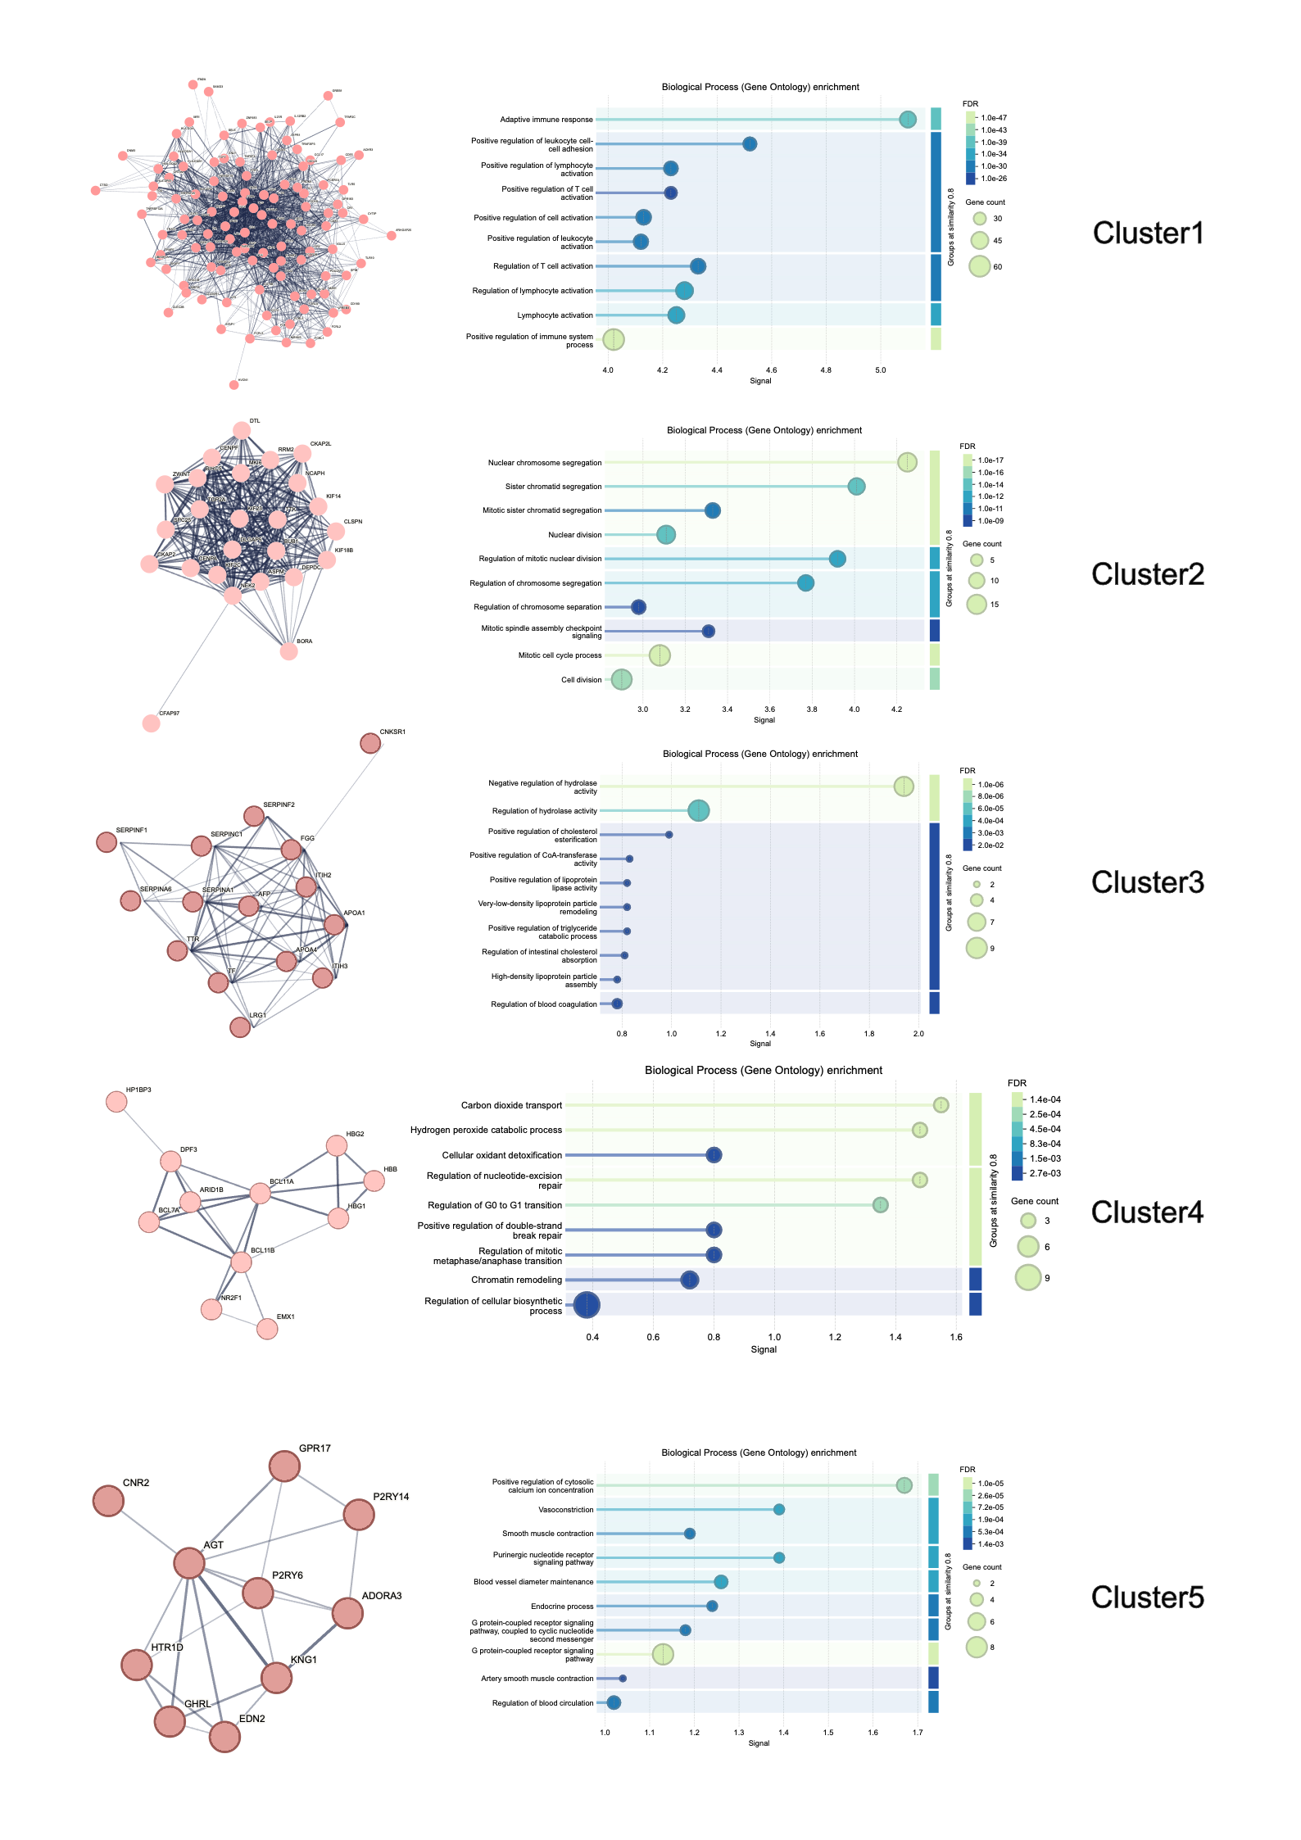
Supplementary Figure 3

