Innovative Evaluation Practices for BCSE308P -Computer Networks Lab
Fall Semester 2026-27
DESIGN AND PERFORMANCE EVALUATION OF A CUSTOM APPLICATION-LAYER PROTOCOL FOR LOW-LATENCY IOT SENSOR DATA EXCHANGE

24BCB0130 | SARADA A
24BCT0270 | SIYA AGRAWAL
24BDS0382 | NIMESHA SUBRAMANIAN

B.Tech.
in
Computer Science and Engineering
School of Computer Science and Engineering


October 2026

ABSTRACT
Small Internet of Things (IoT) devices commonly exchange short sensor readings. This project designs and evaluates the Lightweight IoT Sensor Protocol (LLSP), a custom binary application-layer protocol implemented over UDP using Python sockets.
A 17-byte LLSP DATA message carries a sensor identifier, sequence number, sensor type, numeric reading, timestamp, control flags and a CRC. Five concurrent software-simulated sensors demonstrate the protocol with temperature, humidity and motion readings. LLSP supports an unreliable mode that sends once and a reliable mode that requests acknowledgments and retransmits after timeouts, up to three total attempts.
A separate TCP + JSON implementation provides a reference for application message size and request/acknowledgment timing. Experiments use sender-side probabilistic DATA omission at 0%, 5%, 10% and 20%, with five stored trials of 500 logical readings per LLSP scenario. At 20% omission, reliable LLSP achieved a mean delivery ratio of 99.12%, compared with 79.72% in unreliable mode, while its mean confirmation time increased to 13.910 ms. LLSP DATA occupied 17 application bytes versus 80.418 bytes for the average newline-framed JSON request.
The results demonstrate a compact message representation and a measurable delivery–delay trade-off under the chosen loss model. They do not establish a fair loss-performance ranking against TCP, which was not subjected to the same simulated impairment.

CERTIFICATE
This is to certify that the project report entitled “Design and Performance Evaluation of a Custom Application-Layer Protocol for Low-Latency IoT Sensor Data Exchange” is a record of project work carried out by the student team in partial fulfilment of the requirements of the Innovative Evaluation Practices for BCSE308P -Computer Networks Lab during the Fall Semester 2026-2027.
SARADA A


SIYA AGRAWAL
NIMESHA SUBRAMANIAN

TABLE OF CONTENTS

Section | Title | Page No.
 | ABSTRACT | 2
 | CERTIFICATE | 3
1 | INTRODUCTION | 6
1.1 | Background and Motivation | 6
1.2 | Problem Statement | 6
1.3 | Objectives | 6
1.4 | Scope and Module Mapping | 6
2 | LITERATURE SURVEY | 7
2.1 | Existing Work | 7
2.2 | Related Work Comparison | 7
2.3 | Research Gap and Novelty | 7
3 | PROPOSED SYSTEM | 8
3.1 | Architecture | 8
3.2 | LLSP DATA Format | 8
3.3 | Sender/Receiver Algorithm | 8
3.4 | TCP + JSON Baseline | 9
3.5 | Assumptions | 9
4 | IMPLEMENTATION | 9
4.1 | Software Tools and Modules | 10
4.2 | Live Simulated-Sensor Operation | 11
4.3 | Loss Demonstration | 12
4.4 | TCP Baseline Demonstration | 13
4.5 | Verification | 13
5 | PERFORMANCE EVALUATION AND ANALYSIS | 13
5.1 | Experiment Methodology | 14
5.2 | Observed LLSP Results | 16
5.3 | TCP Baseline and Message Size | 17
5.4 | Limitations and Interpretation | 17
5.5 | Critical Result Summary | 17
6 | CONCLUSION AND FUTURE SCOPE | 18
6.1 | Future Improvements | 18
7 | REFERENCES | 19
Appendix A | Demonstration and Reproducibility | 19

1. INTRODUCTION

1.1 Background and motivation
IoT monitoring applications send readings that are often only a few bytes in logical content. In such systems, the way readings are represented and acknowledged can matter as much as the values themselves. Standard networking protocols offer a range of trade-offs. TCP supplies an ordered, reliable byte stream [1], while UDP supplies datagrams without built-in delivery guarantees [2]. Lightweight application protocols can use UDP and add only the controls required by the application [3].

1.2 Problem statement
The project investigates two related questions: how compactly can a basic sensor reading be represented, and how does optional application-level acknowledgment influence delivery and delay when some DATA sends are omitted? A controlled local experiment makes these effects visible without requiring physical sensors.

1.3 Objectives
- Design a versioned binary LLSP packet with integrity checking and a sensor-specific payload.
- Implement a UDP server and five concurrent simulated sensor sources.
- Support a send-once mode and an acknowledgment-based reliable mode with bounded retries.
- Build a functional TCP + JSON baseline carrying comparable kinds of readings.
- Measure unique delivery, confirmation time, retry attempts and application message size across repeated controlled scenarios.
- Present limitations clearly and provide reproducible commands, plots and test evidence.

1.4 Scope and module mapping
The implementation uses Python, sockets and localhost. The live simulator handles five sensor IDs, while the controlled LLSP benchmark uses sensor 1 (temperature) to simplify repeated measurements. The work relates to socket programming, transport protocols, error detection, reliable transfer, sequence numbers, performance measurement and application-layer protocol design. It does not measure wireless energy, external network delay or real-device performance.

2. LITERATURE SURVEY

2.1 Existing work
CoAP is a standard application protocol for constrained devices and demonstrates that a UDP-based design can offer confirmable and non-confirmable interactions [3]. Recent literature evaluates application-protocol choices in terms of latency, throughput, security and constraints rather than assuming that any one transport is always best [4]–[8]. LLSP does not implement MQTT or CoAP; these studies provide context for selecting metrics and describing trade-offs.

2.2 Related work comparison
Reference / year | Technique / focus | Relevant metrics | Contribution and gap for this work
Seoane et al. [4], 2021 | Performance of CoAP and MQTT with security | Performance; security overhead | Motivates considering protocol-dependent costs; does not define LLSP.
Bayılmış et al. [5], 2022 | Survey and experiments on IoT protocols | Throughput; energy; delay | Explains metric selection; broader scope than a sensor-specific binary format.
Formal models [6], 2022 | Model-based IoT protocol comparison | Protocol verification; performance | Supports rigorous comparisons; not a Python socket-based LLSP experiment.
IoT Open Messaging Standards [7], 2023 | Comparative MQTT/CoAP experiments | Latency; throughput | Shows scenario dependence; focuses on established protocols.
Nwankwo et al. [8], 2024 | MQTT-SN and CoAP integration | Latency; energy use | Addresses multi-protocol integration rather than configurable LLSP retries.

2.3 Research gap and novelty
The educational contribution is not the invention of ACKs, retransmissions or CRC. Rather, the team defines a compact 17-byte sensor-specific DATA representation and evaluates both acknowledgment policies within the same LLSP implementation. A separate TCP + JSON baseline highlights encoding differences. The experiment directly records the delivery cost of suppressing DATA attempts at defined rates, while documenting that the TCP reference is not subjected to equivalent loss.

3. PROPOSED SYSTEM

3.1 Architecture
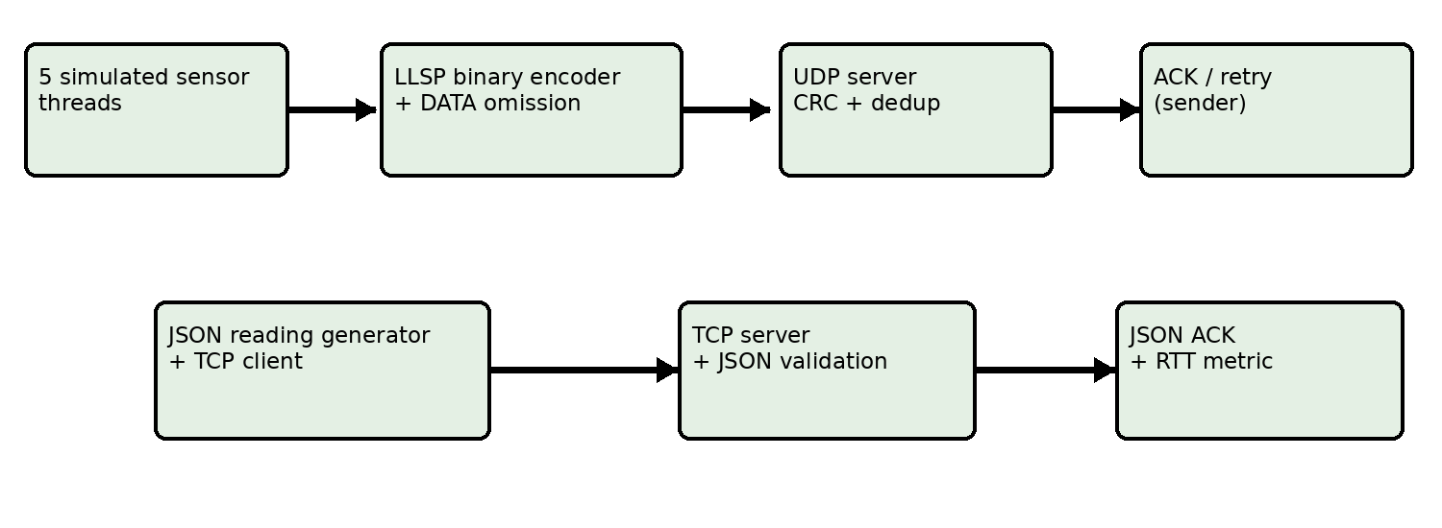
Fig. 3.1. The LLSP UDP implementation and independent TCP + JSON reference path.
The live five-sensor simulator and the controlled benchmark are distinct senders. The benchmark queries server STATS before and after scenarios; the server must be dedicated to avoid interference from unrelated traffic.

3.2 LLSP DATA format
Field | Size (bytes) | Purpose
Version and message type | 1 | Compatibility and message identification
Flags | 1 | ACK-request control
Sensor ID | 2 | Originating sensor
Sequence number | 2 | Duplicate/reply matching
Sensor-type payload | 1 | Temperature/humidity/motion
IEEE 754 float value | 4 | Sensor reading
Truncated millisecond time | 4 | Source timestamp
CRC | 2 | Detect accidental corruption
TOTAL | 17 | LLSP DATA application message

Fields are big-endian. The CRC uses binascii.crc_hqx with initial value 0xFFFF (polynomial 0x1021). ACK and STATS-request messages are 8 bytes; a STATS reply is 16 bytes. This CRC checks corruption but does not authenticate the sender.

3.3 Sender/receiver algorithm
- Sender generates a reading, sensor identifier and sequence number.
- The encoder produces an LLSP DATA packet and CRC.
- Unreliable mode makes one DATA attempt without waiting for ACK.
- Reliable mode requests an ACK; after a timeout it tries again, with three total attempts at most.
- Receiver validates version, packet integrity and reading schema, then checks (sensor ID, sequence).
- Receiver counts unique readings, identifies repeated keys and returns matching ACKs when requested.
- Benchmark records unique receipts, confirmed messages, attempts and retry-inclusive confirmation time.

3.4 TCP + JSON baseline
The TCP baseline uses newline-delimited compact JSON over a persistent localhost connection. The server validates each complete JSON object and sends an application-level JSON acknowledgment. The client measures request-to-ACK round-trip time and tracks JSON request/reply bytes plus newline framing. TCP and LLSP produce comparable categories of sensor readings but not identical shared input sequences or equal network impairment.

3.5 Assumptions
Loss is simulated by suppressing selected LLSP DATA attempts at the sender. ACK loss and TCP transport loss are not deliberately simulated. The receiver keeps duplicate keys within one server session; restart the server between independent sensor sessions to avoid treating reused sequence numbers as old readings.

4. IMPLEMENTATION

4.1 Software tools and modules
Component | Responsibility
Python socket and struct modules | UDP and TCP transport, packet encoding
src/protocol.py | LLSP codec, CRC and sensor payloads
src/server.py | UDP reception, validation, ACK and STATS
src/sensor.py | Five concurrent simulated sensors
src/benchmark.py | Controlled LLSP experiments and CSV
src/baseline_tcp_json.py | TCP reference client/server and metrics
src/plot.py | Aggregated graphs
scripts/run_final_experiments.ps1 | Repeated runs and isolated output directories

4.2 Live simulated-sensor operation
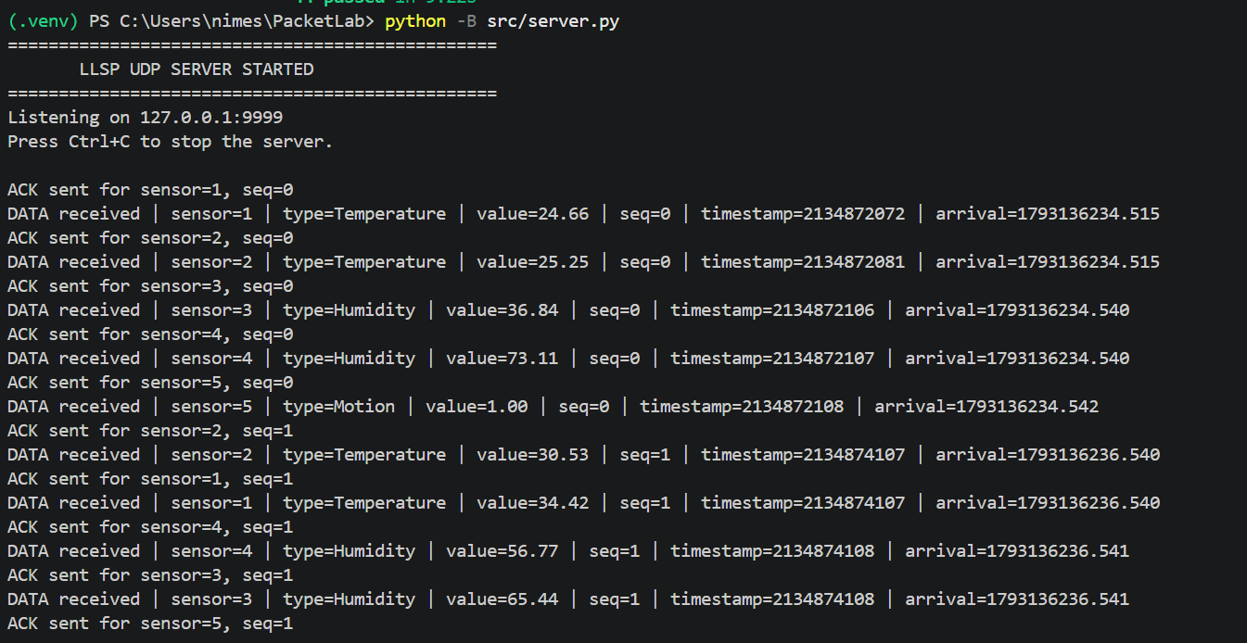
Fig. 4.1. UDP server receives LLSP readings from five sensor IDs and sends matching ACKs.
The output confirms that sensor IDs 1–5 produce valid readings. Temperature, humidity and motion fields are decoded after CRC and schema checks. Arrival timestamps in the log describe the server-side event; they are not used as the reported RTT.
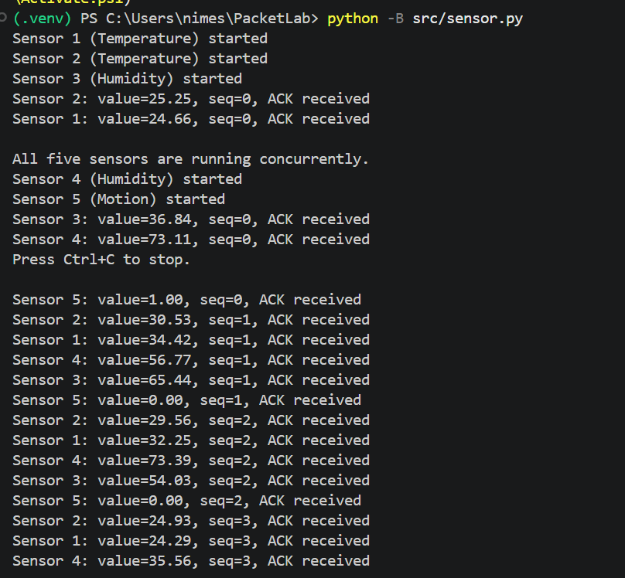
Fig. 4.2. Five concurrently running simulated sensors display sequence numbers and successful ACK reception.
Interleaved lines are expected because the simulated sensors execute in separate threads. Sequence numbers advance independently for each sensor.

4.3 Loss demonstration
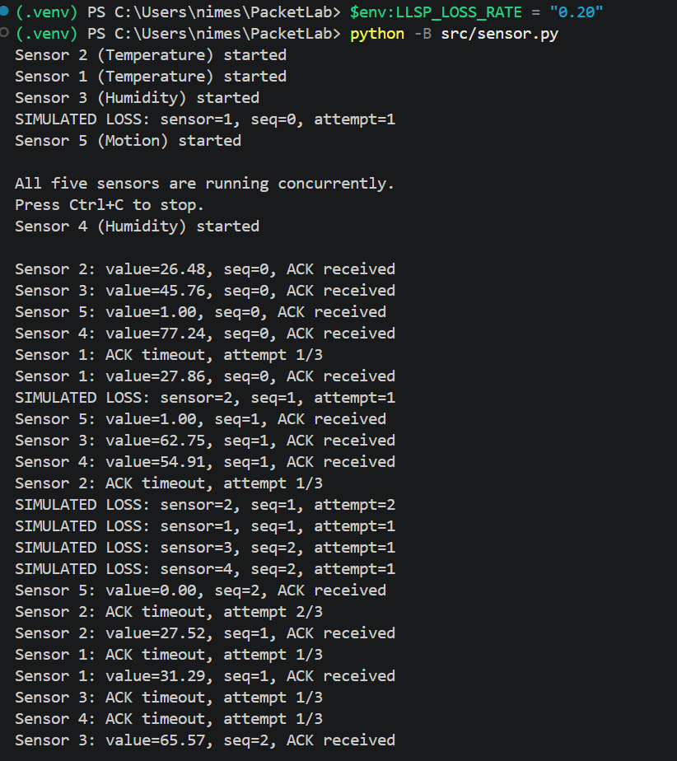
Fig. 4.3. Sender-side DATA omission, ACK timeouts and retransmission followed by successful acknowledgment.
In the example, Sensor 1 experiences a suppressed first attempt, times out and later receives an ACK for the same sequence. The demonstration illustrates a bounded retry mechanism; it does not claim an actual dropped network packet.

4.4 TCP baseline demonstration
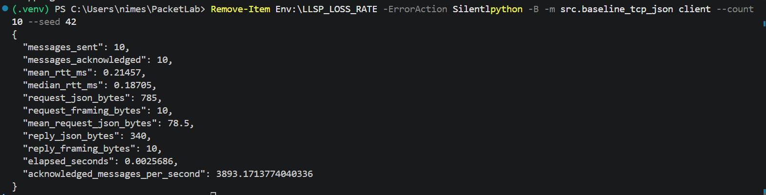
Fig. 4.4. TCP + JSON client reports 10 of 10 acknowledged readings, RTT and byte accounting.
The ten-message live check reports 0.21457 ms mean RTT. This is a small demo run and is not used as the principal performance result. The five-run historical TCP average is presented in Chapter 5.

4.5 Verification
The final main-branch verification reported 44 passing tests with no failures or skips. Coverage includes protocol/CRC validation, sensor simulation, reply checking, retries, duplicate handling, benchmark accounting, TCP framing and associated integration checks. Two bounded end-to-end trial runs also successfully produced LLSP CSVs, TCP CSVs and four graphs. The user reproduced 44 passing tests after resolving a local pytest temporary-directory permission issue.

5. PERFORMANCE EVALUATION AND ANALYSIS

5.1 Experiment methodology
The stored analysis dataset comprises five trials for each of eight LLSP combinations: reliable/unreliable modes crossed with 0%, 5%, 10% and 20% simulated DATA omission. Each LLSP trial contains 500 logical readings, yielding 40 scenario rows. Five 500-message TCP baseline trials are recorded separately. The LLSP benchmark sends one temperature-sensor workload; the live five-sensor demo is a separate functional test. Graph error bars show sample standard deviation across the five trials, not confidence intervals.
Metric | Meaning / measurement
Unique delivery ratio | Distinct valid logical readings received / logical readings sent × 100%
ACK confirmation rate | Reliable readings with matching valid ACK / logical readings sent × 100%
Confirmation time | Elapsed time from first attempt to matching ACK, including retry waits
Retransmissions | Additional send attempts after the first, including simulated suppressions
LLSP request size | 17 bytes of application DATA, excluding IP/UDP headers
TCP RTT | Application request-to-JSON-ACK round-trip time
TCP request size | JSON bytes plus newline framing, excluding IP/TCP headers

5.2 Observed LLSP results
DATA loss | Reliable delivery | Unreliable delivery | Reliable time (ms), mean ± SD | Retries / 500
0% | 100.00% | 100.00% | 0.084 ± 0.025 | 0.0
5% | 100.00% | 95.64% | 3.034 ± 0.375 | 24.4
10% | 99.92% | 90.20% | 7.208 ± 0.761 | 58.0
20% | 99.12% | 79.72% | 13.910 ± 1.305 | 120.8

As controlled DATA omission rises, unreliable delivery drops because it does not resend. Reliable LLSP remains above 99% on average in the stored settings, but confirmation time and additional attempts increase. The bounded three-attempt policy means it cannot guarantee delivery under all loss patterns.
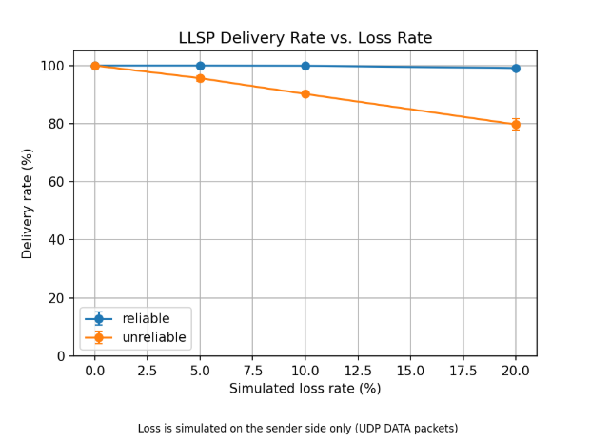
Fig. 5.1. Unique delivery versus simulated DATA omission; five trials per scenario.
At 20% omission, reliable delivery averages 99.12% versus 79.72% unreliable: a 19.40-percentage-point difference in this dataset.
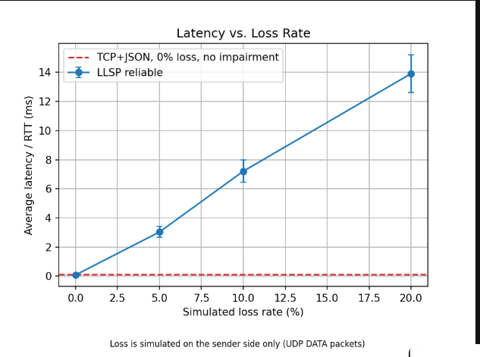
Fig. 5.2. Retry-inclusive LLSP confirmation time; dashed TCP reference is unimpaired.
The LLSP reliable time increases from 0.084 ms to 13.910 ms across the tested conditions. The dashed TCP line remains at 0% impairment and must not be interpreted as an equal-loss comparison.
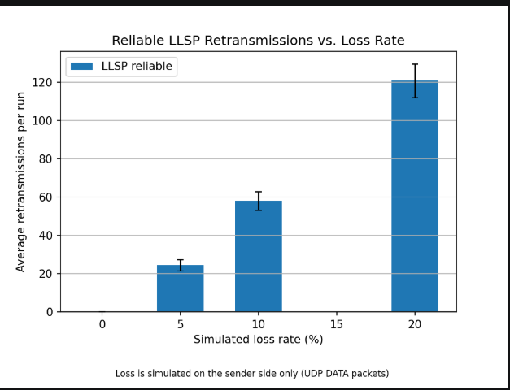
Fig. 5.3. Mean additional attempt count per 500-reading reliable LLSP run.
At 20% omission the mean additional attempt count is 120.8, compared with no additional attempts at 0% loss. Attempts suppressed by the simulation are included, so this is not a wire-level retransmitted datagram count.

5.3 TCP baseline and message size
Metric | Stored TCP baseline average
Mean application RTT | 0.108812 ms
Sample SD of per-run mean RTT | 0.023081 ms
JSON request bytes/read | 79.418
JSON + newline bytes/read | 80.418
JSON reply bytes/read | 34.9
Acknowledged messages/s | 8,266.74

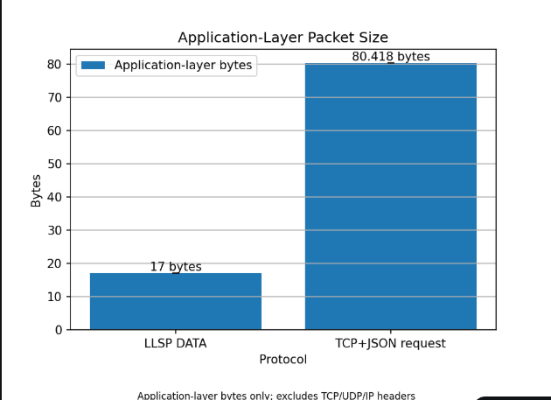
Fig. 5.4. LLSP DATA and TCP + JSON request application bytes.
LLSP represents each DATA reading in 17 application bytes, versus 80.418 average bytes for a newline-framed JSON request in the stored dataset (about 78.9% less). The plotted values exclude IP/UDP/TCP headers, ACK/reply traffic and the extra cost of retries. Thus, request-size reduction is supported, but an equivalent reduction in total network use is not demonstrated.

5.4 Limitations and interpretation
- The loss model suppresses LLSP DATA attempts at the sender; TCP is not given a matching impairment model.
- Localhost RTTs are very small and do not represent physical wireless, LAN, WAN or battery performance.
- LLSP and TCP clients do not replay identical generated input sequences.
- Global STATS counters require a dedicated server; the receiver should restart between independent sensor sessions.
- The retry policy has three total attempts, so even reliable LLSP can fail at sufficient loss.
- Stored historical results remain arithmetically consistent after correction of duplicate counting, but were collected before the final code revision; freshly measured final-code trials should replace them for a strict version-matched evaluation.

5.5 Critical result summary
Within the controlled LLSP experiment, optional reliability improves successful unique delivery at the cost of retransmission attempts and higher confirmation time. The comparison with TCP + JSON supports a narrower finding about application request encoding size. A general claim that LLSP outperforms TCP under identical loss or in a real IoT network would require further matched experiments.

6. CONCLUSION AND FUTURE SCOPE
This project implemented and verified a compact LLSP application protocol over UDP, a five-sensor simulator, receiver-side validation and acknowledgment, reliable/unreliable sending, a TCP + JSON reference and an automated reporting pipeline. Across the stored controlled LLSP loss scenarios, reliable behavior preserved far more unique readings than the send-once mode as omission increased. The cost was more attempts and increased confirmation time. The experiment illustrates that compact encoding and reliability are related but different goals, and both should be measured carefully.

6.1 Future improvements
- Add explicit session identity or bounded deduplication windows.
- Run TCP and LLSP against matched loss/delay impairment and identical input sequences.
- Evaluate separate devices or hosts and report tail latency and actual network bytes.
- Assess security, physical-sensor integration and energy costs where relevant.

7. REFERENCES
[1] W. Eddy, “Transmission Control Protocol (TCP),” IETF RFC 9293, Aug. 2022. doi: 10.17487/RFC9293. https://www.rfc-editor.org/info/rfc9293
[2] J. Postel, “User Datagram Protocol,” IETF RFC 768, Aug. 1980. doi: 10.17487/RFC0768. https://www.rfc-editor.org/info/rfc768
[3] Z. Shelby, K. Hartke, and C. Bormann, “The Constrained Application Protocol (CoAP),” IETF RFC 7252, Jun. 2014. doi: 10.17487/RFC7252. https://www.rfc-editor.org/info/rfc7252
[4] V. Seoane, C. Garcia-Rubio, F. Almenares, and C. Campo, “Performance evaluation of CoAP and MQTT with security support for IoT environments,” Computer Networks, vol. 197, art. 108338, 2021. doi: 10.1016/j.comnet.2021.108338.
[5] C. Bayılmış, M. A. Ebleme, Ü. Çavuşoğlu, K. Küçük, and A. Sevin, “A survey on communication protocols and performance evaluations for Internet of Things,” Digital Communications and Networks, vol. 8, no. 6, pp. 1094–1104, 2022. doi: 10.1016/j.dcan.2022.03.013.
[6] “Formal models for the verification, performance evaluation, and comparison of IoT communication protocols,” in Proc. 2022 IEEE 21st Int. Symp. Network Computing and Applications (NCA), 2022. doi: 10.1109/NCA57778.2022.10013626.
[7] “IoT Open Messaging Standards: Performance Comparison with MQTT and CoAP Protocols,” in Proc. 2023 10th Int. Conf. Future Internet of Things and Cloud (FiCloud), 2023. doi: 10.1109/FiCloud58648.2023.00027.
[8] E. Nwankwo, M. David, and E. N. Onwuka, “Integration of MQTT-SN and CoAP protocol for enhanced data communications and resource management in WSNs,” Bulletin of Electrical Engineering and Informatics, vol. 13, no. 3, 2024. doi: 10.11591/eei.v13i3.5158.

APPENDIX A. DEMONSTRATION AND REPRODUCIBILITY
Repository: https://github.com/saradaahalya/PacketLab
Run from the repository root in separate PowerShell terminals:
- python -B src/server.py
- python -B src/sensor.py
- Set 20% loss in the sensor terminal: $env:LLSP_LOSS_RATE = "0.20"
- python -B -m src.baseline_tcp_json server --timeout 60 --max-messages 10
- python -B -m src.baseline_tcp_json client --count 10 --seed 42
- python -B -m pytest -p no:cacheprovider tests --basetemp="$env:USERPROFILE\PacketLabTestTemp"
- .\scripts\run_final_experiments.ps1 -Runs 2 -Packets 30
Stop each live program with Ctrl+C. Restart the UDP server between independent sensor demonstrations. The PowerShell experiment script writes to a unique temporary output folder and prints the location of its CSVs, logs and graphs.

