Analyzing Customer behavior

By
Sara Abdulla Ahmed Dhaif
Word count: 1486
SRN: 230713279

Table Of Content
1. Executive Summary: 3
2. Introduction 4
1. Who are our customers? 4
a. Geographical location: “customer distribution” 5
b. Customer segments: 5
c. Sales & Profitability of customers and segments 5
2. What does our customers buy? 6
a. Bundles and Cross Selling Though Market Basket Analysis: 6
3. Are discounts effective? 8
a. Discounting popular products 9
4. Recent, Frequent and Monetary Customers 9
a. Occasional Buyers 10
b. Wining Back Lost Customers 10
5. Compounded Annual Growth Rates “CAGR” 11
a. RMF segment CAGR 11
b. CAGR for Product Combinations 12
6. Conclusion 12
7. Technical Appendix 13
a. Market basket analysis 13
b. RFM analysis: 14
8. References 14

Executive Summary:
This report analyzes a customer base dataset from dates extended from 2020 to 2023. Using five dashboards, we were able to uncover some interesting features and patterns in Customer Behavior, To help senior managers make effective decisions and develop operative solutions.
The first dashboard looked at the geographical, demographical and segments’ contributions, identifying that most of the customers are in the USA While the middle east and Africa showed otherwise. Consumers are the dominating segment of our customers while home offices are the lowest. The company took around 25 thousand orders but made 11% profit out of the sales only.
the second dashboard looked at a market basket analysis for the sub-categories, identifying the out preforming sub-category “binders” and its relationship with all the other products, as it showed the highest co-occurrence, suggesting bundling for higher average order value.
the current discounting and promotional strategies are then analyzed in the third dashboard, noticing a high average discount on the subcategory “Tables”, which then led to a loss in its profitability. Further, discovering the inverse relationship of discounting binders and its profit. All that suggested a reduction in overall discounts.
The fourth dashboard identified key customers, some to avoid and some to connect with, Occasional buyers are the highest in the customer base, highlighting the need to convert them into loyal customers. Our lost cheap customers are then analyzed to see the potentiality for growth.
Lastly, in the 5th Dashboard, compounded annual growth rates for RFM segments and product combinations purchased by customers are identified, segments such as “potential to become best customers’ showed the highest growth in profit, while "Lost Cheap Customers" and "Occasional Buyers showed periods of the slowest growth rates. Suggesting special discounts & offers in the holiday period to increase the frequency of purchases for the Occasional buyers and attract the lost customers again.

Introduction
Just like you open Amazon and see ‘Products Frequently Bought Together’, or open Netflix and see ‘for You’ section, companies strive to find more about their customers, their choices and what is their next move to give such suggestions.
Even with the high, diverse and complex markets, understanding customer behavior is vital. As Jeff Bezos, the founder of Amazon, says “We’re not competitor obsessed, we’re customer obsessed”.
This report will look at dataset from 2020 to 2023, identifying key customer features, location, demographics, products they buy and growth patterns. To eventually help mangers in the decision-making process.

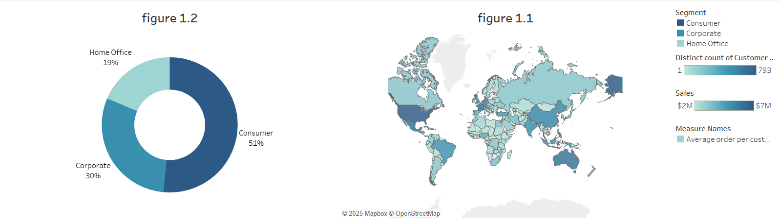
- Who are our customers?

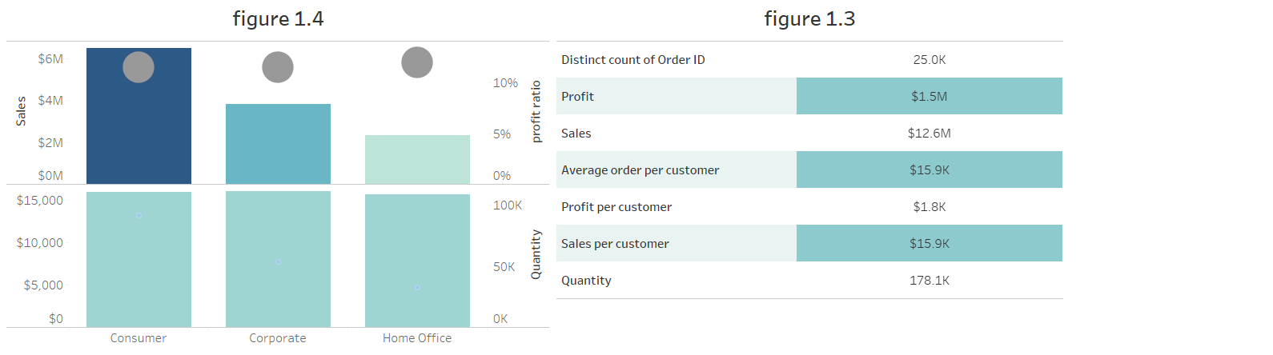

- Geographical location: “customer distribution”
Looking at figure 1.1, it shows that most of our customers are in the United states, followed by Mexico and Australia. On the other hand, Areas in the middle east and Africa shows the lowest number of customers, suggesting the focus on.
- Customer segments:
Our customer base mostly consists of consumers, which is slightly more than half of our customers, 30% are corporate, while the smallest segment consists of home officer’s.

Sales & Profitability of customers and segments
the company received around 25,000 orders, with a sale of around 178,000 units of products.
On average, each person spent about $15,800, resulting in total sales of $12 million, however, the total profit was $1.5 million, which is 11% of the sales only.
figure 1.4 shows that each segment contribute differently to the total sales and buy different quantities, nonetheless, the profit margin and the average order value remains the same across segments, approx. 12% profit ratio and 16,000$ average order value.

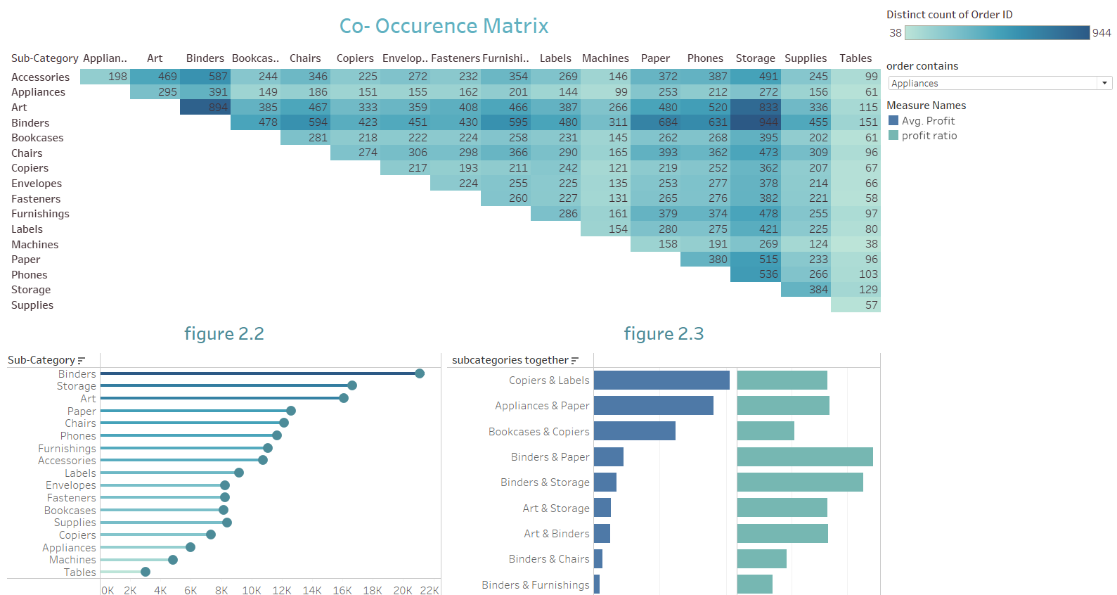
What does our customers buy?

In figure 2.2, we observe differences in sales across sub- categories. Noticeably, Binders is the standout subcategory, boasting sales of nearly 21,000 units. In contrast, the Tables subcategory drops behind, with a total sale of 3,000 units only. This result demonstrates the increased demand for the stationary products, such as labels, binders, folders etc.

a. Bundles and Cross Selling Though Market Basket Analysis:
Now we are going to examine the products customers usually buy together. Analyzing the co-occurrence matrix reveals the number of distinct order IDs that included products from two subcategories. Clearly, Binders show the highest co-occurrence with all the other subcategories, indicating that customers frequently purchase Binders on-the-go with the other categories. This observation can be further substantiated by calculating the Sum of support basket & lift for all combinations within the market basket
Upon performing calculations.” results in the appendix”, the combination of Binders and Storage sub-categories shows the highest Sum of market support, followed closely by binders- Art and Storage -Art. Alternatively, the combination of Labels and Copiers reflects the strongest lift, although it has a relatively low-occurrence probability.
The high market support indicate that the products are a popular choice, marking an important component in all the purchases. As a recommendation, Binders should be emphisised on it popularity by bundlings to increase the average order value and placing in a high visbility shelfs to make it a quick grap-and-go products simulting higher sales.
A high lift “greater than 1” reveals a strong complementary relationship. Which Expresses the likelihood of purchasing an item as a consequence of purchaseing another. For Labels and copiers, Eventhough the market support is low, it suggest the possibility of being a niche market and a big cross selling opportinty. As it already have a high average profit , figure 2.3
To gererate the highest sales, the focus should be on marketing the complementary relationship whether by placing the two sub categories near each others or selling one product cheaper than its complement.

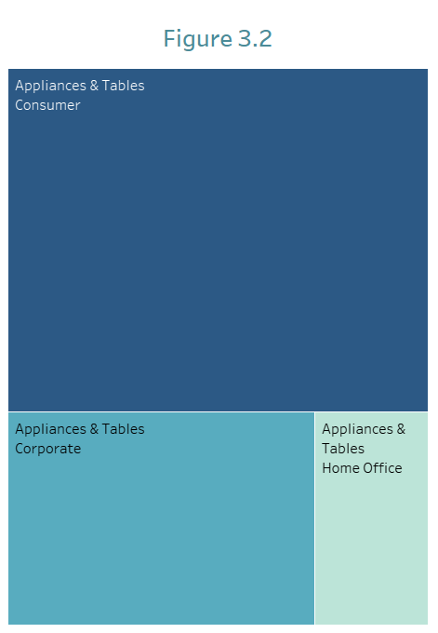
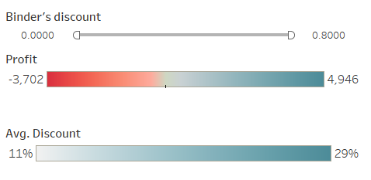
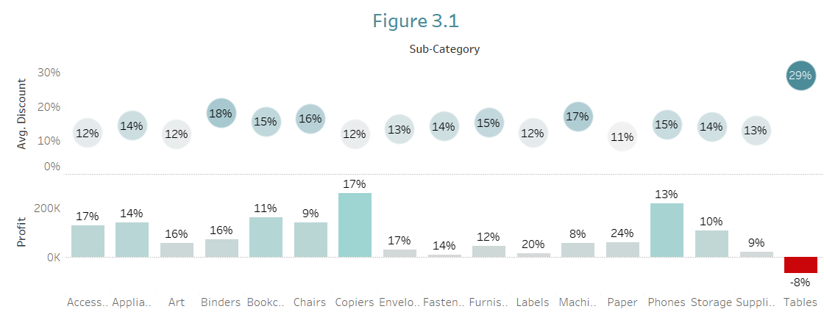
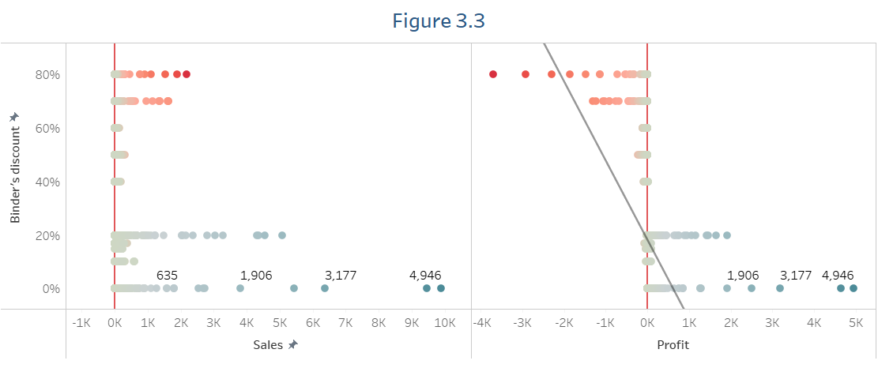
Are discounts effective?

To attract customers, companies implement discounting strategies. Yet, these approaches don’t always generate the desired results. Let's examine our discount performance.
As [figure 3.1] investigates, the % of Average discounts vary from 12% to 29% across the sub-categories, while Tables have the highest average discounts at 29% which led to 8% loss in profit.
As a recommendation, Tables’ discounts should be reduced, and its products could be marketed as bundles with products from subcategories that have a high complementary relationship” high lift” such as Appliances.
For illustration, one of the strategies can be by targeting the Consumers segments - who frequently purchase this combination [figure 3.2] – and promoting the coffee tables “Tables” with coffee grinders “Appliances” in a package. By that, it will help move the slower-selling sub-category ‘Tables’ while enhancing overall sales.

a. Discounting popular products
Since binders are the most popular choice alongside other subcategories, offering discounts is unnecessary, people are buying it while shopping for other products anyways.
Figure 3.3 shows that the highest Profit & Sales of Binders occur at 0%. As the discounts increases, the profit decreases causing a loss during discounts of 40% and above.

Recent, Frequent and Monetary Customers
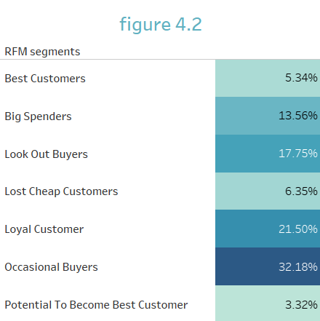
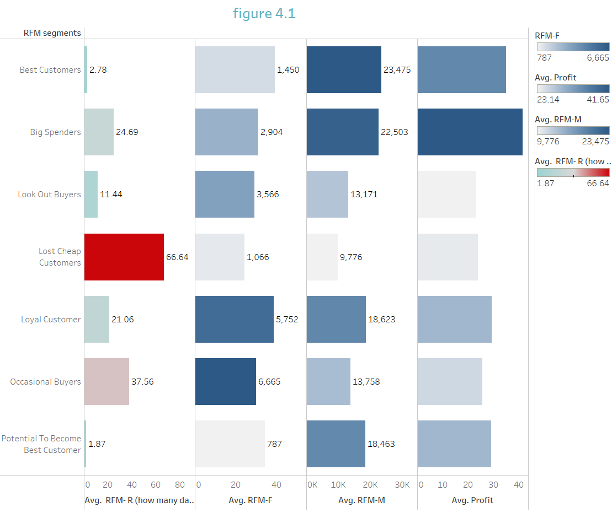

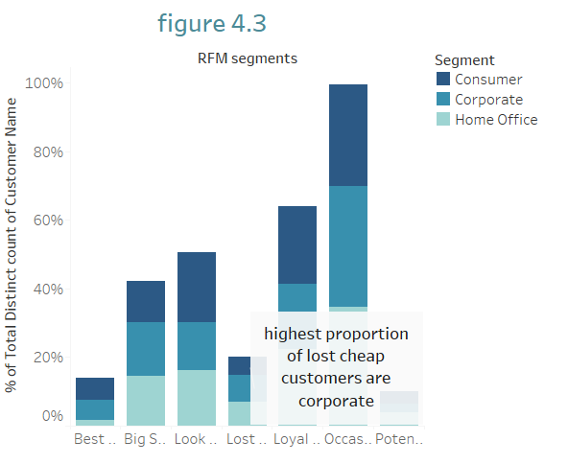
00

To better understand customers, we are going to identify 7 major groups, listed in figure 4.1 as ‘RFM segments’, Giving them a 3-digit score For how Recent, often and how much they purchase ‘RFM score’.” Explanation in the appendix”,.1 being the best and 4 the worst.
Figure 4.1 shows that on average, the longest period of leaving was 66 days by lost cheap customers, as they have the lowest frequency of purchases as well. In contrast, the shortest day of leaving is 2 days on average by the potentially to become best customers. That encourages the need for fostering strong relationships with them to increase the repeatability of purchases. Moreover, our best customers contribute around 23,000$ sales on average, followed closely by big spender customers, who have the highest average profit.

a. Occasional Buyers
Figure 4.2 shows that about 32% of our customers are Occasional Buyers, the highest segment among all, they have a sufficient level of recency but tend to purchase at irregular time intervals, making their purchases unpredictable. Therefore, converting them to loyal customers is vital. Because loyal customers not only result in higher levels of sales, but they are also a good advertising tactic, As they are the best advocates for a business. This can be attained by offering special discounts for frequent buyers or by making loyalty programs such as credit card programs or points system in which they make customers tied into spending more money on the products.

b. Wining Back Lost Customers
Even though lost cheap customers have not shown activity recently, they should not be seen as dead ends, Rather they do represent substantial chances for growth.
As figure 4.1 shows, their average profit is approximately 23$, which is high compared to its sales. These individuals are previously aware of the brand, which takes them to move at a rate faster than the new customers. research indicates that they tend to spend more when they return, As the Customer Winback Benchmark Study 2023 by Winback Labs says, a win back customer beats all marketing strategies.
Therefore, since 7.96% of our corporate customers are Lost cheap Customer ” the highest proportion from the other segments[figure4.3]”, its advised to do the following :
- Understand the reasons of leaving by collecting data through surveys.
- Analyze the competitors and identify the area’s of strengths and weaknesses.
- Provide exceptional customer service for corporate customers, especially that they purchase in bulks.

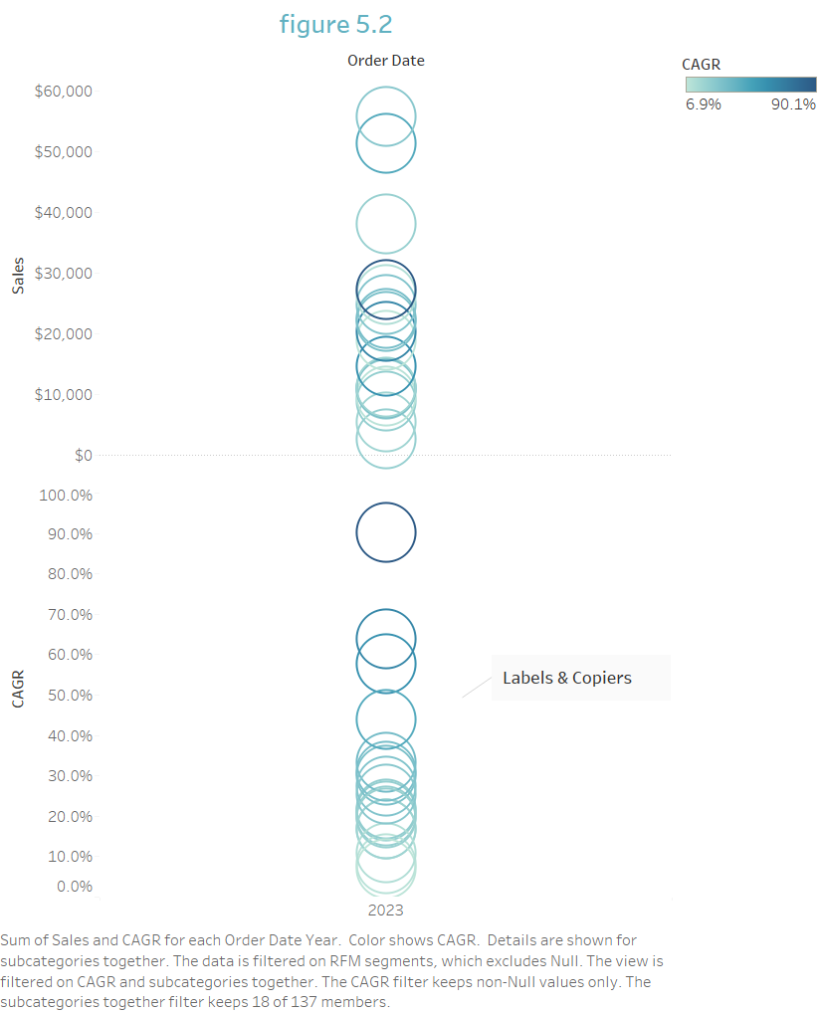
5. Compounded Annual Growth Rates “CAGR”
Lastly, were going to identify the contribution of each customer category to sales and overall profitability.
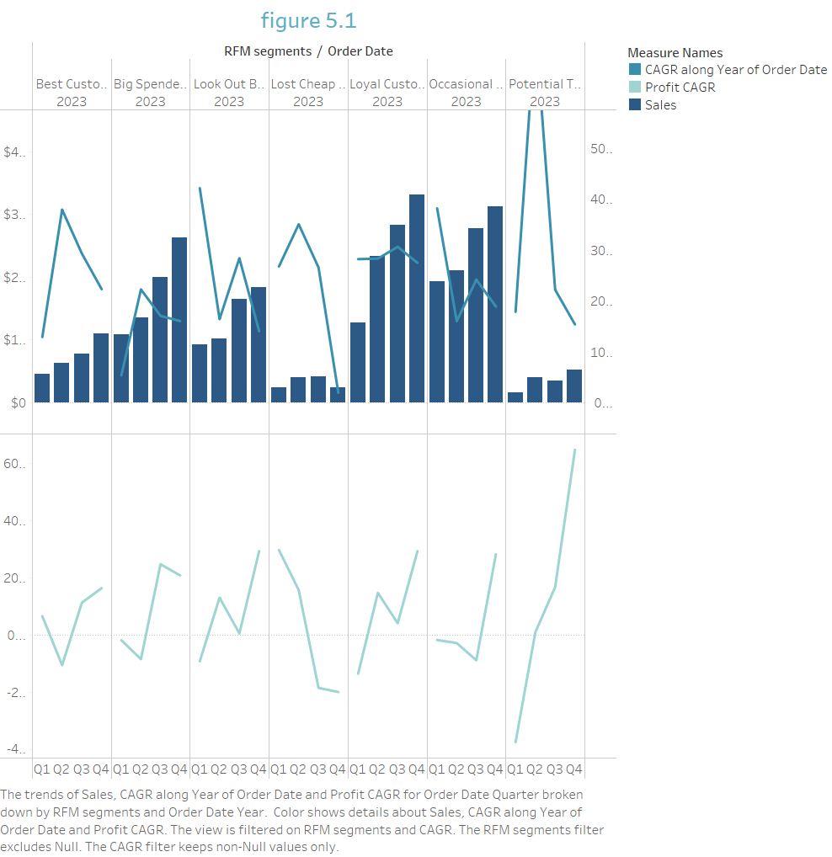

a. RMF segment CAGR
From 2020 to 2023, figure 2 shows the Compounded Annual Growth Rate “CAGR” for RFM segments over the past 3 years.
The “Potential to become best customers” segment faced the highest growth rates over the second quarter of the years compared to the other segments, On the other hand, a huge drop in the rate from the 3rd to the 4th quarter. Even though it had a huge drop in sale’s growth, the profit growth of the segment is the highest, especially in the last quarter, where it reached a compound of 64%.
Conversely, The slowest growth rates was by both the ‘Lost cheap customers’ & “Occasional buyers”, with a notable fall in growth rate for about 23.5% though the 3rd to 4th quarters for the first, 1st to 2nd for the later. Furthermore, the “lost cheap customers” had a decline in profit growth together with the “big spenders” in the last quarter of the years. This shows the necessity of making special offers during the holiday season, whether by making seasonal themed products or by creating social events.

b. CAGR for Product Combinations
To better understand the growth patterns, we will examine the growth trends of the common product combination’s purchases.
As mentioned above, Labels and copiers have the highest lift, Further, figure 5.2 shows that they have a high CAGR, which verify the possibility of being a niche market. So, marketing the two as bundle is needed.
A combination that needs to be advertised together more is Appliances & machines, they have the highest CAGR among the combinations, with a substantial CAGR of 90%.

6. Conclusion
To sum everything up, understanding customer behavior can be tricky sometimes, but the analysis of the data given and the investigation of relationships among the variables can get you to know deeper about the customers, by carefully making decisions that’s data based, and focusing on the right customers, desired results are going to be obtained.

7. Technical Appendix

a. Market basket analysis
A lift is a measure used to calculate the likelihood of purchasing two items together, compared to being purchased independently. a lift equals 1 means that products are independent, however, if it was more than one, it indicates a strong causal relationship.
A Sum of Support Basket is measure used to show the co-occurrence in transitions, which identify the most popular frequently bought together products, Not the causal relationship.
Below is the result of calculating such measures, ordered in a descending order:
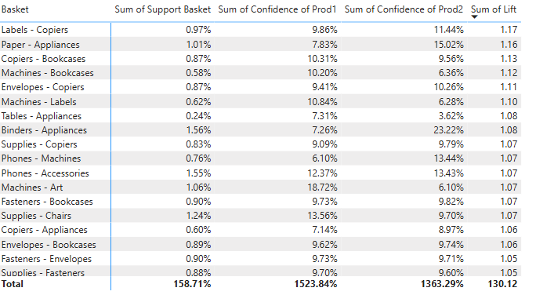
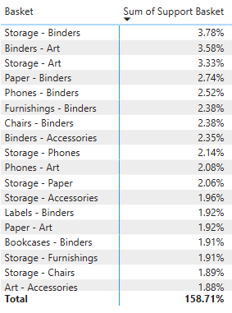

b. RFM analysis:
For this analysis, customers have been given a score for all the 3 measures, Recency, Frequency and Monetary, Each quartile will provide a score between one and four where the RFM segmentation combine them all. Based on that, customers have been categorized into the following groups, X meaning that the value can vary:
- Best Customer have score of 1 for all 3 measures
- Potential to become best customer have a score of 1 (Recency), 2 (Frequency), <= 2 (Monetary)
- Loyal Customer have a score of X (Recency), 1 (Frequency), X (Monetary)
- Big Spenders have a score of X (Recency), X (Frequency),
- Lost Customers have a score of 4 (Recency), 1 (Frequency), 1 (Monetary)
- Lost Cheap Customers have a score of 4 (Recency), 4 (Frequency), 4 (Monetary)
- Look Out Buyers have a score of 2 (Recency)
- Occasional Buyers have a score of 2 or 3 for each (Recency-Frequency-Monetary)

8. References
- WinBack lab (2023) Customer Winback Benchmark Study , Customer WinBack Benchmark Study 2023 F
- Duffy, D.L. (1998), "Customer loyalty strategies", Journal of Consumer Marketing, Vol. 15 No. 5, pp. 435-448. https://doi.org/10.1108/07363769810235910
- Suite Feedback(2019) Amazon & Customer Experience: 13 Quotes from Jeff Bezos, Amazon & Customer Experience: 13 Quotes from Jeff Bezos - Customer Satisfaction Surveys and Feedback Management for NetSuite

