# About Me

Microsoft and Redhat Certified with 7 years of Competent and Result in oriented experience in Automation, Installation and configuration, and troubleshooting of Redhat Linux, Ubuntu, Windows platforms and in DevOps tools like Azure DevOps, Ansible, ARM, CI/CD Deployments, and Azure Cloud.

Administrating, Upgrading patches, Security, Backup, Performance monitoring, and Fine tuning of Redhat Linux systems.

# Certifications

Microsoft

Azure Administrator Associate

Redhat

Redhat Certified System Administrator

170-125- 017

Skills Cloud Platform: Azure

Infrastructure Provisioning: Azure Resource Manager

Configuration Management: Ansible CI/CD Tools: Azure Pipelines

Monitoring tools: Logic Monitor, Icinga Languages: Java, C#

Scripting: PowerShell, Bash/Shell Volume Manager: LVM

Networking: NFS, Samba, SSH, FTP

Package Managements: Yum, RPM, APT, Dpkg

Databases: MySQL, MSSQL

Operating Systems: Windows, Linux

Virtualization Platforms: Oracle Virtual Box

Firewall: Windows Firewall, Barracuda, Firewalld

Ticketing Tools: ServiceNow

# Achievements

Received Rising Star award in Capgemini Selected as Microsoft Student Partner

Organized an event in Microsoft Dream Spark Technovanza

Won Rewards in Windows Phone App

Development conducted by Microsoft

DVLUP

# NAME:*******

AZURE DEVOPS ENGINEER

Experience

***********

************** 2021-2022

Azure Devops Engineer

Designed and automated and deployed CI/CD systems using Azure DevOps on Azure infrastructure as a service (Iaas) and Platform as a service (Paas) which includes virtual machines, virtual networks, and cloud services. Worked with Azure Monitoring tools such as Azure Log Analytics, Azure Network Watcher, and Azure service Health to diagnose and minimize service degradation.

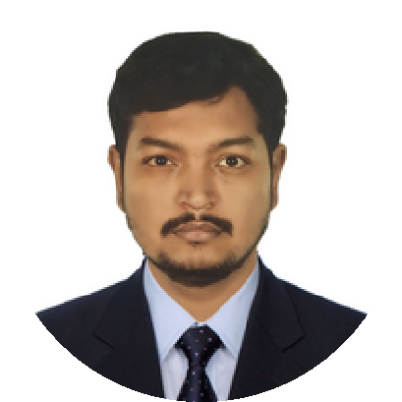

Installation, configuration and adminsitration of Linux and Windows systems Configure Kdump to troubsleshoot crash events on Linux systems Configuring, Automating and Deploying Ansible module, playbooks and tasks for centralized configuration, service package management and troubleshooting to existing infrastructure.

Automated various activities on Azure services using Azure automation Runbooks, Powershell and Bash and also patching using Azure update management.

Troubleshoot system problems using Logic Monitor tools and resolve any reported issue

Build Authentication server and client configuration for centralized user provisioning & management using FreeIPA ( Redhat ID Management) Troublshooting backup and restore problems, server availability, user access issues, and performed day-to-day troubleshooting for the end users on Linux based and also windows servers.

********* pvt.ltd

2018-2021

Technical Support Engineer

Installation and Configuration and Maintenance of Windows server 2012 R2 and CentOS.

Remote login to Virtual Machines to troubleshoot, monitor, and deploy applications.

Installation and configuration of MSSQL Server 2014/2017,

Monitoring SQL jobs, configuring databases backup and restore DB Experience in the creation of logins, users and configuring permissions, and assigning roles to users.

Created Linked servers accordingly in between the different servers based on the requirement.

Setup and maintained Replication for Production servers to provide high availability and monitor using Replication Monitor.

Frequently Monitor Connections, Locks and Database Performance using

Activity Monitor and SQL Profiler

Configure and manage Icinga instance to monitor the overall health of the production environment

Responsible for setting cron jobs and manage SSL certificates on the Linux servers

*************

Desktop Support Engineer

****** Consultancy

**********

2015-2018

Installing and maintaining hardware and computer peripherals.

Troubleshooting networking and connection issues.

Troubleshooting hardware and software issues.

Providing basic training on computer operation and management.

Maintained network facilities in individual machines, such as

drivers and settings of personal computers as well as printers

Trained desktop end users about printing, scanning, email, internet, MS-Office

package etc.

Education

Bachelor of Engineering in Computer Science

**** College of Information Technology

2011-2015

********

********* School

************

2011

Personal Details

Date of Birth

*******

Nationality

*******

Marital Status

******