High-Level Architecture – Report

Security and Management of Information Systems

Group 20

92451 Diogo Barbosa

92470 Guilherme Fontes

93342 Sara Marques

**Business Context**

*Saint Acutis* hospital provides Urgent Care, open 24/7 (24 hours, 7 days a week). Therefore, **availability** is a key component of the system.

It also provides Speciality Consultations, including: Orthopedy, Cardiology, and Dermatology. This means that the system will manage its customers clinical data, creating the need to keep clients consultations data both **confidential** and **integrous**.

**General System Overview**

In this scheme (Figure 1.), we represent the key components for the system to function. Represented in green, are the application level components. While in blue, the physical components.

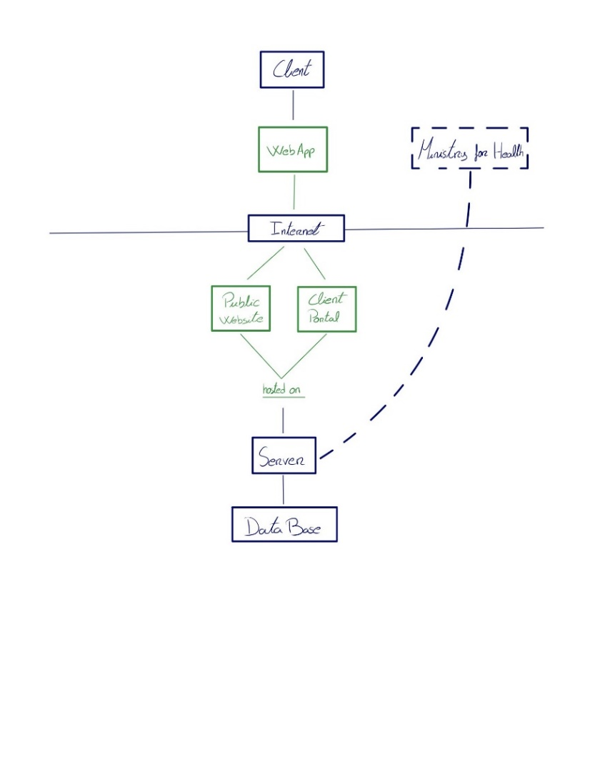

Figure 1.

The *Saint Acutis* hospital provides 2 services through the internet:

* **Public website** with information about the hospital.
* **Client portal** where customers can manage their consultations.

One server hosts both services. Since **availability** is key, it’s a good practice to have a **backup server** (and database server) running on the background ready to takeover whenever needed. (Omitted in the scheme for simplicity.)

The server stores the consultations data in a database server located in the network. By segregating the database from the server, it is possible to store the information in a more secure way, so the **server can’t change it directly.**

**E. g.** If the server component is corrupted, it should not be able to malicious change the database. Also, it is possible to just deploy the backup server, and since the information is in the database, it will be “ready to fly” as soon as deployed.

**Infrastructure Overview**

In this scheme (Figure 2.), the focus is on the network key components for a safe functioning of the system.

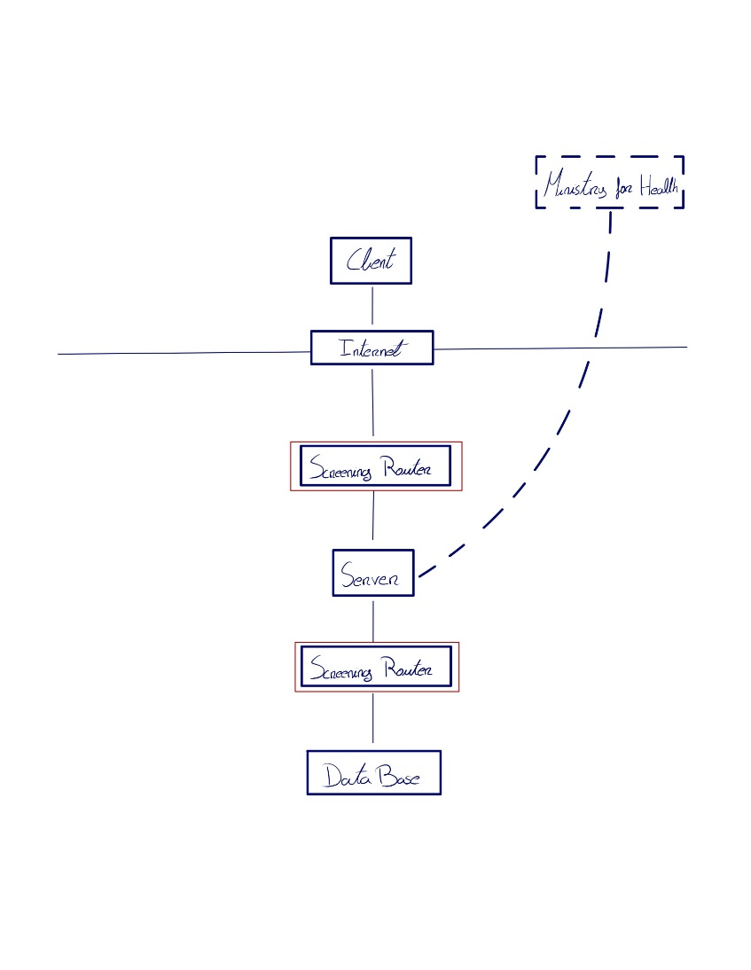

Figure 2.

It’s clear that in this scheme the Server is located in a **demilitarized zone (DMZ)**, delimited by **two** Screening Routers, which will act as a typical router with a **built-in packet filter**, which **segregates the Web Server** from the rest of the Saint Acutis network. (In this case, only the database server is represented.) This creates an extra level of security, **filtrating all the communications** from the server with the rest of the network, specifically with the **database server**.

## Technologies

* Application: Vue.js; Web Application Server framework that facilitates implementing a modern and responsive Web App
* Server: SpringBoot, Java; REST API to communicate with the Application and JPA to ease CRUD operations with the Database
* Database: mySQL in Docker container; SQL Database inside a container to ease deployment and setup