Sara Goodie
C844 – Task 1 Mapping and Monitoring

- Network Topology
The topology I discovered while running Nmap on the 10.168.27.0/24 target was a Star topology. What makes a star topology is when all devices are connected to a central device like a hub, or a switch called the localhost. The localhost is the main point for communication for these devices (PC’s or printers). If you look at figure 1 below, the connections are drawn into the localhost, making it look like a star (hence the name). This design is commonly used for the simplicity of adding or removing devices, and if one of the devices fail, it doesn’t affect the rest of the network. But the downside of the star topology is that if the central localhost fails, all the devices connected to it will fail. For redundancy, you would need to add more devices and connections.

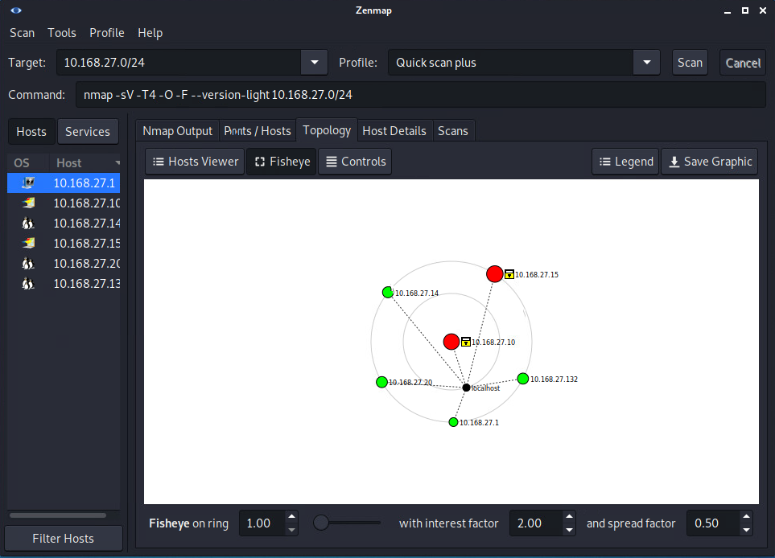
Figure 1

- Finding Vulnerabilities

The first vulnerability I’ve noticed throughout these devices is a whole lot of open ports. Nmap shows us all the open ports available in each device. For example, on 10.168.27.10 there are open ports available like http and ftp (see figure 2 below). Open ports is a security risk because it allows unauthorized access to a computer/network.

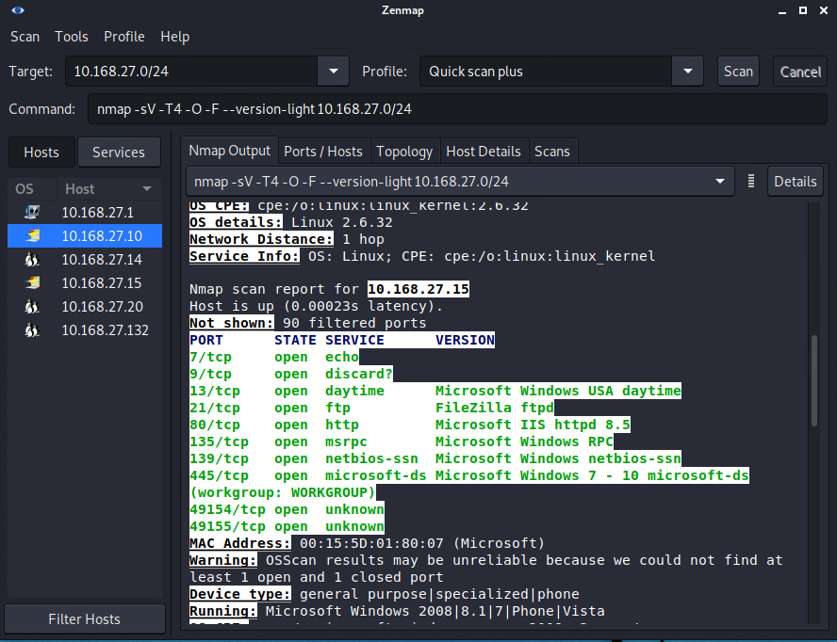
Figure 2

Another vulnerability I’ve found throughout these devices is how they are running outdated operating systems. For example, on system 10.168.27.15 they are operating windows 8.1 (figure 3 below). Windows 8.1 is considered outdated in terms of the Microsoft support lifecycle since January 9th 2018, and extended support was ended on January 10th 2023. Outdated operating systems are targets for hackers, because there are increased vulnerabilities like security flaws whenever the OS is no longer updated.

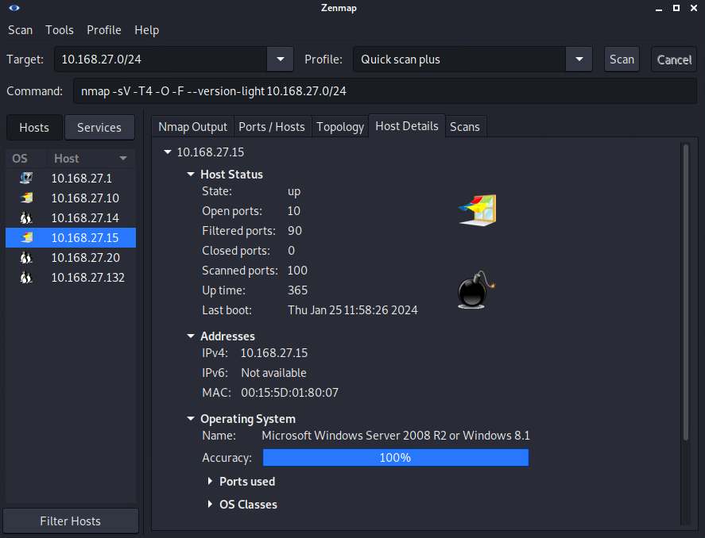
Figure 3

Finally, another vulnerability I’ve found within this Nmap scan is the high uptime highlighted in device 10/168.27.14 of 17248638 (figure 4 below). This high uptime could be a security risk because it could lead to delayed updates and security patches. And updating those are important for decreasing vulnerabilities and improve security. It could also lead to memory leaks and resource exhaustion which could impact the software components in a negative way which could lead to security vulnerabilities as well.
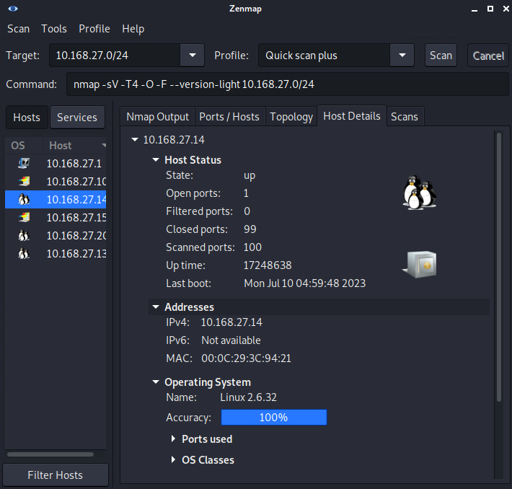
Figure 4

- Wireshark Anomalies

- The first Wireshark anomaly I have found is on frame 15760 “DCERPC TCP spurious retransmission”. This packet capture comes up when packets are being improperly retransmitted. This also happens when a sender doesn’t get a ACK for a particular packet in a certain amount of time. This could slow down the network or indicate some other vulnerability, see evidence below (figure 5).

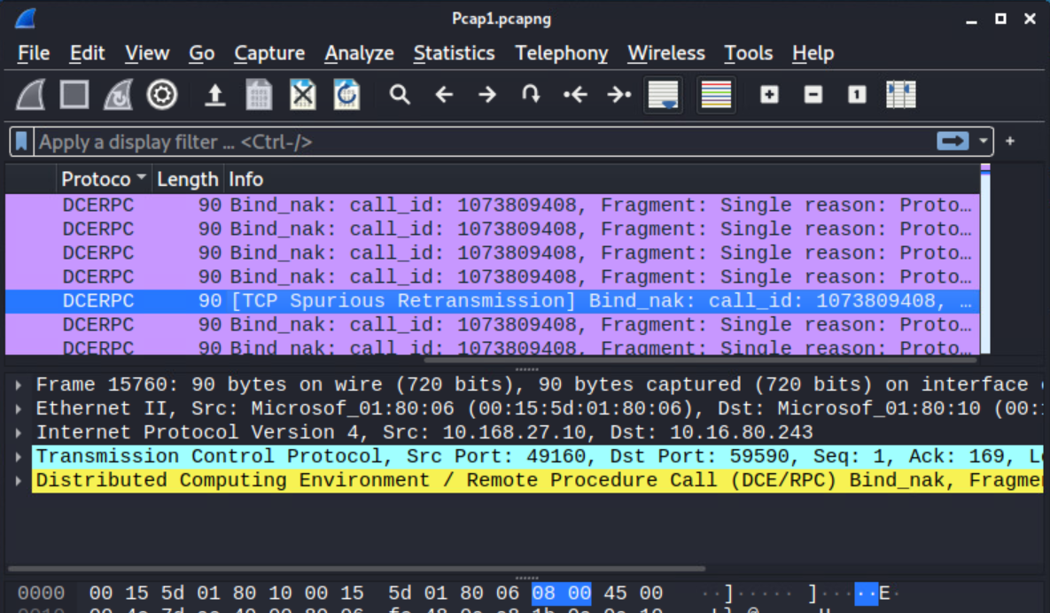
Figure 5

- The second anomaly I saw within the Wireshark pcap file is “TCP ACKed unseen segment” error. TCP is part of the transport layer protocol that provides connection-oriented communication between devices over a network. Usually the “ACK” flag is a confirmation for the sender that the packet has been successfully sent to the recipient, but in this frame capture 85, it says “unseen segment” which means that there was an issue in sending the packet, could be lost (figure 6).

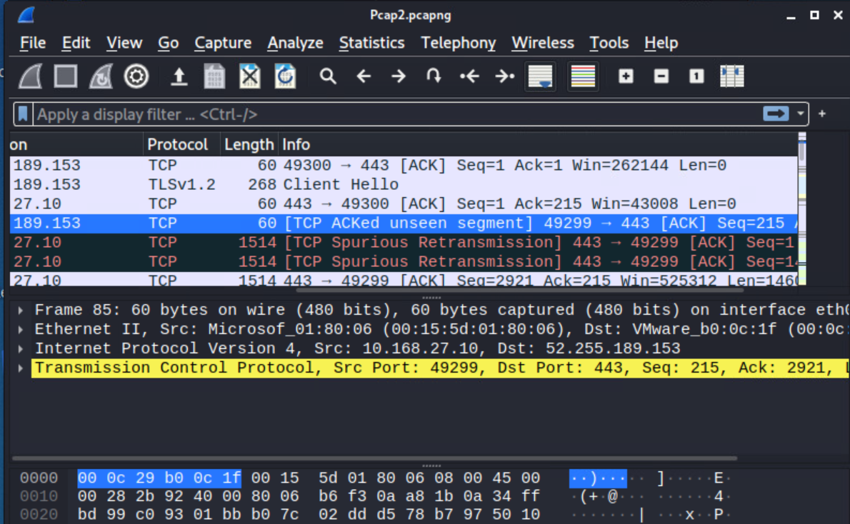 Figure 6
- The last anomaly I saw within the Wireshark pcap file is a HTTP frame 1615. HTTP operates in the application layer, it allows us to transmit data packets across the network but insecurely, letting us clients communicate to servers. As you can see in figure 7, you can see an entire html file in cleartext, telling us a password and username.
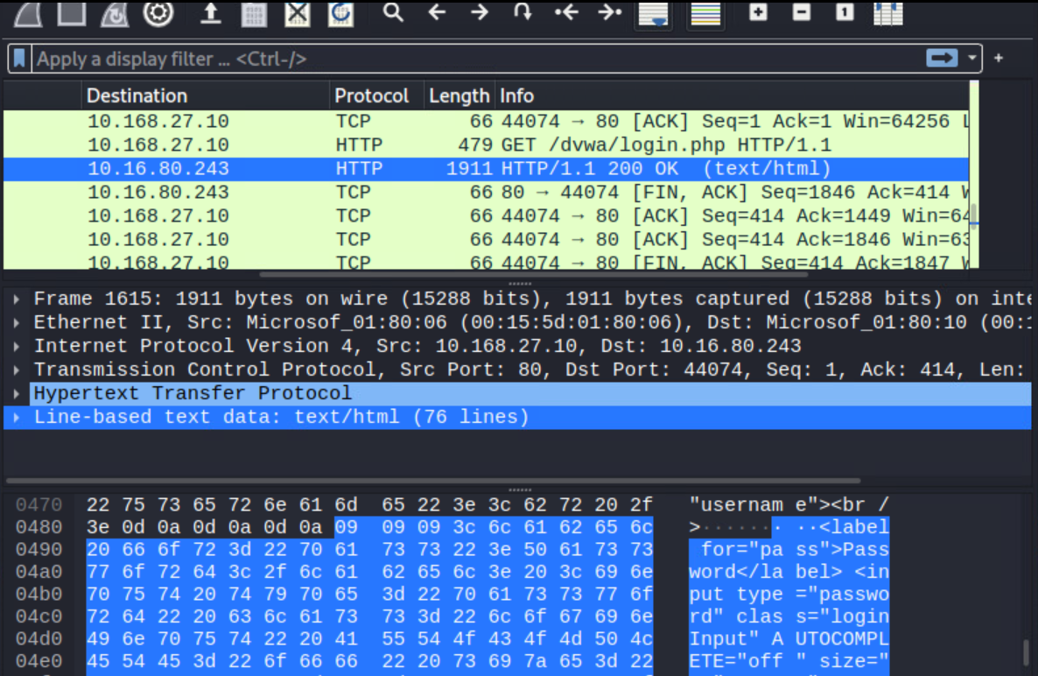Figure 7

- Potential Implications
Potential Implications within the first anomaly is related to spurious retransmissions, this means that the sender thinks that the previous transmission was successful so they send another one, these retransmissions can produce network congestion which in turn produces packet loss. The second anomaly related to “TCP ACKed unseen segment” could indicate a man in the middle attack, which is when an attacker intercepts and alters communication between two parties, and when that happens, it could lead to changed or lost segments, which triggers the “TCP ACKed unseen segment” error. The last anomaly involves a HTTP port which is insecure, it showed us clear text of the html, exposing the contents which is a breach in confidentiality. This can also allow unauthorized actors to access that information.

- Solution recommendations
The solutions for Nmap are as follows; first I suggest closing port 80 which is the HTTP port and enabling port 443 HTTPS which is the secure version of HTTP. This allows secure communication between your browser and the website which wouldn’t allow someone to intercept your traffic. (Raath, 2023). The second port I suggest closing for Nmap is 21 which is FTP, and enabling SFTP port 22, this network protocol is basically the secure version of FTP, which lets you access, manage and transfer files over a network securely (Gillis, 2022). Another issue I found on Nmap is one of the devices were running windows 8.1 which reached the end of its life in January 2023. I suggest upgrading to the latest windows client which is windows 11 (windows). Regarding the increased uptime on one of the Nmap devices, according to York college, they suggest shutting down or restarting the pc when it isn’t being used, you can also schedule your computer to do it automatically. That way, security updates, hardware updates, and overall performance of the computer stays in shape and out of the hacker’s target.
Regarding Wireshark, the solution to the “Spurious Retransmissions” is to follow some troubleshooting methods and adjust as needed. For example, you can analyze the TCP SACK (selective acknowledgement) and if its enabled, it allows the receiver to acknowledge non-contiguous segments of data. You can also check the retransmission timers, if its set too low then it may lead to retransmissions (Ergun, 2023). Next, since the “TCP ACKed unseen segment” could be a sign of a man in the middle attack, ways to avoid the attack is to implement HTTPS, turn on VPN when browsing on the internet, install antivirus software, and invest in IDPS (intrusion detection and prevention systems) for the network (Gougler and Gougler). Lastly, a HTTP frame 1615 credential exposure was shown on Wireshark. A way to not have your information exposed is, again, to close the HTTP port 80 like we did on Nmap, and enable port 443 HTTPS, this allows for secure communication between you and the website without leaving a trace of your personal information.

- Sources

Hardening network devices - U.S. department of defense. (n.d.). https://media.defense.gov/2020/Aug/18/2002479461/-1/-1/0/HARDENING_NETWORK_DEVICES.PDF
Search CVE list. CVE. (n.d.-a). https://cve.mitre.org/cve/search_cve_list.html
Raath, S. (2023b, October 4). HTTPS port 443: What is it, and is it safe to open? Home of Internet Privacy. https://www.expressvpn.com/blog/https-port-443-what-is-it/#:~:text=Port%20443%20is%20important%20because,be%20able%20to%20read%20it.

Why & how to replace FTP | Egnyte. (n.d.). https://www.egnyte.com/guides/file-sharing/ftp-replacement#:~:text=SFTP%20(SSH%20File%20Transfer%20Protocol),-SFTP%2C%20often%20incorrectly&text=It%20provides%20far%20better%20security,server%20using%20SFTP%2Dspecific%20applications.

Windows 8.1 support ended on January 10, 2023 - Microsoft Support. (n.d.-b). https://support.microsoft.com/en-us/windows/windows-8-1-support-ended-on-january-10-2023-3cfd4cde-f611-496a-8057-923fba401e93#:~:text=As%20a%20reminder%2C%20Windows%208.1,service%2C%20and%20supported%20Windows%20release.

Understanding TCP spurious retransmissions and how to diagnose them. (2021, October 23). Premium Courses. https://www.packetsafari.com/blog/2021/10/23/tcp-spurious-retransmissions/#introduction-to-tcp-spurious-retransmissions

Gillis, A. S. (2022b, October 13). Secure File Transfer Protocol (SSH File transfer Protocol). Content Management. https://www.techtarget.com/searchcontentmanagement/definition/Secure-File-Transfer-Protocol-SSH-File-Transfer-Protocol#:~:text=Secure%20File%20Transfer%20Protocol%20(SFTP)%20is%20a%20network%20protocol%20for,of%20files%20over%20a%20network.

Top nine reasons restarting your computer is important. (n.d.-b). https://www.york.cuny.edu/it/service-delivery-unit/service-desk/it-service-reminders/top-ten-reason-restarting-your-computer-is-important?activeAccordion=88ad6191-61fd-4d38-94a2-d24abad1c50b

