A1. Creating the case
I started to create my case by clicking the autopsy64 application and created a new case file by selecting “New Case”
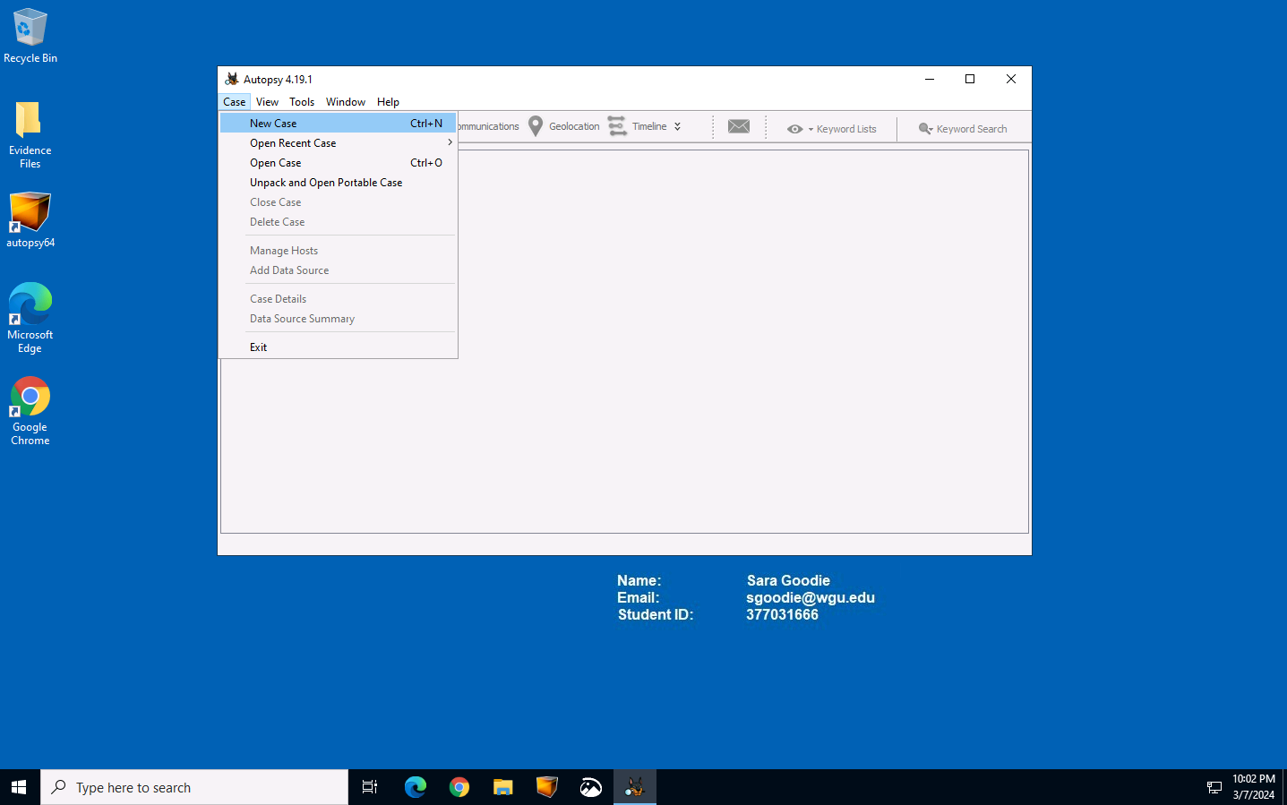
When I created the new case file, I set the directory to C:\Users\LabUser\Desktop\Evidence Files so that the data collected from the workstations can be easily located.
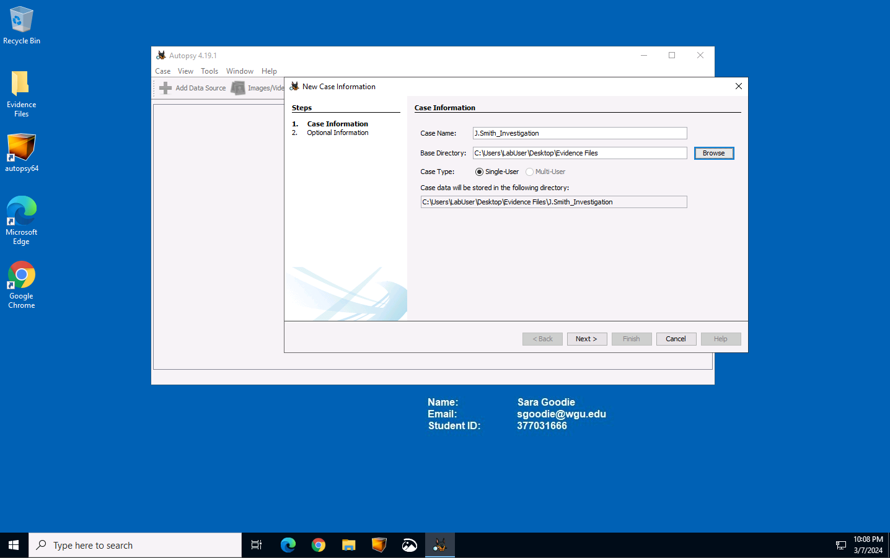
In the next screen, I assigned the case number as my student ID of 377031666, and I put that number as the examiner as well.
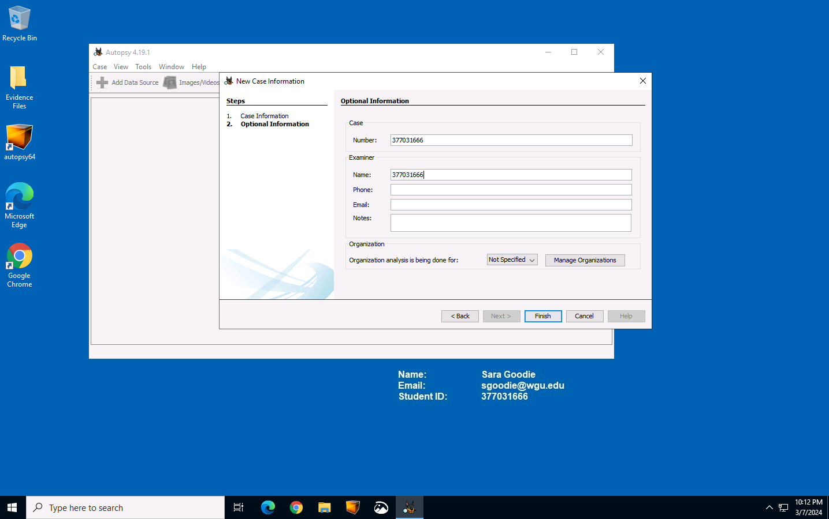
The following screen took me to choose a specific host, but I left it at default settings.
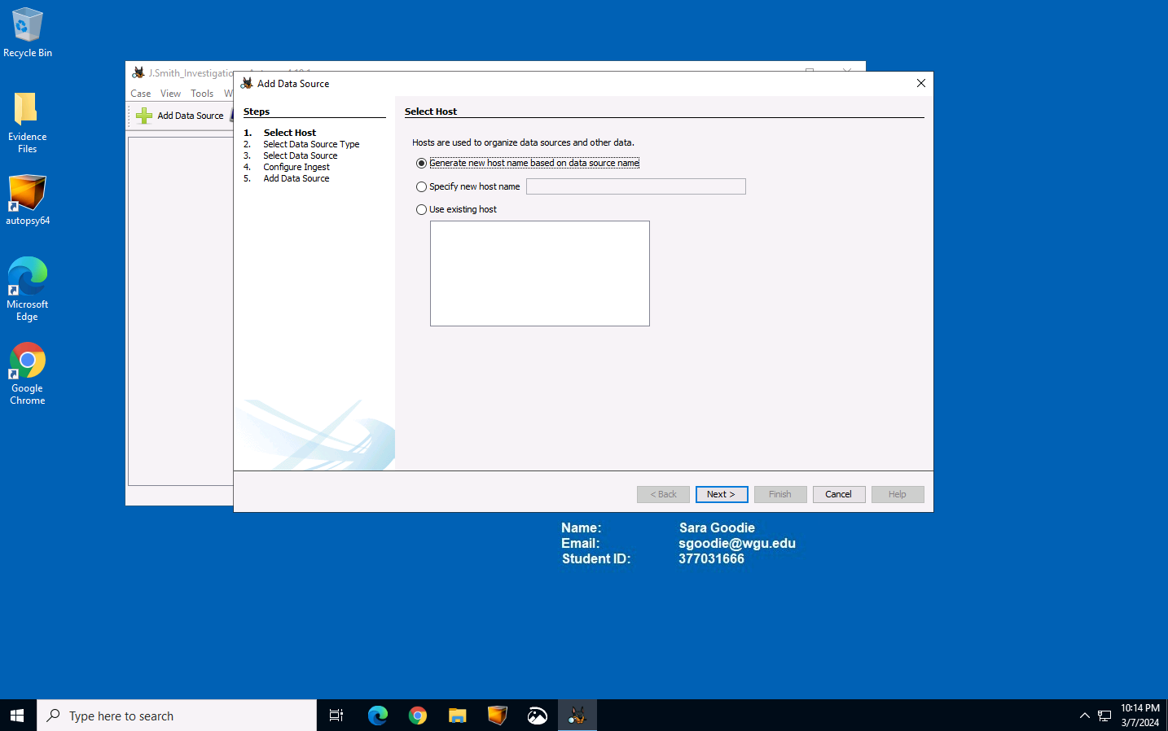
The next screen showed me some data source types to choose from, I chose the “Disk Image/VM file” as the data source.
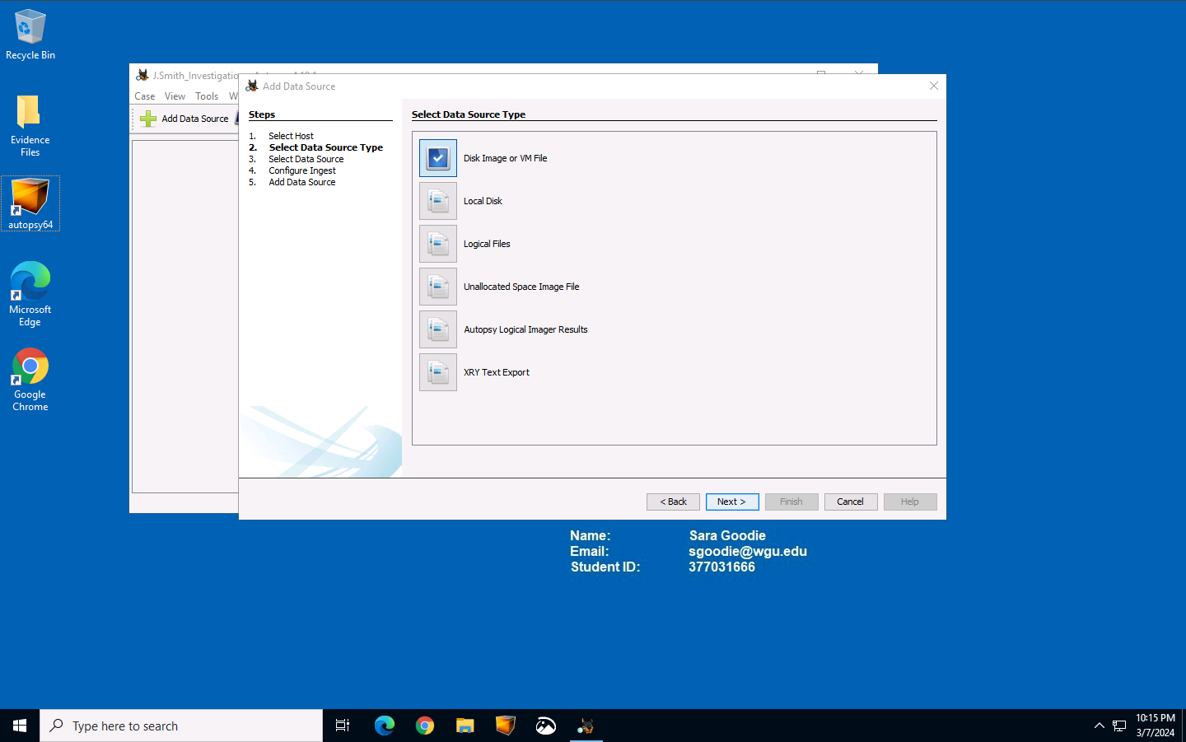
In the next screen where it says, “Select Data Source”, I navigated the directory path to the disk image that was made during the forensic investigation from John Smith’s company PC, which is located on C:\Users\LabUser\Desktop\Evidence Files\JSmith_Q1.001 and moved on to the next screen.
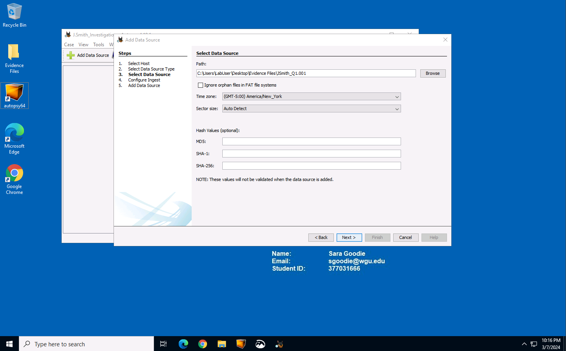
Next, I was prompted to configure some ingest modules, but I decided to leave the default configurations instead.
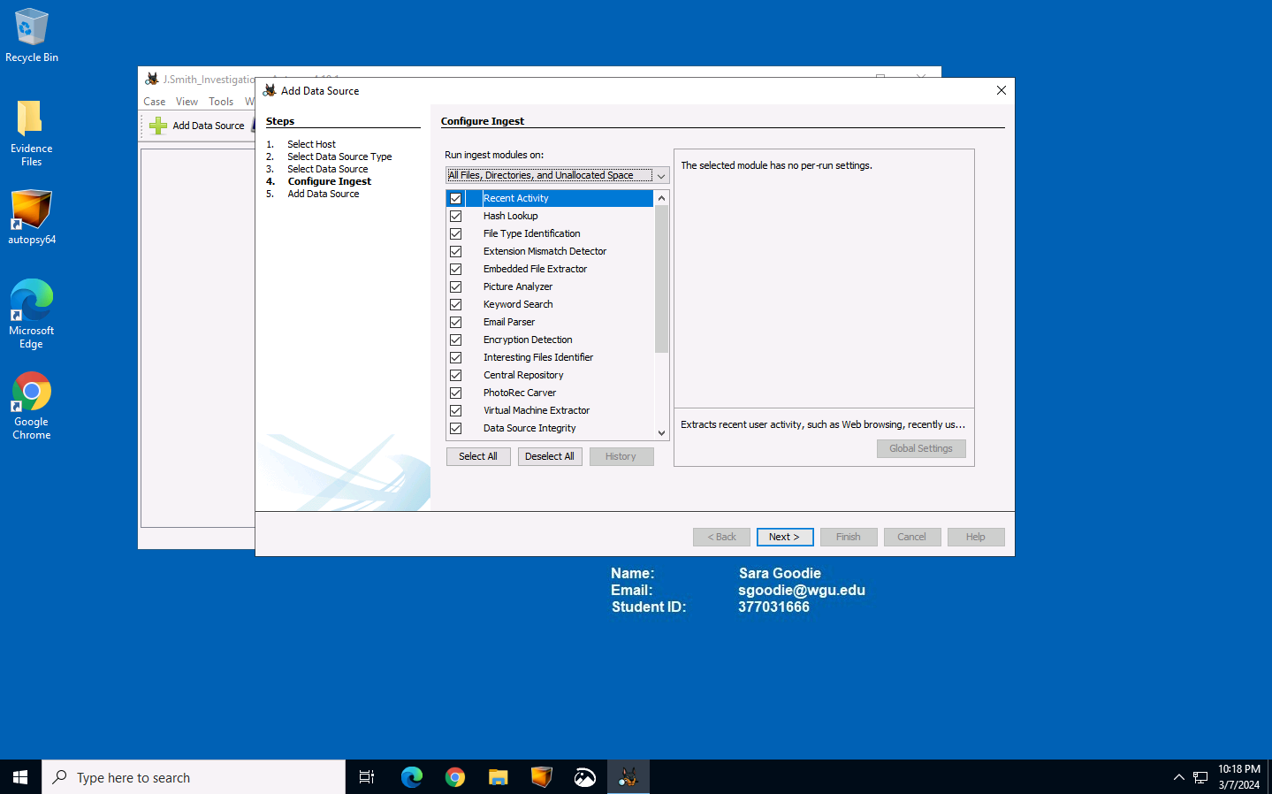
After clicking next, Autopsy will begin loading the data from the “JSmith_Q1.001” using the default ingest modules. After this, we can begin the data analysis.
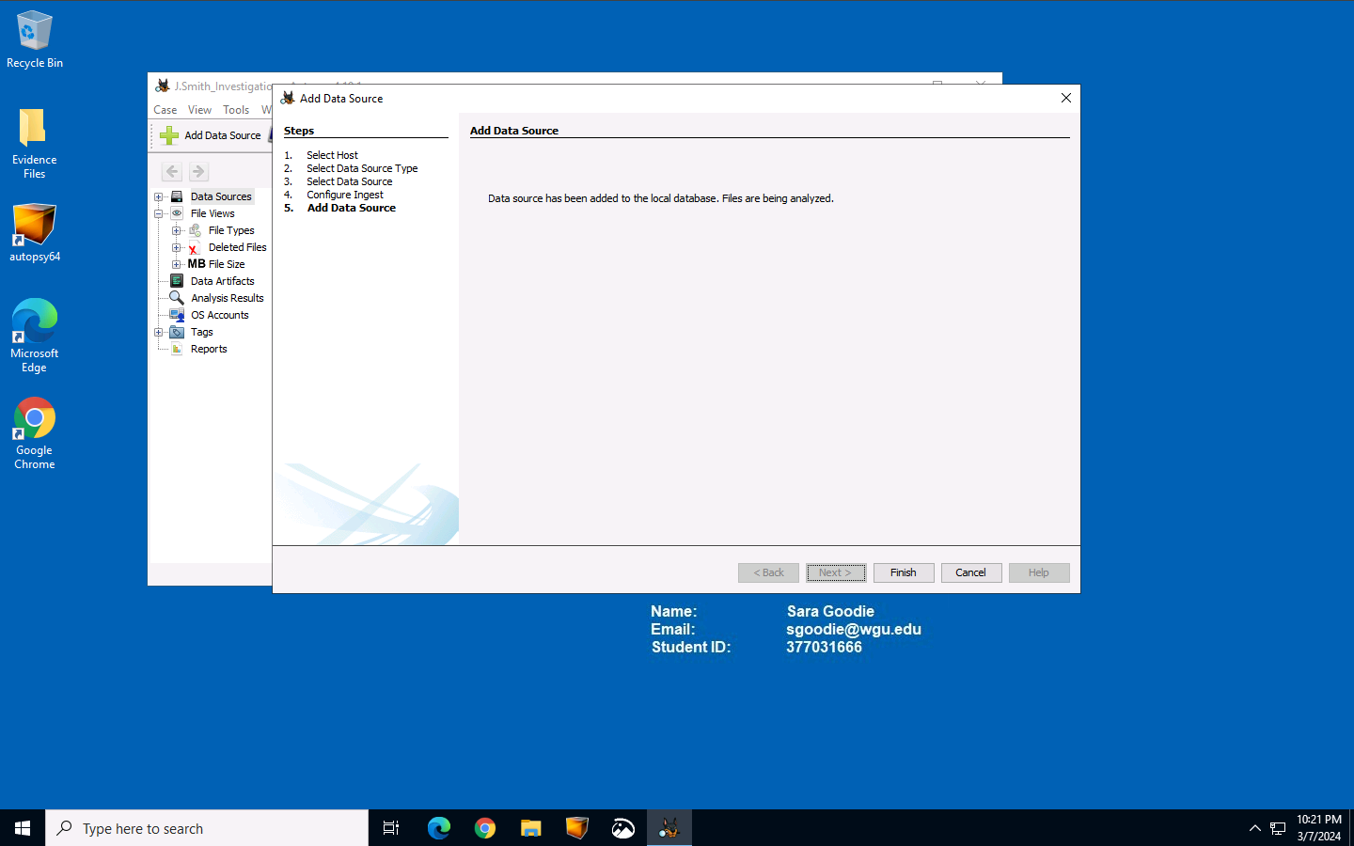

A2. Evidence Analysis

When analyzing the data, we found a folder that has 12 deleted files from John Smith’s workstation. This folder needs to be examined and to do so, we need to extract these files to our workstation so we can take a closer look. It will be extracted to: C:\Users\LabUser\Desktop\Evidence Files\J.Smith_Investigation\Export.
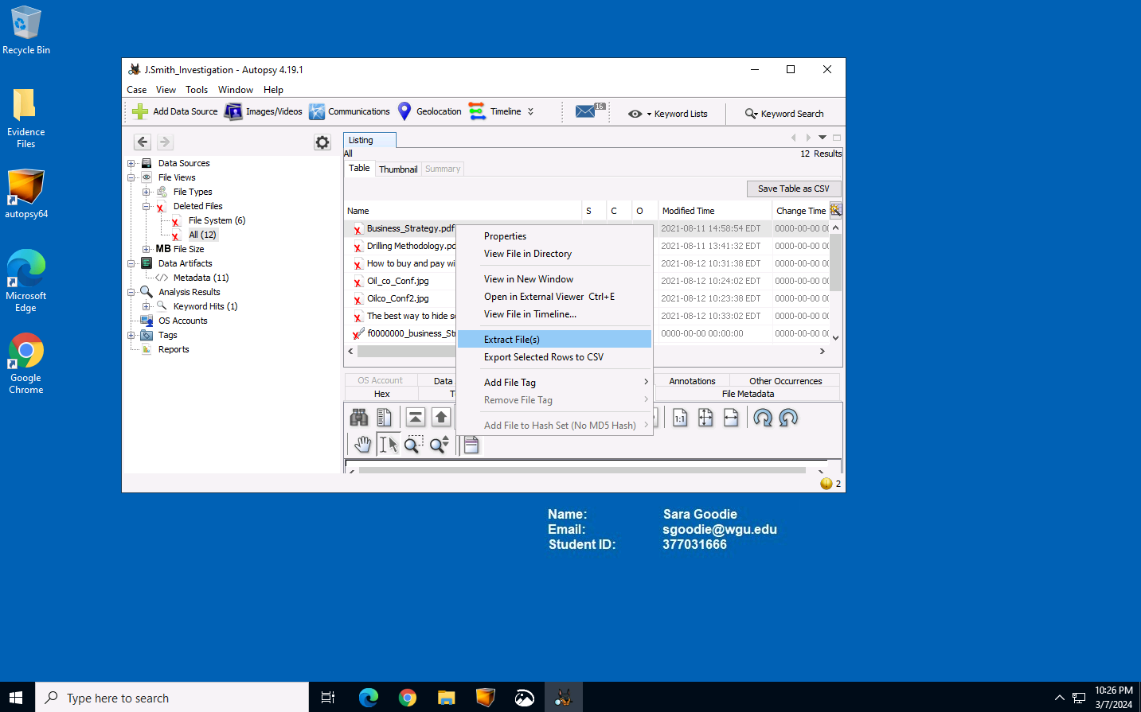
After exporting the deleted files, we can click on the “JSmith_Q1.001 Host” and expand it, then expand “JSmith_Q1.001” for us to be able to investigate John’s image files below.

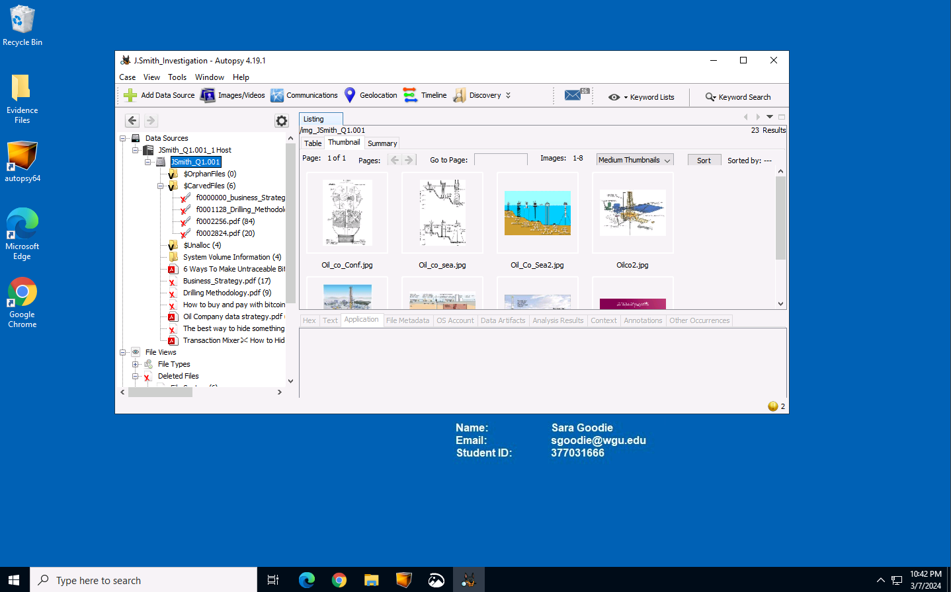
When you scroll down on the left, there are 379 images available on John Smith’s workstation as well as 11 PDF’s on John Smith’s workstation. Some of them even match to the deleted files that we recovered.
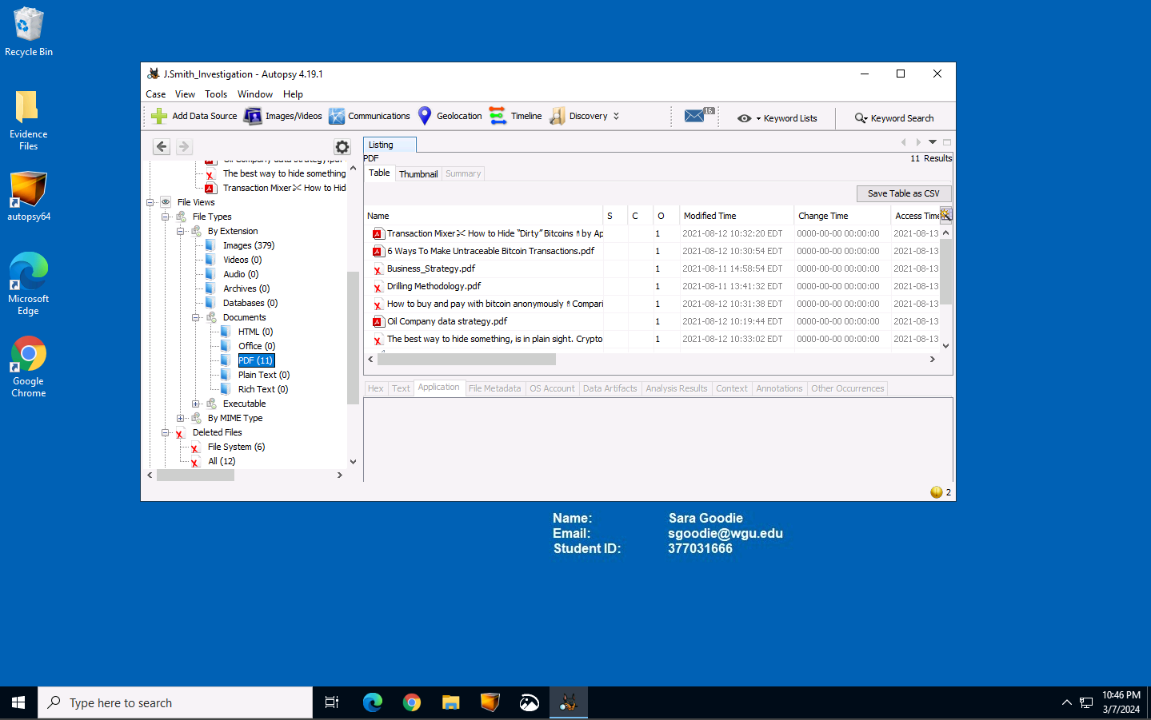

We are shown some data in the middle of the application, like the business strategies and confidential pdf files. We can view these via metadata tab, containing proprietary info from “Mike Morris” which could be the owner of these files.

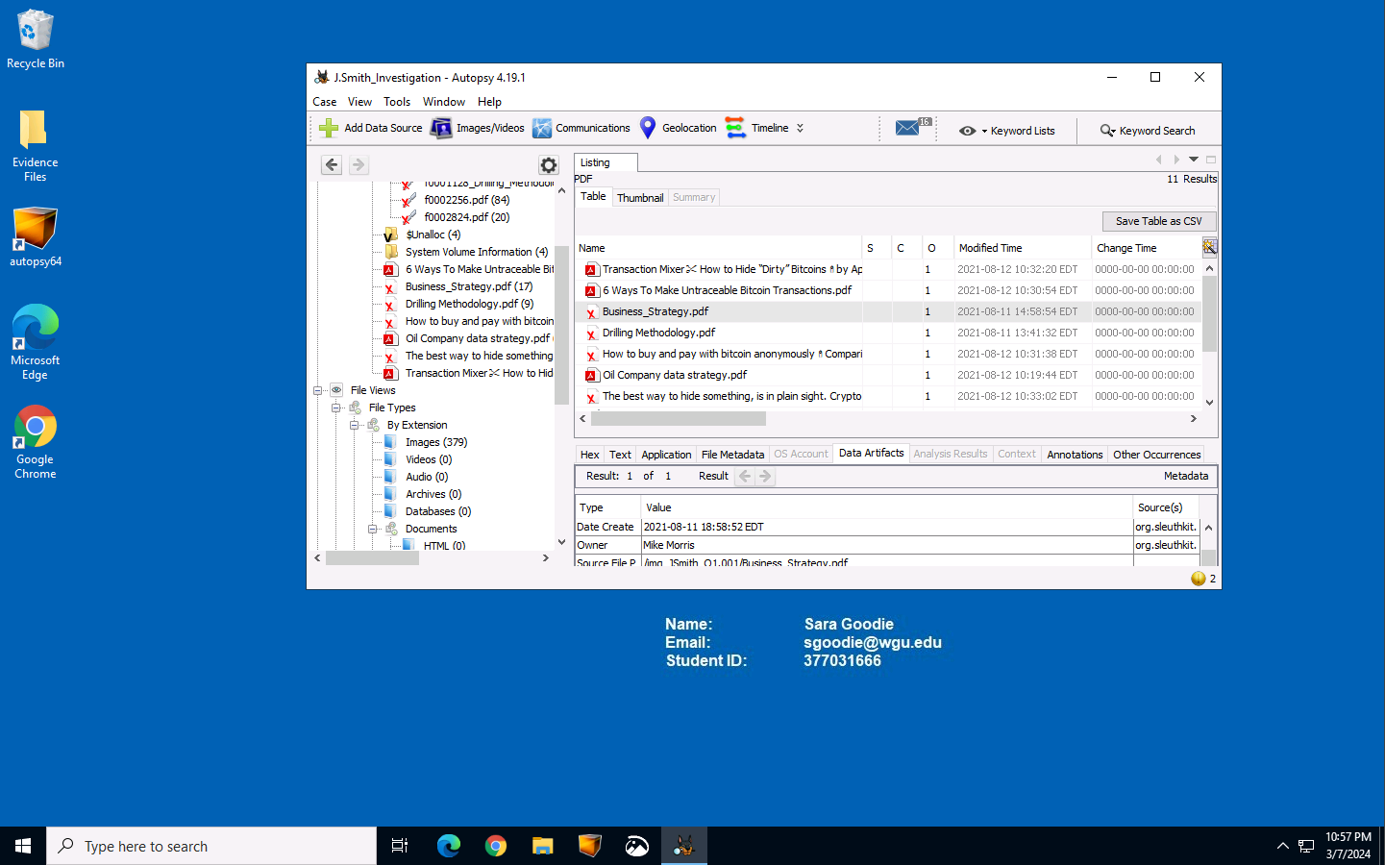

Autopsy has an option for us to use keyword search function, we can use keywords like “confidential” and “restricted” And we can conclude that John Smith accessed files that are confidential and proprietary, exposing these files will hurt the oil company because this information could be helpful for the company’s competitors.
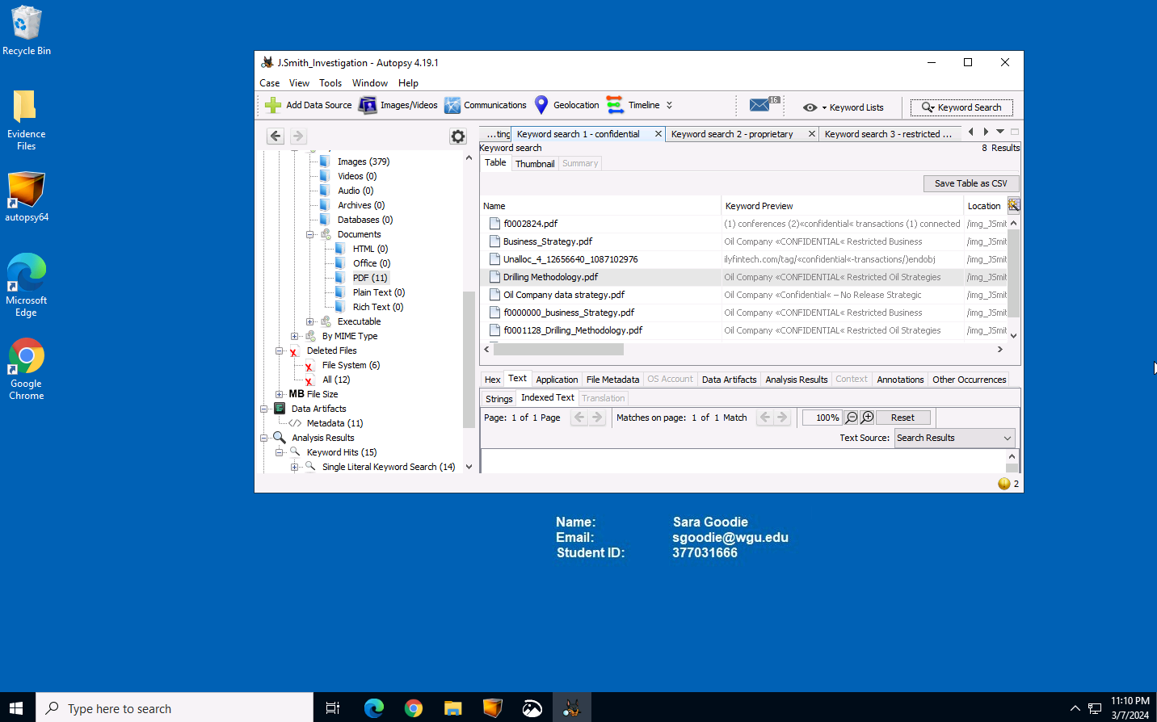
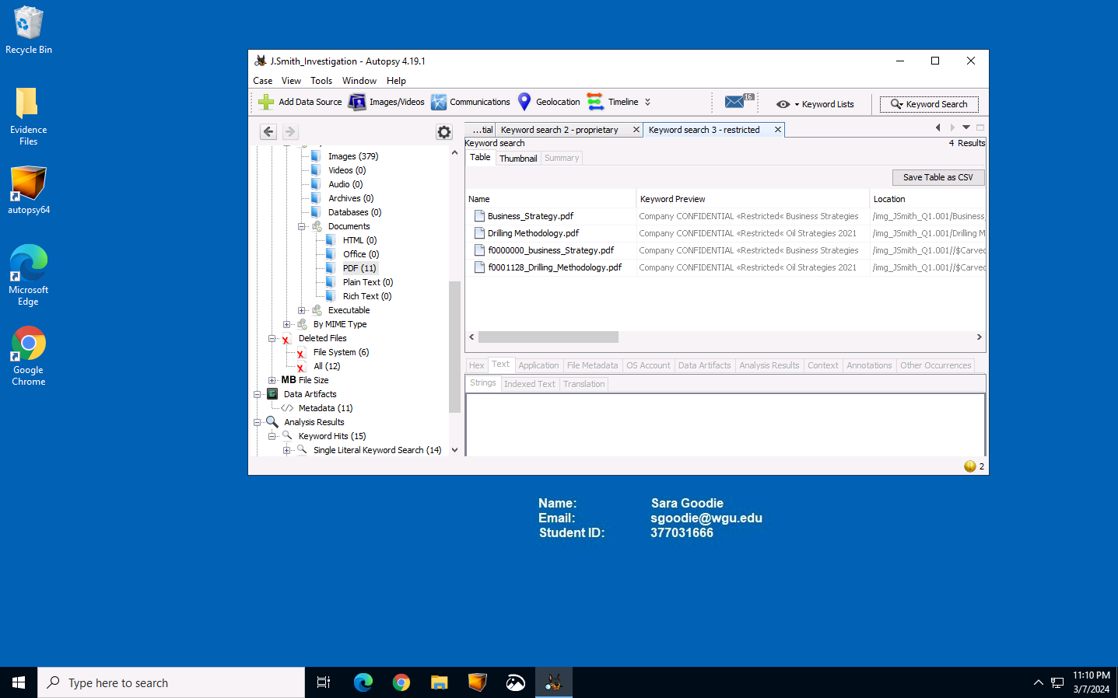

Looking at the deleted files we exported, we see that these were the same files we saw in the keyword search that were labeled as “confidential” and “proprietary”. We can also find more suspicious files like “the best way to hide something”.
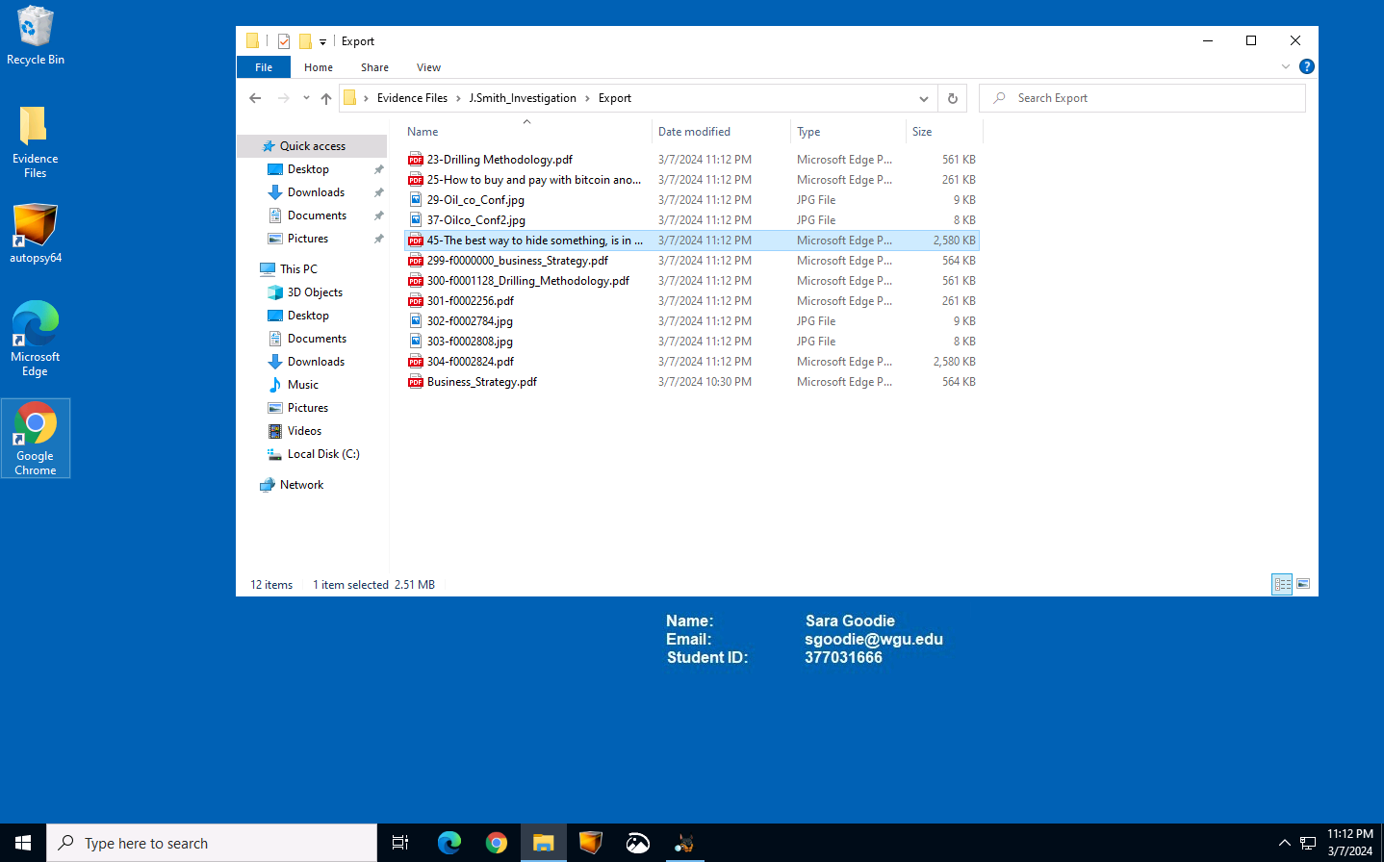

Let’s look at these files. The first document containing proprietary information is the “Drilling Methodology” PDF. This PDF shows us all the methods the oil company is going to use for drilling holes at a new site. In this document, they mention how their biggest risk is other competitors learning their methodology of oil drilling.
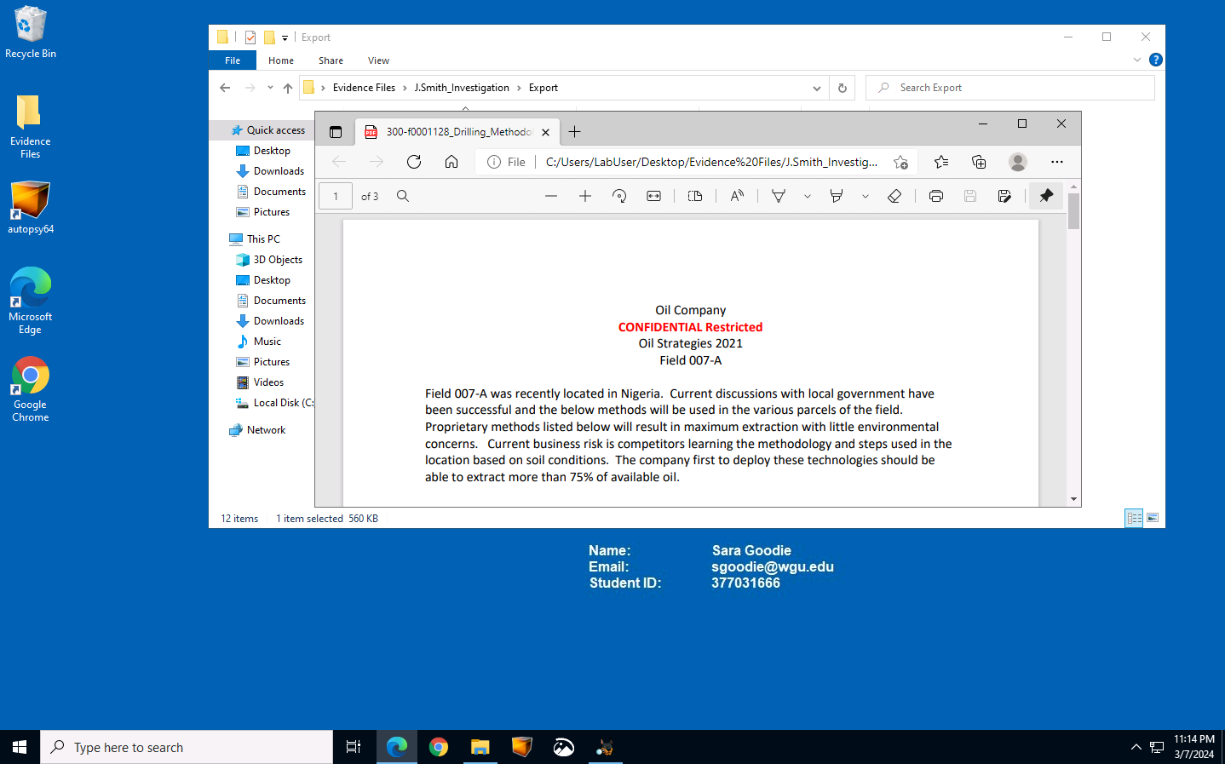

Another example is one of the confidential files labeled as “Business Strategy”. This document contains confidential information about how the company will conduct business in the year of 2021, John Smith is not supposed to access this information.
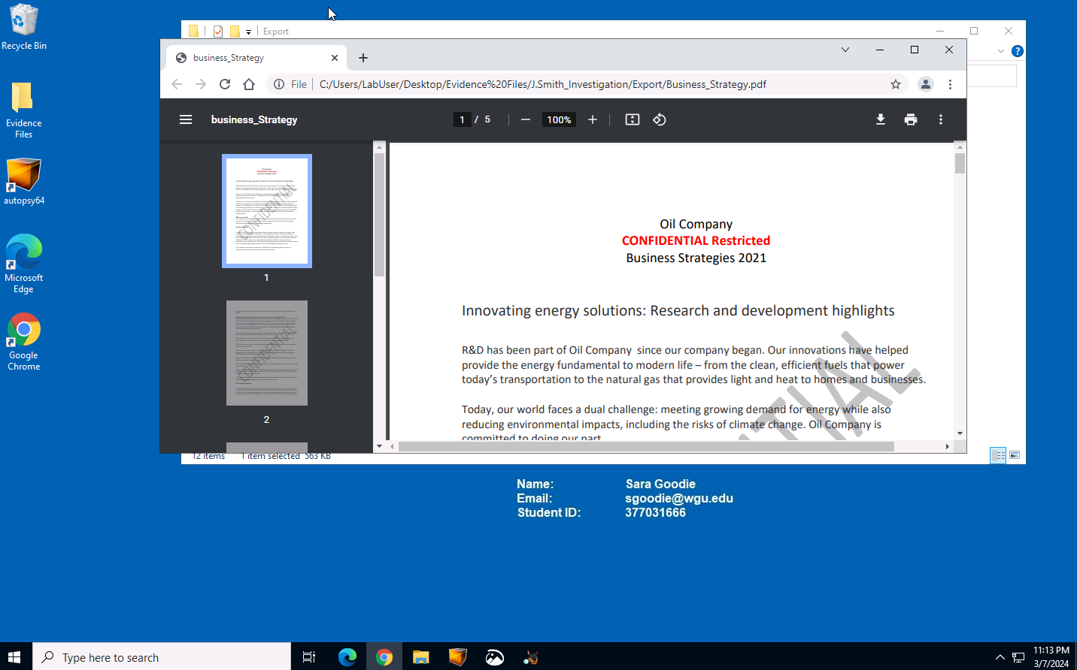
We also discovered more pictures of the oil company’s proprietary diagrams.
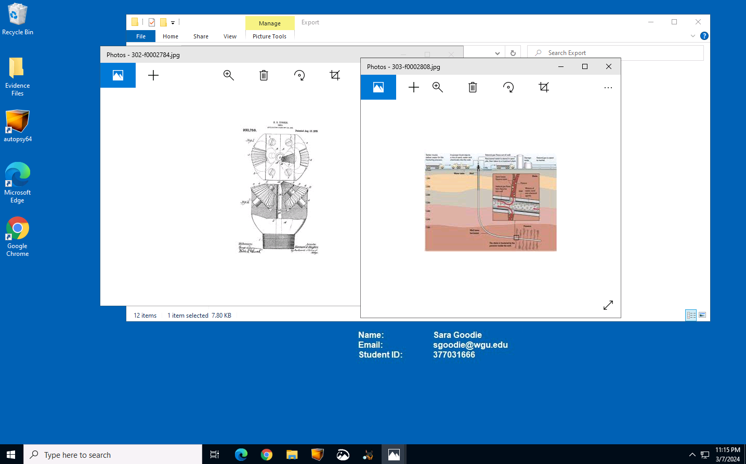
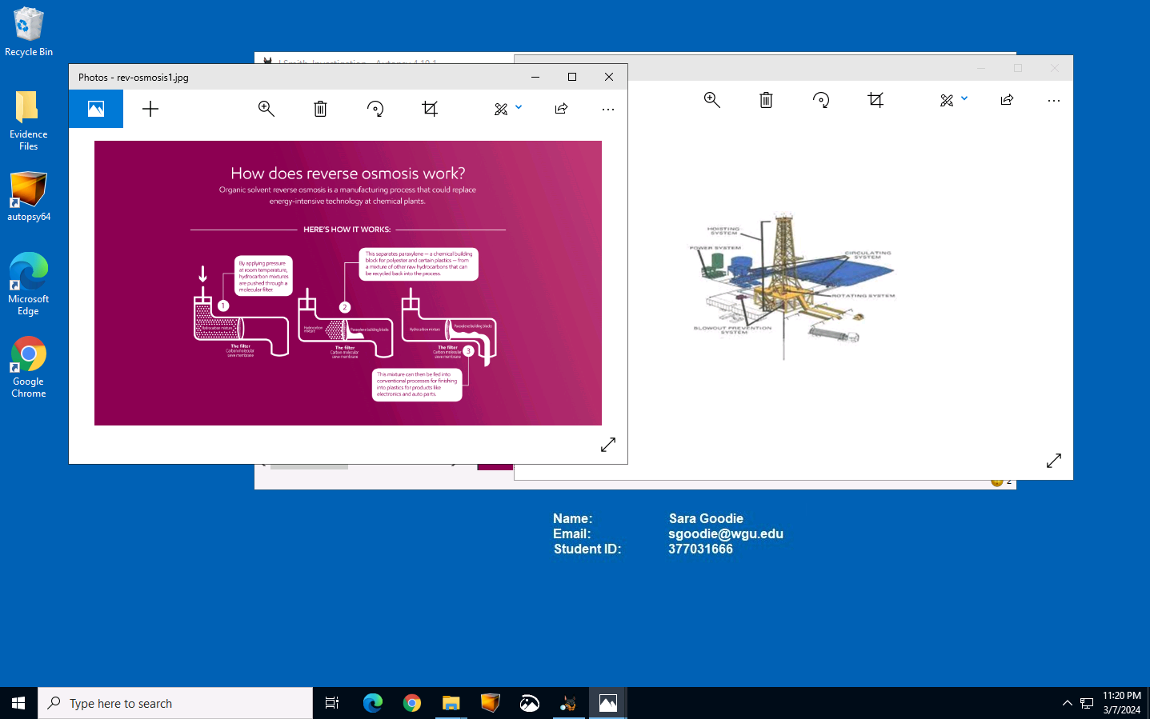

The final thing we found on John Smith’s workstation is these PDF documents about how to make anonymous cryptocurrency transactions article on the Daily Fintech named “The best way to hide something, in plain sight. Crypto laundering”.
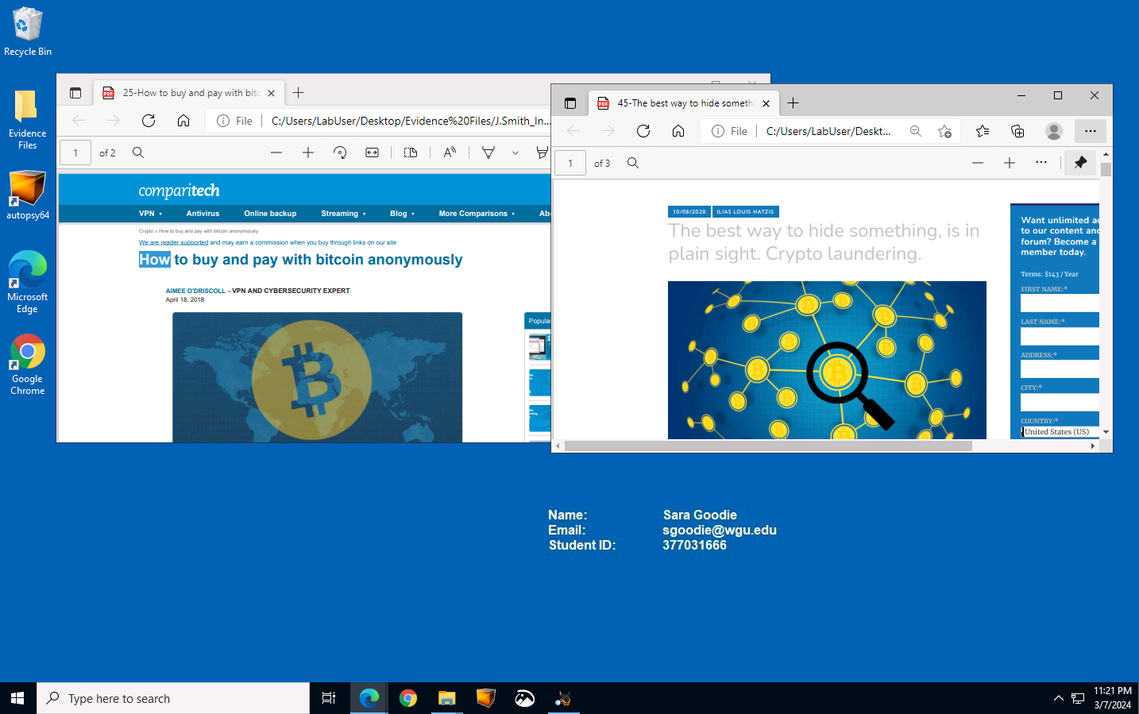
A3. Findings
After doing a thorough analysis of John Smith’s workstation, we found out enough evidence that tells us John Smith is indeed proven to be in violation of company policies that prohibit him from accessing proprietary and confidential information. Documents such as “23-Drilling Methodology.pdf” confidential diagrams, and “21-Business Strategy.pdf” is the evidence to confirm that he violated the Non-Disclosure Agreement. He also tried looking to for financial gain using cryptocurrency anonymously and cryptocurrency laundering, which violates the Acceptable Use Policy.

