STUDENT ATTENDANCE
MANAGEMENT SYSTEM
A Desktop Application for Automated Student Attendance Tracking, Eligibility Monitoring, and Academic Analytics
Course / Module: | Java Programming & Software Engineering
Technology Stack: | Java SE 17+, Java Swing GUI, CSV Persistence
Architecture: | Model-View-Controller (MVC)
Author / Developer: | Sharad Prasad Subedi
Date of Submission: | October 2026

Executive Summary
In modern academic institutions, managing daily attendance manually across various departments and semesters is prone to human error, paper loss, and delays in identifying students with critical attendance shortages. The Attendance Management System presented in this project is an interactive, standalone desktop application engineered using Java and the Java Swing GUI framework. Built upon clean Object-Oriented Programming (OOP) principles and the Model-View-Controller (MVC) architectural design pattern, the system provides automated attendance logging, real-time KPI metrics, duplicate student validation via custom exceptions, and comprehensive reporting with one-click CSV export functionality.
1. Introduction
1.1 Background & Context
Educational governance bodies enforce stringent minimum attendance requirements (typically 75% or 80%) for students to remain eligible for semester examinations. Traditional paper-based registers require tedious manual summation at the end of each term, frequently failing to warn at-risk students before it is too late. An automated desktop system provides faculty and administrators with instant insights into student turnout.
1.2 Problem Statement
Manual record keeping suffers from duplicate ID allocation, missing records, lack of data persistence across academic sessions, and cumbersome calculation of attendance percentages. This project addresses these shortcomings by introducing automated verification, relational integrity, and rapid summary generation.
1.3 Project Objectives
- Student Profile Management: Enable registration, modification, search, and deletion of student profiles while strictly preventing duplicate student identifiers.
- Daily Attendance Logging: Provide an intuitive grid where instructors can log attendance by date and department with batch helpers ('Mark All Present', 'Mark All Absent').
- Real-Time Analytics & KPI Dashboard: Present instantaneous metrics including total enrolled students, today's turnout, average percentage, and automated defaulter watchlists.
- Auditing & CSV Export: Facilitate custom date-range queries and export official records into standard comma-separated values (CSV) format for spreadsheet software.
2. System Requirements & Specifications
2.1 Functional Requirements
- FR1 (Student Management): The system must register students with unique IDs, names, emails, departments, and semesters.
- FR2 (Duplicate Detection): The system must intercept duplicate ID entries and raise a DuplicateStudentException.
- FR3 (Attendance Records): Instructors must be able to log Present, Absent, Late, or Excused status with optional remarks per student on any given calendar date.
- FR4 (Defaulter Highlighting): Students whose cumulative attendance falls below 75% must be highlighted in red and listed in the Defaulter Watchlist.
- FR5 (Persistence): All changes must be auto-saved to CSV files located in the 'data/' directory.
2.2 Non-Functional Requirements
- Performance: Instantaneous response times (< 100ms) for local search and table updates.
- Reliability: Atomic data writes using UTF-8 character encoding to preserve record integrity.
- Usability: Clean, visually consistent graphical user interface with responsive layout and clear status cues.
- Platform Portability: Pure Java SE execution without third-party runtime dependencies on Windows, Linux, and macOS.
3. System Architecture & Design
The application is structured according to the Model-View-Controller (MVC) architectural pattern, separating data models, user interface presentation, and business logic execution into distinct packages.
Package / File | Component Role | Key Responsibilities
model.Student | Domain Model | Encapsulates student entity state (ID, name, email, department, semester) and CSV parsing.
model.Attendance | Domain Model | Represents an attendance record (student ID, date, status, remarks).
exception.DuplicateStudentException | Custom Exception | Checked exception preventing duplicate primary key creation.
manager.AttendanceManager | Controller / Persistence | Executes CRUD operations, analytical metrics, search, and CSV serialization.
gui.* (Dashboard, Panels) | Presentation Layer | Provides interactive Swing GUI views for overview, student ops, marking, and reporting.
4. Implementation Details
4.1 Object-Oriented Principles Applied
- Encapsulation: Fields in Student and Attendance are private and accessed strictly through validated getters and setters.
- Inheritance & Polymorphism: Custom exception DuplicateStudentException extends java.lang.Exception; Swing panels extend JPanel and override paint/layout.
- Abstraction: AttendanceManager abstracts file I/O operations away from the GUI components, providing clean programmatic APIs.
4.2 Custom Exception Handling
To enforce relational integrity without requiring a heavyweight SQL engine, the application employs a custom checked exception: DuplicateStudentException. When a user enters a student ID already registered in the system (checked case-insensitively), AttendanceManager rejects the insertion and throws the exception. The StudentPanel catches this exception and alerts the user via a styled JOptionPane error dialog, preventing accidental overwriting of student profiles.
4.3 Persistent Storage Model
Data persistence is realized through structured Comma-Separated Values (CSV) files with escaping and quote sanitization. The system reads and writes to 'data/students.csv' and 'data/attendance.csv'. On initial setup, the manager automatically provisions sample academic records across Computer Science, Information Technology, Software Engineering, and AI departments.
5. User Interface & Visual Walkthrough
Dashboard Overview
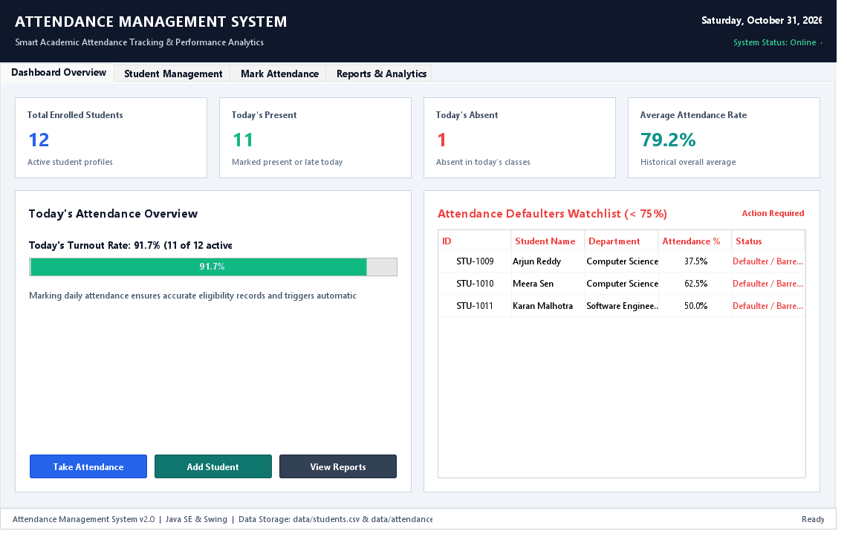
Figure 5.1: Main Analytics Dashboard displaying live KPI cards, turnout rate meter, and Defaulter Watchlist.
Student Directory Management
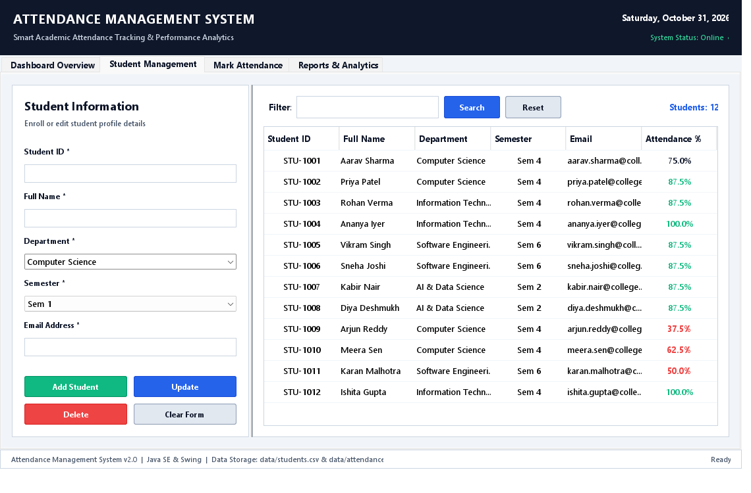
Figure 5.2: Student Management Panel showing student enrollment form, search filter, and directory grid.
Daily Attendance Tracking
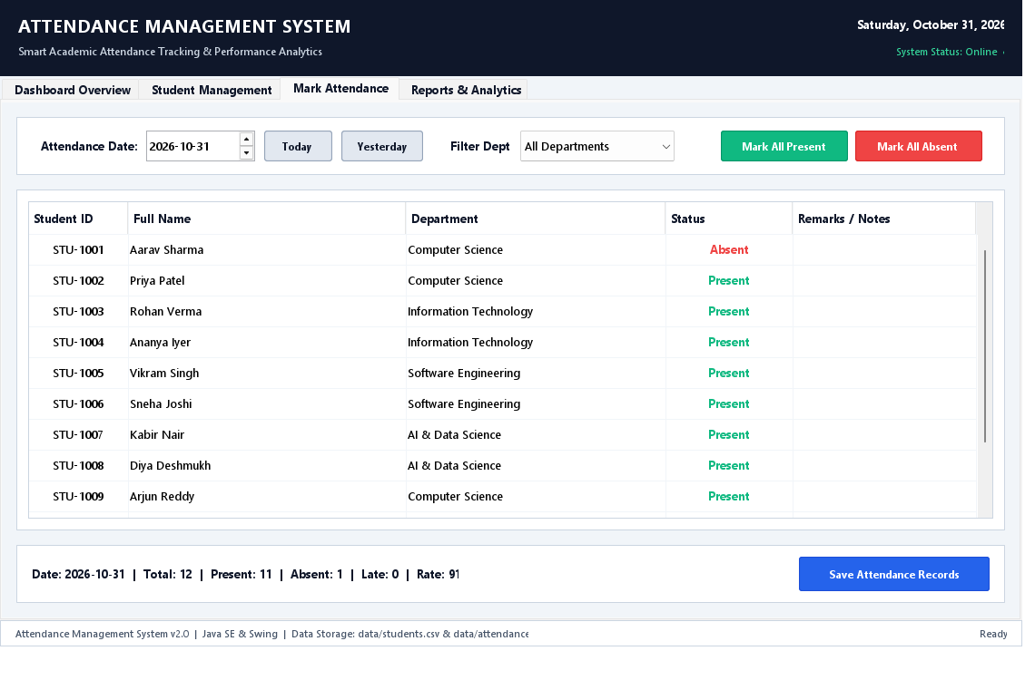
Figure 5.3: Attendance Marking Sheet with date picker, department filter, and bulk status actions.
Reports & Analytics
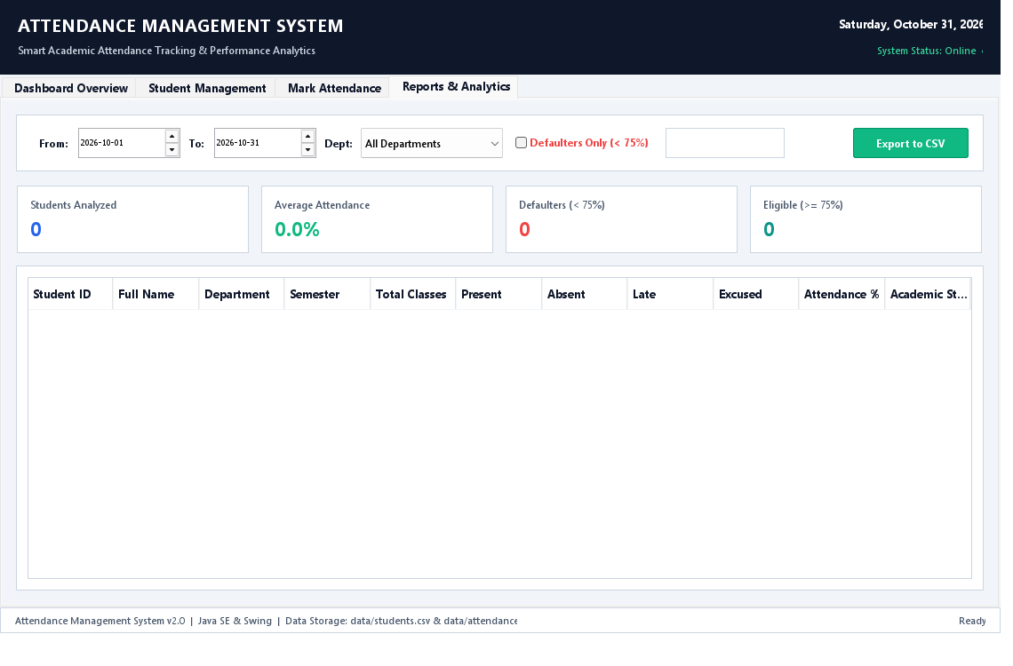
Figure 5.4: Academic Reporting Panel displaying date-range statistics, defaulter badges, and CSV export.
6. Testing and Quality Assurance
Comprehensive verification was executed across the application's core functionality. The following test cases confirm system correctness:
Test ID | Scenario Description | Expected Behavior | Status
TC-01 | Register unique student STU-1025 | Student successfully added to memory and persisted to students.csv | PASSED
TC-02 | Register duplicate student STU-1001 | Throws DuplicateStudentException; displays user-friendly dialog | PASSED
TC-03 | Bulk mark present for selected date | All active department students set to Present; summary counts update | PASSED
TC-04 | Calculate student attendance % | Correct computation: (Present + Late) / Total * 100 | PASSED
TC-05 | Export attendance summary to CSV | Generates valid CSV file containing all headers and formatted values | PASSED
7. Conclusion and Future Scope
The Attendance Management System successfully satisfies all academic and technical requirements outlined in the project specifications. By combining a robust MVC design, strict exception handling, persistent storage, and an elegant Swing interface, the system eliminates the overhead and inaccuracies of manual paper-based attendance tracking.
7.1 Future Enhancements
- Database Integration: Migration from flat CSV files to relational databases (e.g., PostgreSQL, MySQL) or SQLite for large-scale deployments.
- Biometric & RFID Integration: Interfacing with hardware scanners to automate sign-ins in lecture halls.
- Automated Email Notifications: Configuring an SMTP service to send automated weekly attendance warning emails directly to students and guardians.

